Name of Student: Postiwala Vatsal Dipakbhai | PRN: 26070122509
Subject: Web Application and Development | Sem: III AY: 2026-27
EXPERIMENT No: 9 | Assignment No: 9
TITLE: To configure a local document-oriented NoSQL database system using MongoDB, mapping system paths, and managing schema administration shell variables.

Objective
To install MongoDB Community Server and MongoDB Shell (mongosh)/Compass, and to perform basic database creation and deletion operations.
Theory
MongoDB is a document-oriented NoSQL database that stores data as flexible, JSON-like BSON documents grouped into collections (analogous to tables), rather than rigid rows/columns. mongosh is the modern MongoDB Shell for interacting with the database via commands; MongoDB Compass is the official GUI. In MongoDB, a database is not physically created until it contains at least one document — the use <dbname> command simply switches context to (or creates) a database, but it only persists once data is inserted into a collection.
Software / Hardware Requirements
MongoDB Community Server installer, MongoDB Compass, a Windows/Mac/Linux machine with admin rights.
Step-by-Step Procedure
1. Download the MongoDB Community Server installer for your OS from mongodb.com/try/download/community.
2. Run the installer, choose 'Complete' setup type, and ensure 'Install MongoDB as a Service' is checked so it starts automatically.
3. Also install MongoDB Compass (bundled with the installer, or download separately) for a graphical interface.
4. Verify installation by opening a terminal/command prompt and running mongod --version and mongosh --version.
5. Start the MongoDB service if not already running: on Windows check Services app for 'MongoDB Server'; on Mac/Linux run sudo systemctl start mongod (or brew services start mongodb-community).
6. Open a terminal and launch the shell by typing mongosh, which connects to the default local server at mongodb://localhost:27017.
7. List existing databases with the show dbs command to see the default admin, config and local databases.
show dbs

8. Create/switch to a new database named collegeDB using the use command.
use collegeDB

9. Run show dbs again — notice collegeDB does NOT yet appear because it is empty (MongoDB creates the database lazily).
10. Insert one document into a collection to actually materialize the database.
db.students.insertOne({ name: "Aditi Sharma", rollNo: 101, branch: "CSE" })

11. Run show dbs again and confirm collegeDB now appears in the list, since it contains data.
12. Verify the current database context with the db command, and list its collections with show collections.
db
show collections

13. Drop the database entirely using db.dropDatabase() while collegeDB is the active context, then confirm with show dbs that it no longer appears.
use collegeDB
db.dropDatabase()
show dbs

14. Open MongoDB Compass, connect to localhost:27017, and repeat the create/drop database exercise through the GUI to compare it with the shell workflow.

OUTPUT:

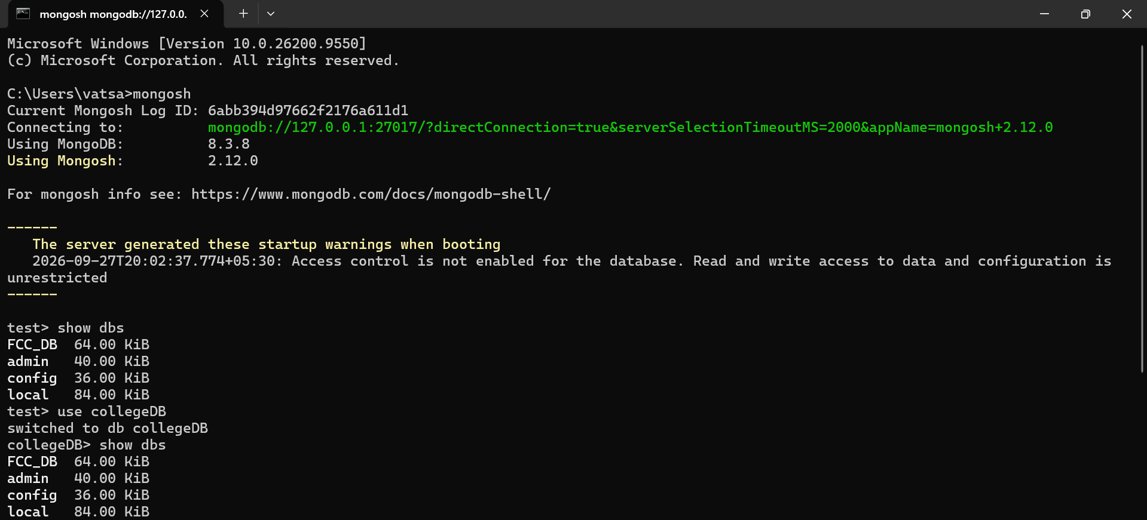

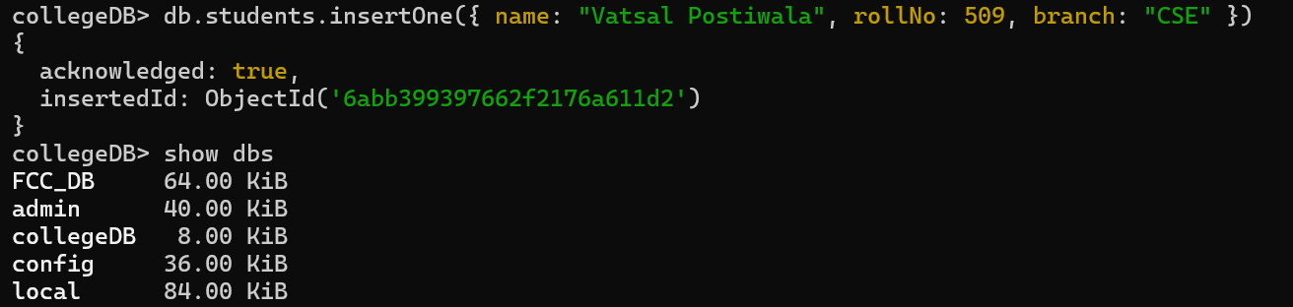

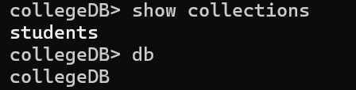

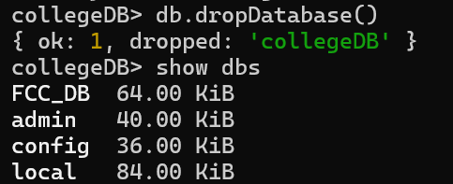
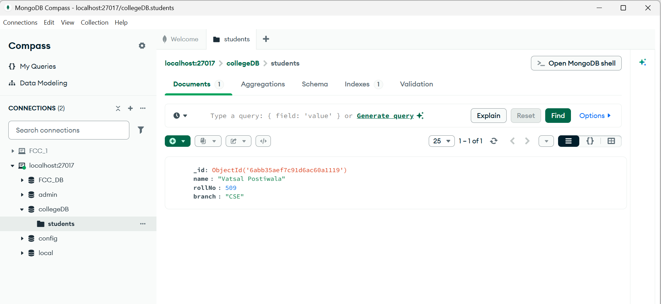

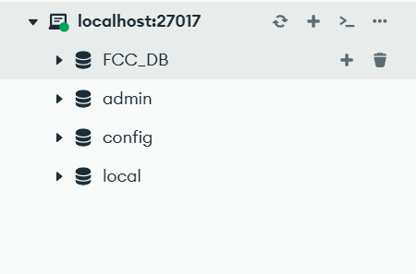

Create volkswagen DB:

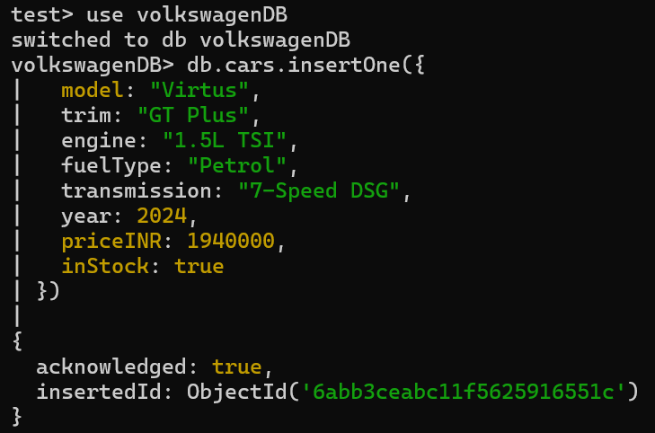

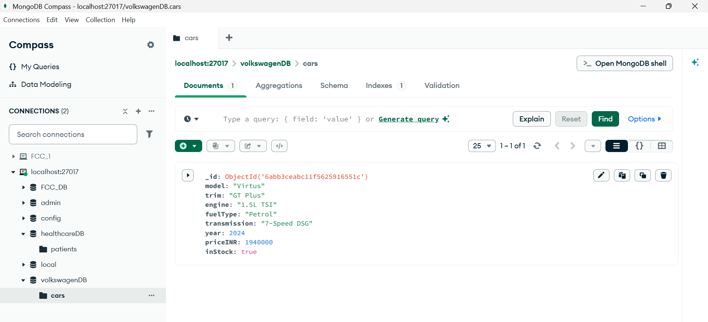

Create HealthCare DB:

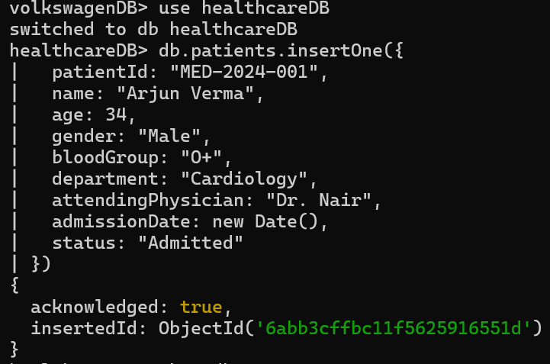

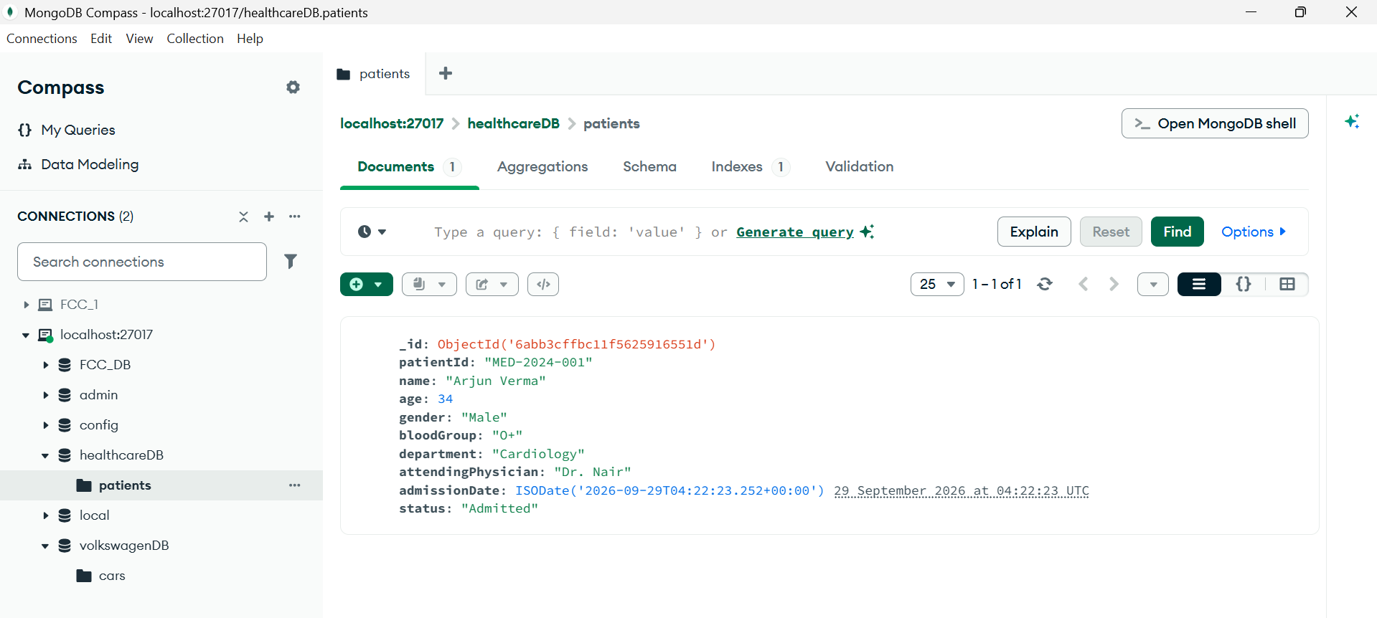

Show dbs :

