Name : Postiwala Vatsal PRN No: 26070122509 Batch : B3
ASSIGNMENT No: 9
TITLE: Write a Java program to demonstrate the use of the final keyword with variables, methods, and classes.

Problem Statement
Write a Java program to demonstrate the use of the final keyword with variables, methods, and classes.

Learning Objectives
To implement the final keyword with variables, methods, and classes.

Theory
The final keyword restricts modification in Java programs. A final variable cannot be reassigned after initialization. A final method cannot be overridden by subclasses, while a final class cannot be inherited. This improves security, prevents accidental modifications, and increases program reliability. Final is commonly used for constants and immutable classes.

Code
final class College {

void display(){

System.out.println("College name : SIT , Pune");

}
}
class Animal{
final void Sound(){
System.out.println("Animals make different Sounds.");
}
}

class Dog extends Animal{

void displayDog (){
System.out.println("Dog braks.");
}

// void Sound(){
// System.out.println("Dog Sound......");
// }
}

public class FinalDemo{

public static void main(String a[]){
final double pi = 3.14;

System.out.println("pi = "+pi);

// pi =5.20;

Dog d = new Dog();
d.Sound();
d.displayDog();

College c = new College();
c.display();

}
}

Output
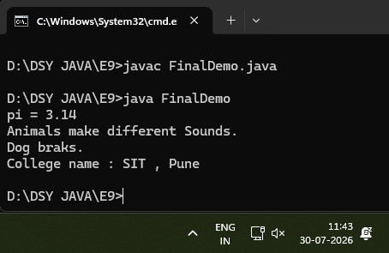

Exercise
- Create a Bank Account program where account number is final and cannot be changed.

Code
class BankAccount {
final int accountNumber;
String name;
double balance;

BankAccount(int accNum, String holderName, double startBalance) {
accountNumber = accNum;
name = holderName;
balance = startBalance;
}

void display() {
System.out.println("Account Number : " + accountNumber);
System.out.println("Name : " + name);
System.out.println("Balance : " + balance);
}
}

public class BankAccountDemo {
public static void main(String[] args) {

BankAccount acc = new BankAccount(509, "Vatsal", 3000.0);
acc.display();

}
}

Output
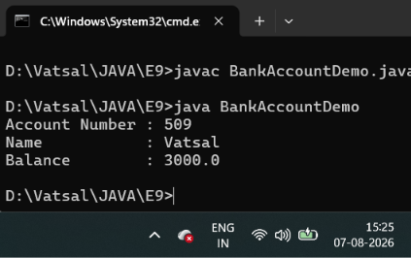

- Create a Library Book Management program where the book ISBN is declared as final and cannot be changed once assigned. Display the book's ISBN, title, author, and price.

Code
class LibraryBook {

final String isbn;
String title;
String author;
double price;

LibraryBook(String bookIsbn, String bookTitle, String bookAuthor, double bookPrice) {
isbn = bookIsbn;
title = bookTitle;
author = bookAuthor;
price = bookPrice;
}

void display() {
System.out.println("ISBN : " + isbn);
System.out.println("Title : " + title);
System.out.println("Author : " + author);
System.out.println("Price : $" + price);
}
}

public class LibraryBookDemo {
public static void main(String[] args) {

LibraryBook book = new LibraryBook("987", "Java", "Yash", 45.00);

book.display();

// Attempting to change the ISBN
// book.isbn = "123";
// ^ ERROR: cannot assign a value to final variable isbn
}
}

Output
