Name : Postiwala Vatsal PRN No: 26070122509 Batch : B3
ASSIGNMENT No: 5
TITLE: Develop a Java application demonstrating the use of ArrayList, Vector, and StringBuffer for dynamic data storage, management, and string manipulation.

Problem Statement
Develop a Java application demonstrating the use of ArrayList, Vector, and StringBuffer for dynamic data storage, management, and string manipulation.

Learning Objectives
To implement dynamic data storage and string manipulation using ArrayList, Vector, and StringBuffer.

Theory
ArrayList and Vector are dynamic array implementations provided by the Java Collections Framework. ArrayList offers faster performance in single-threaded applications, whereas Vector provides synchronized operations for thread safety. StringBuffer is a mutable sequence of characters that allows efficient string modification without creating new objects. These classes are commonly used in applications requiring dynamic memory allocation and efficient string processing.

Code
import java.util.ArrayList;
import java.util.Scanner;

public class TodoList {

public static void main (String a[]){

ArrayList<String> courses = new ArrayList<>();
Scanner sc = new Scanner(System.in);

System.out.println("Enter number of tasks:");
int n =sc.nextInt();
sc.nextLine();

for (int i=0; i < n;i++){

System.out.println("Enter task:"+(i+1)+":");
courses.add(sc.nextLine());

}

StringBuffer sb = new StringBuffer();
sb.append("To-Do-List :\n");

for (int i=0; i < courses.size();i++){

sb.append(i + 1).append(". ").append(courses.get(i)).append("\n");

}
System.out.println(sb);
sc.close();

}

}

Output
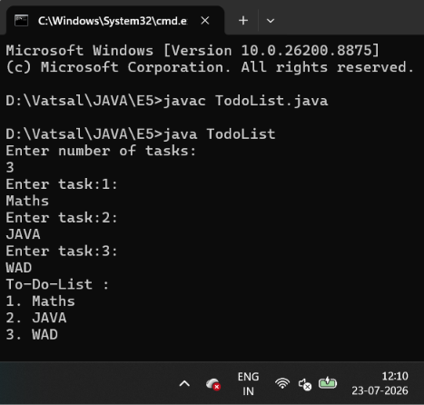

Exercise
- Create a To-Do List application using ArrayList to store tasks and StringBuffer to display tasks.

Code
import java.util.ArrayList;
import java.util.Scanner;

public class ToDoListE {

public static void main(String[] args) {

ArrayList<String> tasks = new ArrayList<>();
Scanner scanner = new Scanner(System.in);

System.out.print("Enter the number of tasks to add: ");
int taskCount = scanner.nextInt();
scanner.nextLine();

for (int i = 0; i < taskCount; i++) {
System.out.print("Enter task " + (i + 1) + ": ");
String task = scanner.nextLine();
tasks.add(task);
}

StringBuffer sb = new StringBuffer();
sb.append("TO-DO LIST\n");

if (tasks.isEmpty()) {
sb.append("No tasks in the list.\n");
} else {
for (int i = 0; i < tasks.size(); i++) {
sb.append(i + 1)
.append(". ")
.append(tasks.get(i))
.append("\n");
}
}

System.out.println(sb.toString());

scanner.close();
}
}

Output
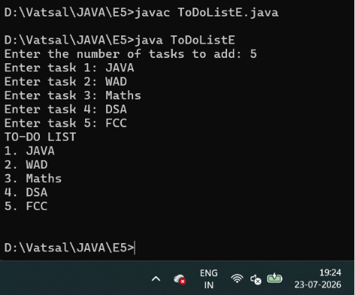

- Create a Student Course Registration System using ArrayList to store the list of courses registered by a student and StringBuffer to generate and display the registered course list. The application should allow users to add, remove, and view registered courses.

Code
import java.util.ArrayList;
import java.util.Scanner;

public class StudentCourseRegistration {

public static void main(String[] args) {
ArrayList<String> courses = new ArrayList<>();
Scanner sc = new Scanner(System.in);
int choice;

do {
System.out.println("\n1. Add Course");
System.out.println("2. Remove Course");
System.out.println("3. Display Courses");
System.out.println("4. Exit");
System.out.print("Enter choice: ");
choice = sc.nextInt();
sc.nextLine();

switch (choice) {
case 1:
System.out.print("Enter course name: ");
courses.add(sc.nextLine());
System.out.println("Course added successfully.");
break;

case 2:
System.out.print("Enter course name to remove: ");
String courseToRemove = sc.nextLine();
if (courses.remove(courseToRemove)) {
System.out.println("Course removed successfully.");
} else {
System.out.println("Course not found.");
}
break;

case 3:
StringBuffer sb = new StringBuffer();
sb.append("\nREGISTERED COURSES\n");
for (int i = 0; i < courses.size(); i++) {
sb.append(i + 1).append(". ").append(courses.get(i)).append("\n");
}
System.out.println(sb.toString());
break;

case 4:
System.out.println("Exiting...");
break;

default:
System.out.println("Invalid choice!");
}
} while (choice != 4);

sc.close();
}
}

Output
