Name : Postiwala Vatsal PRN No: 26070122509 Batch : B3
ASSIGNMENT No: 1
TITLE: Develop an application based on Java environment setup, JDK/JRE/JVM, variables, methods and constructors. and demonstrate the implementation of the concepts through suitable examples.

Problem Statement
Develop an application based on Java environment setup, JDK/JRE/JVM, variables, methods and constructors. and demonstrate the implementation of the concepts through suitable examples.

Learning Objectives
Understand the theoretical concepts, implement them in Java programs, analyze outputs, and apply the concepts to solve practical programming problems.

Theory
Java environment setup, JDK/JRE/JVM, variables, methods and constructors. forms an important component of Java programming. Students should understand the underlying concepts, architecture, advantages, use cases, and implementation methodology. The exercise should focus on understanding the design principles, coding practices, execution flow, and practical applications of these concepts in software development. Detailed study should include syntax, APIs, execution process, and real-world applications.

Code
public class E1
{
static int square(int number)
{
return number*number;
}
public static void main(String[] args)
{
String name="vatsal";
int age=18;
double salary = 55000.50;
int result=square(5);
System.out.println("Name :"+name);
System.out.println("Age :"+age);
System.out.println("salary :"+salary);
System.out.println("Square of 5 ="+ result);

int num1 = Integer.parseInt(args[0]);
int num2 = Integer.parseInt(args[1]);

int sum = num1 + num2;
int difference = num1 - num2;
int multiplication = num1 * num2;
double division = num1 / num2;

System.out.println("Addition: " + sum);
System.out.println("Subtraction: " + difference);
System.out.println("Multiplication: " + multiplication);
System.out.println("Division: " + division);

}
}

Output
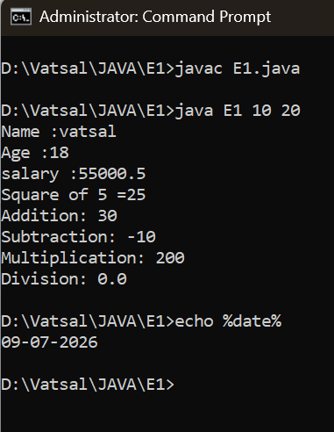

Conclusion

In this program, we successfully learned how to:

Declare, initialize, and display different types of variables (String, int, double).

Create and call a custom static method (Square).

Accept user input using command-line arguments and convert them into numbers.

Perform and display basic arithmetic operations like addition, subtraction, multiplication, and division.

Exercise
- Explain the main concept used in Java environment setup, variables and methods.

Environment Setup: Installing the necessary tools (like the JDK) so your computer can read and run Java code.

Variables: Storage boxes in the computer's memory used to hold data (like numbers or text).

Methods: A small block of code that does one specific job so you can use it whenever you need it.

- What are the advantages of using Java variables and methods?

Variables: They make your code easier to read and easy to change later.

Methods: They save time because you only have to write the code once, and you can reuse it as many times as needed.

- How can this implementation be improved?

Use the Java Scanner class to let the user type numbers easily while the program is running, instead of relying on command-line arguments.

- What are the real-world applications?

Calculator apps

Banking software

Online shopping carts

Student portals

etc

