Name : Postiwala Vatsal PRN No: 26070122509 Batch : B3
ASSIGNMENT No: 2
TITLE: Develop a Java application demonstrating the use of default, parameterized, and copy constructors for object initialization and data management.

Problem Statement
Develop a Java application demonstrating the use of default, parameterized, and copy constructors for object initialization and data management.

Learning Objectives
To understand and implement default, parameterized, and copy constructors for object initialization.

Theory
Constructors are special member functions that are automatically invoked when an object is created. Java supports default constructors provided by the compiler, parameterized constructors for initializing objects with user-defined values, and copy constructors (implemented manually) for creating duplicate objects. Constructors improve code readability and simplify object initialization while supporting object-oriented programming principles.

Default Constructor

Code
public class E2 {
int id;
String name;

E2() {
id = 509;
name = "Vatsal";
}

void display() {
System.out.println("id:" + id);
System.out.println("name:" + name);
}

public static void main(String[] args) {
E2 e = new E2();
e.display();
}
}

Output
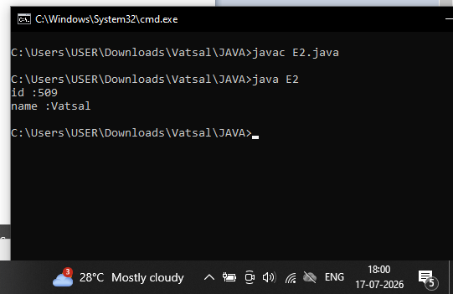

Parameterized Constructor

Code
public class Ex2 {
int id;
String name;

Ex2(int i, String n) {
id = i;
name = n;
}

void display() {
System.out.println("id:" + id);
System.out.println("name:" + name);
}

public static void main(String[] args) {
Ex2 e1 = new Ex2(509, "Vatsal");
e1.display();

Ex2 e2 = new Ex2(512, "Parth");
e2.display();
}
}

Output
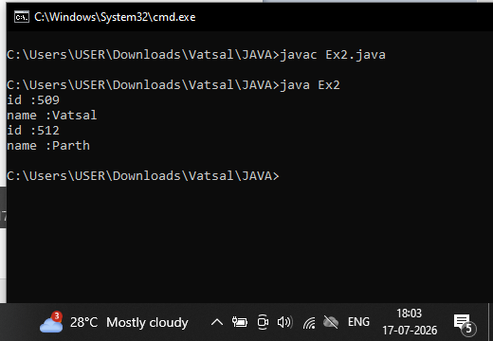

Copy Constructor

Code
public class Exp2 {
int id;
String name;

Exp2(int i, String n) {
id = i;
name = n;
}

Exp2(Exp2 s) {
id = s.id;
name = s.name;
}

void display() {
System.out.println("id:" + id);
System.out.println("name:" + name);
}

public static void main(String[] args) {
Exp2 e1 = new Exp2(509, "Vatsal");
e1.display();

Exp2 e2 = new Exp2(e1);
e2.display();
}
}

Output
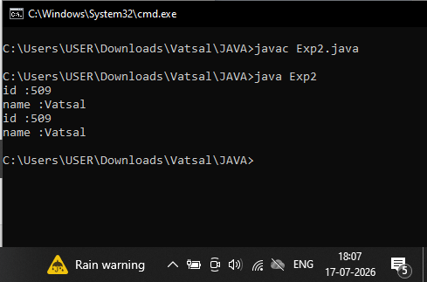

Conclusion
In this program, we learned how different types of constructors work in Java. We understood the use of default, parameterized, and copy constructors to create and initialize objects in different ways. A constructor in Java is a special type of method that is automatically called when an object of a class is created.

Exercise
- Create a Student class using default and parameterized constructors to initialize student name and roll number.

Code
public class Expriment2 {
int id;
String name;

Expriment2() {
id = 509;
name = "Vatsal";
}

Expriment2(int i, String n) {
id = i;
name = n;
}

Expriment2(Expriment2 s) {
id = s.id;
name = s.name;
}

void display() {
System.out.println("id:" + id);
System.out.println("name:" + name);
}

public static void main(String[] args) {
System.out.println("Default Constructor");
Expriment2 e = new Expriment2();
e.display();

System.out.println("Parameterized Constructor");
Expriment2 e1 = new Expriment2(512, "Parth");
e1.display();

System.out.println("Copy Constructor");
Expriment2 e2 = new Expriment2(e1);
e2.display();
}
}

Output
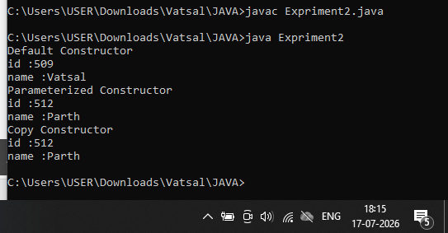

- Develop a Mobile Phone Inventory System using different constructors to initialize mobile details and create duplicate object records.

Code
public class MobileInventory {
int modelId;
String brandName;

public MobileInventory() {
modelId = 1000;
brandName = "Iphone";
}

public MobileInventory(int id, String brand) {
modelId = id;
brandName = brand;
}

public MobileInventory(MobileInventory phone) {
modelId = phone.modelId;
brandName = phone.brandName;
}

void display() {
System.out.println("Mobile ID : " + modelId);
System.out.println("Brand Name : " + brandName);
}

public static void main(String[] args) {
System.out.println("Default Constructor");
MobileInventory Phone1 = new MobileInventory();
Phone1.display();

System.out.println("Parameterized Constructor");
MobileInventory Phone2 = new MobileInventory(2000, "Oppo K13 Turbo");
Phone2.display();

System.out.println("Copy Constructor");
MobileInventory Phone3 = new MobileInventory(Phone2);
Phone3.display();
}
}

Output
