Name : Postiwala Vatsal PRN No: 26070122509 Batch : B3
ASSIGNMENT No: 7
TITLE: Implement a Java program to demonstrate inheritance and interfaces using suitable real-world examples.

Problem Statement
Implement a Java program to demonstrate inheritance and interfaces using suitable real-world examples.

Learning Objectives
To implement inheritance and interfaces for achieving code reusability and abstraction.

Theory
Inheritance allows one class to acquire the properties and methods of another class, promoting code reuse and reducing redundancy. Java supports single inheritance through the extends keyword. Interfaces define a contract that implementing classes must follow, enabling abstraction and multiple inheritance of type. Together, inheritance and interfaces support polymorphism and modular software development. They are fundamental concepts of object-oriented programming.

Code
interface VehicleCar{
void start();
}

class Car implements VehicleCar{

public void start() {
System.out.println("Car is starting.....");
}
}

class ElectricCar extends Car{

void charge() {
System.out.println("Electric car is charging.....");
}
}

public class InheritanceInterfaceDemo {
public static void main(String[] args) {

ElectricCar e = new ElectricCar();
e.start();
e.charge();

}
}

Output
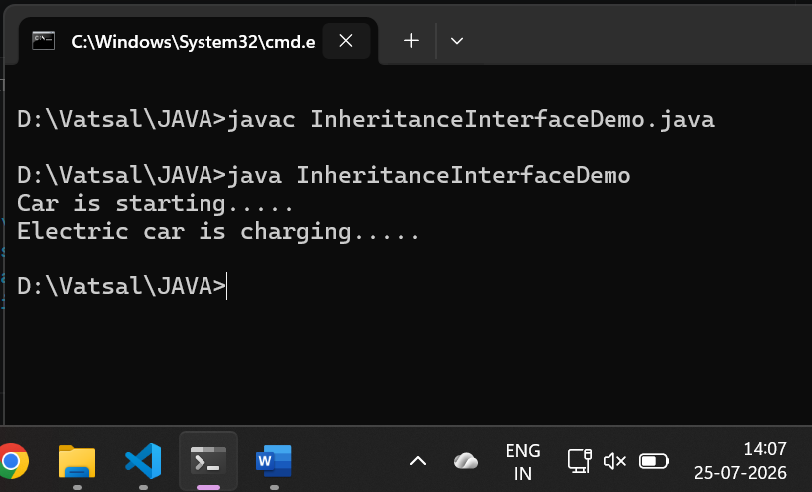

Exercise
- Create a Shape application where Circle and Rectangle inherit from Shape and calculate area.

Code

interface Shape {
void calculateArea();
void displayShape();
}

class Circle implements Shape {
double radius;

Circle(double radius) {
this.radius = radius;
}

public void displayShape() {
System.out.println("\nDisplaying Circle with radius: " + radius);
}

public void calculateArea() {
double area = Math.PI * radius * radius;
System.out.println("Circle Area: " + area);
}
}

class Rectangle implements Shape {
double width;
double height;

Rectangle(double width, double height) {
this.width = width;
this.height = height;
}

public void displayShape() {
System.out.println("\nDisplaying Rectangle with width: " + width + " and height: " + height);
}

public void calculateArea() {
double area = width * height;
System.out.println("Rectangle Area: " + area);
}
}

// Main Class
public class ShapeDemo {
public static void main(String[] args) {

Shape circle = new Circle(10.0);
circle.displayShape();
circle.calculateArea();

Shape rectangle = new Rectangle(4.0, 6.0);
rectangle.displayShape();
rectangle.calculateArea();
}
}

Output
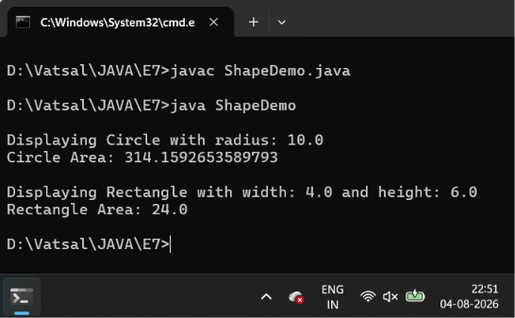
- Develop a E-Commerce Product System where electronic, clothing, and grocery products inherit common properties and implement product interfaces.

Code
interface Product {
void displayDetails();
}

class BaseProduct implements Product {
int id;
String name;
double price;

public void displayDetails() {
}
}

class ElectronicProduct extends BaseProduct {

ElectronicProduct(int pId, String pName, double pPrice) {
id = pId;
name = pName;
price = pPrice;
}

public void displayDetails() {
System.out.println("\n--- Electronic Product ---");
System.out.println("ID: " + id);
System.out.println("Name: " + name);
System.out.println("Price: " + price);
}
}

class ClothingProduct extends BaseProduct {

ClothingProduct(int pId, String pName, double pPrice) {
id = pId;
name = pName;
price = pPrice;
}

public void displayDetails() {
System.out.println("\n--- Clothing Product ---");
System.out.println("ID: " + id);
System.out.println("Name: " + name);
System.out.println("Price: " + price);
}
}

class GroceryProduct extends BaseProduct {

GroceryProduct(int pId, String pName, double pPrice) {
id = pId;
name = pName;
price = pPrice;
}

public void displayDetails() {
System.out.println("\n--- Grocery Product ---");
System.out.println("ID: " + id);
System.out.println("Name: " + name);
System.out.println("Price: " + price);
}
}

public class ECommerceDemo {
public static void main(String[] args) {
ElectronicProduct laptop = new ElectronicProduct(101, "Laptop", 80000.0);
ClothingProduct tshirt = new ClothingProduct(105, "Shirt", 750.0);
GroceryProduct milk = new GroceryProduct(108, "Milk", 80.0);

laptop.displayDetails();
tshirt.displayDetails();
milk.displayDetails();
}
}

Output
