Name : Postiwala Vatsal PRN No: 26070122509 Batch : B3(2025-2029)
ASSIGNMENT No: 15
TITLE: Write a Java program to demonstrate exception handling using finally, throw, and throws.

Problem Statement
Write a Java program to demonstrate exception handling using finally, throw, and throws.

Learning Objectives
To implement finally, throw, and throws for effective exception management.

Theory
The finally block always executes regardless of whether an exception occurs, making it suitable for resource cleanup. The throw keyword explicitly generates an exception, while throws declares exceptions that a method may pass to its caller. These mechanisms improve structured error handling and application stability.

Code
import java.io.*;

public class FinallyThrowThrows{

static void checkAge(int age)throws IOException{
if (age < 18){
throw new IOException("Age must be above 18");
}
System.out.println("Eligible for Voting.");
}

public static void main(String a[]){

try {
System.out.println("Testing age eligibility...");
checkAge(15);

} catch (IOException e) {

System.out.println("Exception: " + e.getMessage());

} finally {

System.out.println("Finally block executed");
}

System.out.println("Program End.");
}
}

Output
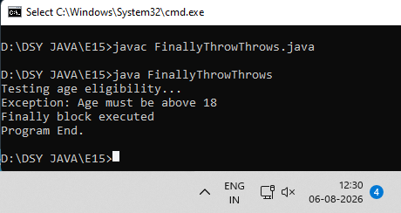

Exercise
- Create a Login program that throws an exception for invalid password and uses finally block.

Code
import java.io.*;
import java.util.Scanner;

public class LoginProgram {

static void login(String password) throws Exception {
if (!password.equals("12345")) {
throw new Exception("Invalid Password!");
}
System.out.println("Login Successful!");
}

public static void main(String[] args) {
Scanner scanner = new Scanner(System.in);

System.out.print("Enter your password: ");
String userInput = scanner.nextLine();

try {
login(userInput);

} catch (Exception e) {
System.out.println("Exception: " + e.getMessage());

} finally {
System.out.println("process ended.");
scanner.close();
}
}
}

Output
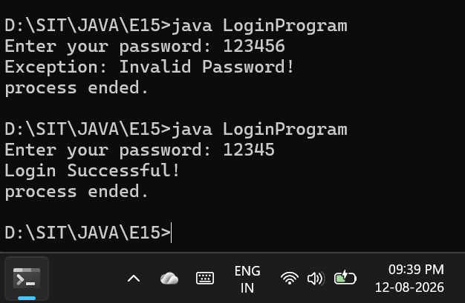

- Create an ATM PIN Verification program that throws an exception for an invalid PIN entered by the user and uses a finally block to display a message indicating that the verification process has completed.

Code
import java.io.*;
import java.util.Scanner;

public class AtmPinVerification {

static void verifyPin(int pin) throws Exception {
int correctPin = 1234;

if (pin != correctPin) {
throw new Exception("Invalid PIN");
}
System.out.println("PIN accepted. Access granted.");
}

public static void main(String[] args) {
Scanner sc = new Scanner(System.in);
System.out.print("Enter your ATM PIN: ");

try {
int enteredPin = sc.nextInt();
verifyPin(enteredPin);

} catch (Exception e) {
System.out.println("Exception: " + e.getMessage());

} finally {
System.out.println("Verification process has completed.");
sc.close();
}
}
}

Output

