Name : Postiwala Vatsal PRN No: 26070122509 Batch : B3(2025-2029)
ASSIGNMENT No: 20
TITLE: Develop a Java application to establish connectivity with a database and perform INSERT, UPDATE, and DELETE operations.

Problem Statement
Develop a Java application to establish connectivity with a database and perform INSERT, UPDATE, and DELETE operations.

Learning Objectives
To perform database modification operations using JDBC.

Theory
JDBC allows Java applications to perform database manipulation using SQL Data Manipulation Language (DML) statements such as INSERT, UPDATE, and DELETE. The INSERT statement adds new records into database tables, UPDATE modifies existing records, and DELETE removes unwanted records. These operations are executed using the Statement or PreparedStatement interface. PreparedStatement is generally preferred because it supports parameterized queries, improves performance, and prevents SQL injection attacks. Proper transaction management ensures that database modifications are performed safely and consistently. These operations form the basis of almost every database-driven application such as banking systems, hospital management systems, and student information systems.

Code:
package E20;

import java.lang.*;
import java.sql.Connection;
import java.sql.DriverManager;
import java.sql.SQLException;
import java.sql.Statement;

public class E20 {

private static final String DB_URL = "jdbc:mysql://localhost:3306/SIT_JAVA";
private static final String USER = "root";
private static final String PASS = "12345";

public static void main(String[] args) {

try (Connection conn = DriverManager.getConnection(DB_URL, USER, PASS);
Statement stmt = conn.createStatement()) {

System.out.println("Connection established successfully.");

String insertQuery1 = "INSERT INTO products (product_id, product_name, quantity, price) VALUES (104, 'Gaming Monitor', 15, 15500.00)";
stmt.executeUpdate(insertQuery1);

String insertQuery2 = "INSERT INTO products (product_id, product_name, quantity, price) VALUES (105, 'Webcam', 30, 2500.00)";
stmt.executeUpdate(insertQuery2);
System.out.println("2 records inserted successfully.");

String updateQuery = "UPDATE products SET quantity = 25 WHERE product_id = 104";
int rowsUpdated = stmt.executeUpdate(updateQuery);
System.out.println(rowsUpdated + " record(s) updated successfully.");

String deleteQuery = "DELETE FROM products WHERE product_id = 105";
int rowsDeleted = stmt.executeUpdate(deleteQuery);
System.out.println(rowsDeleted + " record(s) deleted successfully.");

} catch (SQLException e) {
e.printStackTrace();
}
}
}

Output:
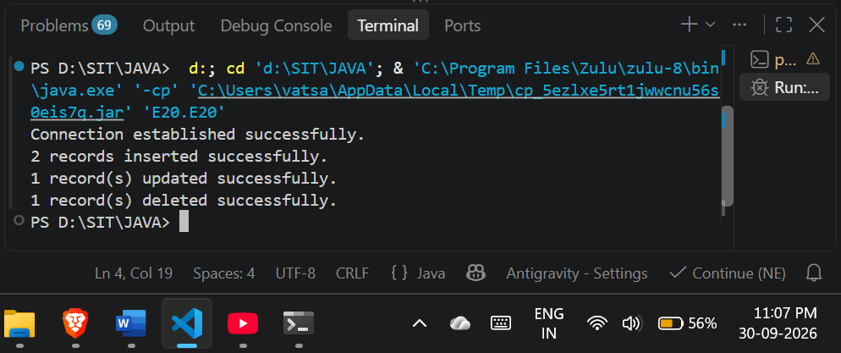
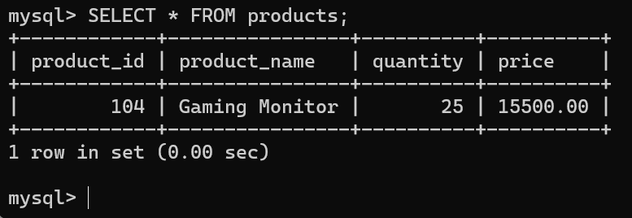

Exercise
- Create a Java application to manage employee records using CRUD operations
Code:
package E20;

import java.lang.*;
import java.sql.Connection;
import java.sql.DriverManager;
import java.sql.SQLException;
import java.sql.Statement;

public class EmployeeCRUD {

private static final String DB_URL = "jdbc:mysql://localhost:3306/SIT_JAVA";
private static final String USER = "root";
private static final String PASS = "12345";

public static void main(String[] args) {
try (Connection conn = DriverManager.getConnection(DB_URL, USER, PASS);
Statement stmt = conn.createStatement()) {

String insertQuery1 = "INSERT INTO employees (emp_id, name, department, salary) VALUES (101, 'Amit Sharma', 'IT', 55000.00)";
stmt.executeUpdate(insertQuery1);

String insertQuery2 = "INSERT INTO employees (emp_id, name, department, salary) VALUES (102, 'Priya Singh', 'HR', 45000.00)";
stmt.executeUpdate(insertQuery2);
System.out.println("CREATE: 2 Employees inserted.");

String updateQuery = "UPDATE employees SET salary = 65000.00 WHERE emp_id = 101";
stmt.executeUpdate(updateQuery);
System.out.println("UPDATE: Employee 101 salary updated.");

String deleteQuery = "DELETE FROM employees WHERE emp_id = 102";
stmt.executeUpdate(deleteQuery);
System.out.println("DELETE: Employee 102 deleted.");

} catch (SQLException e) {
e.printStackTrace();
}
}
}

Output:
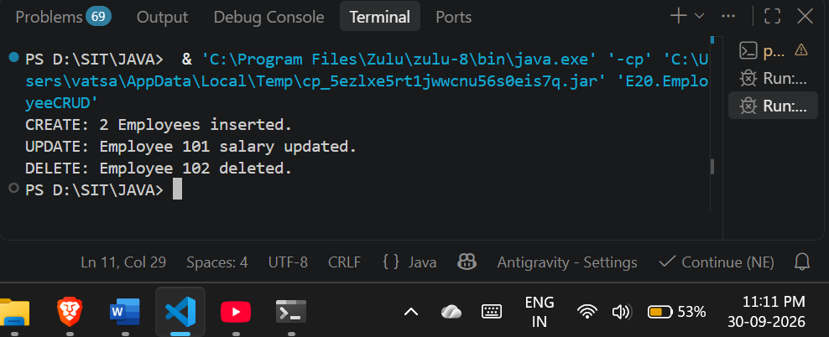
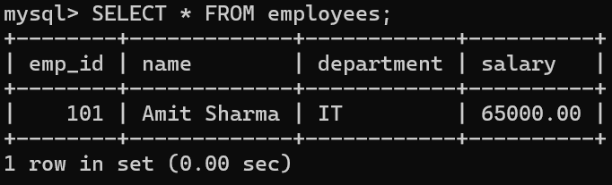

2. Create a Java application to manage student records using CRUD operations. Perform Create, Read, Update, and Delete operations on student details such as roll number, name, course, and marks using a database.

Code:

package E20;

import java.lang.*;
import java.sql.Connection;
import java.sql.DriverManager;
import java.sql.SQLException;
import java.sql.Statement;

public class StudentCRUD {

private static final String DB_URL = "jdbc:mysql://localhost:3306/SIT_JAVA";
private static final String USER = "root";
private static final String PASS = "12345";

public static void main(String[] args) {
try (Connection conn = DriverManager.getConnection(DB_URL, USER, PASS);
Statement stmt = conn.createStatement()) {

String insertQuery1 = "INSERT INTO student_details (roll_number, name, course, marks) VALUES (2607012, 'Postiwala Vatsal', 'B.Tech CSE', 88)";
stmt.executeUpdate(insertQuery1);

String insertQuery2 = "INSERT INTO student_details (roll_number, name, course, marks) VALUES (2607013, 'Rahul Kumar', 'B.Tech IT', 75)";
stmt.executeUpdate(insertQuery2);
System.out.println("CREATE: 2 Student records inserted.");

String updateQuery = "UPDATE student_details SET marks = 95 WHERE roll_number = 2607012";
stmt.executeUpdate(updateQuery);
System.out.println("UPDATE: Student 2607012 marks updated.");

String deleteQuery = "DELETE FROM student_details WHERE roll_number = 2607013";
stmt.executeUpdate(deleteQuery);
System.out.println("DELETE: Student 2607013 record deleted.");

} catch (SQLException e) {
e.printStackTrace();
}
}
}

Output:
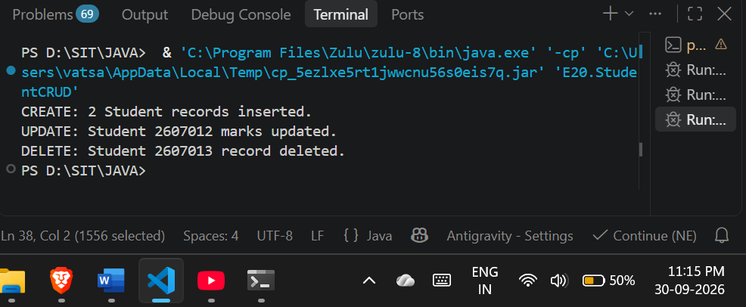
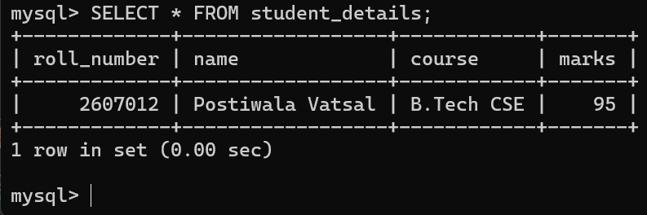

Conclusion:
I learned how to establish a successful connection between a Java application and a MySQL database using the JDBC API. I gained practical experience performing database modification operations by executing fundamental INSERT, UPDATE, and DELETE queries using the standard Statement interface and the executeUpdate() method. Finally, this implementation strengthened my understanding of managing database connections, passing direct SQL string queries from Java, handling SQLException errors, and correctly structuring Java packages.

