Name : Postiwala Vatsal PRN No : 26070122509 Batch : B3
ASSIGNMENT No: 4
TITLE: Develop a Java application demonstrating the use of wrapper classes for conversion between primitive data types and objects, and performing basic operations on wrapped values.

Problem Statement
Develop a Java application demonstrating the use of wrapper classes for conversion between primitive data types and objects, and performing basic operations on wrapped values.

Learning Objectives
To perform conversion between primitive data types and wrapper objects using Java wrapper classes.

Theory
Wrapper classes are predefined classes that encapsulate primitive data types into objects. Java provides wrapper classes such as Integer, Double, Character, and Boolean for every primitive type. They support autoboxing, unboxing, parsing, and conversion methods. Wrapper classes are widely used in Java Collections Framework and when object representation of primitive values is required.

Code
public class Wrapper{

public static void main(String[] args) {

// Autoboxing
int num=509;
Integer intObj=num;

double value= 20.67;
Double doubleObj=value;

// Unboxing
int primitiveInt=intObj;
double primitiveDouble=doubleObj;

//String to Wrapper
Integer number= Integer.valueOf("50");
Double decimal= Double.valueOf("100.38");

//Wrapper to String
String str1 = intObj.toString();
String str2 = doubleObj.toString();

//Basic Operations

int sum = intObj + number;
double product = doubleObj * decimal;

System.out.println("primitive Int: "+primitiveInt );
System.out.println("primitive Double: "+primitiveDouble );

System.out.println("intObj: "+intObj);
System.out.println("doubleObj: "+doubleObj);

System.out.println("Converted from String(Integer): "+number);
System.out.println("Converted from String(Double): "+decimal);

System.out.println("String value of Integer: "+str1);
System.out.println("String value of Double: "+str2);

System.out.println("Sum: "+sum);
System.out.println("Product: "+product);

}

}

Output
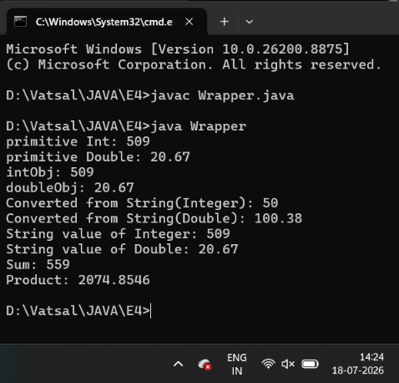

Exercise
- Create a program to convert student marks from String format to Integer and calculate total marks.

Code
import java.util.Scanner;

public class StudentMarks {

public static void main(String[] args) {

Scanner sc = new Scanner(System.in);

System.out.print("Enter Student Name: ");
String name = sc.nextLine();

System.out.print("Enter Subject 1 Mark: ");
String mark1 = sc.nextLine();

System.out.print("Enter Subject 2 Mark: ");
String mark2 = sc.nextLine();

System.out.print("Enter Subject 3 Mark: ");
String mark3 = sc.nextLine();

Integer m1 = Integer.valueOf(mark1);
Integer m2 = Integer.valueOf(mark2);
Integer m3 = Integer.valueOf(mark3);

int total = m1 + m2 + m3;

System.out.println("\nStudent Details");
System.out.println("Student Name: " + name);
System.out.println("Subject 1 Mark: " + m1);
System.out.println("Subject 2 Mark: " + m2);
System.out.println("Subject 3 Mark: " + m3);
System.out.println("Total Marks: " + total);

sc.close();
}
}

Output
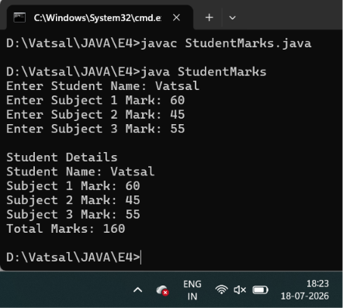
- Develop an Employee Payroll System that accepts employee IDs, basic salary, and bonus amounts from the user. Convert the entered values into wrapper objects and perform validation operations to ensure valid salary values before calculating the net salary.

Code

import java.util.Scanner;

public class EmployeePayroll {

public static void main(String[] args) {

Scanner sc = new Scanner(System.in);

System.out.print("Enter Employee ID: ");
String empId = sc.nextLine();

System.out.print("Enter Basic Salary: ");
String basicSalary = sc.nextLine();

System.out.print("Enter Bonus Amount: ");
String bonusAmount = sc.nextLine();

Integer id = Integer.valueOf(empId);
Double salary = Double.valueOf(basicSalary);
Double bonus = Double.valueOf(bonusAmount);

// Validation
if (salary <= 0) {
System.out.println("Invalid Salary! Basic Salary must be greater than 0.");
} else if (bonus < 0) {
System.out.println("Invalid Bonus! Bonus cannot be negative.");
} else {

double netSalary = salary + bonus;

System.out.println("\nEmployee Payroll");
System.out.println("Employee ID: " + id);
System.out.println("Basic Salary: " + salary);
System.out.println("Bonus Amount: " + bonus);
System.out.println("Net Salary: " + netSalary);
}

sc.close();
}
}

Output

