Name : Postiwala Vatsal PRN No: 26070122509 Batch : B3
ASSIGNMENT No: 8
TITLE: Write a Java program to demonstrate the use of the super keyword in inheritance.

Problem Statement
Write a Java program to demonstrate the use of the super keyword in inheritance.

Learning Objectives
To demonstrate the use of the super keyword for accessing parent class members.

Theory
The super keyword is used to refer to the immediate parent class in Java. It can invoke parent class constructors, access parent class variables, and call overridden methods. Super helps distinguish between parent and child class members with the same name. It ensures proper constructor chaining during object creation. It is an important concept in inheritance and method overriding.

Code
class Animal{
String color="White";
Animal(){
System.out.println("Animal constructor");
}

void sound(){
System.out.println("Animal makes sound");
}
}

class Dog extends Animal{
String color="Black";
Dog(){
super();
System.out.println("Dog constructor");
}

void display(){
System.out.println("Dog color: "+color);
System.out.println("Animal color: "+super.color);
super.sound();
}
}

public class SuperKeyworDemo {
public static void main(String[] args) {
Dog dog = new Dog();
dog.display();
}
}

Output

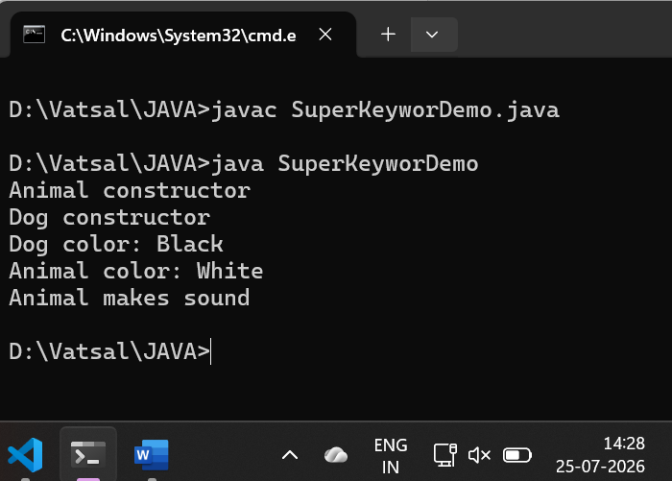

Exercise
- Create an Employee and Manager program where Manager accesses Employee details using super keyword.

Code

class Employee {
String name = "Vatsal";
double salary = 50000;

Employee() {
System.out.println("Employee profile created");
}

void displayInfo() {
System.out.println("Role: General Employee");
}
}

class Manager extends Employee {
String name = "Parth";
double bonus = 15000;

Manager() {
super();

}

void showDetails() {

System.out.println("Manager Name: " + name);
System.out.println("Employee Name: " + super.name);

System.out.println("Base Salary: " + salary);
System.out.println("Bonus: " + bonus);

super.displayInfo();
}
}

public class ManagerDemo {
public static void main(String[] args) {
System.out.println("Manager profile created");
Manager mgr = new Manager();
mgr.showDetails();
}
}

Output
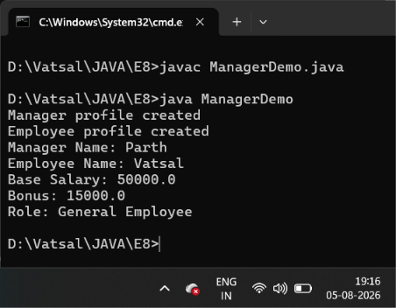

- Develop a Vehicle Insurance System where child insurance classes access parent vehicle information using the super keyword.

Code
class Vehicle {
String vehicleType = "Car";
String model = "Honda City";
int basePremium = 5000;

Vehicle() {
System.out.println("Vehicle registration details fetched.");
}

void displayVehicleDetails() {
System.out.println("Vehicle Type: " + vehicleType);
System.out.println("Vehicle Model: " + model);
}
}

class CarInsurance extends Vehicle {
int basePremium = 7500;
int addOnCoverage = 1500;

CarInsurance() {
super();
System.out.println("Car Insurance policy generated.");
}

void calculateAndDisplay() {
System.out.println("\nVehicle Details");

super.displayVehicleDetails();

System.out.println("\nPolicy Details");

System.out.println("Standard Vehicle Base Premium: " + super.basePremium);
System.out.println("Car-Specific Base Premium: " + basePremium);
System.out.println("Add-on Coverage Fee: " + addOnCoverage);

int totalInsuranceCost = basePremium + addOnCoverage;
System.out.println("Total Insurance Payable: " + totalInsuranceCost);
}
}

public class InsuranceDemo {
public static void main(String[] args) {
CarInsurance policy = new CarInsurance();
policy.calculateAndDisplay();
}
}

Output
