Name : Postiwala Vatsal PRN No: 26070122509 Batch : B3(2025-2029)
TITLE: Write a Java program to demonstrate the use of Swing and Applets
ASSIGNMENT No: 17

Problem Statement
Write a Java program to demonstrate the use of Swing and Applets

Learning Objectives
To develop graphical user interfaces using Swing components and Applets.

Theory
Swing is Java's GUI toolkit that provides lightweight components such as buttons, labels, text fields, and menus. Applets were small Java programs embedded in web pages for interactive applications. Although Applets are obsolete, Swing remains an important framework for desktop application development. Swing supports platform-independent graphical interfaces.

Code :
import java.lang.*;
import javax.swing.*;

public class SwingDemo {
public static void main(String[] args) {

JFrame frame = new JFrame("Swing Demo");

JLabel label = new JLabel("Welcome to Swing!", SwingConstants.CENTER);

frame.add(label);

frame.setSize(400, 300);

frame.setDefaultCloseOperation(JFrame.EXIT_ON_CLOSE);
frame.setVisible(true);
}
}

Output:
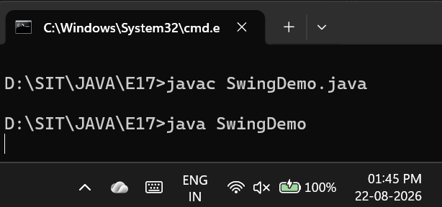
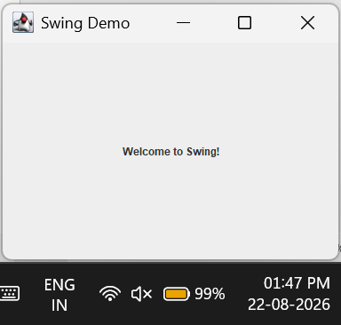

Code :
import java.lang.*;
import java.applet.Applet;
import java.awt.*;

public class AppletDemo extends Applet {
public void paint(Graphics g) {
g.drawString("Hello, this is my first applet!", 50, 50);
}

public static void main(String[] args) {
Frame frame = new Frame("Applet Demo");
AppletDemo applet = new AppletDemo();
frame.add(applet);
frame.setSize(400, 300);
frame.setVisible(true);
}
}

Output:
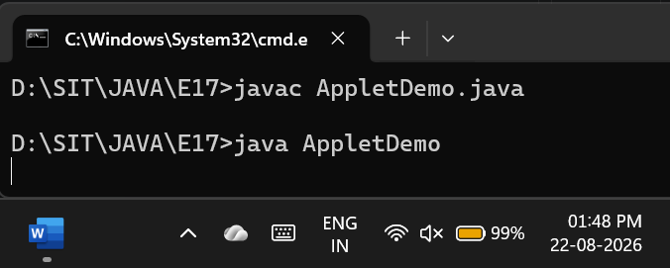
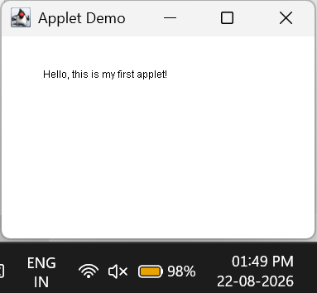

Exercise
- Create a simple Student Registration Form GUI using Swing.

Code :

package E17;

import java.lang.*;
import javax.swing.*;
import javax.swing.border.EmptyBorder;
import java.awt.*;

public class StudentRegistrationForm {
public static void main(String[] args) {
JFrame frame = new JFrame("Student Registration");
frame.setDefaultCloseOperation(JFrame.EXIT_ON_CLOSE);
frame.setSize(450, 350);
frame.setLocationRelativeTo(null);

JPanel panel = new JPanel();
panel.setLayout(new GridLayout(5, 2, 15, 15));
panel.setBorder(new EmptyBorder(25, 25, 25, 25));
panel.setBackground(new Color(240, 248, 255));

Font font = new Font("Arial", Font.BOLD, 14);

JLabel nameLabel = new JLabel("Student Name:");
nameLabel.setFont(font);
JTextField nameField = new JTextField();

JLabel rollLabel = new JLabel("Roll Number:");
rollLabel.setFont(font);
JTextField rollField = new JTextField();

JLabel courseLabel = new JLabel("Course:");
courseLabel.setFont(font);
JTextField courseField = new JTextField();

JButton submitBtn = new JButton("Submit");
submitBtn.setBackground(new Color(70, 130, 180));
submitBtn.setForeground(Color.WHITE);
submitBtn.setFont(font);
submitBtn.setFocusPainted(false);

JButton clearBtn = new JButton("Clear");
clearBtn.setBackground(new Color(220, 53, 69));
clearBtn.setForeground(Color.WHITE);
clearBtn.setFont(font);
clearBtn.setFocusPainted(false);

panel.add(nameLabel);
panel.add(nameField);
panel.add(rollLabel);
panel.add(rollField);
panel.add(courseLabel);
panel.add(courseField);
panel.add(submitBtn);
panel.add(clearBtn);

submitBtn.addActionListener(e -> {
String msg = "Student Registered Successfully!\n\nName: " + nameField.getText() +
"\nRoll No: " + rollField.getText() +
"\nCourse: " + courseField.getText();
JOptionPane.showMessageDialog(frame, msg, "Success", JOptionPane.INFORMATION_MESSAGE);
});

clearBtn.addActionListener(e -> {
nameField.setText("");
rollField.setText("");
courseField.setText("");
});

frame.add(panel);
frame.setVisible(true);
}
}

Output:
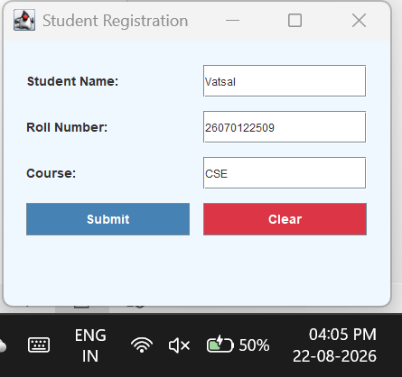
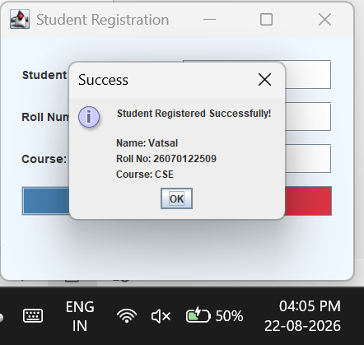

- Create a simple Employee Registration Form using Java Swing GUI that takes employee details such as Employee ID, Name, Department, and Salary. Display the entered information in a dialog box

Code :
package E17;

import java.lang.*;
import javax.swing.*;
import javax.swing.border.EmptyBorder;
import java.awt.*;

public class EmployeeRegistrationForm {
public static void main(String[] args) {
JFrame frame = new JFrame("Employee Registration");
frame.setDefaultCloseOperation(JFrame.EXIT_ON_CLOSE);
frame.setSize(450, 400);
frame.setLocationRelativeTo(null);

JPanel panel = new JPanel();
panel.setLayout(new GridLayout(6, 2, 15, 15));
panel.setBorder(new EmptyBorder(25, 25, 25, 25));
panel.setBackground(new Color(245, 245, 245));

Font font = new Font("Segoe UI", Font.BOLD, 14);

JLabel idLabel = new JLabel("Employee ID:");
idLabel.setFont(font);
JTextField idField = new JTextField();

JLabel nameLabel = new JLabel("Employee Name:");
nameLabel.setFont(font);
JTextField nameField = new JTextField();

JLabel deptLabel = new JLabel("Department:");
deptLabel.setFont(font);
JTextField deptField = new JTextField();

JLabel salaryLabel = new JLabel("Salary:");
salaryLabel.setFont(font);
JTextField salaryField = new JTextField();

JButton submitBtn = new JButton("Register");
submitBtn.setBackground(new Color(40, 167, 69));
submitBtn.setForeground(Color.WHITE);
submitBtn.setFont(font);
submitBtn.setFocusPainted(false);

panel.add(idLabel);
panel.add(idField);
panel.add(nameLabel);
panel.add(nameField);
panel.add(deptLabel);
panel.add(deptField);
panel.add(salaryLabel);
panel.add(salaryField);
panel.add(new JLabel(""));
panel.add(submitBtn);

submitBtn.addActionListener(e -> {
String msg = "--- Employee Registration Successful ---\n\n" +
"Employee ID: " + idField.getText() + "\n" +
"Name: " + nameField.getText() + "\n" +
"Department: " + deptField.getText() + "\n" +
"Salary: " + salaryField.getText();
JOptionPane.showMessageDialog(frame, msg, "Registration Info", JOptionPane.INFORMATION_MESSAGE);
});

frame.add(panel);
frame.setVisible(true);
}
}

Output:

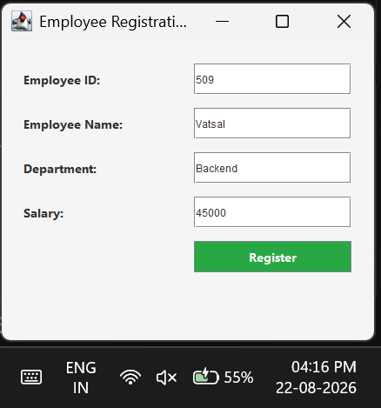
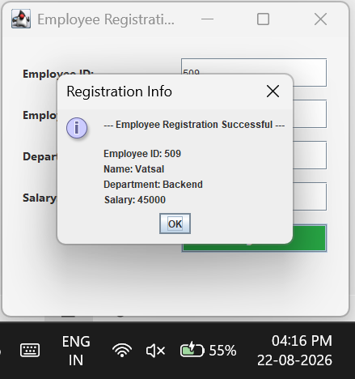
Conclusion:
I successfully demonstrated the creation of graphical user interfaces using Java Swing and Applets. We learned how to construct functional applications using lightweight Swing components—such as frames, labels, text fields, and buttons—while utilizing layout managers to organize them neatly. Additionally, we implemented basic event handling to capture user input and make the applications interactive.

