Name : Postiwala Vatsal PRN No: 26070122509 Batch : B3(2025-2029)
ASSIGNMENT No: 18
TITLE: Write a Java GUI program to demonstrate button click event handling.

Problem Statement
Write a Java GUI program to demonstrate button click event handling.

Learning Objectives
To implement button click events using Java event handling mechanisms.

Theory
Event handling allows Java programs to respond to user actions such as button clicks, mouse movements, and keyboard input. Swing uses ActionListener to process button click events. Event-driven programming separates user interface design from event-processing logic, making applications interactive and user-friendly.

Code :
package E18;

import java.lang.*;
import javax.swing.*;
import java.awt.*;

public class ButtonEventDemo {
public static void main(String[] args) {
JFrame frame = new JFrame("Button Event Demo");
frame.setDefaultCloseOperation(JFrame.EXIT_ON_CLOSE);
frame.setSize(400, 300);
frame.setLocationRelativeTo(null);

JPanel panel = new JPanel();
panel.setLayout(new GridBagLayout());
panel.setBackground(new Color(245, 245, 245));

JPanel innerPanel = new JPanel();
innerPanel.setLayout(new GridLayout(2, 1, 10, 20));
innerPanel.setOpaque(false);

JLabel label = new JLabel("Waiting for click...", SwingConstants.CENTER);
label.setFont(new Font("Segoe UI", Font.ITALIC, 16));
label.setForeground(Color.DARK_GRAY);

JButton button = new JButton("Click Me");
button.setFont(new Font("Segoe UI", Font.BOLD, 16));
button.setBackground(new Color(70, 130, 180)); // Steel Blue
button.setForeground(Color.WHITE);
button.setFocusPainted(false);
button.setPreferredSize(new Dimension(150, 40));

button.addActionListener(e -> {
label.setText("Button Clicked!");
label.setForeground(new Color(40, 167, 69));
label.setFont(new Font("Segoe UI", Font.BOLD, 18));
});

innerPanel.add(button);
innerPanel.add(label);
panel.add(innerPanel);

frame.add(panel);
frame.setVisible(true);
}
}

Output:
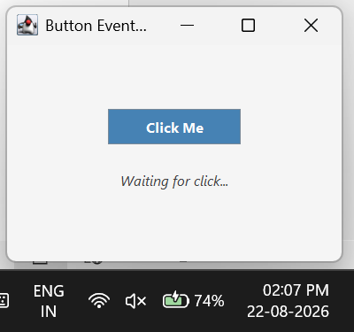
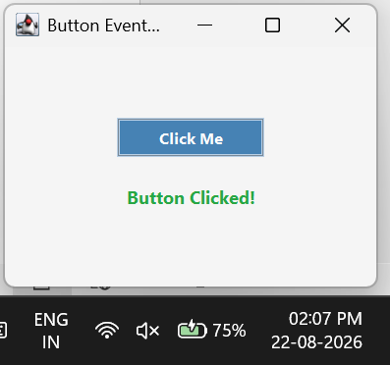

Exercise
- Create a GUI calculator where buttons perform addition and subtraction.

Code :
package E18;

import java.lang.*;
import javax.swing.*;
import javax.swing.border.EmptyBorder;
import java.awt.*;

public class SimpleCalculator {
public static void main(String[] args) {
JFrame frame = new JFrame("Simple Calculator");
frame.setDefaultCloseOperation(JFrame.EXIT_ON_CLOSE);
frame.setSize(350, 250);
frame.setLocationRelativeTo(null);

JPanel panel = new JPanel();
panel.setLayout(new GridLayout(4, 2, 10, 15));
panel.setBorder(new EmptyBorder(20, 20, 20, 20));
panel.setBackground(new Color(250, 240, 230));

Font font = new Font("SansSerif", Font.BOLD, 14);

JLabel num1Label = new JLabel("Number 1:");
num1Label.setFont(font);
JTextField num1Field = new JTextField();

JLabel num2Label = new JLabel("Number 2:");
num2Label.setFont(font);
JTextField num2Field = new JTextField();

JLabel resultLabel = new JLabel("Result: ");
resultLabel.setFont(new Font("SansSerif", Font.BOLD, 16));
resultLabel.setForeground(new Color(0, 102, 204));

JButton addBtn = new JButton("Add (+)");
addBtn.setBackground(new Color(40, 167, 69));
addBtn.setForeground(Color.WHITE);
addBtn.setFocusPainted(false);

JButton subBtn = new JButton("Subtract (-)");
subBtn.setBackground(new Color(220, 53, 69));
subBtn.setForeground(Color.WHITE);
subBtn.setFocusPainted(false);

panel.add(num1Label);
panel.add(num1Field);
panel.add(num2Label);
panel.add(num2Field);
panel.add(addBtn);
panel.add(subBtn);
panel.add(new JLabel(""));
panel.add(resultLabel);

addBtn.addActionListener(e -> {
try {
double n1 = Double.parseDouble(num1Field.getText());
double n2 = Double.parseDouble(num2Field.getText());
resultLabel.setText("Result: " + (n1 + n2));
} catch (NumberFormatException ex) {
JOptionPane.showMessageDialog(frame, "Please enter valid numbers!", "Error", JOptionPane.ERROR_MESSAGE);
}
});

subBtn.addActionListener(e -> {
try {
double n1 = Double.parseDouble(num1Field.getText());
double n2 = Double.parseDouble(num2Field.getText());
resultLabel.setText("Result: " + (n1 - n2));
} catch (NumberFormatException ex) {
JOptionPane.showMessageDialog(frame, "Please enter valid numbers!", "Error", JOptionPane.ERROR_MESSAGE);
}
});

frame.add(panel);
frame.setVisible(true);
}
}

Output:

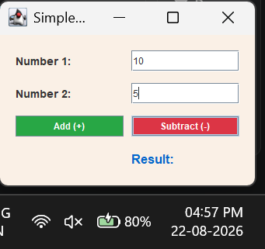
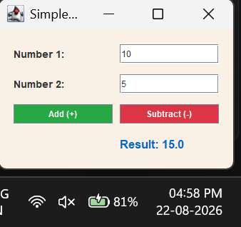
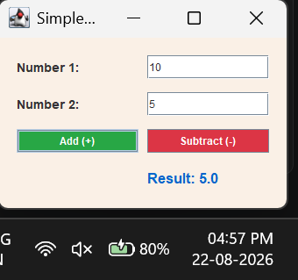

- Create a Bank Balance Calculator GUI application using Java Swing where the user enters the initial balance and transaction amount. Use buttons to perform addition (deposit) and subtraction (withdrawal) and display the updated balance.

Code :
package E18;

import java.lang.*;
import javax.swing.*;
import javax.swing.border.EmptyBorder;
import java.awt.*;

public class BankBalanceCalculator {
public static void main(String[] args) {
JFrame frame = new JFrame("Bank Balance Calculator");
frame.setDefaultCloseOperation(JFrame.EXIT_ON_CLOSE);
frame.setSize(400, 250);
frame.setLocationRelativeTo(null);

JPanel panel = new JPanel();
panel.setLayout(new GridLayout(4, 2, 15, 15));
panel.setBorder(new EmptyBorder(20, 25, 20, 25));
panel.setBackground(new Color(230, 240, 250));

Font font = new Font("Arial", Font.BOLD, 14);

JLabel balLabel = new JLabel("Current Balance (₹):");
balLabel.setFont(font);
JTextField balField = new JTextField("0.00");

JLabel transLabel = new JLabel("Transaction Amt (₹):");
transLabel.setFont(font);
JTextField transField = new JTextField();

// Styled Buttons
JButton depositBtn = new JButton("Deposit");
depositBtn.setBackground(new Color(30, 144, 255));
depositBtn.setForeground(Color.WHITE);
depositBtn.setFont(font);
depositBtn.setFocusPainted(false);

JButton withdrawBtn = new JButton("Withdraw");
withdrawBtn.setBackground(new Color(255, 140, 0));
withdrawBtn.setForeground(Color.WHITE);
withdrawBtn.setFont(font);
withdrawBtn.setFocusPainted(false);

// Status Label
JLabel statusLabel = new JLabel("Status: Ready", SwingConstants.RIGHT);
statusLabel.setForeground(Color.GRAY);

panel.add(balLabel);
panel.add(balField);
panel.add(transLabel);
panel.add(transField);
panel.add(depositBtn);
panel.add(withdrawBtn);
panel.add(new JLabel(""));
panel.add(statusLabel);

depositBtn.addActionListener(e -> {
try {
double bal = Double.parseDouble(balField.getText());
double trans = Double.parseDouble(transField.getText());
bal += trans;

balField.setText(String.format("%.2f", bal));
transField.setText("");
statusLabel.setText("Status: Deposited!");
statusLabel.setForeground(new Color(40, 167, 69));
} catch (NumberFormatException ex) {
JOptionPane.showMessageDialog(frame, "Invalid amount entered.", "Error", JOptionPane.ERROR_MESSAGE);
}
});

withdrawBtn.addActionListener(e -> {
try {
double bal = Double.parseDouble(balField.getText());
double trans = Double.parseDouble(transField.getText());

if (trans > bal) {
JOptionPane.showMessageDialog(frame, "Insufficient Balance!", "Warning", JOptionPane.WARNING_MESSAGE);
} else {
bal -= trans;
balField.setText(String.format("%.2f", bal));
transField.setText("");
statusLabel.setText("Status: Withdrawn!");
statusLabel.setForeground(new Color(220, 53, 69));
}
} catch (NumberFormatException ex) {
JOptionPane.showMessageDialog(frame, "Invalid amount entered.", "Error", JOptionPane.ERROR_MESSAGE);
}
});

frame.add(panel);
frame.setVisible(true);
}
}

Output:
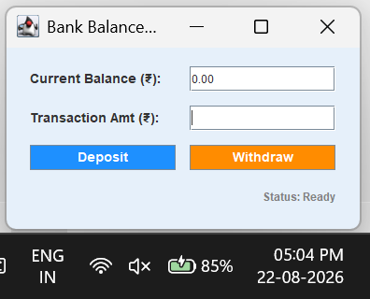
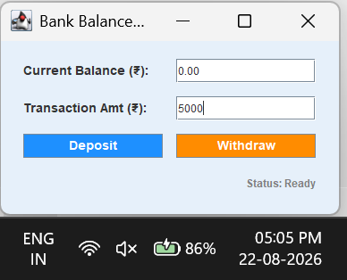

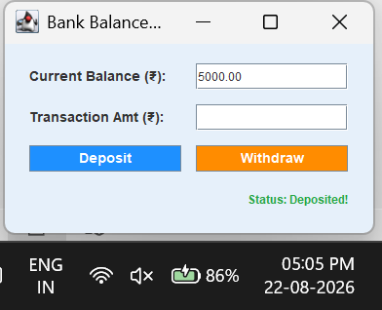
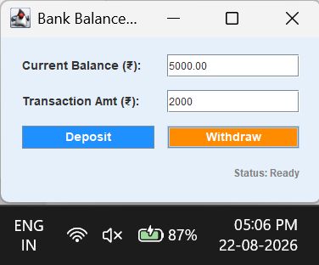
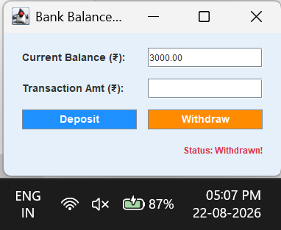

Conclusion:
I successfully demonstrated event-driven programming in Java Swing by capturing and processing user actions. We learned how to implement the ActionListener interface with buttons to trigger specific logic—such as arithmetic calculations and dynamic data updates—allowing us to transform static graphical interfaces into fully interactive applications.

