Name : Postiwala Vatsal PRN No: 26070122509 Batch : B3(2025-2029)
ASSIGNMENT No: 19
TITLE: Develop a Java application to establish connectivity with a database and perform data retrieval using the SELECT operation.

Problem Statement
Develop a Java application to establish connectivity with a database and perform data retrieval using the SELECT operation.

Learning Objectives
To establish database connectivity and retrieve records using JDBC SELECT statements.

Theory
Java Database Connectivity (JDBC) is a standard Java API that enables communication between Java applications and relational databases. It provides a platform-independent mechanism to connect to databases such as MySQL, Oracle, PostgreSQL, and SQL Server. Before executing SQL statements, a JDBC driver is loaded and a connection is established using the DriverManager class. The Connection object represents an active connection to the database, while the Statement object is used to execute SQL queries. The SELECT statement retrieves records from database tables based on specified conditions. The retrieved records are stored in a ResultSet object, which allows sequential access to the data. JDBC simplifies database programming and is widely used in desktop, web, and enterprise applications.

Code:
package E19;

import java.lang.*;
import java.sql.*;

public class E19 {

static String url = "jdbc:mysql://localhost:3306/symbiosis";
static String user = "root";
static String password = "12345";

public static void main(String[] args) {
try {
Class.forName("com.mysql.cj.jdbc.Driver");

Connection con = DriverManager.getConnection(url, user, password);

Statement stmt = con.createStatement();

ResultSet rs = stmt.executeQuery("SELECT * FROM students");

while (rs.next()) {
System.out.println(
rs.getInt("id") + " " +
rs.getString("name") + " " +
rs.getInt("marks")
);
}

con.close();

} catch (Exception e) {
System.out.println(e);
}
}
}

Output:

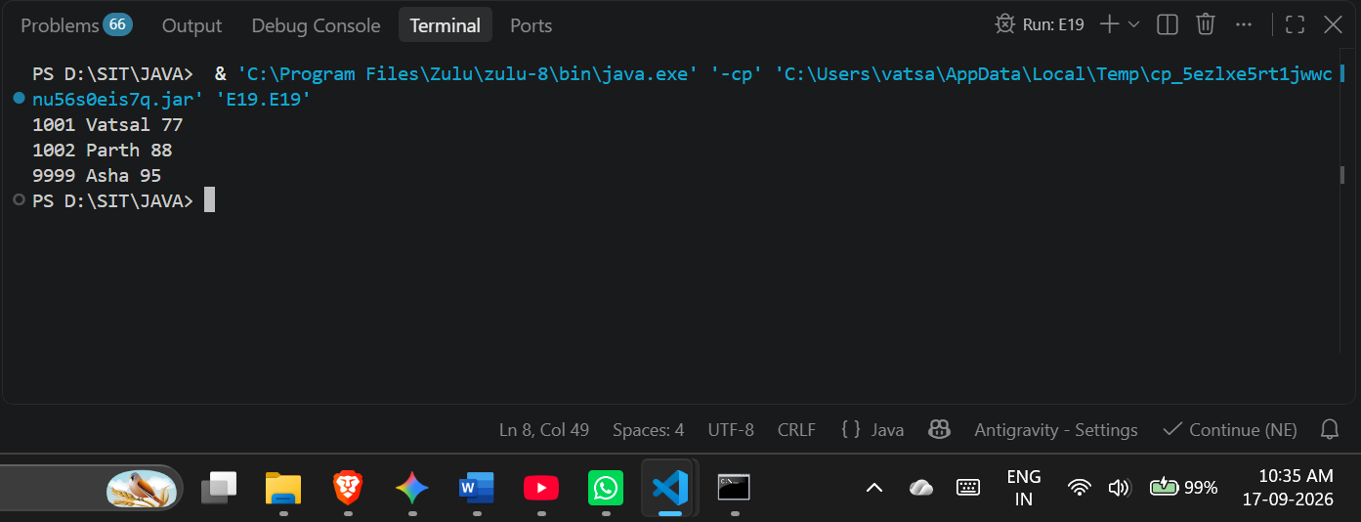

Exercise
- Create a Java application to display student records from database using SELECT query
Code:
package E19;

import java.lang.*;
import java.sql.*;

public class StudentRecords {

static String url = "jdbc:mysql://localhost:3306/SIT_JAVA";
static String user = "root";
static String password = "12345";

public static void main(String[] args) {
try {
Class.forName("com.mysql.cj.jdbc.Driver");
Connection con = DriverManager.getConnection(url, user, password);
Statement stmt = con.createStatement();

ResultSet rs = stmt.executeQuery("SELECT * FROM students");

System.out.println("ID\tName\tMarks");
System.out.println("------------------------");

while (rs.next()) {
System.out.println(
rs.getInt("id") + "\t" +
rs.getString("name") + "\t" +
rs.getInt("marks")
);
}

con.close();

} catch (Exception e) {
System.out.println(e);
}
}
}

Output:
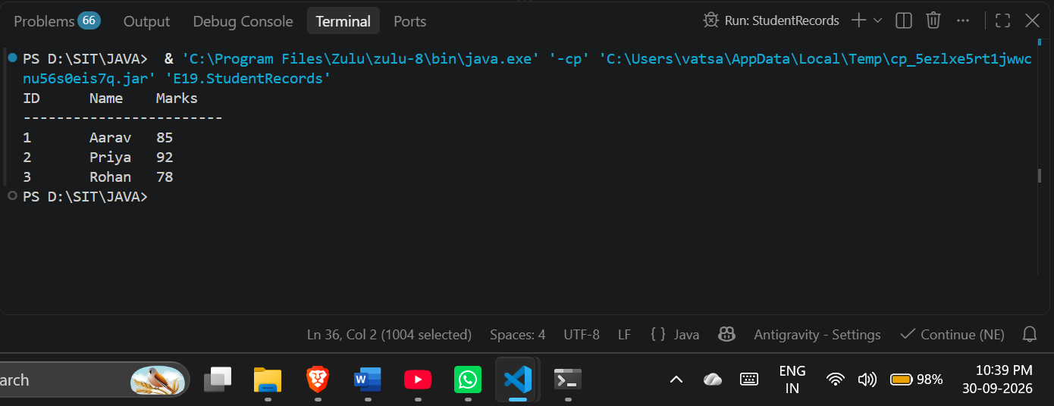

- Create a Java application that connects to a database and displays product details using a SELECT query. Show product ID, product name, quantity, and price.

Code:

package E19;

import java.lang.*;
import java.sql.*;

public class ProductDetails {

static String url = "jdbc:mysql://localhost:3306/SIT_JAVA";
static String user = "root";
static String password = "12345";

public static void main(String[] args) {
try {
Class.forName("com.mysql.cj.jdbc.Driver");
Connection con = DriverManager.getConnection(url, user, password);
Statement stmt = con.createStatement();

ResultSet rs = stmt.executeQuery("SELECT * FROM products");

System.out.println("ID\tProduct Name\t\tQuantity\tPrice");
System.out.println("--------------------------------------------------------------");

while (rs.next()) {
int id = rs.getInt("product_id");
String name = rs.getString("product_name");
int qty = rs.getInt("quantity");
double price = rs.getDouble("price");

System.out.println(id + "\t" + name + "\t" + qty + "\t" + price);
}

con.close();

} catch (Exception e) {
System.out.println(e);
}
}
}
Output:

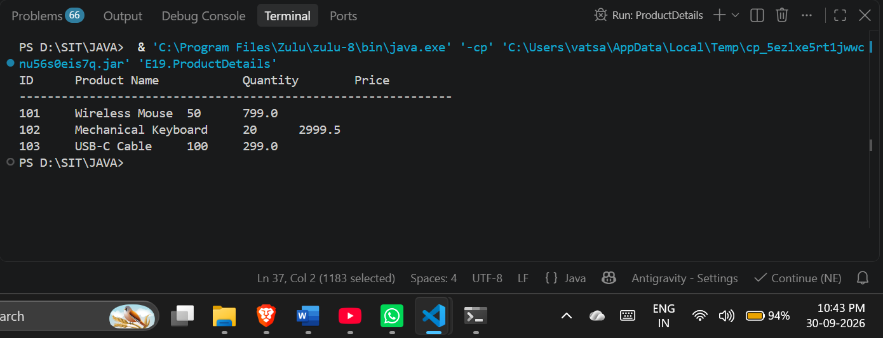

Conclusion:
I learned how to successfully connect a Java application to a MySQL database using the JDBC API by configuring the MySQL connector driver in my project workspace. I learned how to establish a database connection using DriverManager.getConnection() and use the Statement interface to execute SELECT queries. Additionally, I learned how to iterate through a ResultSet to extract specific column data using methods like getInt() and getString(), and how to properly format and print these database records to the console.

