Name : Postiwala Vatsal PRN No: 26070122509 Batch : B3(2025-2029)
ASSIGNMENT No: 10
TITLE: Write a Java program to demonstrate the use of abstract classes and abstract methods

Problem Statement
Write a Java program to demonstrate the use of abstract classes and abstract methods

Learning Objectives
To implement abstraction using abstract classes and abstract methods.

Theory
Abstract classes provide partial implementation of a program and cannot be instantiated directly. They may contain both abstract and concrete methods. Abstract methods declare functionality that must be implemented by subclasses. Abstraction hides implementation details while exposing only essential functionality. This improves code flexibility and maintainability in object-oriented programming.

Code
abstract class Shape{
abstract void draw();
void display(){
System.out.println("This is a Shape");
}
}

class Circle extends Shape{

void draw(){
System.out.println("Drawing a Circle.");
}
}

class Rectangle extends Shape{
void draw(){
System.out.println("Drawing a Rectangle.");
}
}

public class Demo{
public static void main(String a[]){
// Shape s = new Shape();
Circle c = new Circle();
c.draw();
Rectangle r = new Rectangle();
r.draw();
}
}

Output
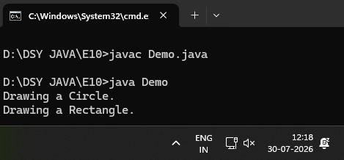

Exercise
- Create an abstract Payment class and implement Credit Card and UPI payment classes.?

Code
abstract class Payment {

abstract void pay(double amount);

void printReceipt() {
System.out.println("Receipt: Transaction Successful.");
}
}

class CreditCard extends Payment {

void pay(double amount) {
System.out.println("Paid " + amount + " using a Credit Card.");
}
}

class UPI extends Payment {

void pay(double amount) {
System.out.println("Paid " + amount + " using UPI.");
}
}

public class PaymentDemo {
public static void main(String[] args) {

CreditCard card = new CreditCard();
card.pay(1500.50);
card.printReceipt();

UPI upi = new UPI();
upi.pay(450.00);
upi.printReceipt();
}
}

Output
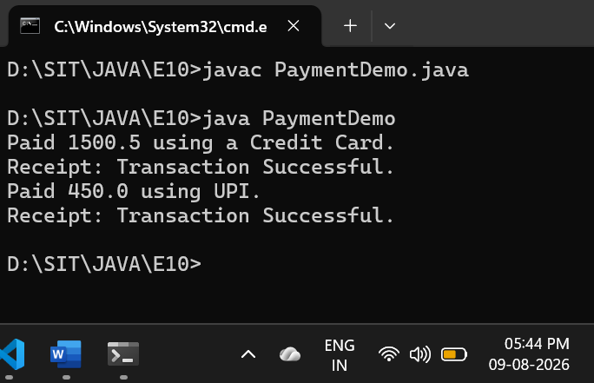
- Create an abstract FoodOrder class with an abstract method calculateBill(). Implement two subclasses, DineInOrder and TakeAwayOrder, to calculate and display the total bill based on the order type.

Code
abstract class FoodOrder {

abstract void calculateBill(double amount);

void printOrderInfo() {
System.out.println("Processing your food order...");
}
}

class DineInOrder extends FoodOrder {

void calculateBill(double amount) {
double serviceCharge = amount * 0.10;
double total = amount + serviceCharge;
System.out.println("Dine-In Total Bill (with 10% service charge): " + total);
}
}

class TakeAwayOrder extends FoodOrder {

void calculateBill(double amount) {
double packagingFee = amount * 0.05;
double total = amount + packagingFee;
System.out.println("Take-Away Total Bill (with 5% packaging fee): " + total);
}
}

public class FoodOrderDemo {
public static void main(String[] args) {

DineInOrder dineIn = new DineInOrder();
dineIn.printOrderInfo();
dineIn.calculateBill(500.00);

TakeAwayOrder takeAway = new TakeAwayOrder();
takeAway.printOrderInfo();
takeAway.calculateBill(500.00);
}
}

Output
