Name : Postiwala Vatsal PRN No: 26070122509 Batch : B3(2025-2029)
ASSIGNMENT No: 16
TITLE: Write a Java program to create and handle a user-defined exception.

Problem Statement
Write a Java program to create and handle a user-defined exception.

Learning Objectives
To create and implement custom exceptions for application-specific error handling.

Theory:
User-defined exceptions are created by extending the Exception class. They allow developers to define meaningful exceptions for specific business logic. Custom exceptions improve program readability and simplify debugging by providing descriptive error messages. They are widely used in enterprise software and validation systems.

Code
import java.io.*;
class InvalidMarksException extends Exception{
InvalidMarksException(String message){
super(message);
}
}

public class UserDefineDemo{
static void checkMarks(int marks)throws InvalidMarksException{
if(marks<0||marks>100){
throw new InvalidMarksException("Marks should be between 0 and 100.");
}
System.out.println("Valid Marks:"+marks);
}

public static void main(String a[]){

try{
checkMarks(110);
}catch(InvalidMarksException e){
System.out.println("Exception"+e.getMessage());
}
System.out.println("Program Done.");
}
}

Output
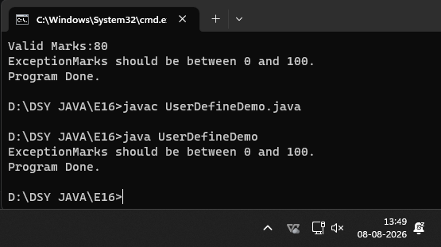

Exercise
- Create a Voting System that throws a custom exception if age is below 18

Code
import java.io.*;
class InvalidAgeException extends Exception {
InvalidAgeException(String message) {
super(message);
}
}

public class VotingSystem {

static void checkEligibility(int age) throws InvalidAgeException {
if (age < 18) {

throw new InvalidAgeException("You must be at least 18 years old to vote.");
}
System.out.println("You are eligible to vote!");
}

public static void main(String[] args) {

int voterAge1 = 16;
System.out.println("Checking voter 1 (Age: " + voterAge1 + ")...");

try {
checkEligibility(voterAge1);
} catch (InvalidAgeException e) {
System.out.println("Error: " + e.getMessage());
}

int voterAge2 = 21;
System.out.println("\nChecking voter 2 (Age: " + voterAge2 + ")...");

try {
checkEligibility(voterAge2);
} catch (InvalidAgeException e) {
System.out.println("Error: " + e.getMessage());
}
}
}

Output
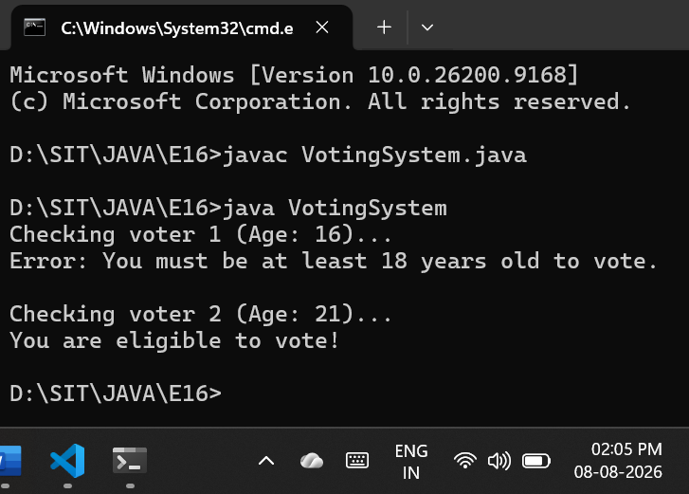

- Create a Driving License System that throws a custom exception if the user’s age is below 18. If the age is valid, display that the user is eligible for a driving license

Code
import java.io.*;

class UnderageException extends Exception {
UnderageException(String message) {
super(message);
}
}

public class DrivingLicenseSystem {

static void checkLicenseEligibility(int age) throws UnderageException {
if (age < 18) {
throw new UnderageException("Age is below 18. You are not eligible for a driving license.");
}
System.out.println("You are eligible for a driving license!");
}

public static void main(String[] args) {

int applicantAge1 = 15;
System.out.println("Checking applicant 1 (Age: " + applicantAge1 + ")...");

try {
checkLicenseEligibility(applicantAge1);
} catch (UnderageException e) {
System.out.println("Error: " + e.getMessage());
}

int applicantAge2 = 24;
System.out.println("\nChecking applicant 2 (Age: " + applicantAge2 + ")...");

try {
checkLicenseEligibility(applicantAge2);
} catch (UnderageException e) {
System.out.println("Error: " + e.getMessage());
}
}
}

Output
