Name : Postiwala Vatsal PRN No: 26070122509 Batch : B3(2025-2029)
ASSIGNMENT No: 11
TITLE: Write a Java program to demonstrate the implementation of interfaces.

Problem Statement
Write a Java program to demonstrate the implementation of interfaces.

Learning Objectives
To implement interfaces for achieving abstraction and multiple inheritance of type.

Theory
An interface specifies a set of abstract methods that implementing classes must define. It provides complete abstraction and supports multiple inheritance of type. Interfaces improve modularity, loose coupling, and software flexibility. They allow different classes to implement common behavior while maintaining independent implementations. Interfaces are widely used in enterprise application development.

Code
interface Vehicle {

void start();
void stop();
}

class Car implements Vehicle {

public void start() {
System.out.println("Car starting");
}

public void stop() {
System.out.println("Car stopped.");
}
}

class Bike implements Vehicle {

public void start() {
System.out.println("Bike starting");
}

public void stop() {
System.out.println("Bike stopped.");
}
}

public class Demo{
public static void main(String[] args) {

// Vehicle v1=new Vehicle(); error: Vehicle is abstract; cannot be instantiated

Vehicle v1 = new Car();
v1.start();
v1.stop();

Vehicle v2 = new Bike();
v2.start();
v2.stop();
}
}

Output
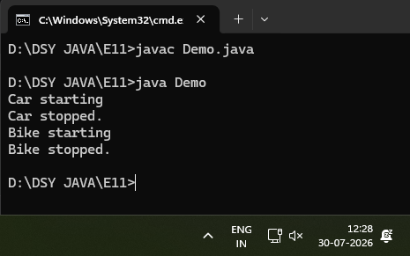

Exercise
- Create an interface Printable and implement it in Student and Employee classes.

Code
interface Printable {
void print();
}

class Student implements Printable {
private String name;
private int rollNumber;

public Student(String name, int rollNumber) {
this.name = name;
this.rollNumber = rollNumber;
}

public void print() {
System.out.println("Student Details");
System.out.println("Name: " + name);
System.out.println("Roll Number: " + rollNumber);
System.out.println();
}
}

class Employee implements Printable {
private String name;
private double salary;

public Employee(String name, double salary) {
this.name = name;
this.salary = salary;
}

public void print() {
System.out.println("Employee Details");
System.out.println("Name: " + name);
System.out.println("Salary: " + salary);
System.out.println();
}
}

public class PrintableDemo {
public static void main(String[] args) {

Printable student = new Student("Vatsal", 509);
Printable employee = new Employee("Parth", 65000.50);

student.print();
employee.print();
}
}

Output
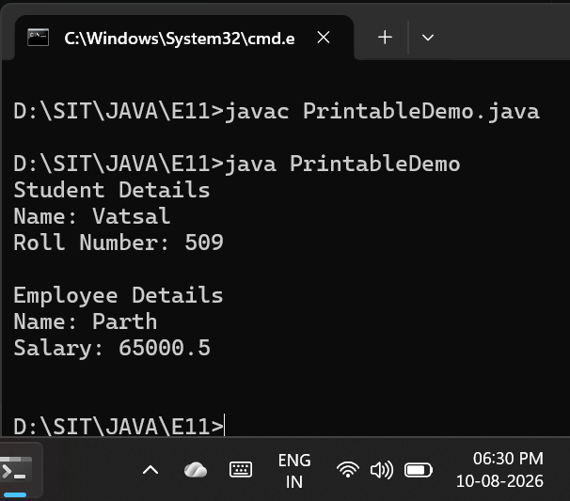

- Create an interface Switchable with a method turnOn(). Implement the interface in Light and Fan classes to display the device status.

Code
interface Switchable {
void turnOn();
}

class Light implements Switchable {
public void turnOn() {
System.out.println("Status: The Light is now turned ON.");
}
}

class Fan implements Switchable {
public void turnOn() {
System.out.println("Status: The Fan is now turned ON and spinning.");
}
}

public class SwitchableDemo {
public static void main(String[] args) {

Switchable livingRoomLight = new Light();
Switchable ceilingFan = new Fan();

livingRoomLight.turnOn();
ceilingFan.turnOn();
}
}

Output
