Name : Postiwala Vatsal PRN No: 26070122509 Batch : B3(2025-2029)
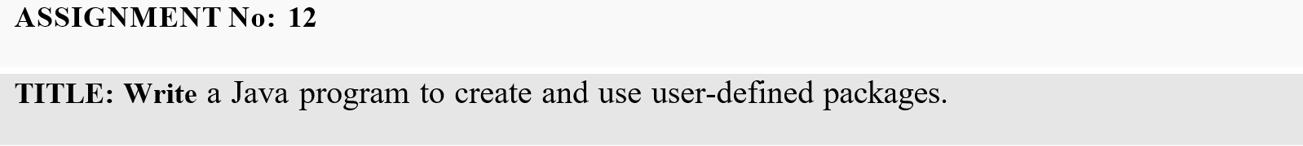

Problem Statement
Write a Java program to create and use user-defined packages.

Learning Objectives
To create and use user-defined packages for organizing Java programs.

Theory
Packages are used to organize related classes and interfaces into namespaces. User-defined packages improve code organization, reduce naming conflicts, and enhance reusability. They also support access protection and modular application development. Java packages simplify project management by grouping logically related components together. Large-scale software systems extensively use packages.

Code
Calculator.java

package mypackage;

public class Calculator{
public int add(int a,int b){
return a + b;
}
public int multiply(int a,int b){
return a*b;
}
public int subtract(int a,int b){
return a - b;
}
public double division(int a,int b){
return a/b;
}
}

Demo.java
import mypackage.*;

public class Demo {
public static void main(String[] args) {

int a = 50;
int b = 10;

Calculator c = new Calculator();
int sum = c.add(a, b);
System.out.println("sum of a and b: " + sum);

int multiply = c.multiply(a, b);
System.out.println("multiply of a and b: " + multiply);

int subtract = c.subtract(a, b);
System.out.println("subtract of a and b: " + subtract);

double division = c.division(a, b);
System.out.println("division of a and b: " + division);

}
}

Output

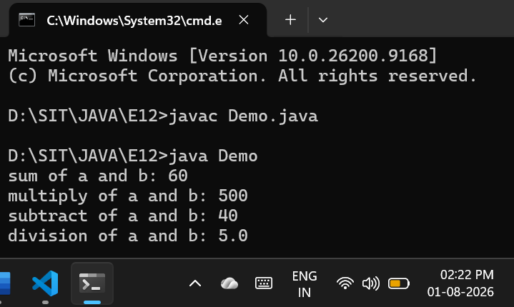

Exercise
- Create a Java program by developing user-defined packages for a College Management System. Create separate packages for student and faculty details, and display their information using classes from these packages.

Code

StudentDetails.java

package college;

public class StudentDetails {
String name;
int rollNo;
String course;

public StudentDetails(String studentName, int studentRollNo, String studentCourse) {
name = studentName;
rollNo = studentRollNo;
course = studentCourse;
}

public void displayStudentInfo() {
System.out.println("Student Details");
System.out.println("Name : " + name);
System.out.println("Roll Number : " + rollNo);
System.out.println("Course : " + course);
}
}

FacultyDetails.java

package college;

public class FacultyDetails {
String name;
String employeeId;
String department;

public FacultyDetails(String facultyName, String id, String dept) {
name = facultyName;
employeeId = id;
department = dept;
}

public void displayFacultyInfo() {
System.out.println("Faculty Details");
System.out.println("Name : " + name);
System.out.println("Employee ID : " + employeeId);
System.out.println("Department : " + department);
}
}

CollegeSystem.java

import college.*;

public class CollegeSystem {
public static void main(String[] args) {
System.out.println("\nCollege Management System\n");

StudentDetails student1 = new StudentDetails("Vatsal", 509, "B.Tech Computer Science");

FacultyDetails faculty1 = new FacultyDetails("Dr. Anita Desai", "EMP-705", "Computer Science");

student1.displayStudentInfo();
faculty1.displayFacultyInfo();
}
}

Output
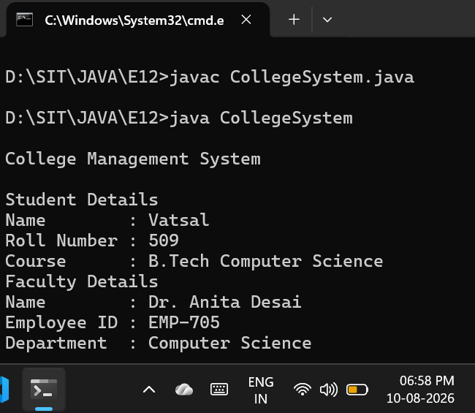

- Create a Java program by developing a user-defined package named library that contains a class to store and display book details such as book ID, title, author, and price. Import the package into the main program and display the book information.

Code

Book.java

package library;

public class Book {
int bookId;
String title;
String author;
double price;

public Book(int id, String bookTitle, String bookAuthor, double bookPrice) {
bookId = id;
title = bookTitle;
author = bookAuthor;
price = bookPrice;
}

public void displayBookInfo() {
System.out.println("Book Details");
System.out.println("Book ID : " + bookId);
System.out.println("Title : " + title);
System.out.println("Author : " + author);
System.out.println("Price : " + price);
}
}

LibrarySystem.java

import library.*;

public class LibrarySystem {
public static void main(String[] args) {
System.out.println("\nLibrary Management\n");

Book book1 = new Book(101, "JAVA", "Joshua Bloch", 450.99);
Book book2 = new Book(102, "DSA", "Robert Sedgewick", 399.99);

book1.displayBookInfo();
System.out.println();
book2.displayBookInfo();
}
}

Output
