Name : Postiwala Vatsal PRN No: 26070122509 Batch : B3(2025-2029)
ASSIGNMENT No: 13
TITLE: Write a Java program to perform reading from and writing to a file using file handling operations.

Problem Statement
Write a Java program to perform reading from and writing to a file using file handling operations.

Learning Objectives
To perform file reading and writing operations using Java file handling classes.

Theory
Java provides file handling through the java.io package. Classes such as File, FileReader, FileWriter, BufferedReader, and BufferedWriter are used to perform input and output operations. File handling enables permanent storage and retrieval of application data. Proper exception handling is necessary to manage file-related errors. These concepts are essential for data persistence.

Code
import java.io.*;

public class FileDemo {

public static void main(String[] args) {

try {

FileWriter w = new FileWriter("sample.txt");
w.write("Name : Vatsal.\n");
w.write("Welcome to SIT , Pune\n");
w.write("Welcome to Pune\n");
w.close();

System.out.println("Data written successfully.\n");

FileReader r = new FileReader("sample.txt");
BufferedReader br = new BufferedReader(r);

String line;
System.out.println("Contents of File:\n");

while ((line = br.readLine()) != null) {
System.out.println(line);
}

} catch (IOException e) {
System.err.println("File Error:"+e.getMessage());
}
}

}

Output
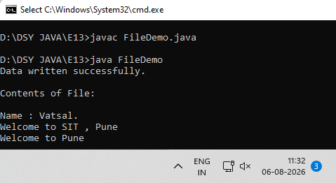

Exercise
- Create a program to write and read employee details from a file.

Code
import java.io.*;

class Employee {
int id;
String name;
double salary;

public Employee(int empId, String empName, double empSalary) {
id = empId;
name = empName;
salary = empSalary;
}
}

public class EmployeeFile {

public static void main(String[] args) {

Employee emp1 = new Employee(1, "Ravi", 45000.50);
Employee emp2 = new Employee(2, "Vatsal", 55000.00);

try {
FileWriter writer = new FileWriter("employees.txt");

writer.write(emp1.id + " - " + emp1.name + " - " + emp1.salary + "\n");
writer.write(emp2.id + " - " + emp2.name + " - " + emp2.salary + "\n");

writer.close();
System.out.println("Data written to employees.txt successfully.\n");

} catch (IOException e) {
System.out.println("Error writing to file: " + e.getMessage());
}

try {
FileReader reader = new FileReader("employees.txt");
BufferedReader br = new BufferedReader(reader);

String line;
System.out.println("Contents of employees.txt:");

// Reading and printing data line by line
while ((line = br.readLine()) != null) {
System.out.println(line);
}

br.close();
reader.close();

} catch (IOException e) {
System.out.println("Error reading from file: " + e.getMessage());
}
}
}

Output
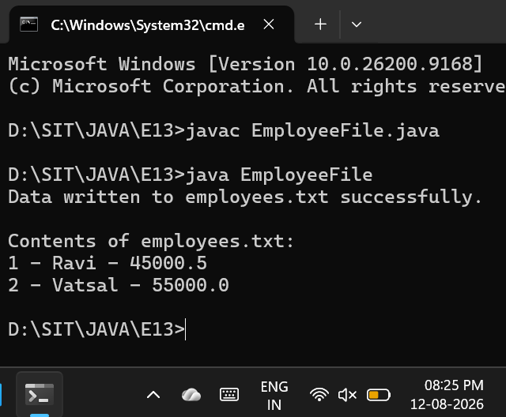

- Create a Java program to write patient details (patient ID, name, age, and diagnosis) to a file and read the details from the file for display.

Code
import java.io.*;

class Patient {
int id;
String name;
int age;
String diagnosis;

public Patient(int pId, String pName, int pAge, String pDiagnosis) {
id = pId;
name = pName;
age = pAge;
diagnosis = pDiagnosis;
}
}

public class PatientFile {

public static void main(String[] args) {

// Creating patient objects
Patient p1 = new Patient(101, "Amit Sharma", 45, "Viral Fever");
Patient p2 = new Patient(102, "Neha Singh", 32, "Migraine");

try {
FileWriter writer = new FileWriter("patients.txt");

writer.write("ID: " + p1.id + ", Name: " + p1.name + ", Age: " + p1.age + ", Diagnosis: " + p1.diagnosis + "\n");
writer.write("ID: " + p2.id + ", Name: " + p2.name + ", Age: " + p2.age + ", Diagnosis: " + p2.diagnosis + "\n");

writer.close();
System.out.println("Patient details written to patients.txt successfully.\n");

} catch (IOException e) {
System.out.println("Error writing to file: " + e.getMessage());
}

try {
FileReader reader = new FileReader("patients.txt");
BufferedReader br = new BufferedReader(reader);

String line;
System.out.println("--- Contents of patients.txt ---");

while ((line = br.readLine()) != null) {
System.out.println(line);
}

br.close();
reader.close();

} catch (IOException e) {
System.out.println("Error reading from file: " + e.getMessage());
}
}
}

Output
