Name : Postiwala Vatsal PRN No : 26070122509 Batch : B3
ASSIGNMENT No: 3
TITLE: Develop a Java application demonstrating method overloading and the use of static variables, methods in class design.

Problem Statement
Develop a Java application demonstrating method overloading and the use of static variables, methods in class design.

Learning Objectives
To implement method overloading and use static variables and methods in Java programs.

Theory
Method overloading allows multiple methods to have the same name with different parameter lists, enabling compile-time polymorphism. The static keyword is used for variables and methods that belong to the class instead of individual objects. Static members share common data among all objects and reduce memory usage. These concepts improve code flexibility, readability, and efficient resource management.

Code
class Calculator {

static int count=0;

Calculator(){
count++;
}

int add(int n1, int n2) {
return n1 + n2;
}

double add(double n1,double n2){
return n1 + n2;
}

int add(int n1, int n2, int n3) {
return n1 + n2 + n3;
}

static void displayCount(){
System.out.println("Objects Created:"+ count);
}

}

public class Method{

public static void main(String[] args) {

Calculator c1= new Calculator();
Calculator c2= new Calculator();
System.out.println("Addition of 2 int:"+c1.add(10,20));
System.out.println("Addition of 2 double:"+c1.add(10.5,20.2));
System.out.println("Addition of 3 int:"+c1.add(10,20,20));
Calculator.displayCount();
}

}

Output
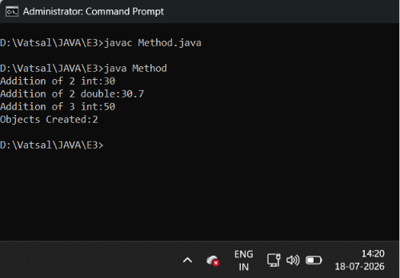

Exercise
- Develop a Calculator program using overloaded methods for addition of integers and decimals. Use a static variable to count calculations.

Code
class MathOperations {

static int count = 0;

int add(int n1, int n2) {
count++;
return n1 + n2;
}

double add(double n1, double n2) {
count++;
return n1 + n2;
}

int add(int n1, int n2, int n3) {
count++;
return n1 + n2 + n3;
}

static void displayCount() {
System.out.println("Total Calculations Performed: " + count);
}
}

public class E3 {

public static void main(String[] args) {

MathOperations math = new MathOperations();

System.out.println("Addition of 2 ints: " + math.add(30, 20));
System.out.println("Addition of 2 doubles: " + math.add(20.5, 20.2));
System.out.println("Addition of 3 ints: " + math.add(40, 20, 50));

MathOperations.displayCount();
}
}

Output
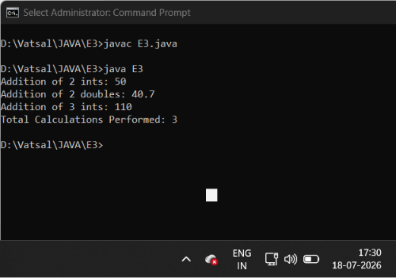

- Develop a Restaurant Billing Application where overloaded methods calculate bills for dine-in, takeaway, and delivery orders, while static variables track total orders.

Code

class RestaurantBilling {

static int totalOrders = 0;

double calculateBill(double price, double tax) {
totalOrders++;
return price + tax;
}

double calculateBill(double price, int packagingFee) {
totalOrders++;
return price + packagingFee;
}

double calculateBill(double price, double deliveryFee, double packagingFee) {
totalOrders++;
return price + deliveryFee + packagingFee;
}

static void displayTotalOrders() {
System.out.println("Total Orders: " + totalOrders);
}
}

public class Ex3 {

public static void main(String[] args) {

RestaurantBilling billing = new RestaurantBilling();

System.out.println("Dine-in Bill: " + billing.calculateBill(100.0,10.0));
System.out.println("Takeaway Bill: " + billing.calculateBill(150.0, 2));
System.out.println("Delivery Bill: " + billing.calculateBill(300.0, 50.0, 3.0));

RestaurantBilling.displayTotalOrders();
}
}

Output

