Data Lakehouse Design from R2R Master Data Perspective

1. What is Data in the R2R Domain?
Record-to-Report (R2R) is the financial process of recording transactions, reconciling accounts, and reporting financial results. Data in R2R is financially critical and must be accurate, auditable, and compliant.
Categories of Data:
- Master Data: Chart of Accounts, Cost Centers, Legal Entities, Currency Codes, Product Hierarchies
- Transactional Data: Journal Entries, Trial Balances, Sub-ledger details (AP, AR, FA)
- Reference Data: Exchange Rates, Fiscal Calendars, Tax Codes

2. What is Data Lakehouse Concept? How is it Related to R2R?
A Data Lakehouse combines the flexibility of a Data Lake with the structure and performance of a Data Warehouse. It supports open formats, ACID transactions, schema enforcement, and is optimized for analytics.
Relevance to R2R:
- Multi-ERP Integration: Consolidates data from SAP, Oracle, Workday, etc.
- Harmonization: Aligns different CoAs, fiscal calendars, and currencies.
- Real-Time Analytics: Enables faster close and reporting cycles.
- Audit & Compliance: Maintains lineage and reconciliation between source and reporting.

3. Categorization for Data Lakehouse Design in R2R

Layered Architecture:
- Raw Zone:
  - Direct extracts from ERP systems.
  - Includes GL, SL, and master data in native format.
- Cleansed Zone:
  - Data quality checks (nulls, duplicates).
  - Standardization of date formats, currency codes.
- Harmonized Zone:
  - Unified Chart of Accounts.
  - Currency conversion to group currency.
  - Mapping of local entities to global hierarchy.
- Semantic Zone:
  - Business-friendly models for BI tools.
  - Pre-aggregated views for dashboards.

4. Step-by-Step Design:
Step 1: Identify Source Systems and Extract Data
- Objective: Understand all ERP and sub-ledger systems feeding into R2R (e.g., SAP, Oracle, Workday).
- Activities:
  - Inventory all source systems and their modules (GL, AP, AR, FA).
  - Identify data extraction methods: APIs, flat files, ETL tools.
  - Define extraction frequency: real-time, daily, monthly.
- Key Considerations:
  - Ensure completeness (all entities, periods).
  - Maintain audit logs for compliance.
- Output: Raw data files or streams in the Raw Zone of the Lakehouse.

Step 2: Define Global Data Model (CoA, Entity Hierarchy)
- Objective: Create a harmonized structure for reporting across multiple ERPs.
- Activities:
  - Define Global Chart of Accounts (CoA) mapping local accounts to global accounts.
  - Establish Entity Hierarchies: Legal Entity → Region → Group.
  - Define Dimensions: Account, Entity, Period, Currency, Scenario.
- Key Considerations:
  - Align with corporate reporting standards (IFRS, GAAP).
  - Include master data governance rules.
- Output: A data dictionary and mapping tables stored in the Lakehouse.

Step 3: Apply Transformation Rules (Mapping, FX Conversion)
- Objective: Standardize and enrich data for consolidated reporting.
- Activities:
  - Apply mapping logic: Local Account → Global Account.
  - Perform currency conversion: Local → Group currency using FX rates.
  - Apply sign logic: Revenue positive, expenses negative.
  - Validate data quality: Check for missing mappings, invalid codes.
- Key Considerations:
  - Maintain version control for mapping tables.
  - Ensure FX rates are sourced from an authoritative system.
- Output: Harmonized data in the Cleansed/Harmonized Zone.

Step 4: Store Curated Data in Lakehouse with ACID Compliance
- Objective: Ensure reliability, consistency, and scalability.
- Activities:
  - Use open formats (Parquet, ORC) for storage.
  - Implement transaction layer (Delta Lake, Apache Iceberg) for ACID compliance.
  - Partition data by Entity, Period, Scenario for performance.
- Key Considerations:
  - Enable schema evolution for future changes.
  - Implement data versioning for audit and rollback.
- Output: Curated, query-ready datasets in the Lakehouse.

Step 5: Expose Data to BI Layer for Reporting and Analytics
- Objective: Deliver harmonized data to end-users for reporting and analysis.
- Activities:
  - Create semantic models for BI tools (Power BI, Tableau).
  - Build pre-aggregated views for dashboards (e.g., Trial Balance by Entity).
  - Implement security rules (row-level, column-level).
- Key Considerations:
  - Optimize for performance (indexes, caching).
  - Ensure data lineage is traceable from BI back to ERP.
- Output: Business-friendly datasets and dashboards for financial close, reconciliations, and compliance.

4. Data Model Architecture

Scenario A: Single ERP
Flow: ERP → Lakehouse → BI Layer
Attribute | Description
Entity | Legal Entity Code, Name
Account | GL Account, Description, Account Type
Hierarchy | Entity → Region → Group; Account → Account Group → Reporting Line

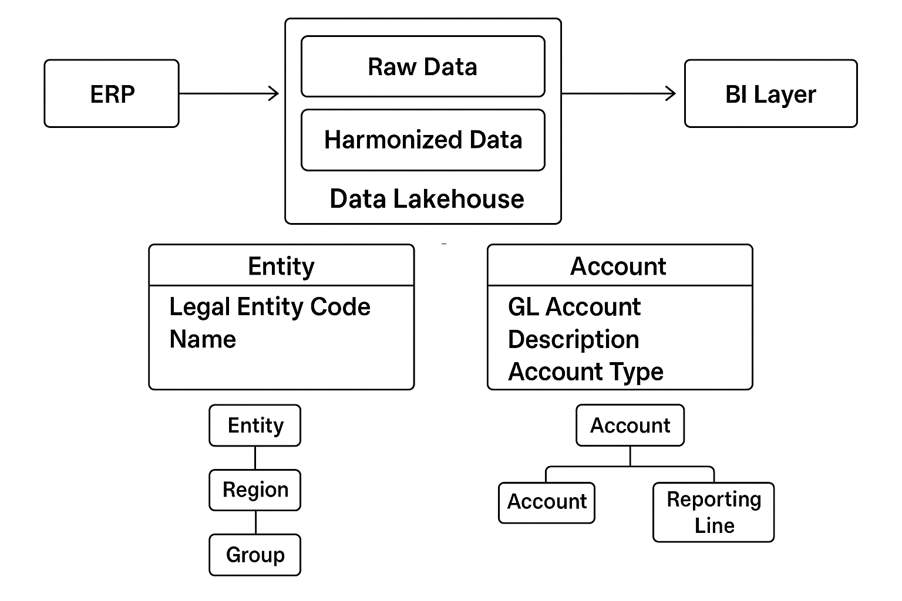

Scenario B: Multiple ERPs
Flow: ERP1 + ERP2 + ERP3 → Lakehouse → Harmonized Layer → BI
Attribute | Description
Source System ID | Identifier for ERP source
Local Account | Account code in source ERP
Global Account | Mapped global account code
Currency | Transaction currency
Amount | Monetary value
Hierarchy | Local → Global → Consolidated

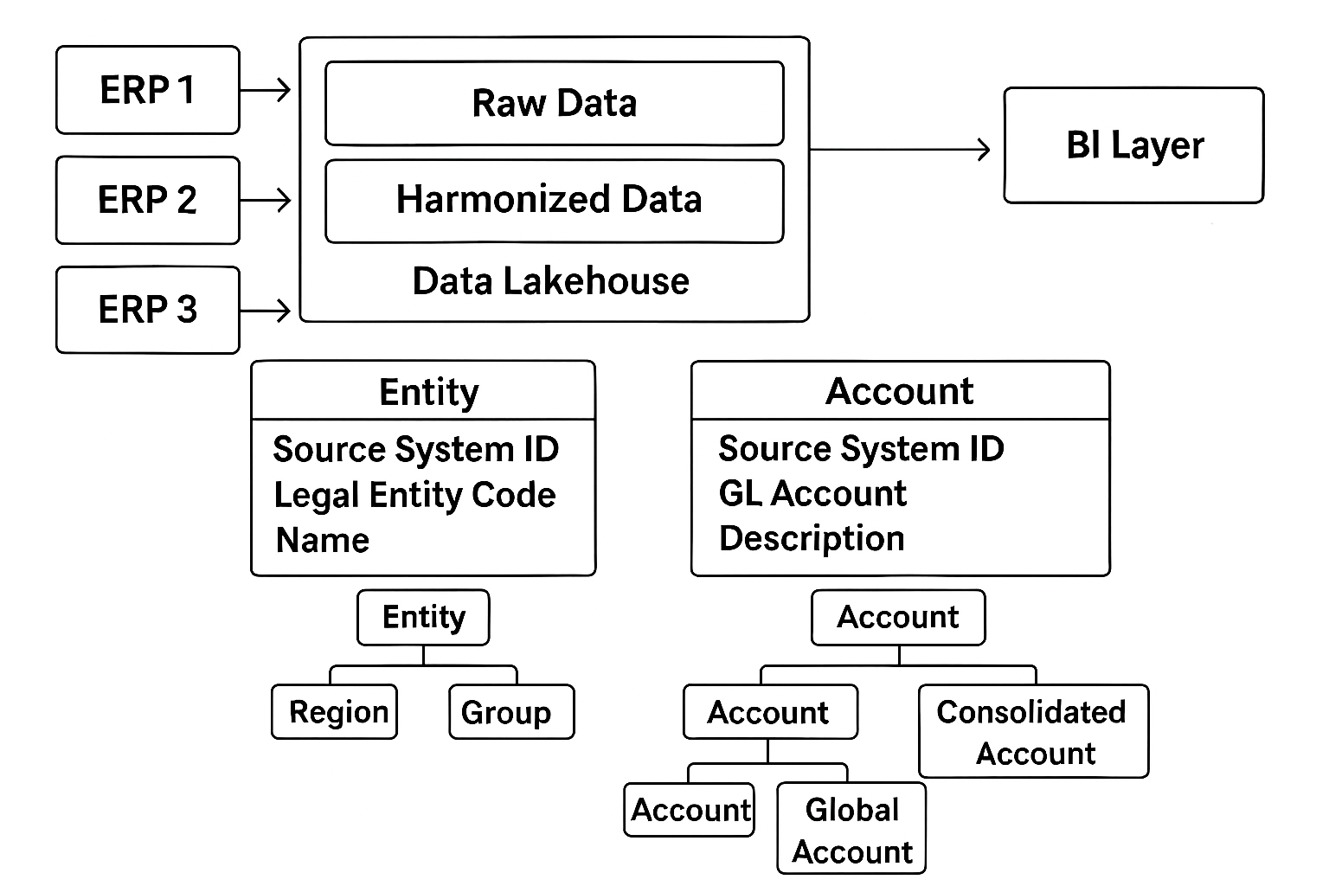

5. Sample Transformation Logic for Harmonized Reporting
Example:
- Local Account `4000` (SAP) → Global Account `REV_SALES`
- Apply FX Conversion: Local Currency → Group Currency
- Apply Sign Logic: Revenue positive, Expenses negative
SQL Example:
SELECT
CASE WHEN local_account IN ('4000','4010') THEN 'REV_SALES'
WHEN local_account IN ('5000','5010') THEN 'COGS'
END AS global_account,
amount * fx_rate AS amount_in_usd
FROM raw_gl_data
JOIN fx_rates ON raw_gl_data.currency = fx_rates.currency;

6. Reconciliation Between Source and Reporting Layers
Purpose: Ensure data integrity between ERP and BI reports.
Methods:
- Control Totals: Compare Trial Balance totals
- Hash Totals: Validate record counts and sums
- Exception Reports: Identify unmapped accounts
Tools:
- Automated reconciliation scripts
- BI dashboards for reconciliation status

7. Visual Flowcharts
Data Pipeline: ERP → Lakehouse → BI
