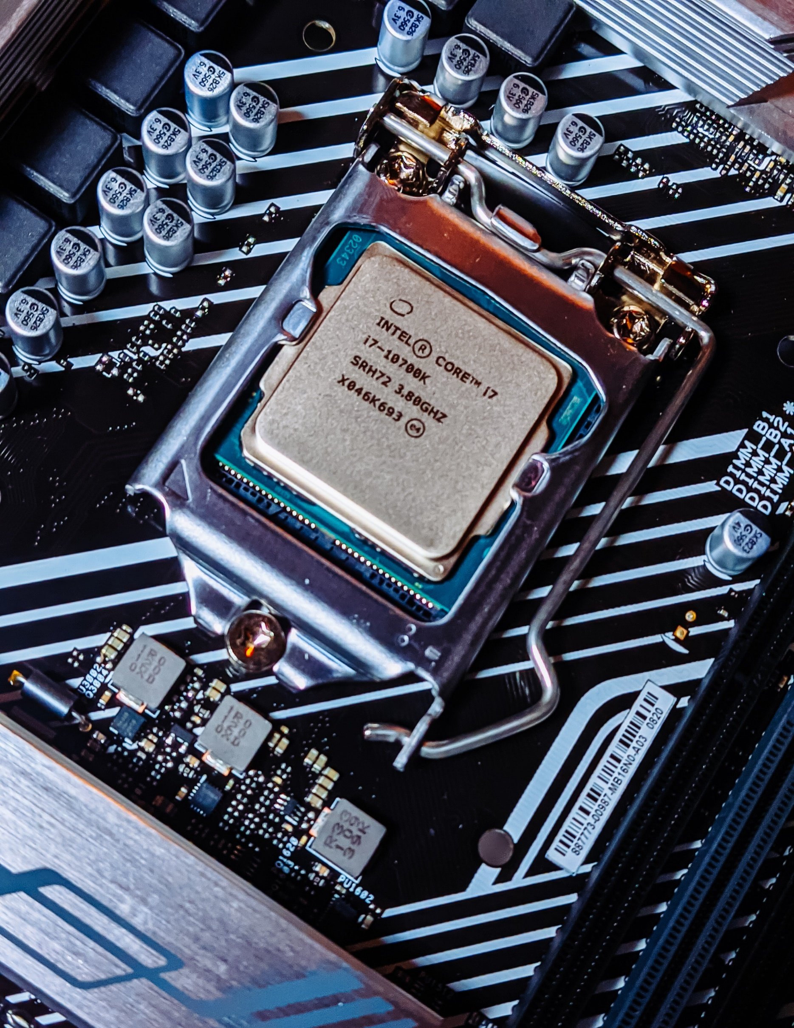 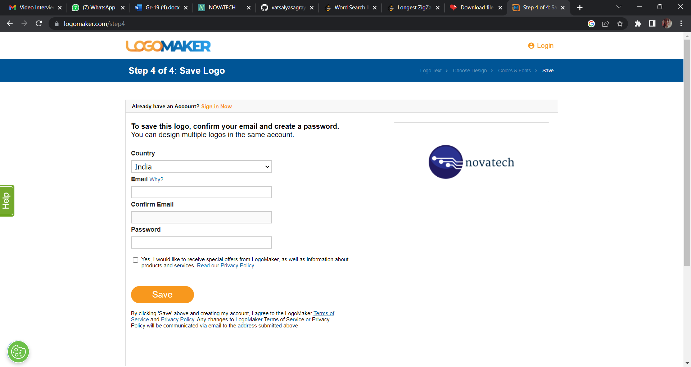

[link for the simulation of the program](https://novatech-omega.vercel.app/)





Computer Architecture Project 2023

Group 14

Moxesh Shah - 2020UEC1080  
Prakhar Agrawal - 2020UEC1135  
Vatsalya Sagraya - 2020UEC1198  
Khushbu Swami - 2020UEC1706  
Hitakshi Baharwani - 2020UEC1710

Introduction to the Architecture of our Processor

* Our Processor includes the following elements with proper sizing:

RAM Size = 64 * 8

bit Register Used: A, B Temp Register Size: 8 bits Internal Data Bus: 8 bits

Instruction Format:

|  |  |  |
| --- | --- | --- |
| I | OPCODE | ADDRESS |

* The functional Units of our processor include:

1. Accumulator
2. Program counter
3. Register B
4. ALU
5. Temporary register
6. ROM
7. RAM
8. Instruction Register
9. Memory access register

* Basic processor architecture is used with some modifications. Registers used:

1. Accumulator: 8-bit register. The result is stored in the accumulator.
2. PC: PC stands for program counter. PC is 8-bit. It stores the location of the next instruction to be executed.
3. TEMP: TEMP is 8 bits. TEMP is used to store a value temporarily.
4. Register B: B is 8 bits.
5. MAR: MAR is 8-bit.
6. IR: Instruction register is 8-bit.

* React-based design: Our project is built using ReactJS, a popular and widely-used JavaScript library for building user interfaces. This design choice allows for a more modular and reusable codebase, as well as a more streamlined development process.
* JavaScript-based Implementation: By using JavaScript to build out the processor's functionality, we were able to create a more modular and scalable architecture that is easy to modify and extend over time.

Unique Features of NovaTech:

* Dynamic visualizations: Our project provides users with dynamic and interactive visualization of the processor's operation. By displaying each step of the process in real time, users can gain a deeper understanding of how the processor works and how their code is executed.
* Register swapping: One of the key features of our processor is the ability to swap the values of two registers. This feature can be useful for a variety of applications, from sorting algorithms to optimizing code execution.
* Clock cycle tracking: Our project also includes a clock cycle tracker that displays the current clock cycle and updates in real time as the processor executes code. This feature provides users with a clear understanding of how long each step of the process takes and can be helpful for debugging and optimization.

Instruction Set

|  |  |  |  |  |
| --- | --- | --- | --- | --- |
| SR  NO: | MNEMONICS | DESCRIPTION | FLAGS  AFFECTED | OPCODE |
| 1 | MOV A, B | MOVE CONTENTS FROM ONE REGISTER  TO ANOTHER | NONE | 0X00 |
| 2 | MVI A | MOVE IMMEDIATE  TO A | NONE | 0X01 |
| 3 | LDA X | LOAD CONTENTS TO A FROM MEMORY | NONE | 0X30 |
| 4 | ADD A, B | ADD B TO A | NONE | 0X02 |
| 5 | SUB | SUBTRACT B FROM A | NONE | 0X96 |
| 6 | AND | AND THE VALUES OF  BOTH REGISTERS | NONE | 0X03 |
| 7 | OR | OR THE VALUES OF BOTH THE REGISTERS | NONE | 0X25 |
| 8 | INR A | INCREMENT A | NONE | 0X04 |
| 9 | DCR A | DECREMENT A | NONE | 0X05 |
| 10 | CMA | COMPLIMENT OF A | NONE | 0X08 |
| 11 | SWAP A, B | SWAP VALUES OF A  AND B | NONE | 0X09 |
| 12 | SQR A | SQUARE OF A  REGISTER | NONE | 0X0B |
| 13 | HCF A, B | SQUARE ROOT OF A  REGISTER | NONE | 0X0C |
| 14 | LCM A, B | LOWEST COMMON MULTIPLE OF A AND B | NONE | 0X0D |

Micro-instruction for Each instruction set

1. **MVI:**

T0: PC(E), MAR (E, L)

T1: PC(I), RAM(E), IR(L)

T2: RAM(E), A(L)

T3:

T4:

T5:

T6:

1. **MOV:**

T0: PC(E), MAR (E, L)

T1: PC(I), RAM(E), IR(L)

T2: A(E), B(L)

T3:

T4:

T5:

T6:

1. **ADD:**

T0: PC(E), MAR (E, L)

T1: PC(I), RAM(E), IR(L)

T2: B(E), A (E, L), A=A+B

T3:

T4:

T5:

T6:

1. **AND:**

T0: PC(E), MAR (E, L)

T1: PC(I), RAM(E), IR(L)

T2: B(E), A(E, L), A=A&B

T3:

T4:

T5:

T6:

1. **SUB:**

T0: PC(E), MAR (E, L)

T1: PC(I), RAM(E), IR(L)

T2: B(E), A(E, L), A=A-B

T3:

T4:

T5:

T6:

1. **OR:**

T0: PC(E), MAR (E, L)

T1: PC(I), RAM(E), IR(L)

T2: B(E), A(E, L), A=A||B

T3:

T4:

T5:

T6:

1. **INR:**

T0: PC(E), MAR (E, L)

T1: PC(I), RAM(E), IR(L)

T2: A (E, L), A=A+1

T3:

T4:

T5:

T6:

1. **DCR:**

T0: PC(E), MAR (E, L)

T1: PC(I), RAM(E), IR(L)

T2: A (E, L), A=A-1

T3:

T4:

T5:

T6:

1. **SQR:**

T0: PC(E), MAR (E, L)

T1: PC(I), RAM(E), IR(L)

T2: A(E, L), A=A*A

T3:

T4:

T5:

T6:

1. **SWAP:**

T0: PC(E), MAR (E, L)

T1: PC(I), RAM(E), IR(L)

T2:

T3:

T4: B(E), TMP(L)

T5: A(E), B(L)

T6: A(E), B(L)

1. **LCM:**

T0: PC(E), MAR (E, L)

T1: PC(I), RAM(E), IR(L)

T2: B(E), A(E, L), LCM(A,B)

T3:

T4:

T5:

T6:

1. **HCF:**

T0: PC(E), MAR (E, L)

T1: PC(I), RAM(E), IR(L)

T2: B(E), A(E, L), HCF(A,B)

T3:

T4:

T5:

T6:

1. **CMA:**

T0: PC(E), MAR (E, L)

T1: PC(I), RAM(E), IR(L)

T2: A (E, L), A=A’

T3:

T4:

T5:

T6:

1. **LDA:**

T0: PC(E), MAR (E, L)

T1: PC(I), RAM(E), IR(L)

T2: PC(E), MAR (E, L)

T3: PC(I), RAM(E), TEMP(L)

T4: TEMP(E), A(L)

T5:

T6:

Working with Diagram

Architecture of our Processor:

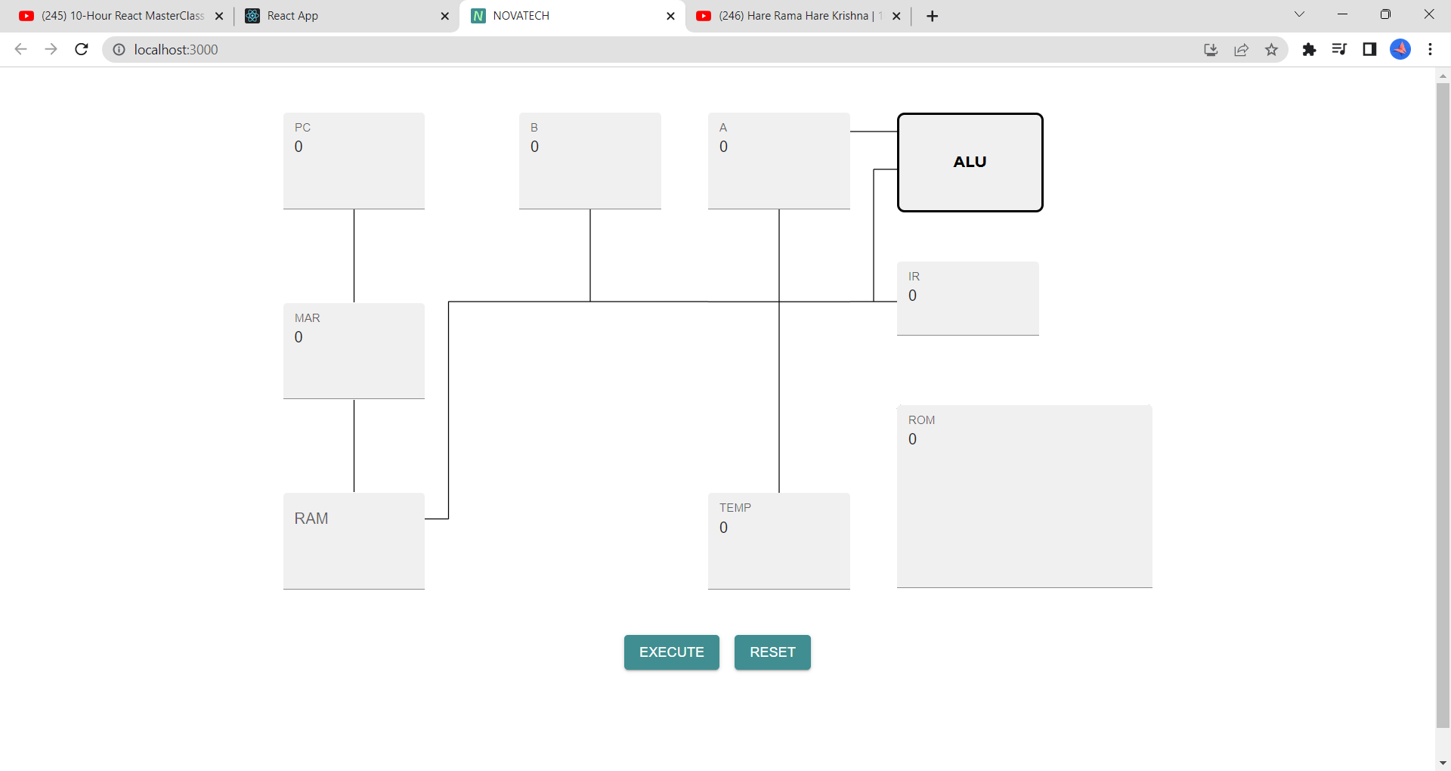

Screenshots of Output of the Simulation of the Program

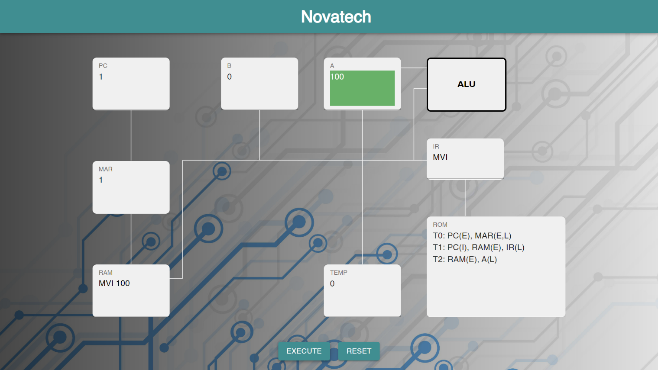

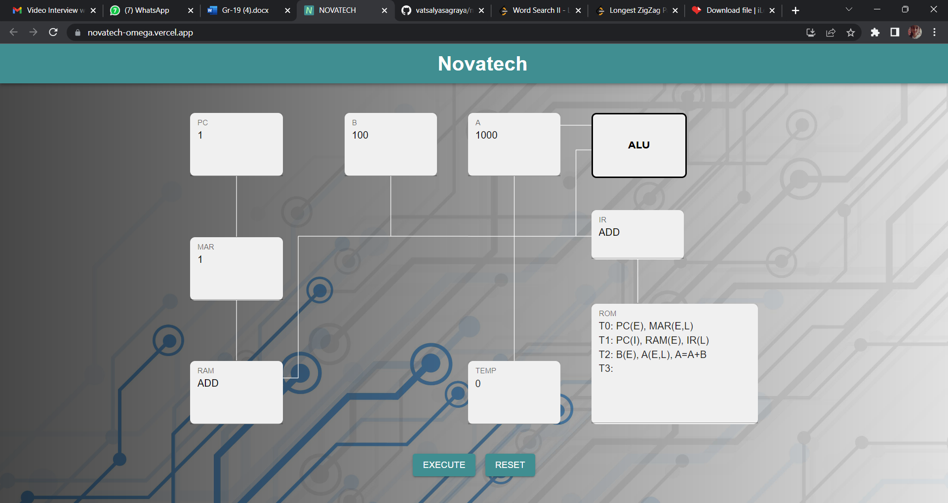

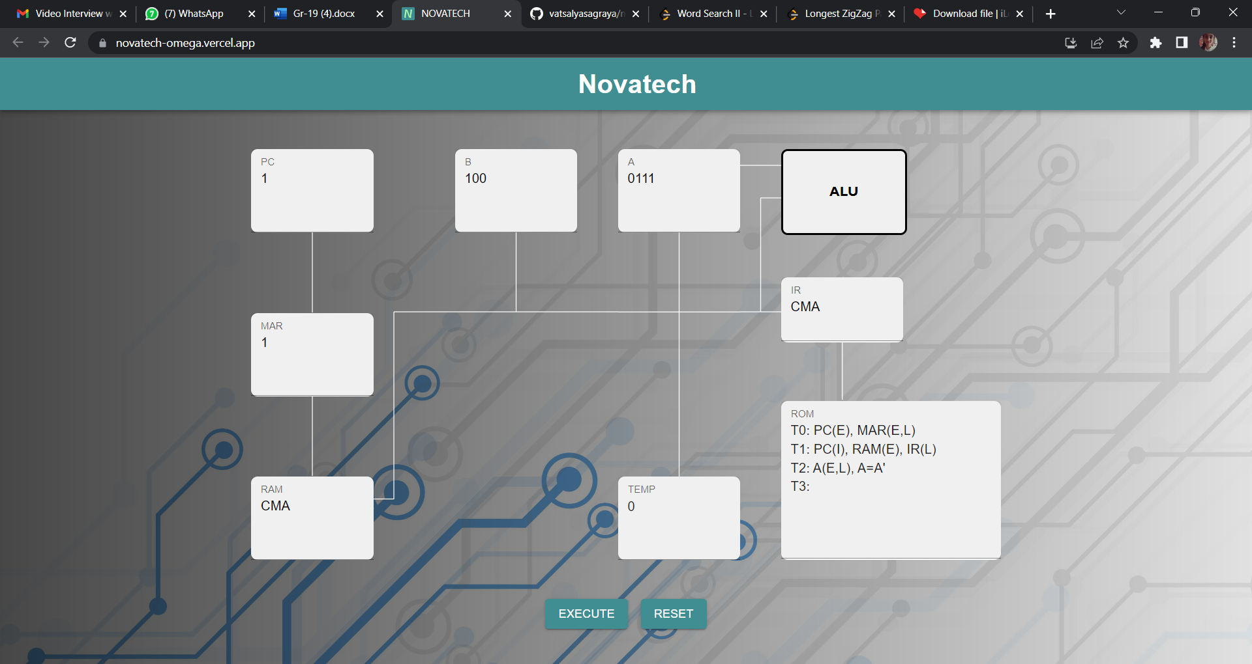

* **Educational value:** Overall, our project has significant educational value for anyone looking to learn more about processor architecture and operation. By providing a clear and interactive display of the processor's workings, users can gain a deeper understanding of this complex topic.