CRISP-DM

Cross Industry Standard Process for Data Mining.

It a standard set to simply the efforts put into data mining,

CRISP-DM is an iterative data mining mode and is a comprehensive methodology for data mining projects which procides structured approach to guide data-driven decision-making.

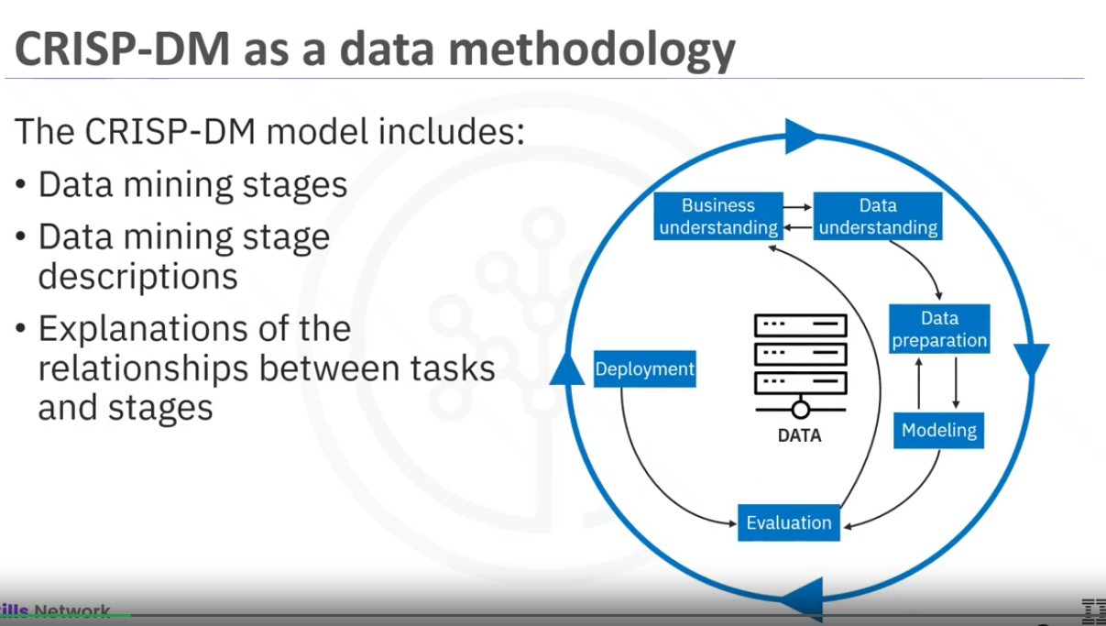

It provides insights into data mining life cycle.

Data Scientists might need to

Communicate with peers, management and stakeholders to keep the project on track.

Revisit ealier stage

