1. Which of the following is the valid override of equals method in java.lang.Object
   1. public boolean equals(Employee eobj) {}
   2. Private Boolean equals(Employee eobj) {}
   3. public boolean equals(Object eobj) {}
   4. All of the above
2. Which of the following statements are true
   1. catch(X x) can catch subclasses of X.
   2. The Error class is a RuntimeException.
   3. Any statement that can throw an Error must be enclosed in a try block.
   4. Any statement that can throw an Checked Exception MUST be enclosed in a try block.
   5. Any statement that can throw a RuntimeException MUST be enclosed in a try block.
3. Identify the type to which “ArrayIndexOutOfBoundsException” fall?
   1. Checked Exception
   2. Unchecked Exception
   3. Runtime Exception
   4. Both (B) and (C)
4. Which of the following Statement about finally Block is valid
   1. Try-catch MUST have finally Block
   2. Finally Block Gets always executed
   3. Finally Block will get executed if System.exit() is in a catch block
   4. Finally Block gets executed event if there is a forced exit in try-catch block
5. If the block of a Method method1() throws an IOException what the Method could do
   1. Can have throws Clause with public void method1() throws IOException{}
   2. Can handle the IOException with try-catch Block
   3. Can have Both throws Clause and handle the exception
   4. Can have throws Clause with public void method1() throw IOException{}
6. Which of the following method is implicitly called when an object is garbage collected
   1. finally ()
   2. final()
   3. hashCode()
   4. finalize()
7. Which is valid about java.lang.Exceptions
   1. The Class Exception and all its sublcasses that are not subclasses of Runtime Exceptions are checked exceptions
   2. The class Error and all its subclasses are unchecked Exceptions
   3. The Class Runtime Exception and all its subclasses are unchecked exception
   4. None of the Above
8. What will be output of following program -

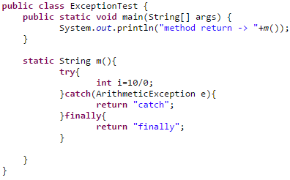

1. Runtime exception
2. Method return ->finally
3. Method return -> catch
4. Compile time error
5. What will happen when catch and finally block both have return value?  
   1. Method will return value returned by finally block but Not Considered as the good practice as it overrides all return values.
   2. Method will return value returned by catch block
   3. Finally Block won’t execute
   4. None of the Above
6. Which of these points will be valid If superclass method does not throw any exception
   1. Overridden method of subclass can throw any RuntimeException
   2. Overridden method of subclass cannot throw any checked exception
   3. Overridden method of subclass may not throw any exception
7. What will be output of following program -   
     
   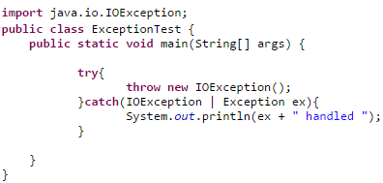
   1. Runtime exception
   2. Program will compile
   3. Program won’t compile
   4. None of the above
8. In which condition will the finally block will not be executed?
   1. When some error occurs
   2. When Exception is raised
   3. Whey System.exit() is called
   4. In all the Cases
9. Exception and Error are direct subclasses of
   1. BaseEception
   2. Throwable
   3. Object
   4. Runtime Exception
10. Which keyword is used to explicity raise a exception
    1. Catch
    2. Throw
    3. Throws
    4. Raise
11. Which of the following List the exception types from Most Specific and to Least Specific
    1. Throwable,Exception,RunTimeException
    2. RunTimeException,Throwable,ArrayIndexOutOfBoundsExeception
    3. Error,Exception,Throwable
    4. Object,IOException,FileNotFoundException
12. How many finally blocks can be there in a try/catch structure
13. Which of the following Class Best Suits for User Defined Exception
    1. RunTimeException
    2. Object
    3. NullPointerException
    4. Exeception
14. Equals Method in Java can Throw which of the following Exception
    1. ArithmeticExcpetion
    2. NumberFormatException
    3. Any CheckedExcpetion
    4. None of the Above