* **Creating a Repository**
  + Create a new empty directory c:\svn_repos
  + Right click on the new folder and from the context menu choose **TortoiseSVN** → **Create Repository here...**.
  + It will create the default internal folder structure by clicking the **Create folder structure** button.
* **Importing a Project**
  + Navigate to an already existing directory like  C:\Projects\quickStart
  + Right click on that Folder and Select **TortoiseSVN** → **Import...** which brings up a dialog
* **Figure 1.2. The Import dialog**

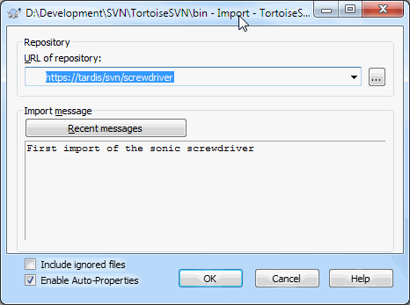

Point to the local repository which has a URL of file:///c:/svn_repos/trunk, and to which we add project name qucikStart.

* **Checking out a Working Copy**
  + To create a working copy to use for day-to-day work need to checkout the quickStart
  + Create a folder of our repository C:\Projects\project -Dev.
  + Create that folder, then right click on it and select **TortoiseSVN** → **Checkout...**.
  + Enter the URL to checkout, in this case file:///c:/svn_repos/trunk/quickStart and click on **OK**.
  + Development folder is populated with files from the repository.
* **Making Changes**
  + In the quickstart-Dev folder start editing files
  + Notice that the icon overlays on these files have now changed to red
  + Right click on changed files and select **TortoiseSVN** → **Diff**.
  + TortoiseSVN's file compare tool starts, showing you exactly which lines have changed.
* **Figure 1.3. File Difference Viewer**
* 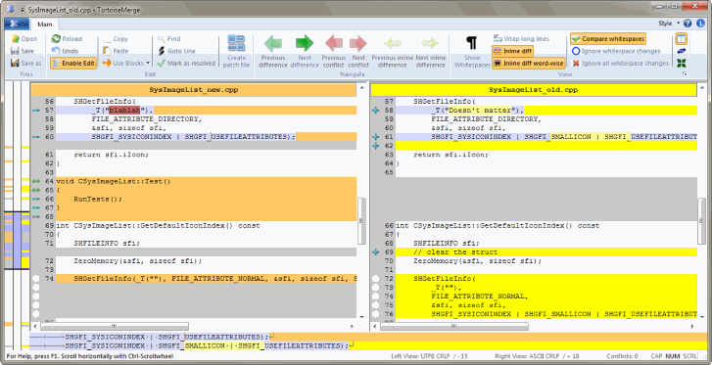
* To Update the repository. Commit of the changes.
* Right click on the qucikStart-Dev folder and select **TortoiseSVN** → **Commit**.
* Enter up a message to describe what the change is all about and click on **OK**.
* The progress dialog shows the files being uploaded to the repository
* **Adding More Files**
  + Try adding new files
  + Right click on the folder and **TortoiseSVN** → **Add**.
  + The Add dialog now shows you all unversioned files and you can select which ones you want to add.
  + Can also right click on the file itself and select **TortoiseSVN** → **Add**.
* Now when you go to commit the folder, the new file shows up as *Added* and the existing file as *Modified*.
* Double click on the modified file to check exactly what changes were made.

* **Viewing the Project History**
  + To view the Log dialog.
    1. From the TortoiseSVN context submenu
    2. From the property page
    3. From the Progress dialog after an update has finished.
       1. Then the Log dialog only shows those revisions which were changed since your last update
    4. From the repository browser
* **Figure 1.4. The Log Dialog**
* 