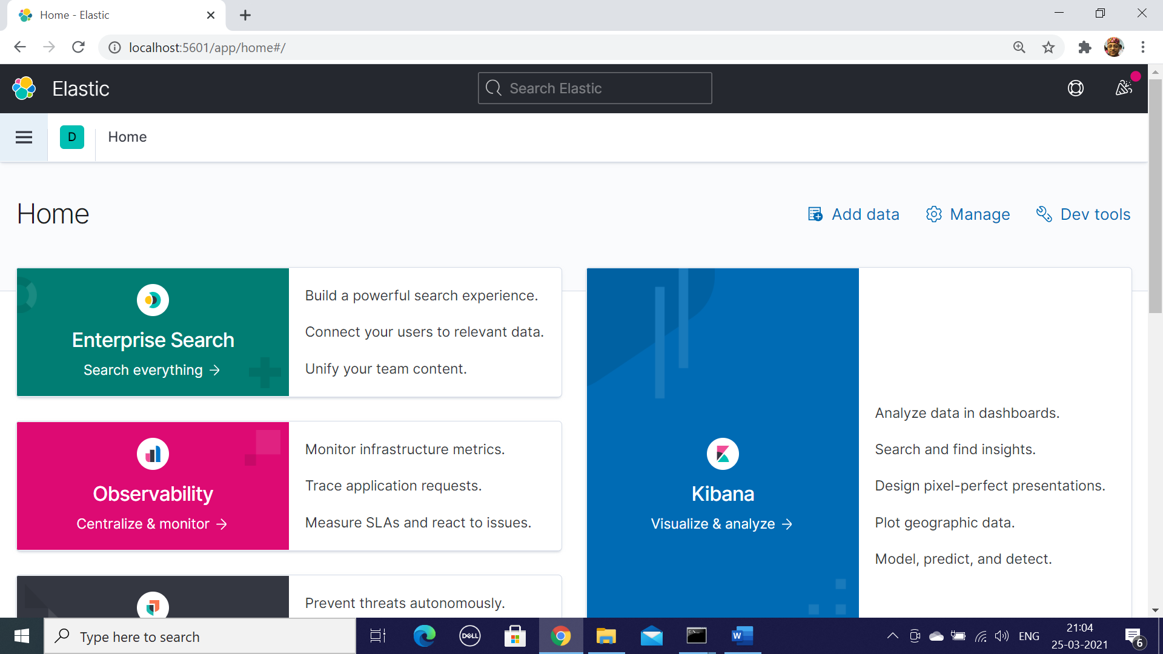

* From the Kibana Home Select Manage
* In the Kibana Option Select index Pattern
* 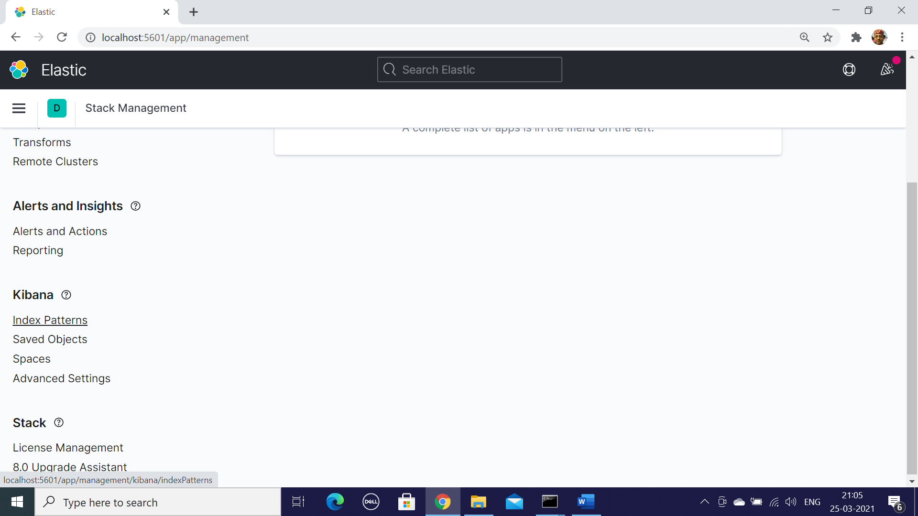
* Select Create Index Pattern
* 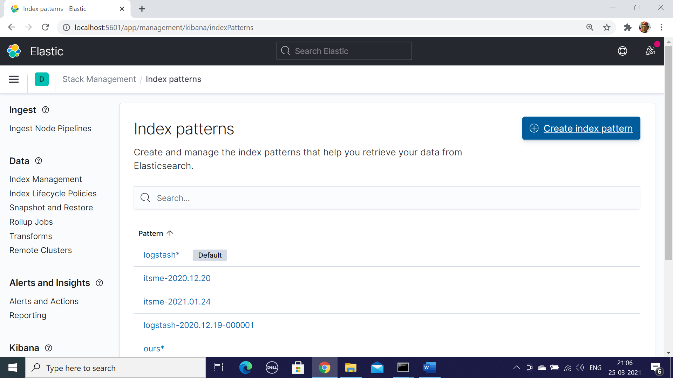
* It will show the available index in elastic Search , Select our-2021-03-25 or which ever index you want to work with and paste on the search field
* Then Select the Button Next Step

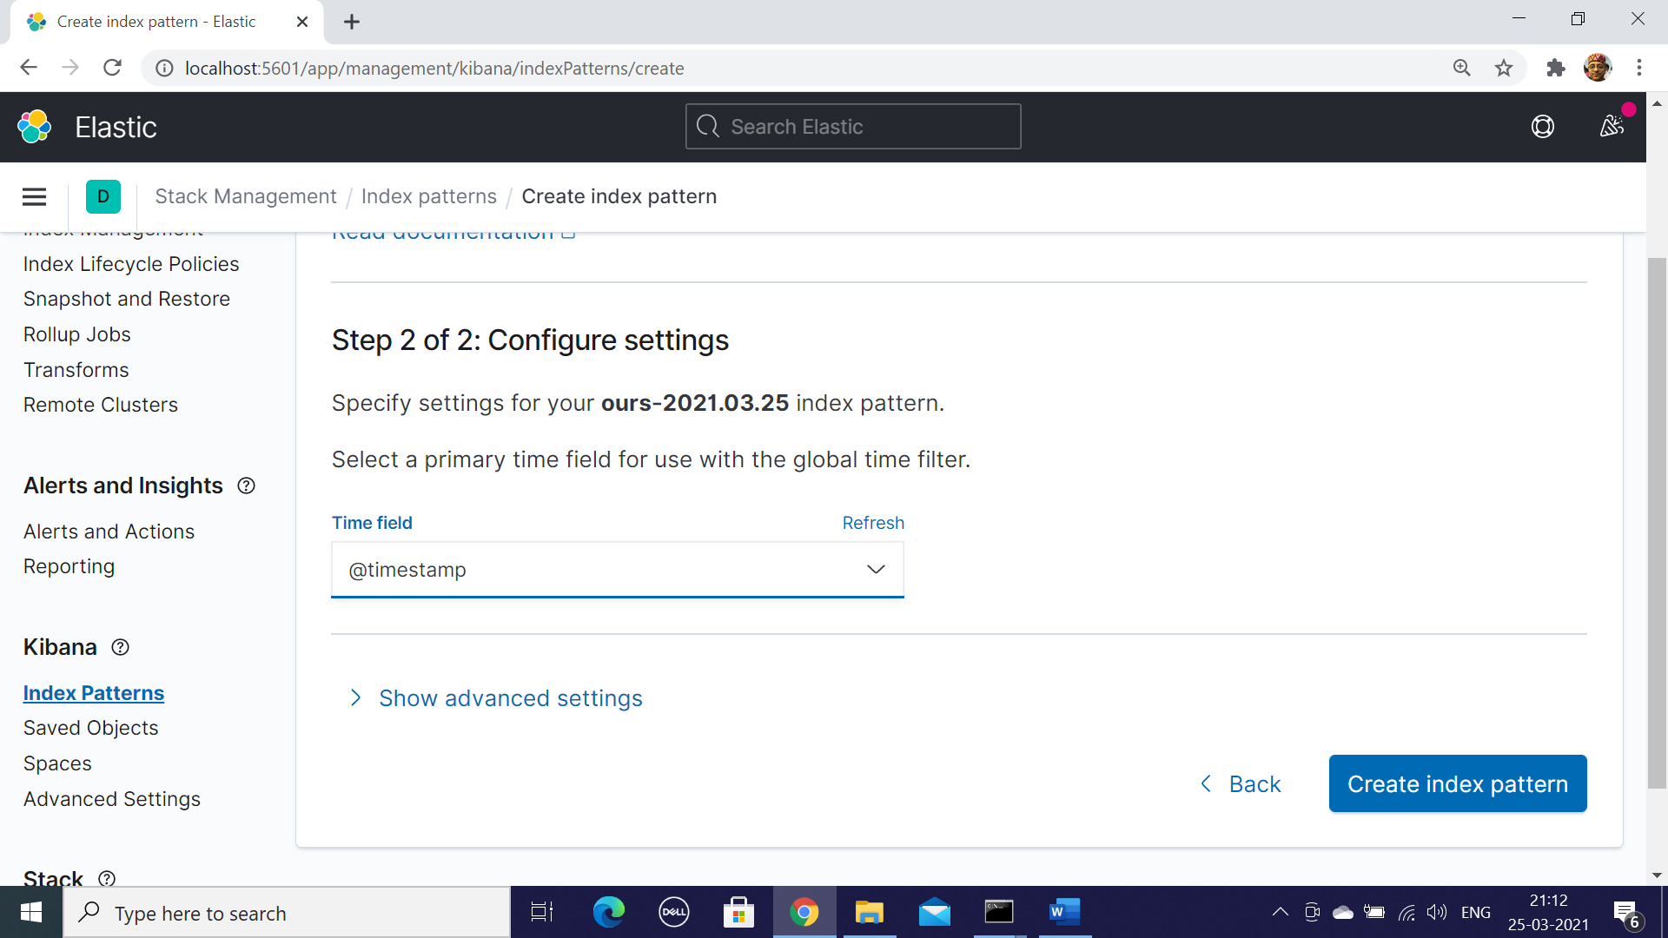

* From the drop down Field select Time Stamp and Click Create Index Pattern
* 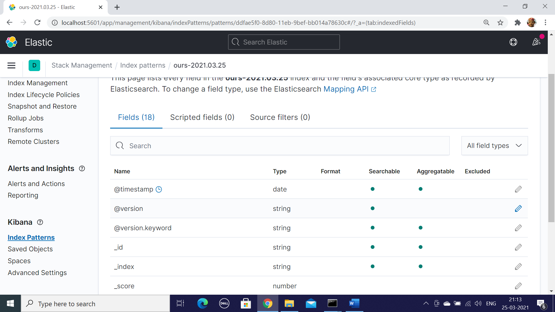
* After Getting the following screen select Menu Discover
* 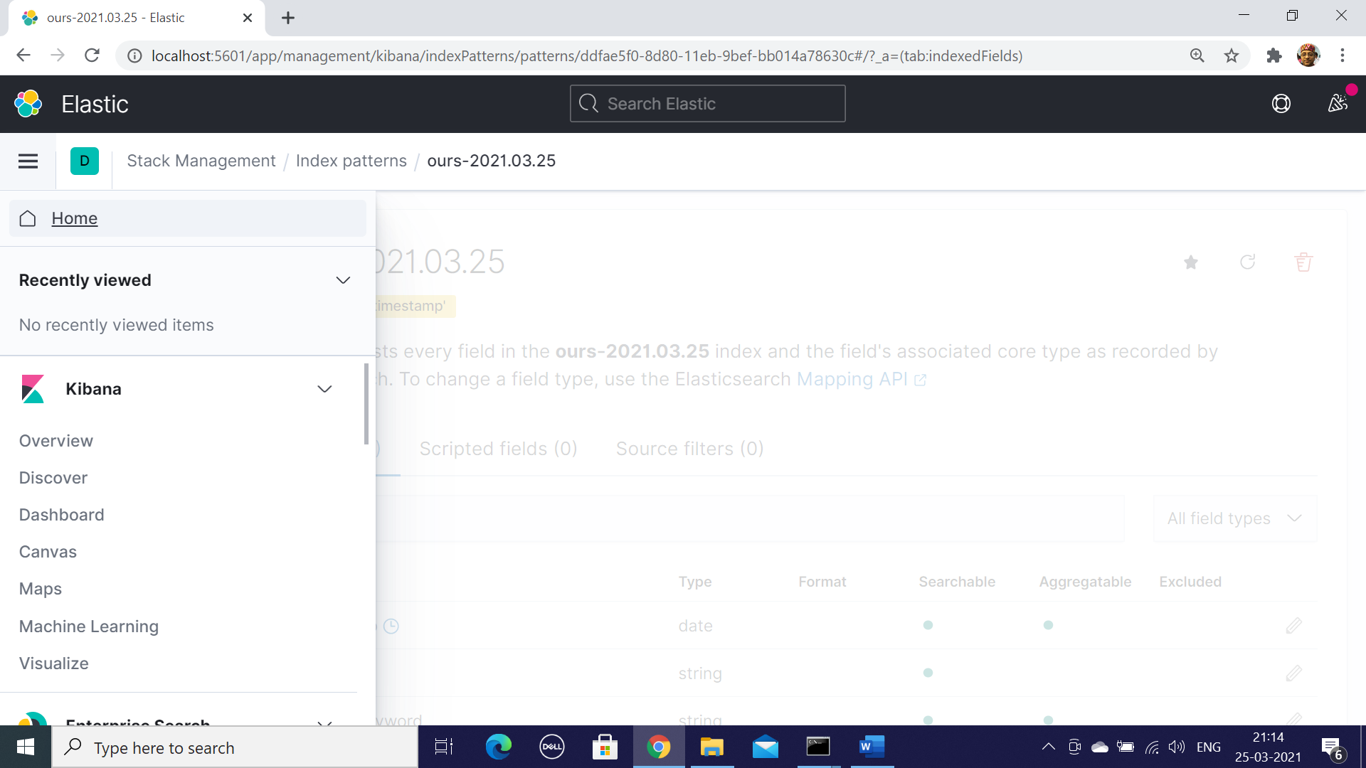
* Select Menu – Discover and In the Filer Drop Down choose the index and you can see the log messages and also the graph associated with ,there are ways to query and filer the data
* 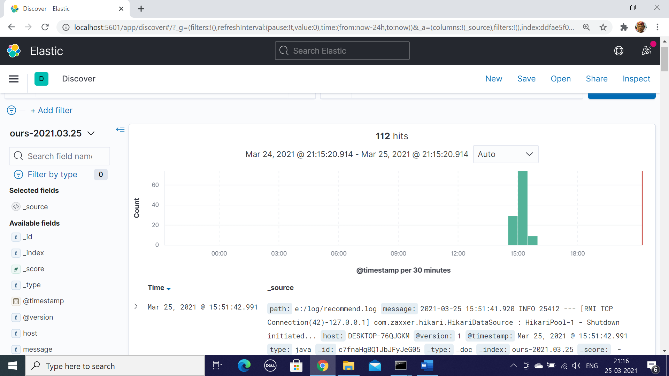

<https://www.elastic.co/downloads/logstash>

Create a File logstatsh.conf

Invoke by calling logstash -f logstash-custom.config

In the kibana.yml file uncomment

elasticsearch.hosts: ["http://localhost:9200"]

input {

file {

type => "java"

path => "e:/logs/*.log"

codec => multiline {

pattern => "^%{TIMESTAMP_ISO8601} "

negate => true

what => "previous"

}

}

}

filter {

date {

match => [ "timestamp" , "dd/MMM/yyyy:HH:mm:ss Z" ]

}

}

output {

stdout {

codec => rubydebug

}

elasticsearch {

hosts => ["localhost:9200"]

index => "april-%{+YYYY.MM.dd}"

}

}

1. First Run Elastic Search elasticsearch.bat
2. Logstash logstash -f logstash-config.conf
3. Kibana
4. Start the Spring Boot Application