Create a MongoDB Atlas Account

- Use this link to create an account https://account.mongodb.com/account/register
- Fill in the registration formand Sign up.
- Create a New Cluster
- Fill in organization's name, project's name and required information and click the green Continue button and answer few question and click Finish
- In the "Deploy a cloud database" page, click the Create button under the Shared cluster type, which would be the only free option:
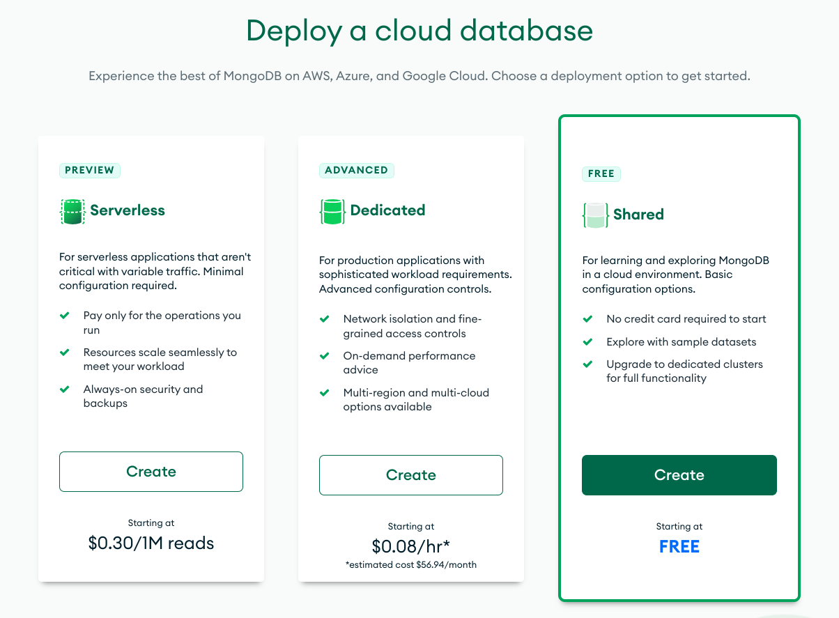
- In the Cloud Provider & Region dropdown, leave everything as default.
- In the Cluster Tier dropdown, leave this as the default, M0 Sandbox (Shared RAM, 512 MB Storage).
- Click the green Create Cluster button at the bottom of the screen.
- Will take few minutes, Wait until the cluster is created before going to the next step.
- Create a New User for the Database
- On the left side of screen under SECURITY, click on Database Access.
- Click the green Add New Database User button.
- Under Authentication Method, make sure Password is selected, then enter in a username and password for your user.
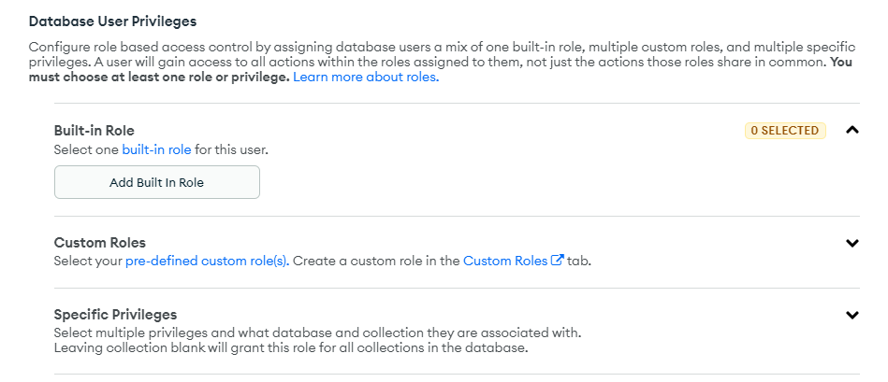
- Click "Add Built In Role" to select "Read and Write to Any Database".
- Click the Add User button to create new user.
- Allow Access From All IP Addresses
- On the left side of the screen under SECURITY, click on Network Access.
- Click the green Add IP Address button.
- In the modal, click the ALLOW ACCESS FROM ANYWHERE button. should see 0.0.0.0/0 in the Access List Entry field.
- Click the green Confirm button.
- Connect to Your Cluster
- On the left side of the screen under DEPLOYMENT, click on Database.
- Click the Connect button to cluster:
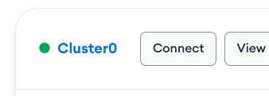
- In the popup modal, click on Connect your application.
- You should see the URI string you'll use to connect to your database similar to this: mongodb+srv://<username>:<password>@<cluster-name>.prx1c.mongodb.net/<db-name>?retryWrites=true&w=majority.
- Click the Copy button to copy your URI to your clipboard.
- Notice that the <username> and <cluster-name> fields of the URI you copied are already filled out for you. All you need to do is replace the <password> field with the one you created in the previous step, and be sure to add the name of your database before the query string (?retryWrites=true&w=majority).

