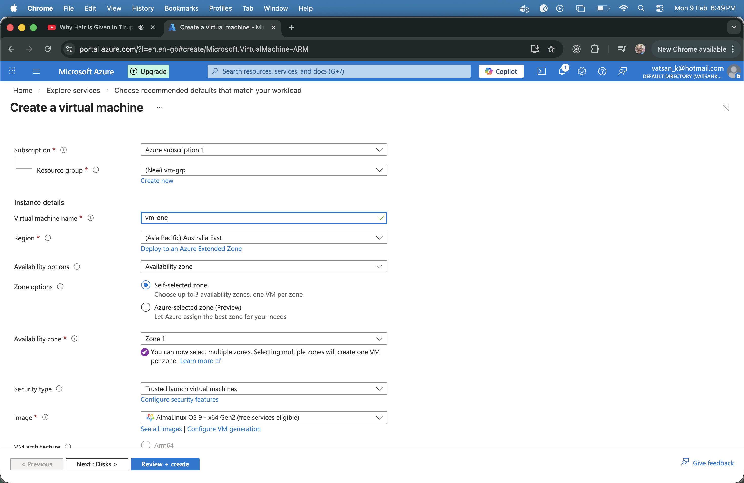

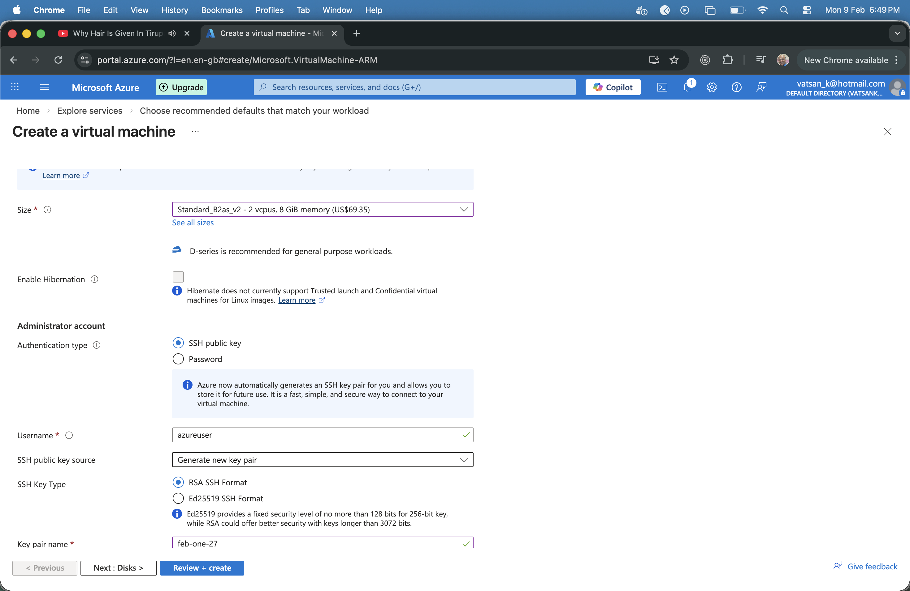

- Click Review and Create
- Copy the generated .pem file to a folder
- When the deployment is complete navigate to the VM Instance using Goto Resource Button
- Click on the Connect Link in the page

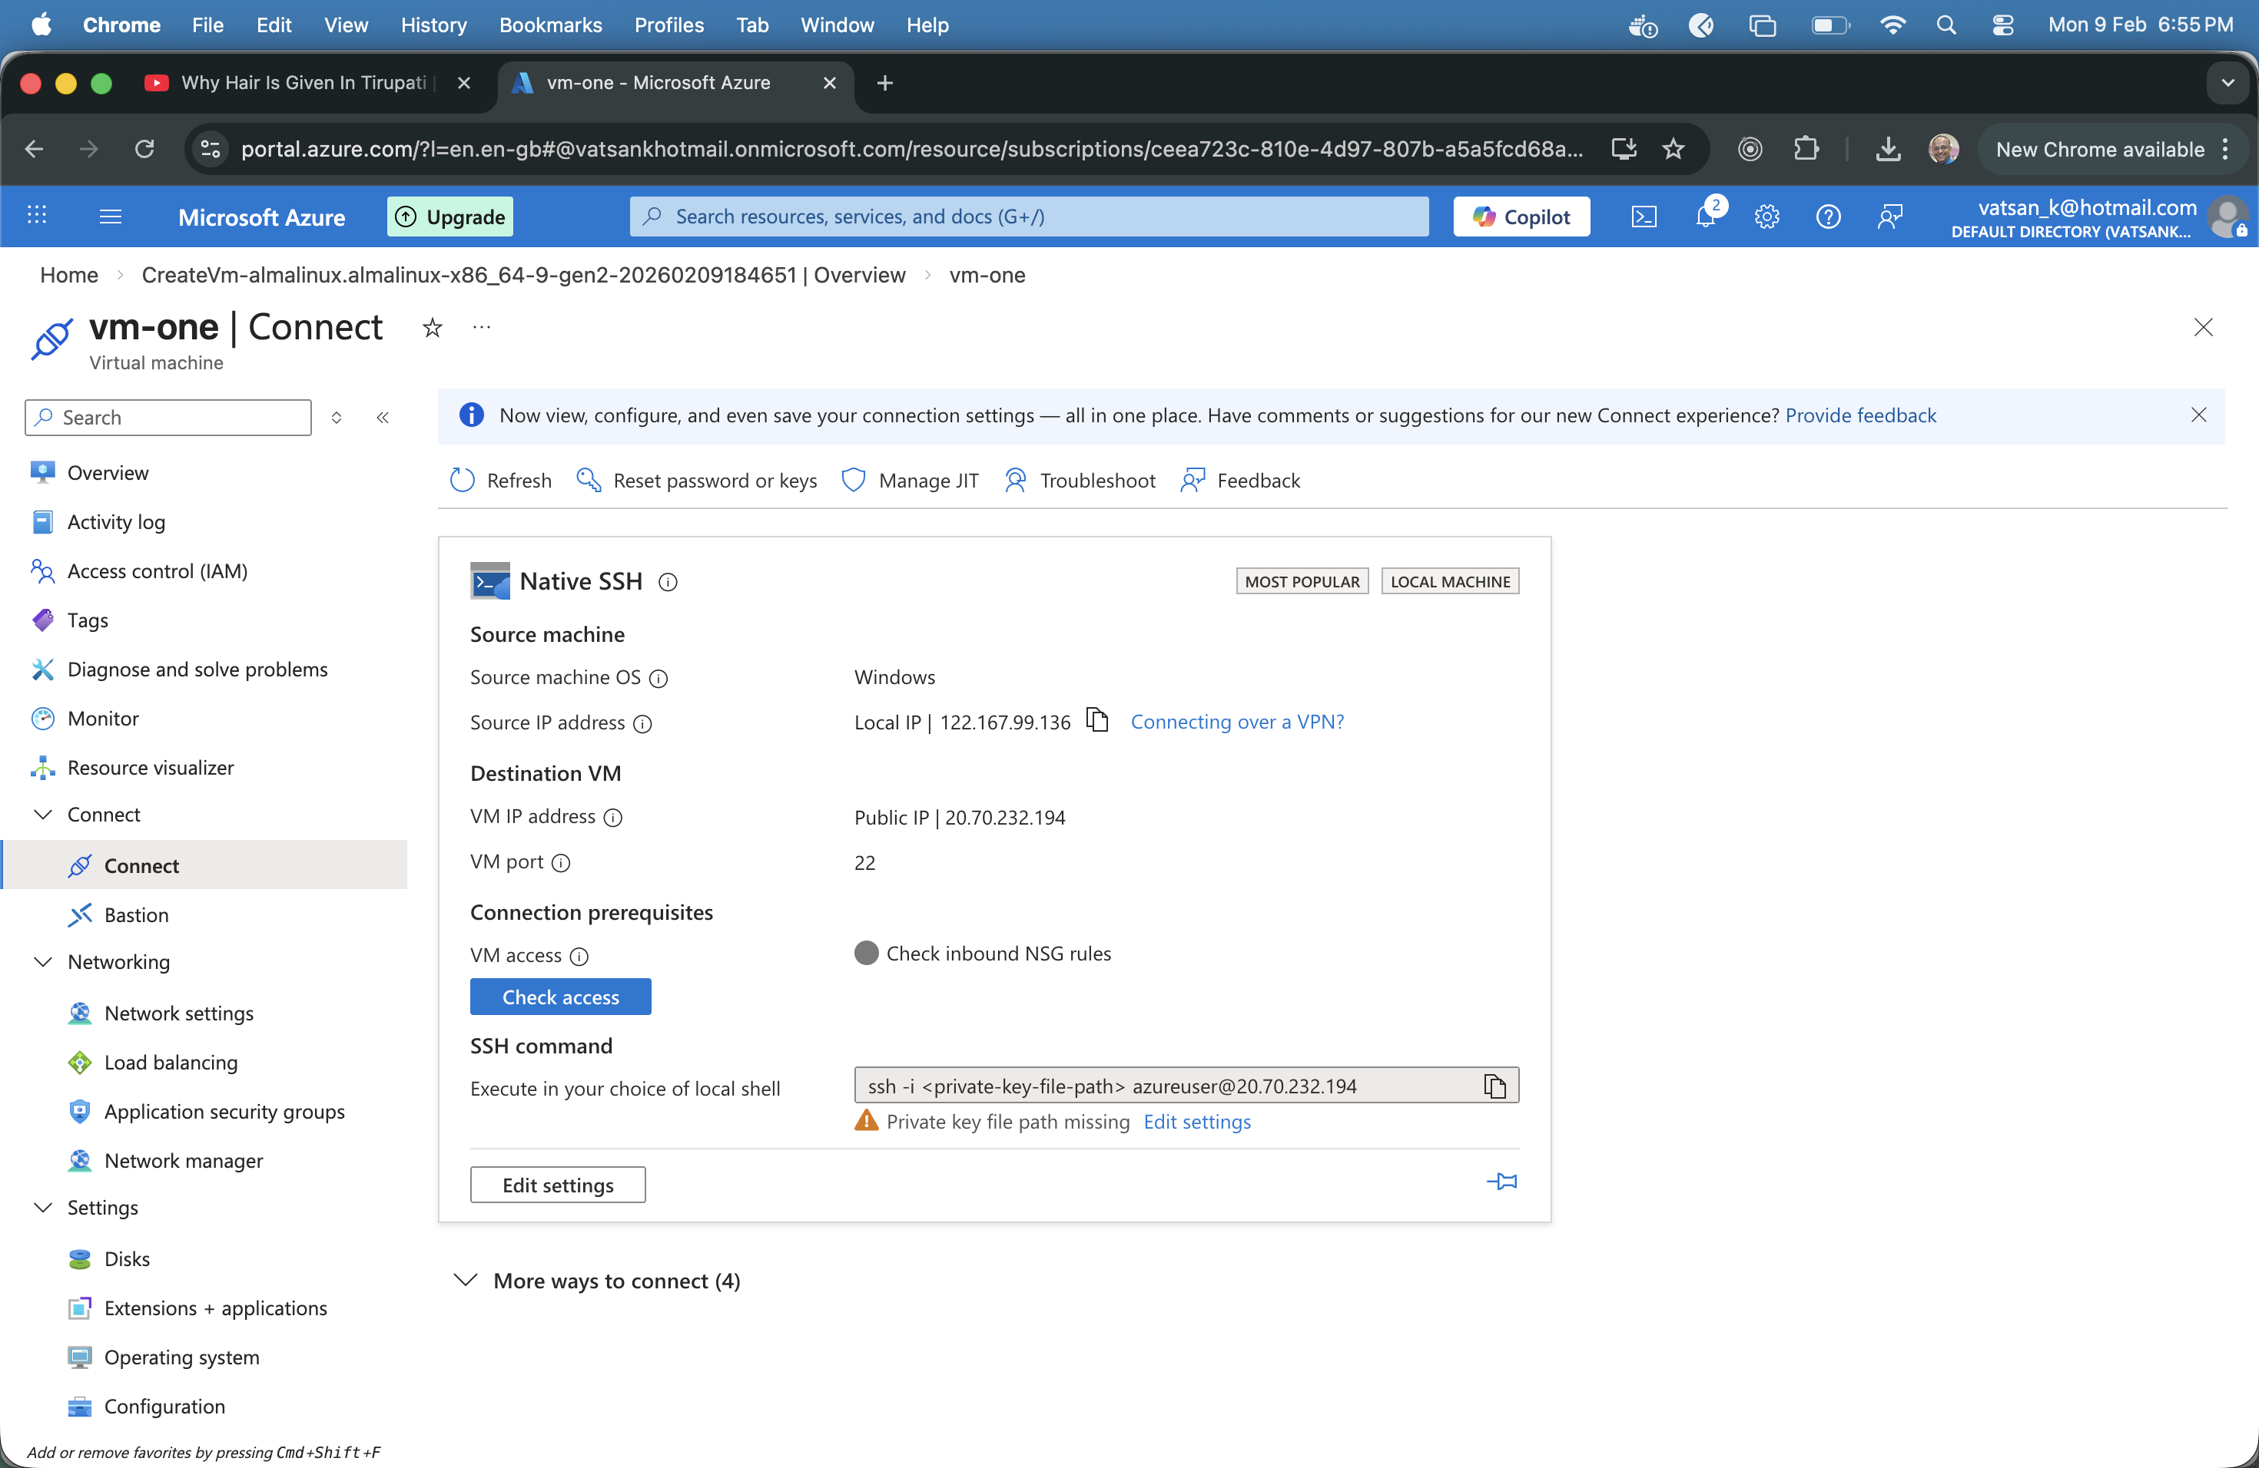
- Observe a Public Ip is associated with setting , if not assign a public key
- Navigate to the folder with .pem key file
- Run the ssh command
- ssh -i /path/to/your/private.pem azureuser@20.70.232.194
- verify the host fingerprint with yes to continue
- Check the Java 8 versions available
- sudo dnf search java-1.8.0-openjdk
- Install the OpenJDK to the virtual machine
- sudo dnf install java-1.8.0-openjdk java-1.8.0-openjdk-devel -y
- sudo dnf install nano -y
- Check java installed correctly using java –version
- Nano Hello.java
- Create a Simple Java code
- Compile with javac -d . *.java
- Execute the Code

