**Word as Features - Performance Report**

**Emotion Classification**

Naive Bayes Classifier

Base Model – {alpha = 1.0}

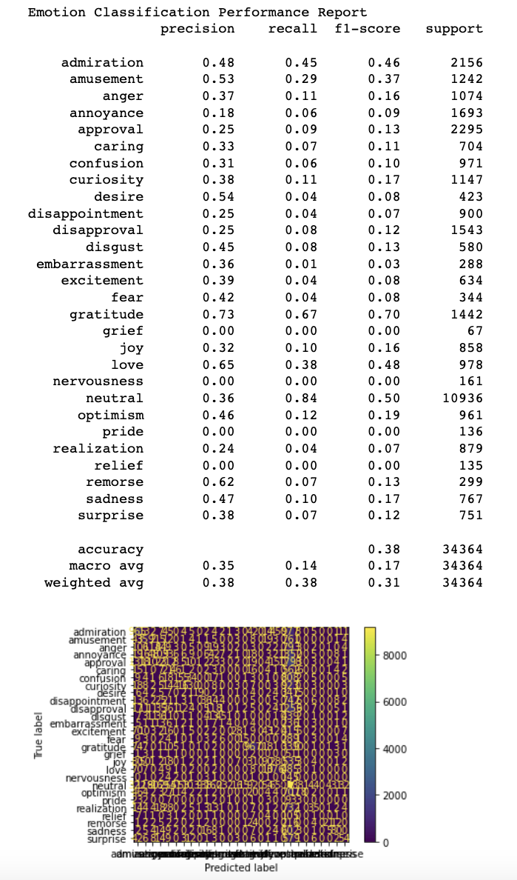

Optimized Model – {alpha = 0}

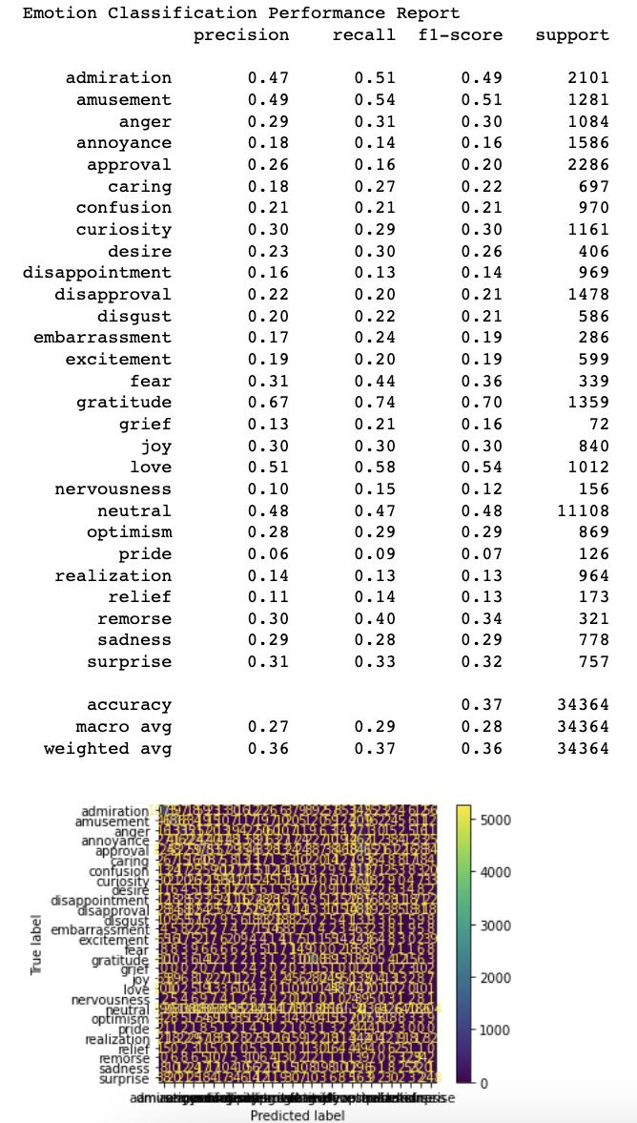

Decision Tree Classifier

Base Model – {criterion: “gini”, max_depth: None, min_samples_split: 2}

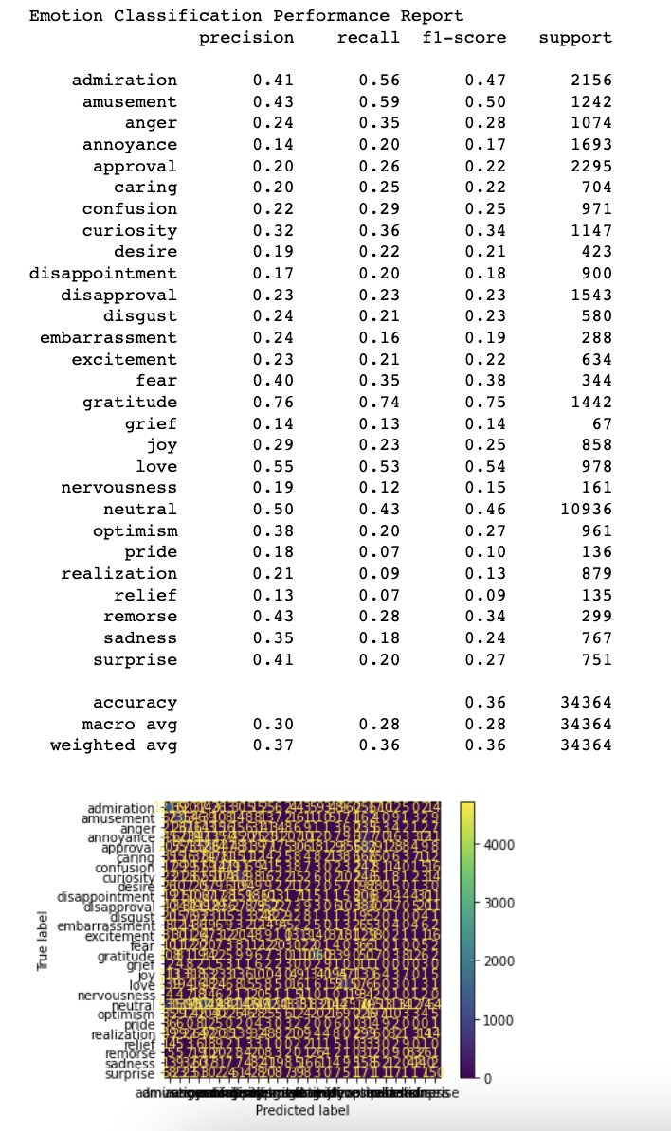

Optimized Model – {criterion: “gini”, max_depth: 50, min_samples_split: 2}

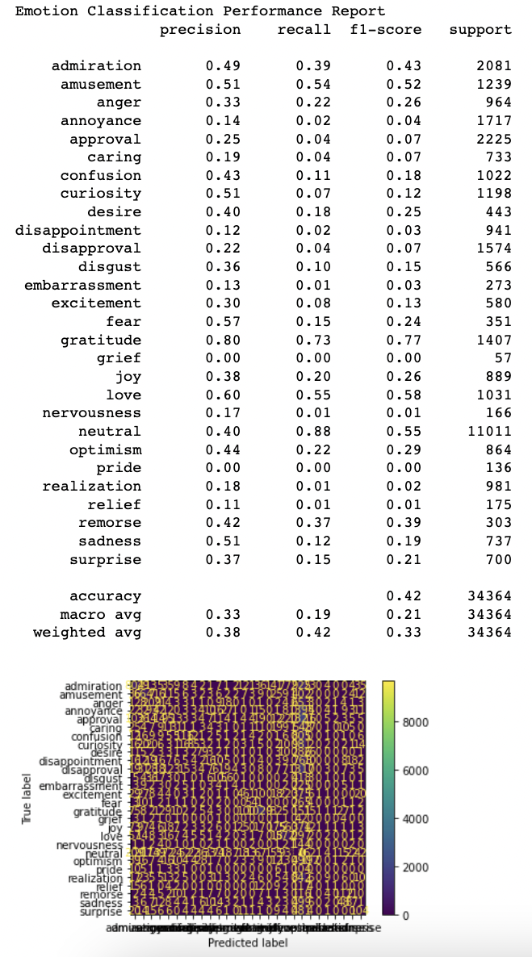

Multi-Layered Perceptron Classifier

Base Model – {activation: ‘relu, hidden_layer_sizes: (100,), solver: ‘adam’}

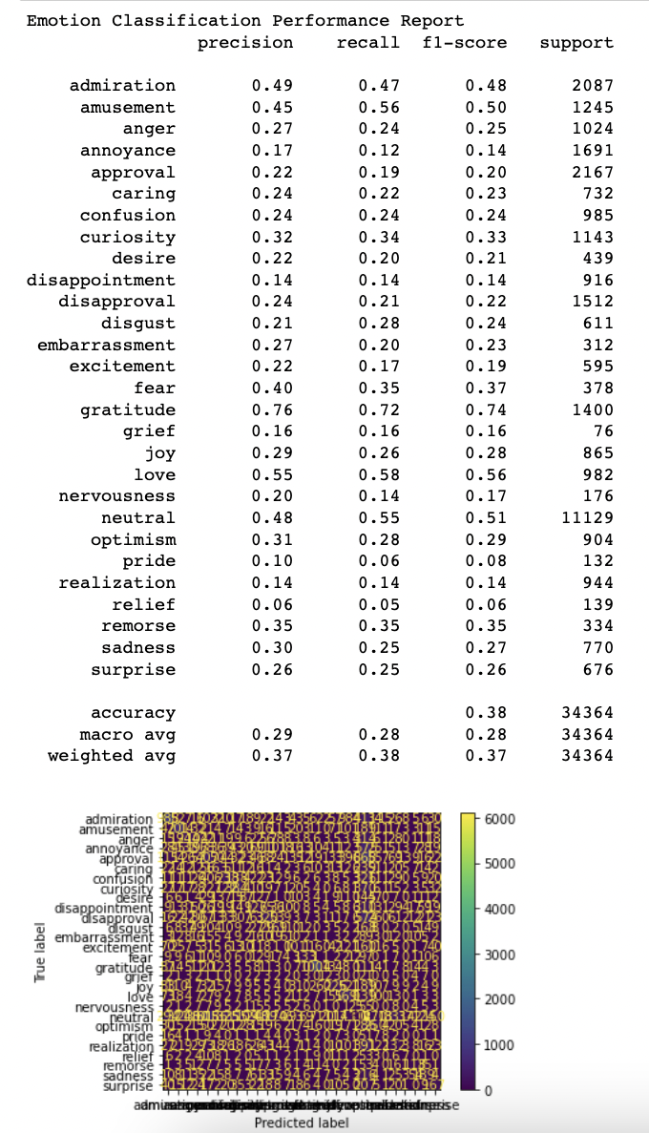

Optimized Model – {activation: ‘tanh, hidden_layer_sizes: (30,50), solver: ‘sgd’}

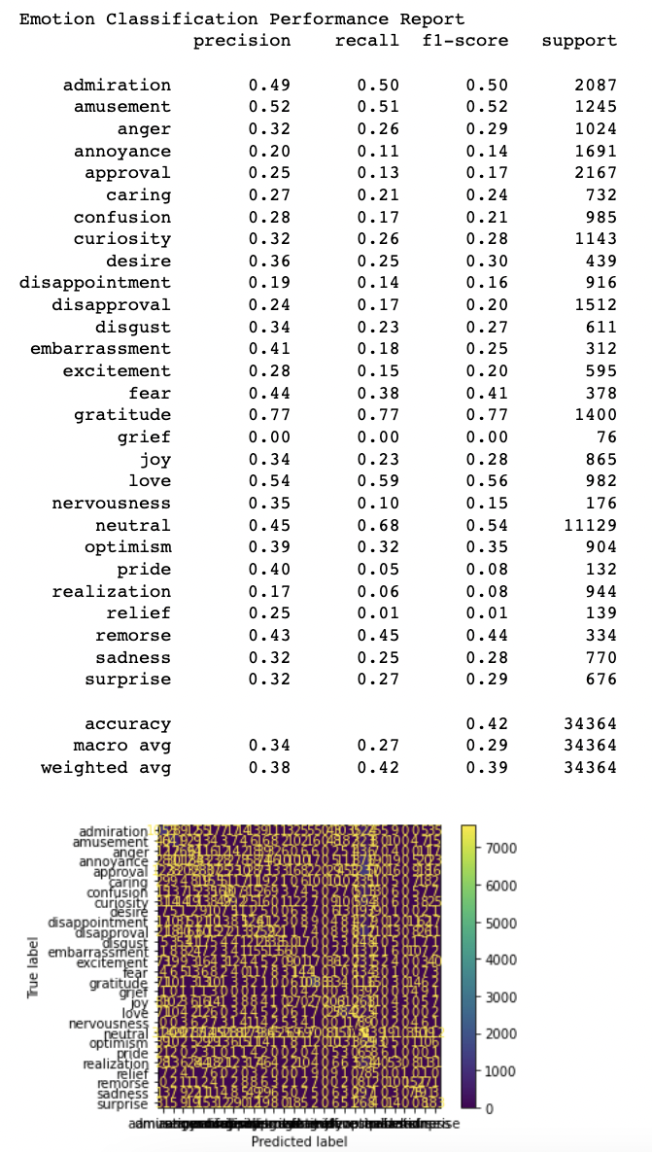

**Sentiment Classification**

Naive Bayes Classifier

Base Model – {alpha = 1.0}

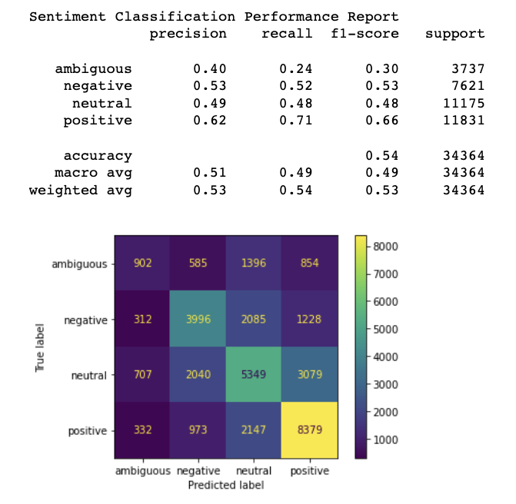

Optimized Model – {alpha = 0.5}

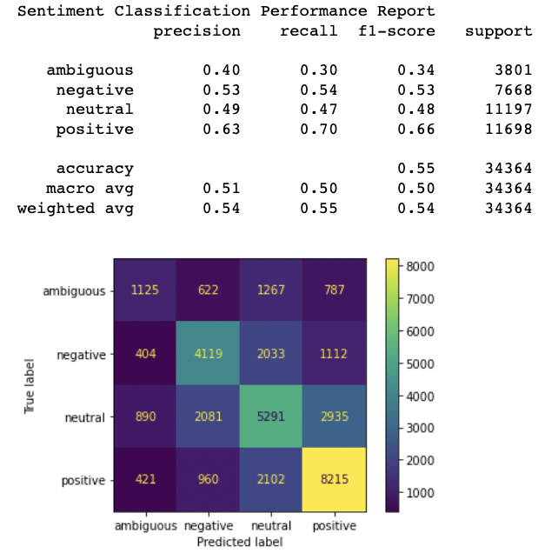

Decision Tree Classifier

Base Model – {criterion: “gini”, max_depth: None, min_samples_split: 2}

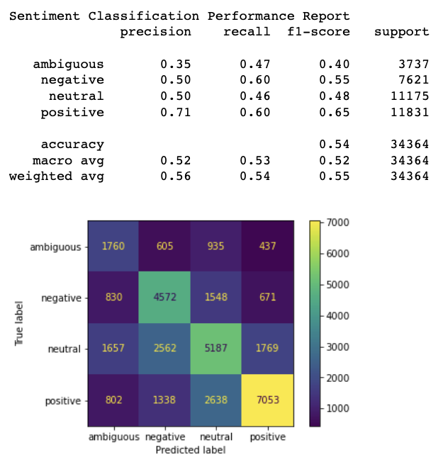

Optimized Model – {Same hyperparameter configuration as base model}

Multi-Layered Perceptron Classifier

Base Model – { activation: ‘relu, hidden_layer_sizes: (100,), solver: ‘adam’}

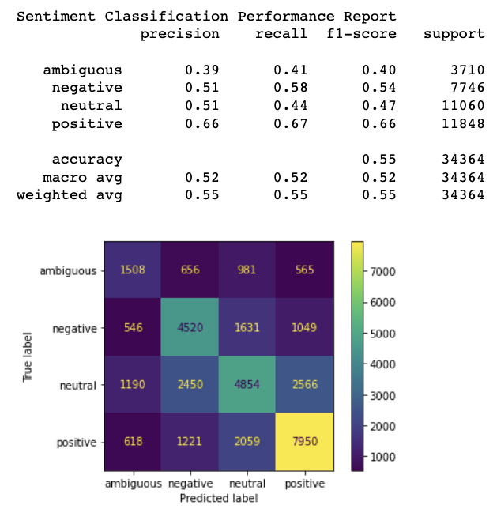

Optimized Model – {activation: ‘relu’, hidden_layer_sizes: (30,50), solver: ‘sgd’}

