MedCore HMS
Project Report
A Multi-Tenant Hospital Management Platform
Technical decisions, challenges faced, and lessons learned across a 17-phase, phase-gated build
September 2026

1. Executive Summary
MedCore HMS is a production-quality, multi-tenant Hospital Management Platform built end to end: patient registration and EMR, appointment scheduling, prescriptions, lab workflows with four-eyes approval, pharmacy inventory and dispensing, automatic billing and payments, real-time notifications, role-based analytics dashboards, and a self-service patient portal — serving multiple hospitals from one shared deployment with their data fully isolated.
The project was built under a strict phase-gated methodology: seventeen phases, each requiring explicit authorization before starting and a full written review (implementation, tests executed, bugs found and fixed, security review, and a pass/fail gate) before the next could begin. This discipline is the reason the codebase reached this report's numbers: 448 backend integration tests, 140 frontend component tests, 47 browser end-to-end journeys, all nine mandatory and eight risk-based test scenarios from the original brief individually verified, and 92% statement coverage on the business logic that actually matters — not retrofitted at the end, but carried and re-verified through every phase.
This report focuses on the decisions and problems that shaped the system — not a feature-by-feature walkthrough (the README and API documentation cover that), but the engineering judgment calls: why a monolith instead of microservices, why tenancy isolation has three independent layers instead of one, and the real bugs — a leaked password hash, a silent Decimal comparison bug, a timezone miscalculation, a Jest configuration quirk that made a coverage report silently report zero — that were found, root-caused, and fixed rather than patched around.

2. System Overview
A layered modular monolith: a NestJS API behind Nginx, a Next.js 15 frontend, PostgreSQL as the system of record, Redis for sessions/cache/queues, S3 for files, Socket.IO for real-time push, and BullMQ workers sharing the Redis instance for background jobs (email, SMS, PDF generation, appointment reminders, nightly stock-expiry scans).
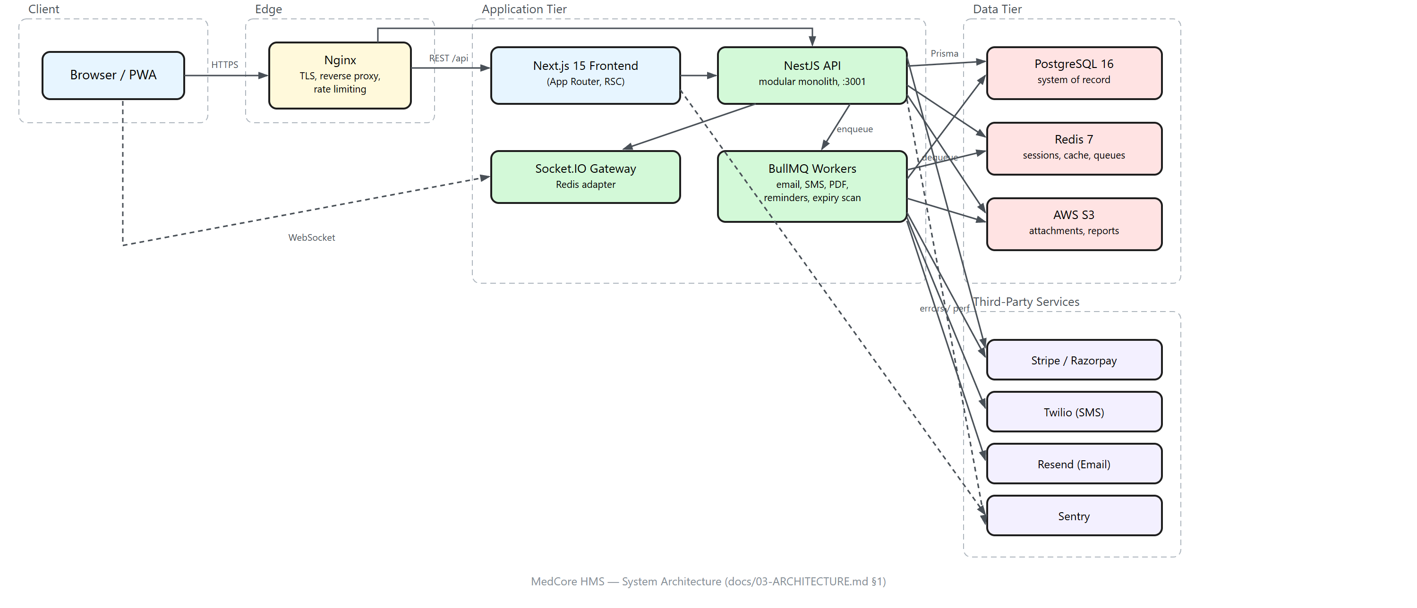
Figure 1 — System architecture and data flow (full source: docs/diagrams/architecture-diagram.excalidraw)
Nine distinct roles are supported — Super Admin, Hospital Admin, Doctor, Nurse, Receptionist, Lab Technician, Pharmacist, Accountant, and Patient — each with its own dashboard, navigation, and API permissions, enforced identically whether the request comes from the UI or a direct API call.
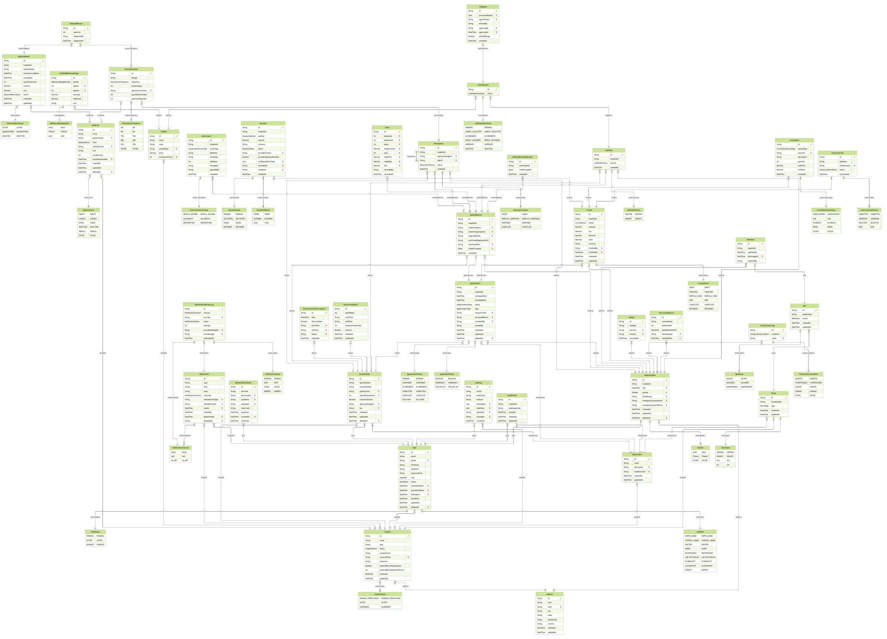
Figure 2 — Database entity-relationship diagram, generated directly from the Prisma schema (full resolution: docs/diagrams/er-diagram.svg)

3. Key Technical Decisions
Every non-obvious engineering choice in this project is recorded, with rejected alternatives, in docs/11-DECISIONS.md — 44 entries by the end of Phase 16. The ones below are the highest-leverage.

3.1 Monolith, not microservices
A single deployable NestJS application, organised into strict feature modules, rather than a distributed microservices architecture. For a system built by one developer against a fixed timeline, the operational tax of distributed services (service discovery, distributed tracing, network-partition handling, eventual consistency between services) buys nothing that strong module boundaries inside one process don't already provide, and it would have directly traded away time that went instead into correctness: tenancy isolation, RBAC, and the nine mandatory test scenarios. The module boundaries were kept strict specifically so a future split into services, if ever needed, would follow existing seams rather than requiring a rewrite.

3.2 Three-layer tenant isolation, not one
Every hospital's data lives in the same tables as every other hospital's, distinguished by a hospitalId column — the brief's ask, and the right call for this scale (a separate schema or database per tenant is operationally heavier for no correctness benefit at a few dozen hospitals). The risk of that choice — a single forgotten WHERE clause leaking one hospital's patient records to another — is answered with three independent, redundant layers: a Prisma client extension that automatically injects the caller's hospitalId into every query before it reaches the database; a service-layer re-check that the returned record actually belongs to the caller (defense against the extension itself having a gap); and CI-blocking regression tests that assert a cross-tenant lookup returns 404, not the record. A tenancy breach is treated as a Critical defect that blocks a phase gate outright — not a bug to schedule for later.

3.3 Exclusion constraints for double-booking, not application-level locking
Two patients booking the same doctor's slot at the same instant is a genuine race condition, and the brief explicitly asks how it's handled. Rather than a mutex, a row lock, or an optimistic-concurrency retry loop in application code, the database itself enforces it: a PostgreSQL EXCLUDE USING gist constraint on (doctorId, timeRange) makes a second overlapping insert fail at the database level, atomically, regardless of how many application server instances are running. This also meant handling a subtlety the naive version misses: two truly concurrent inserts into the same exclusion constraint can make Postgres detect a deadlock between the two transactions' index-page locks (error 40P01) instead of the expected exclusion-violation error (23P01) — confirmed with a direct repro against Postgres (25 of 25 concurrent insert pairs raised 40P01, never 23P01). Both mean the same thing to the caller ("you lost the race") and both are now caught.

3.4 Application-level field encryption, not database-native
Clinical notes are encrypted with AES-256-GCM at the application layer before they're ever sent to PostgreSQL, using a per-environment key, rather than relying on Postgres's own pgcrypto SQL functions. This keeps the encryption key out of the database entirely (a compromised database backup is not a compromised patient-notes backup) and keeps the encryption logic testable and auditable in application code rather than embedded in SQL.

3.5 Hospital-local wall-clock scheduling, not UTC-first
A doctor's weekly availability ("Mondays 9am–5pm") is a wall-clock statement in the hospital's own timezone; the appointment that gets booked from it is a UTC instant. Converting between the two correctly — including across daylight-saving boundaries — turned out to be a real bug source (see §4.3) and is now handled by one shared, tested utility rather than ad hoc Date arithmetic at each call site.

3.6 Every invoice line goes through one service, inside the clinical transaction
A prescription, a lab order, and a consultation each generate their own billing line automatically, and always inside the same database transaction as the clinical action that caused it — never a separate step a developer could forget to wire up. The database itself enforces the arithmetic (a line's total must equal quantity × price, an invoice's subtotal must equal the sum of its lines) via a deferred constraint trigger, and a non-draft line cannot be mutated at all. This means billing can structurally never drift from what actually happened clinically.

3.7 An outbox pattern for notifications, not direct dispatch
A notification ("your lab result is ready") is recorded inside the same transaction as the clinical event, then published afterward; if the publish step fails for any reason, a 30-second sweep picks up anything left undelivered. This means a notification is never lost even if the in-process publish call throws, at the cost of at most 30 seconds of latency on the rare failure path — an explicit, documented trade-off rather than a silent gap.

3.8 Response minimisation for patient-facing data
A patient sees a doctor's name and specialisation; never their email, phone, or any field not needed for the patient's own task. This is enforced with explicit, hand-written view types in the shared types package rather than trusting that a general-purpose "doctor" serializer happens not to leak a field — the kind of gap that's invisible until someone actually inspects the response payload, which is exactly how the passwordHash leak in §4.1 was originally found.

4. Challenges Faced
The project's quality protocol treats a phase as complete only after root-causing and fixing every issue found, not patching around it — the following are the most significant problems that surfaced across seventeen phases, several of which would have shipped invisibly under a lighter testing standard.

4.1 A bcrypt hash leaking into API responses
A bare Prisma include: { user: true } on a doctor/patient/user creation response returns every column on the User row — including passwordHash. This shipped in three endpoints (POST /doctors, POST /patients, POST /users) before a deliberate response-shape test caught it. The fix was systemic, not local: a single SAFE_USER_SELECT constant now used at every one of the seven call sites that return a user relation, plus a standing rule that a bare user: true include is never acceptable in a response path.

4.2 Prisma.Decimal treats zero as positive
Prisma's Decimal.isPositive() returns true for zero. Money-comparison code written against that assumption made every freshly finalised, unpaid invoice compute as PARTIALLY_PAID instead of UNPAID, and would have allowed a zero-amount checkout to appear to succeed. The e2e status assertions caught it before it reached a review; the fix was a one-line change (.gt(0) instead of .isPositive()), but the lesson — verify a library's documented behaviour against the actual edge case your domain cares about, don't assume the obviously-named method does the obvious thing — generalised well beyond this one call site.

4.3 Doctor schedules read as UTC instead of hospital-local
Until this was found, a doctor's 9am appointment slot, entered as “9:00” in a hospital operating in India Standard Time, was being treated as 9:00 UTC — a 5.5-hour error that produced technically-valid but clinically-wrong appointment times. The fix required a dedicated, tested time-zone-conversion utility used at every scheduling call site, and a standing rule that no appointment time is ever constructed with raw Date arithmetic again.

4.4 A pre-signed S3 upload that had never actually worked
The AWS SDK's default checksum behaviour (requestChecksumCalculation: "WHEN_SUPPORTED") signs a checksum requirement into every pre-signed upload URL it issues — but a pre-signed URL's body is uploaded later, by a browser the SDK never sees, so nothing ever computes that checksum. Every browser upload to attachment storage had been silently broken since the feature was first built, because the gap was invisible to server-side tests (which never actually PUT bytes through the URL) and was only caught once a real browser-based test exercised the full round trip. The fix was a single SDK configuration flag; the lesson was that a feature is not verified until it's tested the way a real client actually uses it, not the way it's convenient to test on the server.

4.5 An audit trail that can outlive the transaction it's auditing
The audit-log mechanism mirrors every create/update/delete on a sensitive model to an AuditLog row, implemented as a Prisma client extension so no service method has to remember to call it. The extension writes through the database client it was originally defined against — which, inside an interactive transaction, is not the same client as the transaction itself. If that surrounding transaction rolls back due to an unexpected database fault, the audit row survives the rollback of the very write it was recording. This was investigated seriously in the testing-and-hardening phase: the obvious fix (asking Prisma's own extension API for “whichever client this operation is currently running on”) was implemented, and immediately caught by the same test suite it needed to pass — the fix itself was broken, throwing on every audited write, because that specific API does not behave the way its own name suggests inside this kind of extension. The broken fix was reverted in full rather than shipped or silently patched around, and the gap is now tracked by an automated regression test that is deliberately written to fail until a correct fix — a larger refactor touching roughly fifteen call sites — actually lands.

4.6 A coverage report that silently reported zero
Asking Jest for a coverage report across the whole integration test suite returned “Unknown% (0/0)” — not an error, just silence, despite 448 tests clearly exercising almost the entire codebase. The root cause took real investigation to find: a custom Jest --config file's rootDir: "." resolves relative to the configuration file's own directory, not the directory the command is run from — invisible for running tests (they live right next to the config file) but fatal for coverage collection, which only ever considers files inside that resolved root. No error is thrown because the glob pattern is syntactically valid; it simply, silently, matches nothing. The fix was moving the coverage-specific configuration file to the location whose natural root actually was the source directory. This is a strong example of a class of bug this project treats seriously: the absence of an error is not evidence of correctness, and a suspiciously-round number (here, exactly zero) deserves the same scrutiny as a crash.

4.7 A CI pipeline that had never actually run
This repository was never pushed to a real GitHub remote during development, which meant its GitHub Actions workflow had literally never executed — not once, on any commit, in any phase — despite looking complete on paper. Reproducing its exact environment locally (the same services, the same environment variables) surfaced three independent bugs stacked on top of each other, any one of which alone would have failed every single test in the integration job: a missing build step for a shared internal package, two required secrets with no default that the application correctly refuses to boot without, and a missing S3-compatible service that three test files depend on. A workflow file that has never executed is not a verified workflow file, no matter how carefully it reads; this project's own “no fake completion” rule applied here to its own tooling, not just its product code.

5. Testing & Quality Assurance
Business logic here is verified almost entirely through integration tests against a real, ephemeral PostgreSQL instance, not mocked-database unit tests — a deliberate choice, because integration tests are the layer that can actually catch a tenancy or authorization bug; a unit test that mocks the database structurally cannot see a query that forgot to scope by hospital.
Metric | Result
Backend integration/e2e tests | 448 / 448 passing, across 19 test suites
Frontend component tests (Vitest) | 140 / 140 passing
Browser end-to-end journeys (Playwright) | 47 / 47 passing, against production builds
Statement coverage (business logic) | 92.12%
Function coverage | 93.37%
Line coverage | 93.33%
Branch coverage | 70.8%
Mandatory test scenarios from the brief | 9 / 9, each a dedicated test
Risk-based scenarios identified beyond the brief | 8 / 8, each a dedicated test

5.1 The nine mandatory scenarios
The brief names nine scenarios explicitly as non-negotiable, each written as an integration test against a real database and real guards rather than a mocked unit test, because the property under test is precisely the interaction between layers: a doctor cannot access another hospital's patient records; a patient cannot view another patient's medical records; two concurrent bookings for the same slot — exactly one succeeds; a refresh token cannot be reused after rotation; an expired medicine cannot be dispensed; an invoice total always matches the sum of its line items, even against a deliberately malformed client-supplied total; an unauthorized role cannot reach a protected endpoint; a payment webhook with an invalid signature is rejected; and a cross-tenant access attempt fails uniformly across every resource type. All nine were audited against the actual test suite — not assumed present because they were once planned — and confirmed passing.

5.2 Security review
Security is reviewed at every phase gate, not deferred to one final pass. The project's dedicated hardening phase additionally ran a full OWASP Top 10-oriented review and a complete dependency audit: 43 advisories were found across the dependency tree, every one traced to its actual dependency chain and assessed for real exploitability in this specific deployment (the large majority were either install-time-only, development-tooling-only, or gated behind a feature that is off by default and never reachable pre-authentication) rather than accepted or dismissed on the advisory's severity label alone. A separate automated review of the deployment pipeline's GitHub Actions configuration caught two real issues — a script-injection risk from an unvalidated git ref interpolated into a shell command, and third-party actions pinned by a mutable version tag rather than an immutable commit hash — both fixed and re-verified before being considered resolved.

5.3 Role-based access control
Every route in the API is checked at request time by a single global guard operating on a deny-by-default principle: a route with neither an explicit role list nor an explicit public marker is refused, not silently allowed. This is additionally checked statically in the automated test suite — a test that scans every controller in the codebase via reflection and asserts every single HTTP handler declares one or the other, catching the case a developer simply forgets the decorator on a new endpoint, before it ever reaches a running server.

6. Deployment & DevOps
The deployment pipeline is fully built and locally verified without provisioning real, billable cloud infrastructure — a deliberate scope decision, mirroring how every third-party provider in this project (Stripe, Twilio, Resend) was integrated against test-mode credentials rather than live accounts throughout development.
- A production Docker Compose topology and an Nginx configuration with TLS (Let's Encrypt convention) are written and validated — syntax-checked against a real self-signed certificate, network-resolution the only thing that requires the real compose network to succeed.
- A health-check-gated blue-green deployment script was proven end to end, in both directions, against a real (if temporary) running stack: the new version starts, is polled against its own health check until healthy, traffic is switched to it, and the previous version drains and stops — verified with a concurrent load of health-check requests spanning the entire cutover window, with zero failed requests in either direction.
- A GitHub Actions pipeline builds and pushes a container image on every push to the main branch and deploys via the blue-green script on a version tag — written, syntax-validated, and security-reviewed, though not yet exercised against a real GitHub Actions run, since this repository has no remote.
- A complete, step-by-step deployment runbook documents exactly how to provision the remaining pieces — an AWS EC2 instance, an RDS PostgreSQL database, an S3 bucket, a Vercel project for the frontend, and a real domain with a Let's Encrypt certificate — ready to execute the moment real credentials and a domain are available.

7. Lessons Learned

7.1 Documentation is a claim, not a fact
This project's own documentation, at more than one point, described something as already true that turned out not to be: an API-documentation generator referenced as “wired since an early phase” that had in fact never been implemented at all; a CI pipeline whose configuration read as complete but had never actually executed once. The standing discipline that caught both was a simple one, applied consistently: when a document describes the system, verify it against the running code, not the other way around. A codebase is the only source of truth for what is actually implemented.

7.2 The absence of an error is not evidence of correctness
Three of this project's most instructive bugs — the zero-coverage report, the silently-broken S3 checksum, the audit-log extension's own fix throwing on every write — each produced no crash, no exception, no red test on their own. Each was only caught because a test asserted a specific, expected positive outcome (a real coverage percentage, a successful upload round trip, a passing regression suite) rather than merely the absence of a thrown error. “It ran without crashing” and “it did the right thing” are different claims, and only the second one is worth trusting.

7.3 Integration tests catch what unit tests structurally cannot
Every serious tenancy or authorization bug in this project's own history would have passed a unit test with a mocked database, because the bug was precisely in how a real query interacted with a real constraint — a forgotten WHERE clause, a race condition only the database's own locking can resolve, a decimal comparison against a database-returned value. This project's low mocked-unit-test coverage (under 2%) alongside its high integration coverage (over 92%) is not a gap; it is evidence that testing effort was spent where it could actually catch what mattered, and generalizes to a principle worth carrying into future projects: choose the test layer that can see the bug, not the layer that is fastest to write.

7.4 A fix is not done until it is re-verified by the full suite, not just the test that prompted it
The audit-log extension fix (§4.5) looked correct by inspection and passed type-checking; it was the act of running the entire existing test suite afterward — not just a new test for the change itself — that caught it throwing on every audited write. This is the single habit most responsible for this project's bug list containing fixes that actually held, rather than fixes that introduced a second problem while solving the first.

7.5 A phase gate is worth the friction it adds
Requiring an explicit go-ahead before starting each phase, and a full written review before the next could begin, added real overhead across seventeen phases. It also meant that by the time any phase was marked complete, its regressions had already been found and fixed — not discovered three phases later, entangled with unrelated work, and far more expensive to root-cause. The phase reviews in this repository are not a formality; they are the record of exactly when and how each of the bugs in §4 was found.

8. Conclusion & Future Work
MedCore HMS demonstrates a complete, production-quality hospital management workflow — registration through discharge, prescription through dispensing, encounter through paid invoice — built with the kind of engineering discipline (phase gates, mandatory negative testing, root-cause-only fixes, continuous security review) that a real engineering team would apply, not the discipline of a project built only to pass a demo.
The honest remaining gaps are documented, not hidden: a NestJS major-version upgrade deferred as out of scope for a hardening pass; a ClamAV malware-scanning step deferred to when real deployment infrastructure exists to run it on; the audit-log transaction-atomicity gap in §4.5, tracked by a test specifically written to fail until it is properly fixed; and live deployment itself, fully built and locally proven but not executed against real, billable cloud infrastructure by deliberate choice. Each of these has a clear next step already written down — in the deployment runbook, in the decisions log, or in the test suite itself — rather than being a surprise for whoever picks the project up next.

