Game Design Document

Fill up the Following document

1. Write the title of your project.

Greyscale

1. What is the goal of the game?

To collect all the colors while the game slowly fades to grayscale. The player can only walk on colors which they select. However they will not be able to see those colors when the game is in grayscale

1. Write a brief story of your game?

All the colors have dissapeared from the PC’s village. And the colors are

Gradually disappearing from everywhere. You must follow the fade and

Return the colors to the temple

1. Which are the playing characters of this game?

* Playing characters are the ones which respond to the user based on the input from the user
* Cars, monkeys, dinos, wizards etc, are the playing characters in the game.

|  |  |  |
| --- | --- | --- |
| Number | Character Name | What can this character do? |
| 1 | Hue | Can change color to traverse the levels |
| 2 | Helv | Can gradually add colors back to the game |
| 3 |  |  |
| 4 |  |  |
| 5 |  |  |
| 6 |  |  |
| 7 |  |  |
| 8 |  |  |

1. Which are the Non Playing Characters of this game?

* Non Playing characters are the ones which don't have an action or a behaviour when the user interacts with the game.
* Hurdles, stones, bananas, coins, etc are non playing characters in the game.

|  |  |  |
| --- | --- | --- |
| Number | Character Name | What can this character do? |
| 1 | Villagers | Gives the story line to the PC in the tutorial |
| 2 | Canvas | Hoards the colors and can randomly change the colors of the game |
| 3 | Moving platforms |  |
| 4 | Empty buckets of paint | Can knock out the character |
| 5 | Color pencils | Player can collect these for specific powers |
| 6 |  |  |
| 7 |  |  |
| 8 |  |  |

Draw your imagination of this game. What does this game look like?

* Draw the game either on your computer or on paper,
* Add images of scenes of the game to show each of the playing and non-playing characters at least once.

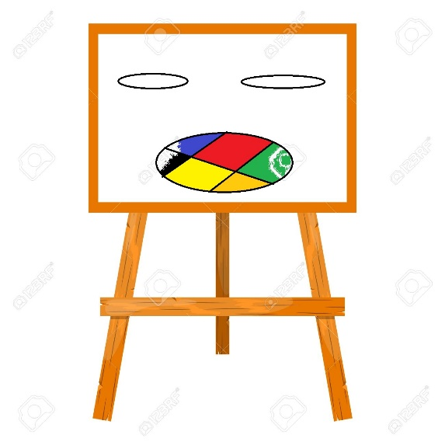

How do you plan to make your game engaging?

There will be a starring system based on Time, color remaining and lives of the player.

The player will have to collect all the colors to win with each color adding itself to the game.

The game will have engaging music and no adds