Agentic Healthcare Assistant
for Medical Task Automation
Applied Generative AI · Course-End Project 2
Agentic AI · LangChain tool-calling agent · RAG (FAISS) · Memory · Google Gemini LLM
Author: Vattanac Sim
Date: ______________ · Student ID: ______________

1. Introduction & Problem Statement
Managing patient care involves many interdependent administrative tasks — appointment scheduling, maintaining patient histories, and retrieving timely disease information. Healthcare systems often rely on siloed tools with limited automation, causing inefficiency and a fragmented patient experience. Agentic AI, combining Large Language Models with Retrieval-Augmented Generation (RAG), can coordinate these tasks autonomously.
InsightMed is an Agentic Healthcare Assistant that acts as a virtual medical-administration assistant. It plans a user's request into sub-goals and uses tools to carry them out, coordinating booking, records, history summarization, and trusted-source medical search from a single conversational interface.

2. Objective
The assistant was built to deliver the four capabilities in the brief:
- Book medical appointments — automate slot discovery and scheduling from patient intent and doctor availability.
- Manage medical records — add or update structured and unstructured patient history.
- Retrieve medical histories — summarize past diagnoses, treatments and alerts using an LLM.
- Perform medical information searches — fetch up-to-date disease information from trusted sources (MedlinePlus / WHO).

3. System Architecture
InsightMed is a LangChain tool-calling agent. A planning system prompt directs the LLM to decompose each request into ordered sub-goals and choose the right tool for each. Six tools back the four capabilities; a FAISS vector store holds patient summaries for semantic retrieval (RAG); and ConversationBufferMemory retains patient context across turns so follow-up questions resolve correctly. Every tool call is logged for performance monitoring, and a Streamlit dashboard surfaces the data, metrics, memory traces and logs. The LLM backend is Google Gemini (free tier).
Each capstone step maps to a concrete component:
Step | Capstone requirement | Where it is implemented
1 | Agent planning & goal decomposition | SYSTEM_PROMPT + tool-calling agent (build_agent)
2 | Tool & memory setup (booking, EHR, search, FAISS, memory) | 6 tools + FAISS patient store + ConversationBufferMemory
3 | Prompt engineering & task chaining | System prompt + each tool's docstring prompt
4 | Agent execution flow (sample scenario) | run_agent() on the CKD / nephrologist scenario
6 | Model evaluation + performance monitoring | evaluate_summaries() (QAEvalChain) + performance_metrics()
7 | Data visualization & UI | Streamlit dashboard (6 tabs)
8 | Memory & logs interface | Memory & Logs tab: memory traces, tool success/failure

4. Implementation — Part 1 (Agentic System Design)

4.1 Agent Planning & Goal Decomposition
The agent's planning system prompt instructs it to break a request into ordered sub-goals, identify and load the relevant patient context first, choose the correct tool for each sub-goal, and never invent data — slots, doctors, appointment ids and histories all come from tools. A tool-calling AgentExecutor runs this plan-act-observe loop until the goals are met.

4.2 Tool & Memory Setup
Six tools cover the four capabilities:
Tool | Purpose
find_available_slots | Discover doctors of a specialty and their open appointment slots.
book_appointment | Book a slot; validates availability, writes the appointment, frees the slot.
get_patient_history | Retrieve a patient's full EHR (diagnoses, treatments, meds, alerts).
add_or_update_record | Add/update structured or unstructured patient history.
semantic_patient_search | FAISS semantic search over patient summaries (vector DB / RAG).
search_medical_info | Trusted-source disease info (MedlinePlus/WHO), live with offline fallback.

Patient data (the EHR / Patient DB) and doctor schedules are JSON-backed and update in real time as the agent acts. A FAISS vector store embeds each patient summary for semantic retrieval, and ConversationBufferMemory provides the long-term patient context required by the brief.

4.3 Prompt Engineering & Task Chaining
Prompts are structured at two levels: the agent system prompt governs planning, safety and synthesis, while each tool's docstring is a focused prompt telling the LLM when and how to call it. Together they chain summarization, planning and action-triggering, and patient context enters through memory lookups.

4.4 Agent Execution Flow — the Sample Scenario
User input: “My 70-year-old father is patient P001. He has chronic kidney disease. I want to book a nephrologist for him. Also, can you summarize the latest treatment methods?” The agent decomposes and executes:
1. Identify the patient and load context — get_patient_history('P001').
2. Discover availability — find_available_slots('Nephrologist').
3. Book the appointment — book_appointment('P001', 'Dr. Anita Rao', <slot>).
4. Search & summarize treatments via the RAG/search pipeline — search_medical_info('latest treatment for chronic kidney disease').
It then synthesizes a single reply reporting the appointment id and the treatment summary. Because of memory, a follow-up such as “what should he avoid?” is answered in the same patient context (e.g. avoid NSAIDs).

5. Implementation — Part 2 (LLMOps)

5.1 Model Evaluation (QAEvalChain)
Summary and search quality are assessed with QAEvalChain: a ground-truth question set is answered through the assistant and graded CORRECT/INCORRECT by an LLM grader, yielding an accuracy score. This checks both EHR-grounded answers (e.g. a patient's conditions) and trusted-source medical answers.

5.2 Performance Monitoring
Every tool call is logged with success/failure, enabling per-module metrics — overall tool-success rate and, specifically, the booking success rate required by the brief. In a representative session the booking success rate was 50% because a deliberate double-booking of an already-taken slot was correctly rejected, demonstrating the guardrail.
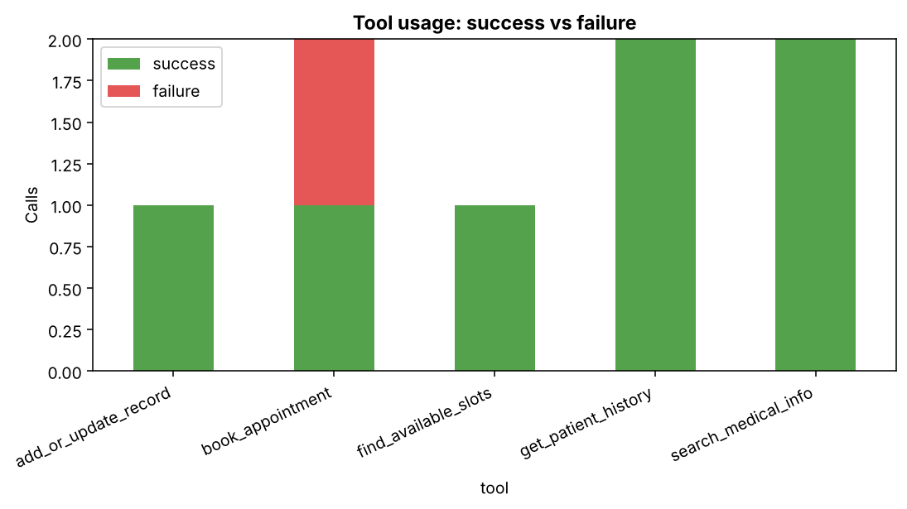
Figure 1 — Tool usage: success vs failure by module (performance monitoring).
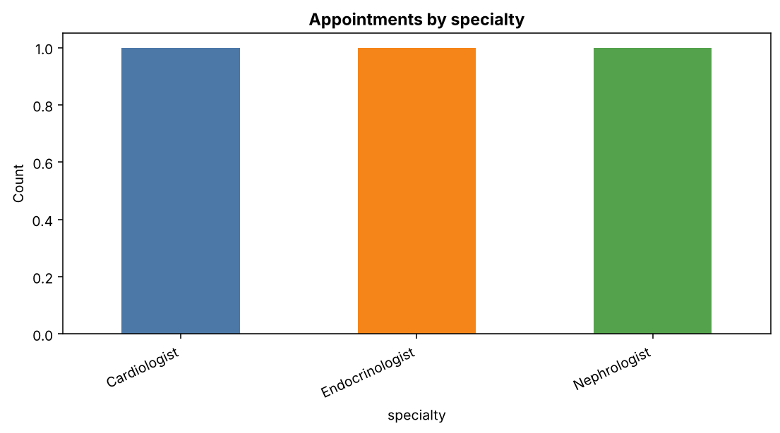
Figure 2 — Appointments by specialty.

5.3 Dashboard & User Interface
The Streamlit dashboard delivers every Part-2 UI requirement across six tabs. The Assistant tab shows the agent's planning/tool trace; Patients & Doctors provides the two required views; Appointments gives real-time tracking; Medical Info shows the latest retrieved information; Evaluation reports metrics; and Memory & Logs exposes the agent's state.
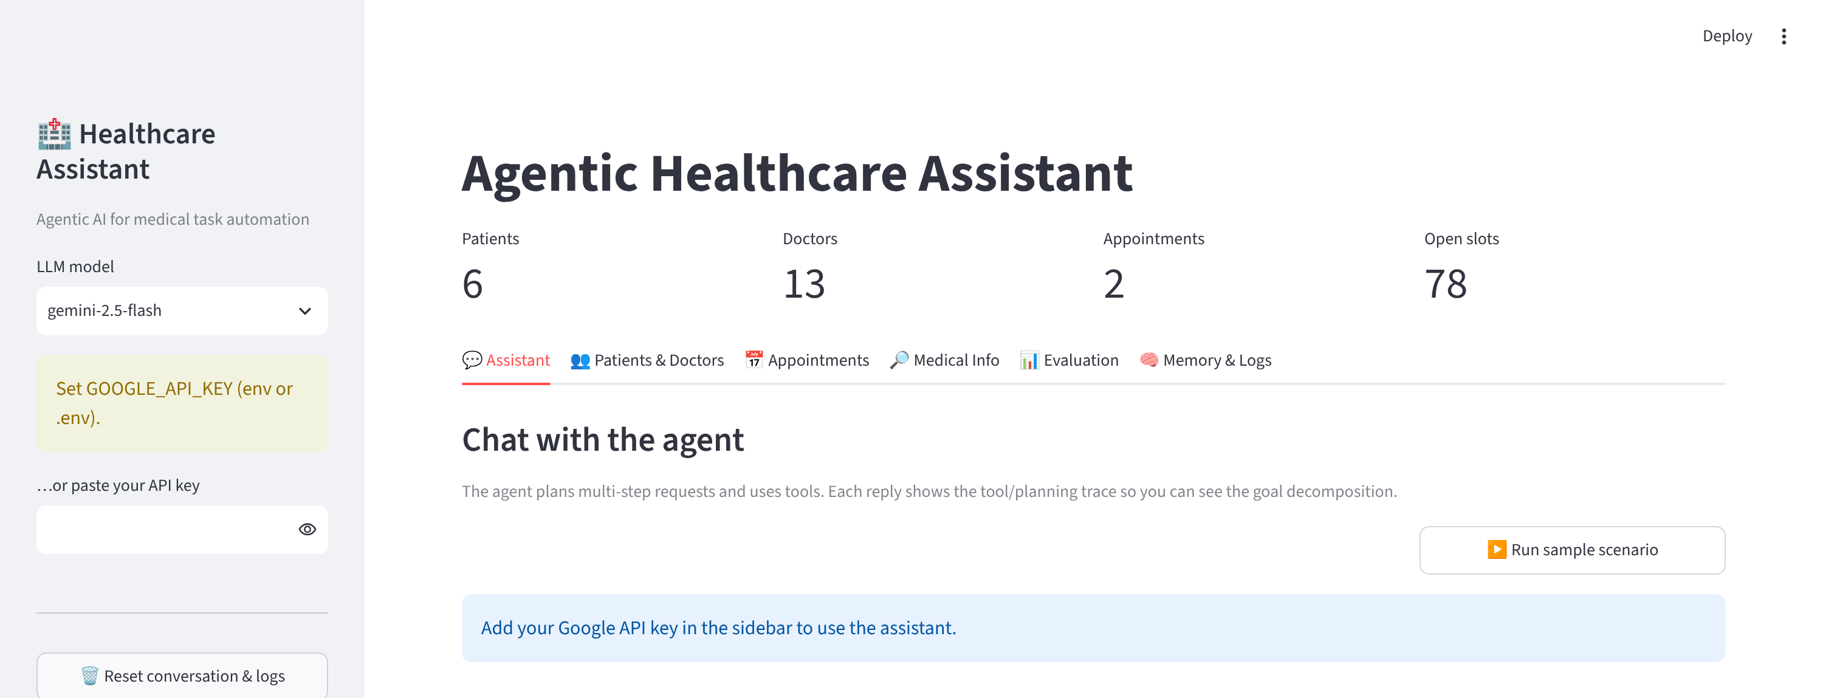
Figure 3 — Dashboard: KPI header and the six tabs.
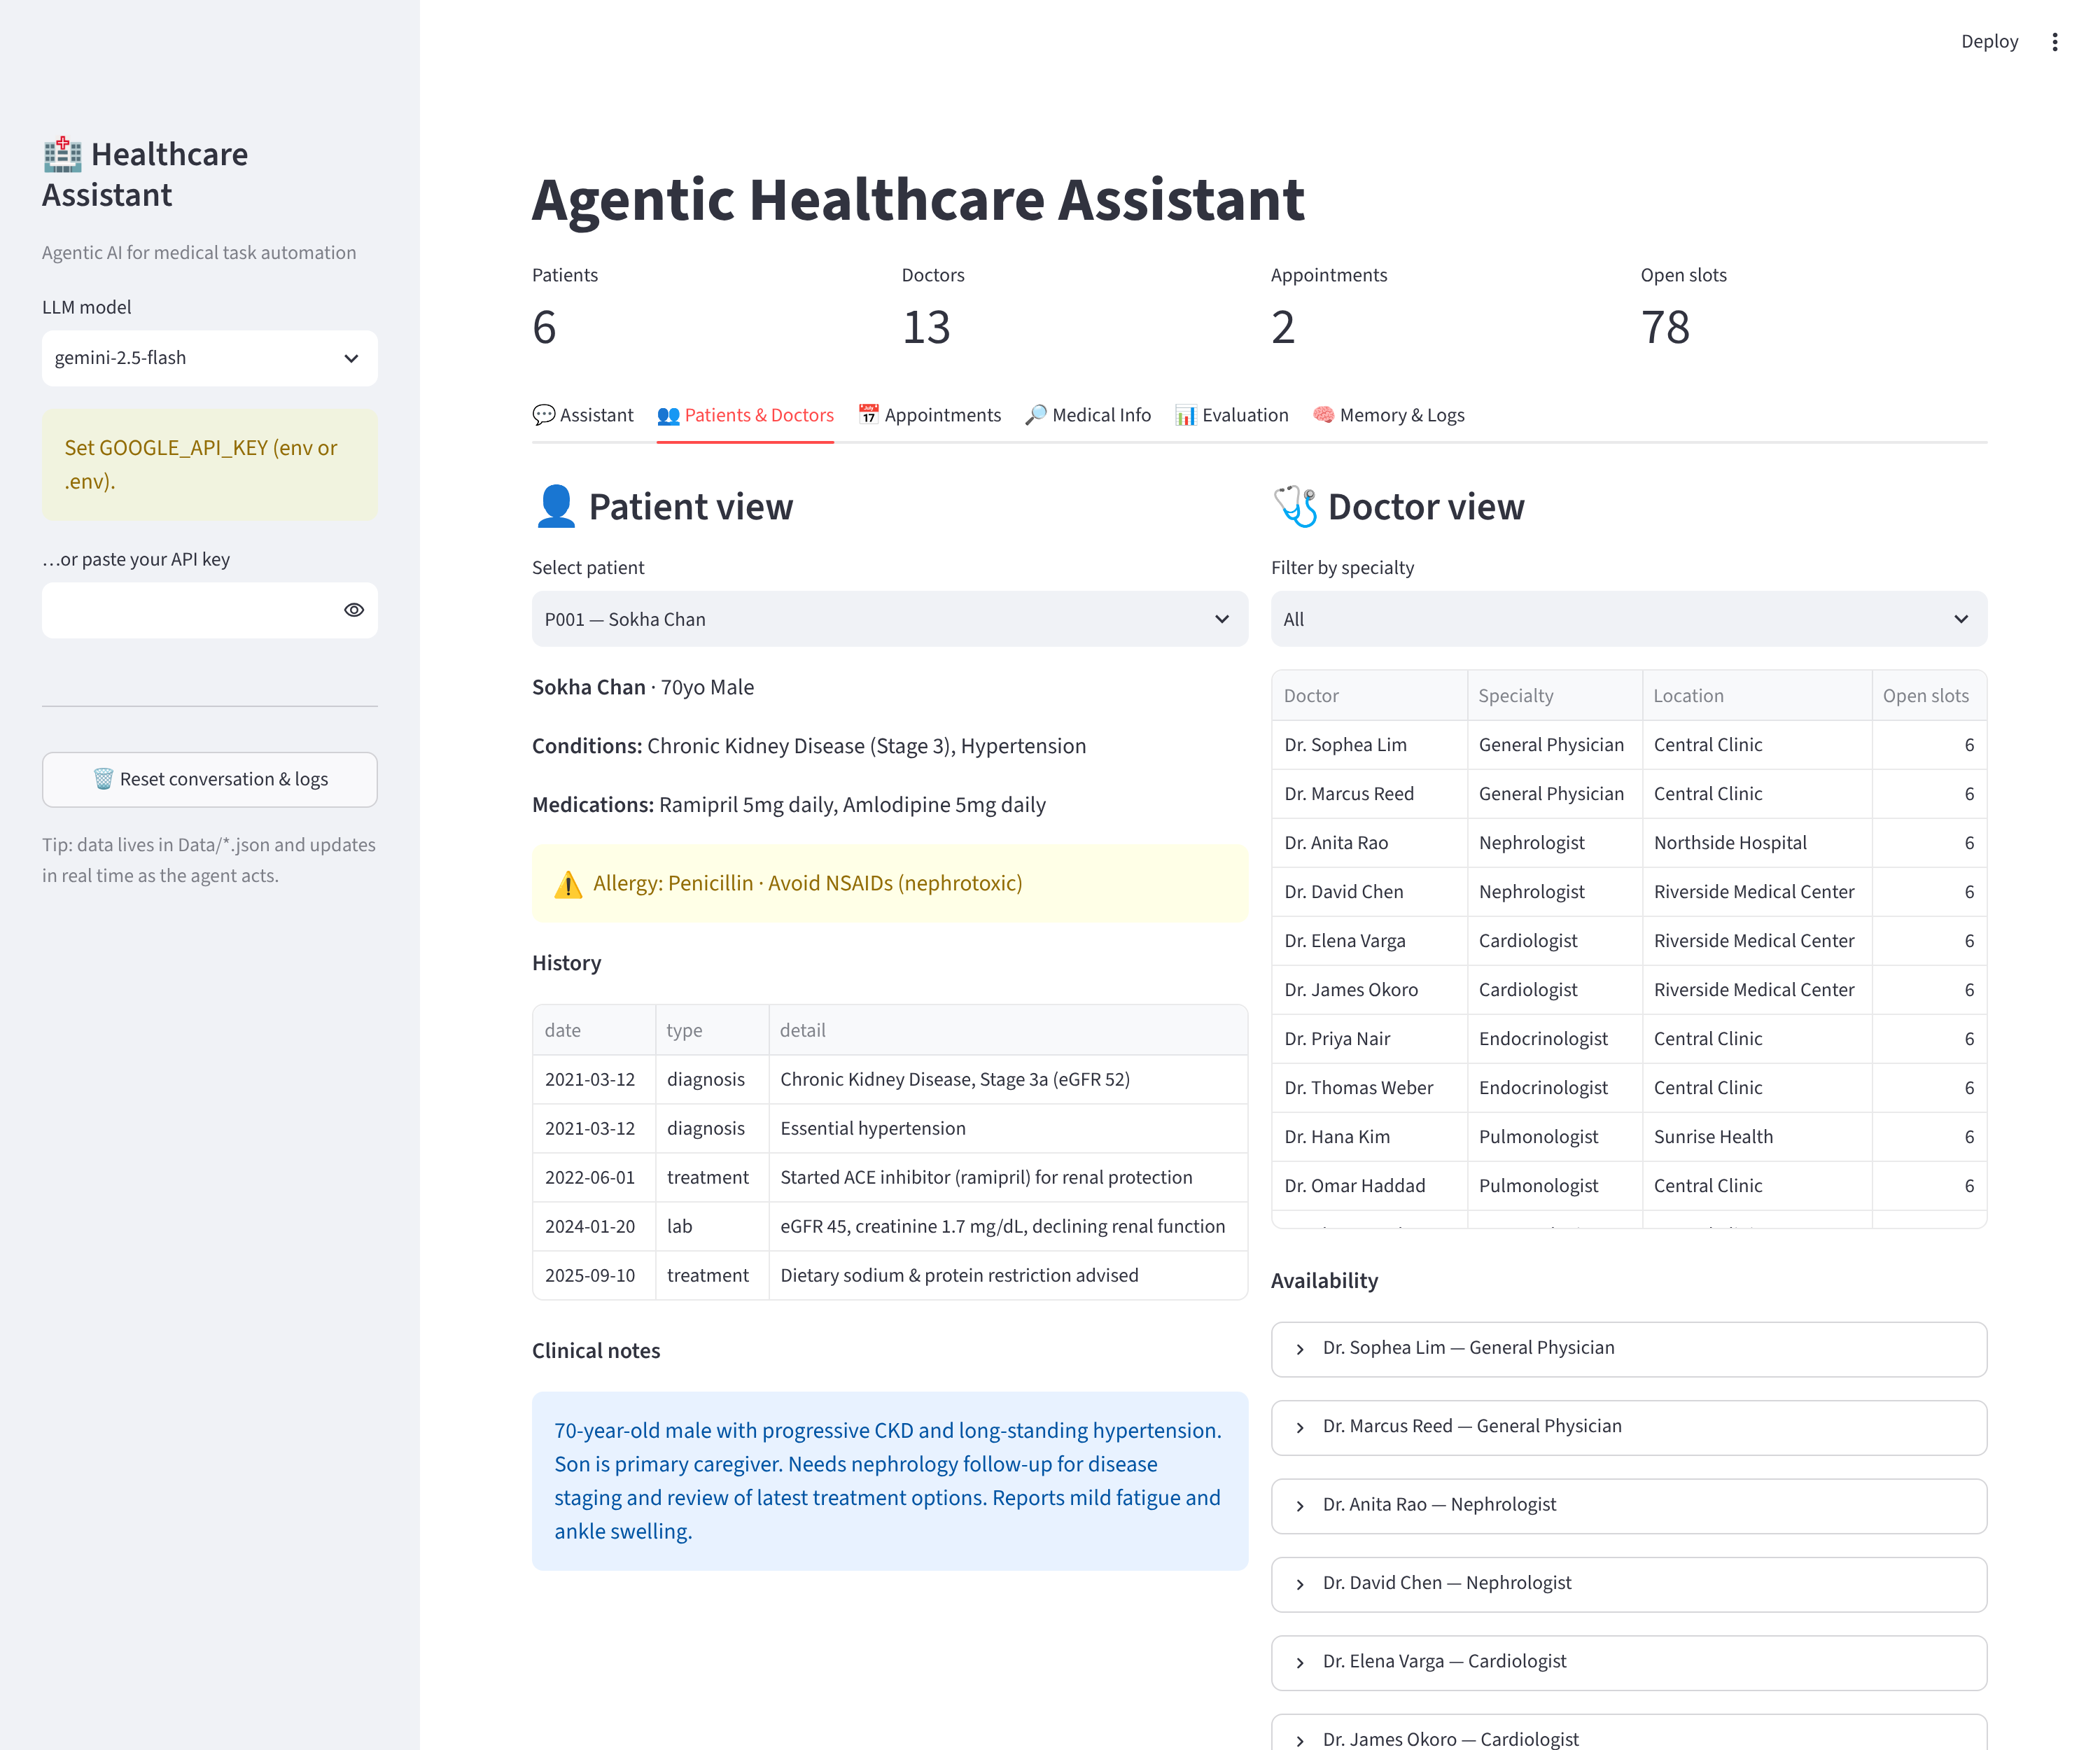
Figure 4 — Patient & doctor views (patient P001's EHR, doctor roster).
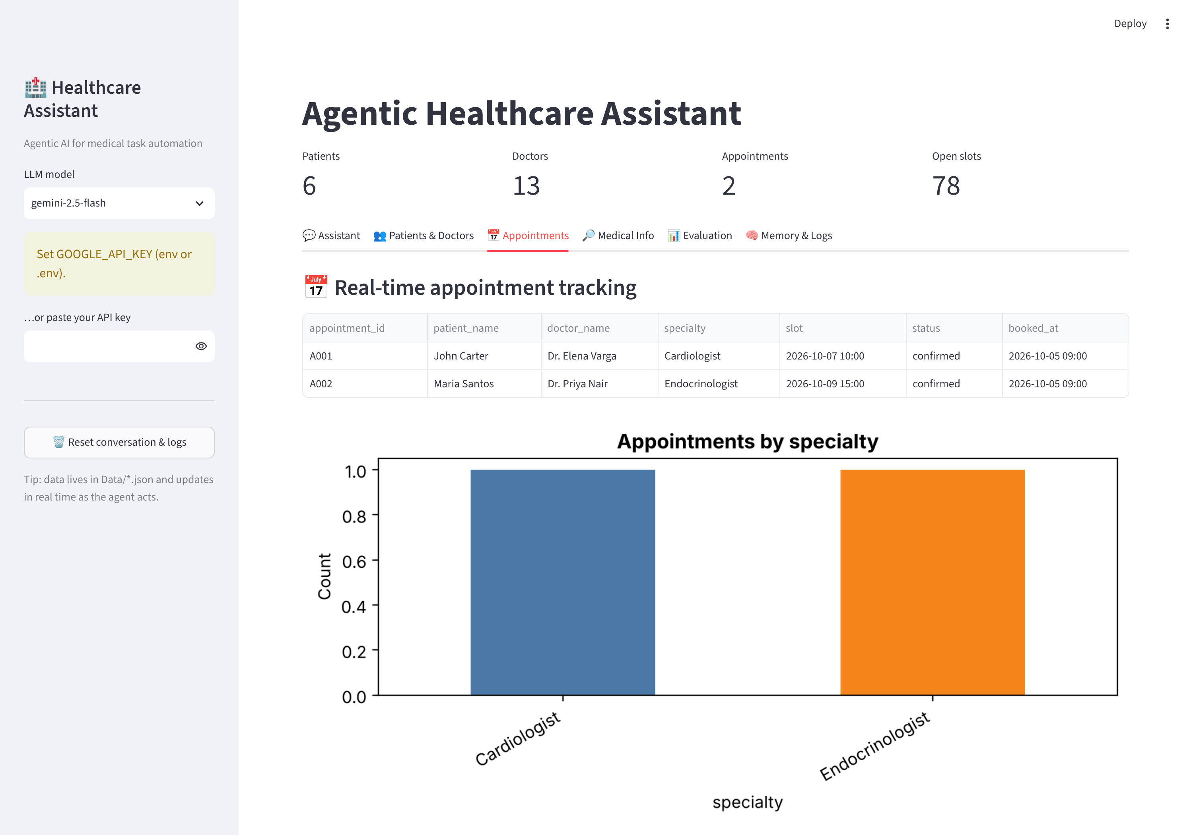
Figure 5 — Real-time appointment tracking.
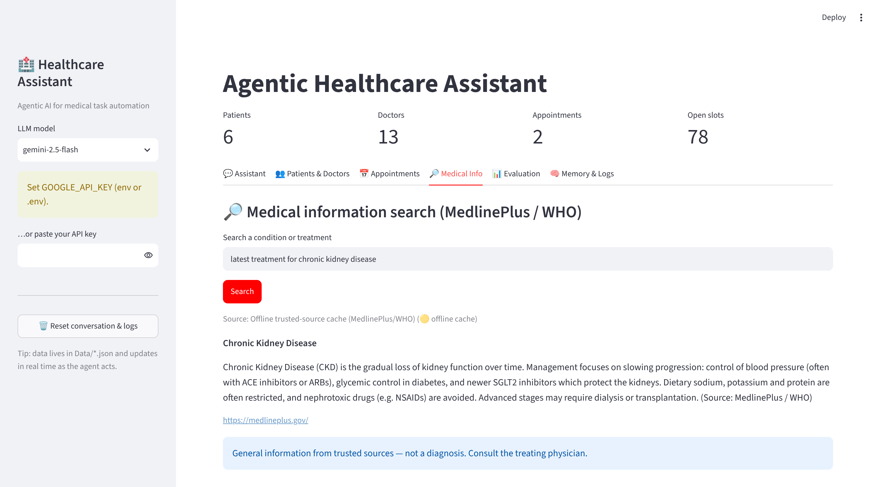
Figure 6 — Medical information search (MedlinePlus/WHO) with safety note.

5.4 Memory & Logs Interface
The Memory & Logs tab displays conversation memory traces (the long-term patient context) alongside the tool-usage log with success/failure across tasks, plus the per-module chart — making the agent's planning and actions auditable.
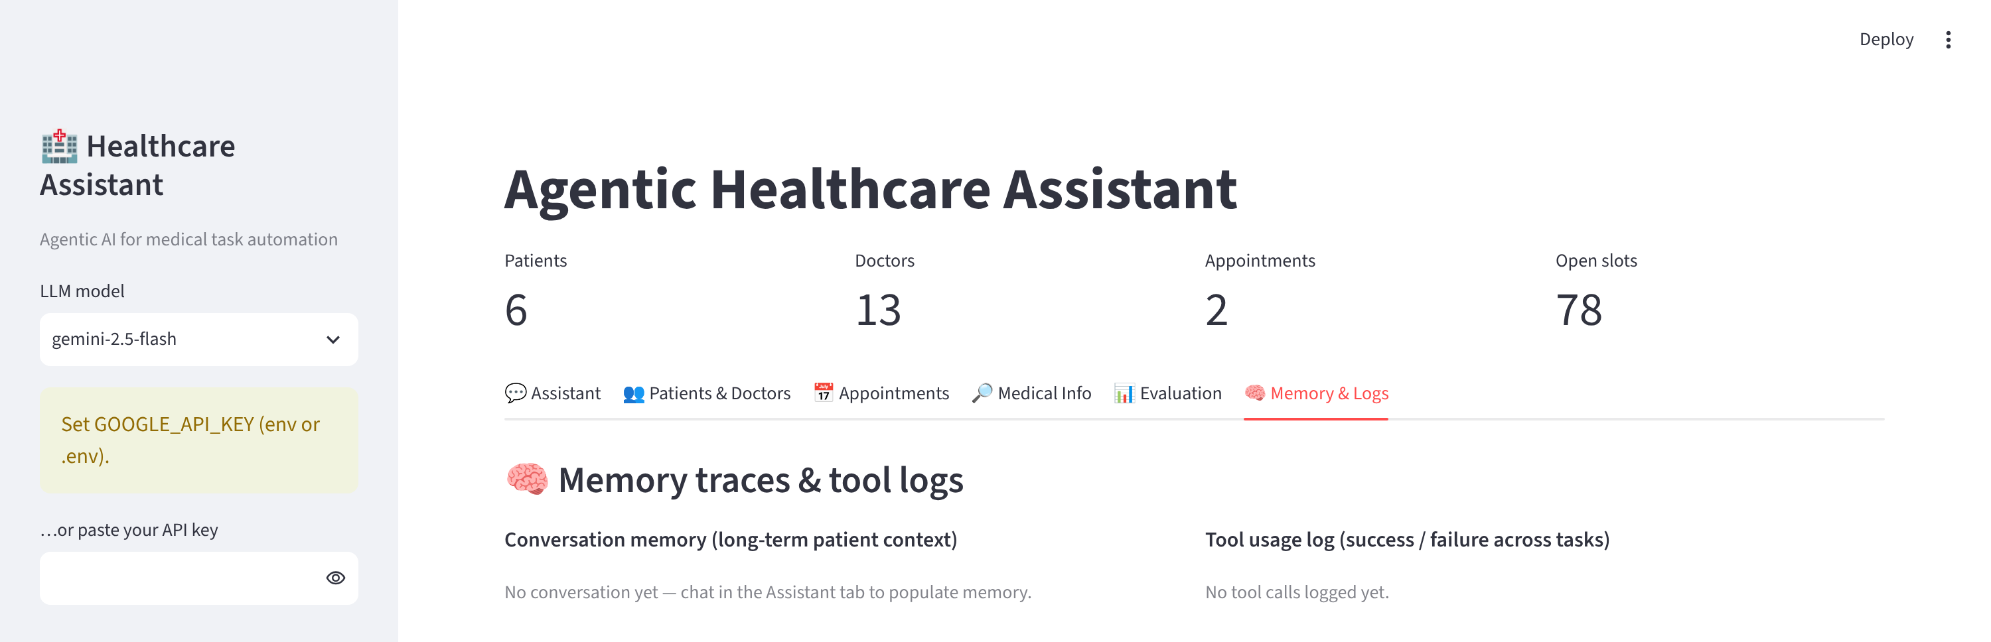
Figure 7 — Memory & logs interface.

6. Sample Data
All data is fictional and for demonstration. The dataset includes 13 doctors across 8 specialties (each with open slots), 6 patients with structured histories, medications, alerts and unstructured clinical notes, and seed appointments. Patient P001 (Sokha Chan, 70, CKD + hypertension) and two nephrologists support the capstone's sample scenario.

7. How to Run
From inside the project folder (a free Gemini key is available at aistudio.google.com/apikey):
pip install -r requirements.txt
cp .env.example .env # then edit .env and set GOOGLE_API_KEY
streamlit run app.py
The notebook (AgenticHealthcareAssistant.ipynb) implements and documents all eight steps and runs top-to-bottom; the agent cells require the API key. Source files: the notebook, healthcare_core.py, app.py, requirements.txt, README.md, and the Data/ JSON files.

8. Safety & Limitations
InsightMed provides administrative support and general, trusted-source information only — not personal medical advice or diagnosis — and every medical answer carries that disclaimer. Patient data is fictional. The medical search prefers the live MedlinePlus service and falls back to an offline cache when offline. As an LLM-driven agent, outputs should be reviewed by a qualified professional before any clinical use.

9. Conclusion
InsightMed implements the full Agentic Healthcare Assistant: planning and goal decomposition, a six-tool and memory setup with a FAISS patient knowledge base, prompt engineering and task chaining, the end-to-end sample scenario, QAEvalChain evaluation with per-module performance monitoring, and a Streamlit dashboard with a memory & logs interface. It shows how an agentic LLM system can coordinate fragmented healthcare administration tasks autonomously from a single conversational interface.

