Figure 12 — Explained
The Overall Transformer-Based Encoder–Decoder Architecture
Source: Buoy et al., "Toward a Low-Resource Non-Latin-Complete Baseline: An Exploration of Khmer OCR," IEEE Access, Vol. 11, 2023.
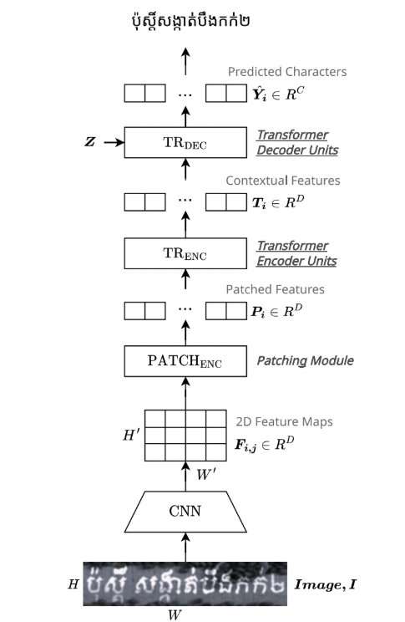

🔍 What is Figure 12 About?
Figure 12 shows the complete pipeline the model uses to read (recognize) Khmer text in an image. It answers the question: "How does the computer go from a photo of text to actual readable characters?"
The architecture has four main modules that work one after another, like an assembly line. Each module transforms the data into a more useful form.
💡 Key idea — Encoder + Decoder
An "encoder" reads the image and understands what it sees. A "decoder" uses that understanding to write out the text. Together they form an encoder–decoder architecture — the same concept used in machine translation (e.g., Google Translate).

🗺️ Architecture at a Glance
The pipeline flows from bottom to top (as drawn in the paper), but reading left-to-right it works like this:
Image  I | → | CNN | → | PATCH  ENC | → | TR  ENC | → | TR  DEC

Module | Role in the pipeline
CNN | Reads the image pixels and extracts visual features (shapes, strokes)
PATCHₑₙₓ | Converts 2D visual features into a 1D sequence of tokens
TRₑₙₓ | Transformer Encoder — understands context between tokens
TRᴅᴇᴄ | Transformer Decoder — generates the output text character by character

📋 Step-by-Step Walkthrough
We will follow one Khmer textline image through all four stages. Each step explains what happens, what goes in, and what comes out.
Step  1 | The Input Image (Image I)  What it is: A grayscale photo or scan of a Khmer textline.  Technical details: The image has height H pixels and width W pixels.  Actual textline from Figure 12 (the paper): "ប៉ុស្តិ៍ សង្កាត់បឹងកក់២" — this is the real Khmer textline shown in Figure 12 of the paper.  No resizing needed: Unlike most OCR methods, this model does not resize the image to a fixed width — it handles any length. This is important for Khmer because textlines can be very long.  Formula: I is a grayscale image of (H × W) pixels

Step  2 | CNN Module — Extract Visual Features  What it is: A modified ResNet — a well-known Convolutional Neural Network (CNN).  What it does: Scans the image with small filters to detect edges, curves, strokes, and patterns — the building blocks of characters.  Input: Image I of size H × W pixels  Output: A 2D feature map F of size H' × W' × D  Downsampling: The CNN shrinks the image by a factor of 4 in both directions: H' = H ÷ 4 and W' = W ÷ 4.  Think of it as: Like squeezing the image into a compact, information-rich summary grid — each cell holds a D-dimensional description of what that region looks like.  Formula: F = CNN(I)

🔑 Why 2D features matter for Khmer
Most OCR systems for Latin text use 1D feature maps (just a single row). Khmer characters stack vertically — vowels go above and below consonants. Using 2D feature maps (H' rows × W' columns) preserves this vertical information, which is essential for correctly reading stacked Khmer characters.

Step  3 | PATCH_ENC — Patching Module (2D → 1D tokens)  What it is: The Patching Encoder — inspired by Vision Transformer (ViT) technology.  The problem it solves: The Transformer (next step) needs a sequence of items — but the CNN outputs a grid. PATCHₑₙₓ bridges this gap.  What it does: Divides the 2D feature map into small rectangular patches of size k₁ × k₂. Each patch is flattened and projected into a D-dimensional vector. Position information is then added (positional encoding) so the model knows where each patch came from.  Input: F — 2D feature map (H' × W')  Output: P = (P₁, P₂, ..., P_n) — a sequence of n patch tokens, each Pᵢ ∈ ℝ^D  Formula: P = PATCHₑₙₓ(k₁, k₂)(F)  Think of it as: Like cutting a painting into small tiles, describing each tile in words, then arranging the descriptions in reading order.

Step  4 | TR_ENC — Transformer Encoder Units  What it is: A stack of standard Transformer encoder layers (the same technology behind BERT, GPT, etc.).  What it does: Reads the sequence of patch tokens P and uses self-attention to understand relationships between all patches. For example: "this stroke above is a vowel belonging to the consonant below."  Input: P — sequence of patched feature tokens  Output: T = (T₁, T₂, ..., T_n) — contextual feature tokens, each Tᵢ ∈ ℝ^D  Formula: T = TRₑₙₓ(P)  Think of it as: Like a team of analysts reading all the tiles simultaneously and annotating each one with context from the others: "this tile makes sense only because of that tile over there."  Self-attention note: This is where the quadratic cost problem occurs for long images (see Figure 3). The chunking technique (Figure 13/15) fixes this by limiting how many tokens TRₑₙₓ sees at once.

Step  5 | TR_DEC — Transformer Decoder Units (generates the text)  What it is: A stack of Transformer decoder layers with an important twist: it uses static position encoding for variable-length output.  What it does: Reads the contextual features T (from TRₑₙₓ) alongside a context sequence Z, and predicts one character at a time. Each prediction feeds back as input for the next character (autoregressive generation).  Input 1 — T: Contextual features from the encoder  Input 2 — Z: Context sequence (starts with a special SOS "start of sentence" token, then grows with each predicted character)  Output: Ŷ = (Ŷ₁, Ŷ₂, ..., Ŷ_L) — predicted character probabilities, each Ŷᵢ ∈ ℝ^C (C = 131 possible characters)  Actual output from Figure 12 in the paper: "ប៉ុស្តិ៍ សង្កាត់បឹងកក់២" — the model decodes the input image into this complete Khmer text.  Formula: Ŷ = TRᴅᴇᴄ(T, Z)  Think of it as: Like a translator who has fully read the source image and now writes out each word/character one by one, always checking what they've written so far to decide what comes next.

📊 Complete Data Flow Table
This table shows exactly what data looks like at each stage of the pipeline:
Stage | What goes IN | What comes OUT | Technical notation
① Input | A photo/scan of Khmer text | Grayscale image of H × W pixels | I ∈ ℝ^(H×W)
② CNN | Image I | 2D feature map grid (smaller but richer) | F_{i,j} ∈ ℝ^D  size: H'×W' (=H/4 × W/4)
③ PATCH_ENC | 2D feature map F | Ordered sequence of patch tokens | P = (P₁…Pₙ)  Pᵢ ∈ ℝ^D
④ TR_ENC | Patch tokens P | Context-aware feature tokens | T = (T₁…Tₙ)  Tᵢ ∈ ℝ^D
⑤ TR_DEC | Features T + context Z | Per-character probability vectors | Ŷ = (Ŷ₁…ŶL)  Ŷᵢ ∈ ℝ^C (C=131)
⑥ Output | Probability vectors Ŷ | "ប៉ុស្តិ៍ សង្កាត់បឹងកក់២"  (actual text from Figure 12) | argmax(Ŷᵢ) → character

🇰🇭 Why This Architecture Suits Khmer Specifically
The architecture in Figure 12 was carefully designed around four challenges unique to Khmer script:
Challenge 1 — Character Stacking
Khmer vowels appear above AND below consonants. 2D feature maps (from CNN) preserve this vertical layout. A 1D approach would lose this information.

Challenge 2 — No Word Boundaries
Khmer text has no spaces between words. The textline image can be arbitrarily wide. TR_DEC uses autoregressive decoding — it does not need to know word boundaries in advance.

Challenge 3 — Small Diacritics
Khmer has tiny vowel marks above/below that would be lost if the image is resized. The architecture processes images at their native resolution, preserving these small details.

Challenge 4 — Variable Prediction Length
Because there are no word boundaries, the number of characters to output is not known in advance. TR_DEC uses a special SOS/EOS token scheme to start and stop generation dynamically. C = 131 characters covers all Khmer chars + symbols + special tokens.

🔠 Output Vocabulary (C = 131 Characters)
The decoder's output at each step is a probability over 131 possible characters. Here is what those 131 slots cover:
Category | Details
Khmer consonants | 33 base consonants (1st series + 2nd series)
Khmer subscripts | 14 consonant subscripts (stacked below base)
Khmer dependent vowels | 23 vowels attached to consonants
Khmer diacritics | 8 diacritics (tone markers etc.)
Khmer independent vowels | 14 vowels that stand alone
Khmer numerals | 10 digits (0–9 in Khmer form)
Khmer punctuation | 5 punctuation marks
Common symbols | Hyphen, space, period + other foreign symbols
Special tokens | PAD (padding), EOS (end of sentence), SOS (start of sentence)
Total | ≈ 131 character classes

🎯 How the Model is Trained
The model learns by comparing its predictions to the correct answers using a loss function:
Ŷ = TRDEC(T, Z) → Loss = CE(Ŷ, Y)
CE = Cross-Entropy Loss | Y = ground-truth character sequence | Ŷ = model prediction

Term | Plain-language meaning
Y (target) | The correct text for the image, provided during training
Ŷ (prediction) | The text the model guessed
CE Loss | A score of how wrong the prediction was — the model adjusts its weights to reduce this score over many training examples
Autoregressive | During training, Y is fed in as Z. During inference, the model's own previous outputs are fed back in as Z

✅ Summary — Figure 12 in One Paragraph
Figure 12 uses the actual Khmer textline "ប៉ុស្តិ៍ សង្កាត់បឹងកក់២" to demonstrate the full recognition pipeline: A Khmer image is first processed by a CNN that extracts 2D visual features at native resolution. The PATCH_ENC converts those 2D features into a flat sequence of patch tokens. The TR_ENC transformer encoder lets each token "see" all others via self-attention, producing rich contextual features T. Finally, the TR_DEC transformer decoder takes T plus a running context Z and generates the recognized characters one by one, producing the final text Ŷ. Using 2D features throughout preserves Khmer's stacked character structure, while the autoregressive decoder handles arbitrarily long lines without needing to know word boundaries.

Document prepared from: Buoy et al. (2023), IEEE Access Vol. 11, DOI: 10.1109/ACCESS.2023.3332361

