Figure 15 — Explained
The Complete Chunking & Merging Pipeline for Khmer OCR
Source: Buoy et al., "Toward a Low-Resource Non-Latin-Complete Baseline: An Exploration of Khmer OCR," IEEE Access, Vol. 11, 2023.
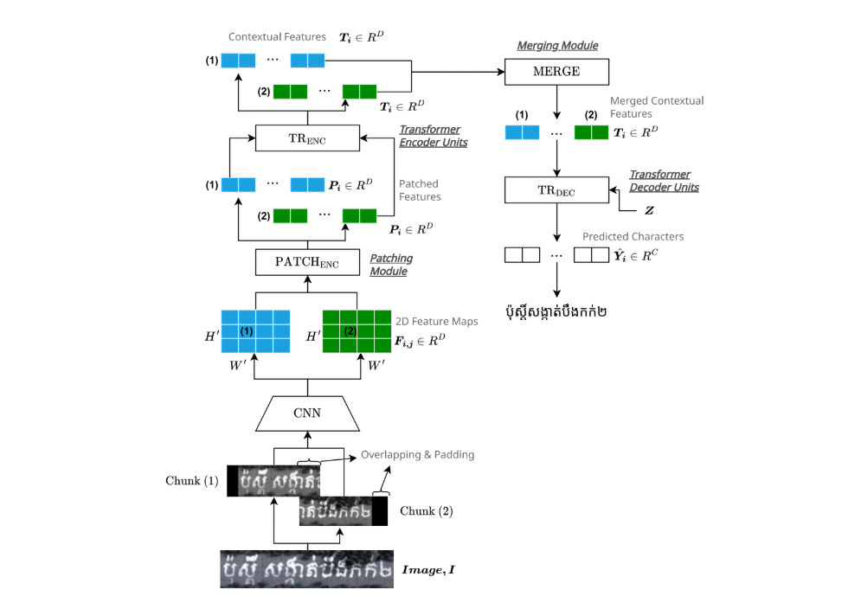

🔍 What is Figure 15 About?
Figure 15 is the complete picture of how the Khmer OCR system handles a long textline. While Figure 13 showed what chunking is and Figure 12 showed what the architecture looks like, Figure 15 combines both into one diagram — showing two chunks flowing through the full pipeline in parallel, being merged, and then decoded into final text.
📌 Official paper caption (Figure 15)
Two image chunks (1) and (2) are each encoded independently by the pipeline CNN → PATCH_ENC → TR_ENC. Their feature maps are then concatenated and augmented with positional encoding in the MERGE block. The merged feature sequence becomes the context Z, which the Attentional Decoder TR_DEC uses to generate the final recognized text.

🧩 The Three Key Ingredients in Figure 15
Before walking through Figure 15 step by step, it helps to know the three building blocks it combines:
Building Block | What it is / What it does
Chunking (from Fig. 13) | A long Khmer textline image is split into short overlapping chunks (each W = 100 px wide) so self-attention stays cheap: O(5C) not O(25C).
Encoder pipeline (from Fig. 12) | Each chunk passes through CNN → PATCH_ENC → TR_ENC independently. CNN extracts features; PATCH_ENC flattens them into a 1-D sequence; TR_ENC applies self-attention to understand local context.
MERGE + Decoder (new in Fig. 15) | The encoded feature maps from all chunks are concatenated and augmented with positional encoding (MERGE). The result becomes context sequence Z, which TR_DEC reads to generate the output text one character at a time.

📋 Step-by-Step: Walking Through Figure 15
Figure 15 shows exactly two chunks labelled (1) and (2). The actual Khmer textline shown in Figure 15 of the paper is "ប៉ុស្តិ៍ សង្កាត់បឹងកក់២", split into two chunks for this illustration.
Step  1 | Input — a long Khmer textline image  What we start with: A single photograph or scanned image of one line of Khmer text.  Actual textline from Figure 15 (the paper): "ប៉ុស្តិ៍ សង្កាត់បឹងកក់២" — this is the real Khmer textline shown in the paper's Figure 15.  Why it is a problem: If fed whole into the Transformer, self-attention cost grows quadratically with width (O(5²C) = O(25C) for a 5× wide image).  Solution starting point: Split the image into chunks of W = 100 px each before processing.

Step  2 | Split into chunks — here, Chunk (1) and Chunk (2)  How it works: A sliding window of width W = 100 px moves left to right, cutting the image into equal slices with a small overlap ε at each boundary.  In Figure 15: Two chunks are shown for clarity. In practice a 500 px textline produces 5 chunks, a 700 px textline produces 7 chunks, and so on.  Overlap ε: Each chunk shares a tiny pixel margin with its neighbours so that a character that sits exactly on a boundary appears in both adjacent chunks — the decoder can then read it completely.  Chunk labels: The paper labels them (1), (2), … to show their left-to-right order in the original image. Positional encoding later uses this order.

Step  3 | CNN — extract visual features from each chunk  Input to CNN: One chunk image: H pixels tall × W (100) pixels wide.  What CNN does: A convolutional neural network scans the chunk with small filters to detect strokes, curves, and shapes that make up Khmer characters.  Output of CNN: A 2-D feature map of size H' × W' — a compressed grid of "what features appear where" in the chunk.  One CNN for ALL chunks: The same CNN weights are shared by every chunk. No retraining needed for different image widths. Chunk (1) and Chunk (2) go through the identical CNN in parallel.

Step  4 | PATCH_ENC — flatten the 2-D feature map into a sequence  Problem: The Transformer Encoder (TR_ENC) expects a 1-D sequence of vectors, not a 2-D grid.  What PATCH_ENC does: It "unrolls" each column (or patch) of the CNN feature map into a single vector, creating an ordered sequence of patch vectors from left to right across the chunk.  Output of PATCH_ENC: A sequence of W' vectors, where each vector summarises one vertical column of the chunk's features.  Why this matters: Because each chunk is only W = 100 px wide, this sequence is short — self-attention over a short sequence is cheap (O(C)).

Step  5 | TR_ENC — apply self-attention within each chunk  Input: The sequence of patch vectors from PATCH_ENC.  What TR_ENC does: Transformer Encoder layers apply multi-head self-attention. Each patch vector "looks at" every other patch in the same chunk, building up context — e.g., learning that a subscript below a consonant belongs to it.  Complexity per chunk: O(C) = O((H'W')²) — the same low cost as a short Latin image, because we only attend within one 100 px chunk at a time.  Output per chunk: A rich contextual feature vector for every patch in the chunk. Chunk (1) and Chunk (2) each produce their own feature map independently and in parallel.

Step  6 | MERGE — concatenate chunk features + add positional encoding  What MERGE does — part 1 (Concatenate): The encoded feature sequences from Chunk (1) and Chunk (2) are placed side by side (concatenated) in order, creating one long feature sequence that covers the entire textline.  What MERGE does — part 2 (Positional Encoding): A positional encoding is added to every element in the combined sequence. This tells the decoder "this feature came from position X in the full textline", so it knows the left-to-right order of all chunks even though they were encoded separately.  Why positional encoding is needed: Without it, the decoder would not know whether Chunk (1) came before or after Chunk (2). The positional encoding restores the spatial order that was lost when chunks were processed independently.  Output of MERGE: The context sequence Z — a single ordered sequence of feature vectors covering the full textline from left to right.

Step  7 | TR_DEC — decode context Z into output text  Input to TR_DEC: The context sequence Z (the full merged feature sequence from MERGE).  What TR_DEC does: An attentional (Transformer) decoder generates the output text one character at a time. At each step it uses cross-attention to "look at" any part of Z — meaning it can read features from Chunk (1) and Chunk (2) together when deciding each character.  Why cross-chunk attention matters: A Khmer character at the boundary between Chunk (1) and Chunk (2) may have part of its glyph in each chunk. Because TR_DEC attends over the full Z, it sees both parts and can correctly identify the character.  Output: The complete recognized Khmer text for the full textline.  Actual output from Figure 15 in the paper: "ប៉ុស្តិ៍ សង្កាត់បឹងកក់២" — both chunks are decoded together into this seamless full-line result.

🗺️ Architecture at a Glance
Here is the full pipeline of Figure 15 as a single reference table:
Stage | Input → Output
Image split | Long textline image → Chunk (1) [px 0–W], Chunk (2) [px W–2W], …
CNN (per chunk) | Chunk image H×W → 2-D feature map H'×W' (detects strokes, curves, shapes)
PATCH_ENC (per chunk) | 2-D feature map H'×W' → 1-D sequence of W' patch vectors (flattens columns for Transformer input)
TR_ENC (per chunk) | 1-D sequence of W' vectors → contextual feature sequence of W' vectors (self-attention within chunk; cost O(C) per chunk)
MERGE | Feature sequences from all chunks → context sequence Z (concatenate + positional encoding; cost O(N·C) for N chunks)
TR_DEC | Context Z → output text characters one by one (cross-attention over full Z; generates the complete recognized line)

🔑 What is Z and Why Does it Matter?
The letter Z appears in the paper's Figure 15 diagram as the output of MERGE. Understanding Z is the key to understanding why Figure 15 works.
Z = MERGE( TR_ENC(chunk 1), TR_ENC(chunk 2), … )
Z = Positional_Encoding( Concatenate( feature maps ) )

Property of Z | What it means in practice
Z covers the full textline | Even though chunks were encoded separately, Z stitches them together in the correct left-to-right order before decoding.
Z carries positional information | Each position in Z knows whether it came from Chunk 1, Chunk 2, etc. The positional encoding embeds this left-to-right order into the vectors.
TR_DEC reads Z with cross-attention | At each decoding step, TR_DEC can attend to any position in Z — near or far — so characters that span chunk boundaries are handled correctly.
Z is the "context" (hence the name) | Think of Z as the model's complete understanding of the whole textline image, assembled from independently-processed chunk pieces.

⚡ Parallel Encoding, Sequential Decoding
A key efficiency feature of Figure 15 is that encoding and decoding use different strategies:
⚡ Encoding — fully parallel
Chunk (1) and Chunk (2) go through CNN → PATCH_ENC → TR_ENC at the same time (in parallel). The model processes both chunks simultaneously on the GPU. This means adding more chunks does NOT slow down the encoder proportionally — with enough GPU cores, 5 chunks take the same wall-clock time as 1 chunk.

📝 Decoding — sequential (auto-regressive)
TR_DEC generates output one character at a time. Each new character is predicted using all previously generated characters plus the full context Z. This is standard for sequence-to-sequence OCR — the decoder must know "I have already written ក" before deciding the next character.

🏆 Net result
The expensive part (encoding the image) is fast thanks to parallelism. The output generation (decoding) is sequential but operates on compressed feature vectors, not raw pixels — so it is already much lighter than processing the raw image.

🎯 Real-World Analogy
Think of the Figure 15 pipeline like a team translating a very long book:
📖 The book = the Khmer textline image
The full textline is too long for one person to hold in their head at once.

✂️ Chunking = splitting the book into chapters
Each chapter (chunk) is given to a different team member to read and summarize. All team members work at the same time (parallel encoding). Each person only needs to understand their own short chapter.

📋 MERGE + Z = the meeting where summaries are shared
Everyone presents their chapter summary in order. A facilitator writes them all down in sequence with numbered sections (positional encoding). This ordered list of summaries is Z.

🖊️ TR_DEC = the translator
The translator reads Z — the full ordered set of summaries — and writes the translation one sentence at a time, consulting any part of the summaries as needed. Even when a sentence spans two chapters, the translator can look at both.

🔗 How Figure 15 Connects to Other Figures
Figure 15 is the culmination of the paper's architecture section. It brings together every concept from Figures 3, 12, and 13:
Figure | What it shows / How it connects
Figure 3 | THE PROBLEM: self-attention grows O(n²) with image width. Without chunking, a 5× wide Khmer textline costs 25× more. Figure 15 is the full solution to this problem.
Figure 12 | THE ARCHITECTURE: CNN → PATCH_ENC → TR_ENC → TR_DEC for a single image. Figure 15 extends this by showing what happens when the input is split into multiple chunks.
Figure 13 | THE CHUNKING IDEA: one long image split into W = 100 px slices to reduce complexity from O(25C) to O(5C). Figure 15 adds the MERGE step and shows how the decoder uses the merged features.
Figure 14 | THE PROOF: a graph of FLOPs vs. textline width shows chunking stays nearly flat while no-chunking curves upward. Figure 15 is the architecture behind that flat curve.
Figure 15 (this figure) | THE COMPLETE SYSTEM: two-chunk parallel encoding + MERGE + TR_DEC with context Z. Everything the OCR pipeline does in one diagram.

✅ Summary — Figure 15 in One Paragraph
Figure 15 uses the actual Khmer textline "ប៉ុស្តិ៍ សង្កាត់បឹងកក់២" to demonstrate the complete Khmer OCR pipeline . The image is first split into overlapping chunks (e.g., two chunks as shown in the figure). Each chunk is encoded in parallel through CNN → PATCH_ENC → TR_ENC, keeping self-attention cheap at O(C) per chunk. The encoded features are then merged (MERGE) — concatenated and augmented with positional encoding — to form context sequence Z. Finally, the Attentional Decoder TR_DEC reads Z with cross-attention to produce the recognized Khmer text — bridging chunk boundaries seamlessly. Total encoding cost is only O(N·C) for N chunks, compared to O(N²·C) without chunking — making this approach N times more efficient.

