**Thu Dau Mot University**

**Faculty of Information Technology, Electrical and Electronic Engineering**

**Lecture: Vo Thi Hong Tham**

**DATABASE PROGRAMMING PROJECT REPORT**

**Dictionary Viet Nam - Laos**

***Team: MyFriend - Class: D14HT01***

*1424801040031 - Nguyen Cong Kieu Tam*

*1424801040205 - Vatthana Vongpaxa*

*1424801040103 - Duong Hai Minh*

*1324801040070 - Phomaly Khammone*

*1424801040111 - Le Do Dang Khoa*

April 2017

# COURSE SUMMARY

After finishing this course, we have learned a lot about teamwork skills, improved friendships, quicker reflexes, and better management of resources. Learn more new knowledge as well as consolidate our old knowledge about programming with the database.

Study and practice in a fun, comfortable, friendly and sociable environment. Do exercises, compete the team through fun games and useful.

**TABLE OF CONTENTS**

1 Team Information 4

2 Plan 5

2.1 Plan overview 5

2.2 Plan details 6

2.3 Suport Tools 6

3 Project report contents 7

3.1 Part 1 – Project Introduction 7

3.2 Part 2 – Database design 8

3.3 Part 3 – Different types of SQL SELECT statements and application 10

3.4 Part 4 – Different types of stored procetures and application 11

3.5 Part 5 – Different types of functions and application 13

3.6 Part 6 – Different types of triggers and application 15

3.7 Part 7 – Application overview 16

# Team Information

|  |  |  |  |
| --- | --- | --- | --- |
| Student Code | Full name | Email | Role |
| 1424801040031 | Nguyen Cong Kieu Tam | nguyencongtam95@gmail.com | Leader |
| 1424801040205 | Vatthana Vongpaxa | vatthanavongpaxa@gmail.com | Coordinator |
| 1424801040103 | Duong Hai Minh | minh20696@gmail.com | Implementer |
| 1324801040070 | Khammone Phommaly | bl.pakse.it@gmail.com | Completer |
| 1424801040111 | Le Do Dang Khoa | dangkhoal2dk@gmail.com | Team worker |

# Plan

## Plan overview

|  |  |  |  |
| --- | --- | --- | --- |
| Date & time | Tasks | Time frame  (man hour) | Products |
| 20/2/2017  Starting | Divide group & Choose topic | 1day | Name group: MyFriend  App: Dictionary Viet Nam - Laos |
| 21/02/2017 | Requirement | 6 day | Identify user needs. Programming on android platform. |
| 27/02/2017 | System analysis | 7 day | Using SQLite Data base.  User interface. |
| 6/3/2017 | Data base design | 7 day | Database is complete (db_TUDIEN.db) |
| 13/3/2017 | User Interface design | 14 day | Dictionary Viet Nam – Laos for Android. |
| 27/3/2017 | Testing | 7 day | Fix bug.  Fix logic error. |
| 03/4/2017 | Implementation | 7 day |  |
| 10/4/2017 | Presentation |  |  |

## Plan details

Team meeting agenda

|  |  |  |  |
| --- | --- | --- | --- |
| Date & time | Expected | Method | Prepare |
| 20/2/2017 | Divide group & choose topic | Discuss | Refer template topic |
| 21/2/2017 | Requirement | Discuss & refer | Document, internet, note |
| 27/2/2017 | System analysis | Discuss & refer | Document, internet, note |
| 6/3/2017 | Design Database | Discuss & refer | Document, internet, note |
| 13/3/2017 | User Interface Design | Discuss & Refer | Document, internet, note |
| 27/3/2017 | Testing & Fix bug, fix logic error | Discuss & Refer | Document, interface, note |
| 3/4/2017 | Implementation | Discuss & Refer | Document, interface, note |
| 10/4/2017 | Submit and report project | Presentation |  |

## Support Tools

* Google Mail, Facebook, Slack: Communication
* Android Studio: Coding application.
* MS Word: Writing project report.
* Visual studio: Creating Add word form
* Github: Save and update version of application
* SQLite Studio: Create Data Base.
* Sniping tool & paint: creating screen shot.

# Project report contents

## Part 1 – Project Introduction

The offline software Viet-Lao Dictionary application explains the meaning of

Viet Name - Lao words!

It’s work offline and won’t further download

Features:

* Quick search.
* User-Friendly interface.
* Support for Laos student studying, working and traveling in Viet Nam.
* Easy bookmark for your Word.

## Part 2 – Database design

### Table TUDIEN

|  |  |  |  |
| --- | --- | --- | --- |
| Attributes | Data type | Allow Null | Detail |
| ID(Pk) | INTERGER  (Auto Increment) | Not null | The primary key for a word, each word will carry a different key |
| VNWORD | TEXT(Unique) | Not null | Words are written in Vietnamese |
| LAOWORD | TEXT | Not null | Words are written in Lao language |
| BOOKMARK | BOOLEAN | Default(0) | Mark the words of interest |

### TABLE TUDIEN_BACKUP

|  |  |  |  |
| --- | --- | --- | --- |
| Attributes | Data type | Allow Null | Detail |
| ID | INTERGER | Not null | The primary key for a word, each word will carry a different key |
| VNWORD | TEXT | Not null | Words are written in Vietnamese |
| LAOWORD | TEXT | Not null | Words are written in Lao language |
| BOOKMARK | BOOLEAN | Default(0) | Mark the words of interest |
| TIME | DATETIME  (CURRENT_TIMESTAMP) | Not null | Time of back up words |

## Part 3 – Different types of SQL SELECT statements and application

### Quick search command

SELECT *

FROM TUDIEN

WHERE VNWORD LIKE *‘ tu tieng viet % ’*

### Show bookmark word

SELECT *

FROM TUDIEN

WHERE BOOKMARK = 1

### Translate

SELECT *

FROM TUDIEN

WHERE VNWORD = *‘ ai ai ’*

### Show all words

SELECT * FROM TUDIEN

## Part 4 – Different types of stored procedures and application

### Add new word

CREATE PROCEDURES sp_addWord

(@VNWORD NVARCHAR (100), @LAWORD NVARCHAR (100))

AS BEGIN

INSERT INTO TUDIEN (VNWORD, LAWORD)

VALUES (@VNWORD, @LAWORD)

END

EXEC sp_AddWord N

### Update word

CREATE PROC sp_UpdateWord

(@ID INT, @VNWORD NVARCHAR (100), @LAWORD NVARCHAR (100))

AS BEGIN

UPDATE TUDIEN SET VNWORD = @VNWORD, LAWORD = @LAWORD

WHERE ID = @ID

END

EXEC sp_UpdateWord 15, N *‘đi’*, N *‘ໄປ’*

### Delete Word

CREATE PROC sp_DeleteWord (@ID INT)

AS BEGIN

DELETE FROM TUDIEN WHERE ID = @ID

END

EXEC sp_ DeleteWord 12

### Set Bookmark

CREATE PROC sp_UpdateBookmark

(@ID INT)

AS BEGIN

UPDATE TUDIEN SET BOOKMARK = 1

WHERE ID = @ID

END

EXEC sp_UpdateBookmark 14

## Part 5 – Different types of functions and application

### Translate function

CREATE FUNCTION dbo.translate (@VNWORD NVARCHAR(100))

RETURNS TABLE

AS

RETURN

(SELECT * FROM TUDIEN WHERE VNWORD=@VNWORD)

END

SELECT * FROM dbo.translate (‘xin chào ’)

### Show Bookmark function

CREATE FUNCTION dbo.Bookmark (@bm bit)

RETURNS TABLE

AS

RETURN ( select * from TUDIEN

where BOOKMARK = 1)

SELECT * FROM dbo. Bookmark (‘true’)

### Search function

CREATE FUNCTION dbo.search (@VNWORD NVARCHAR(100)

RETURNS @CAU3 TABLE

(ID INT, LAWORD NVARCHAR (100), BOOKMARK BIT)

AS BEGIN

INSERT INTO @search

SELECT ID, LAWORD, BOOKMARK FROM TUDIEN WHERE VNWORD LIKE @VNWORD + ‘%’

RETURN

END

## Part 6 – Different types of triggers and application

### Backup Word

CREATE TRIGGER BACKUP

AFTER UPDATE

ON TUDIEN

FOR EACH ROW

BEGIN

INSERT INTO BACKUP (ID, VNWORD, LAWORD, TIME)

VALUES (OLD.ID, OLD.VNWORD, OLD.LAWORD, CURRENT_TIMESTAMP);

END;

## 12 Part 7 – Application overviews

|  |  |  |
| --- | --- | --- |
|  | Function list | Application |
| 1 | Create Database with Microsoft SQL Server Management | ( Part 3, 6 ) |
| 2 | Form Management Word with Visual Studio | ( Part 4, 7 ), ( Part 4, 8 ), ( Part 4, 9 ) |
| 3 | Management Word with SQLiteStudio | ( Part 6, 14 ) |
| 4 | Search word in MainActiviy.class  ( Android application ) | ( Part 3, 3 ), ( Part 5 ,13 ) |
| 5 | Translate in DetailActivity.class  ( Android application ) | ( Part 3, 5 ), ( Part 5, 11 ) |
| 6 | Set bookmarked word in DetailActivity.class  ( Android application ) | ( Part 5, 10 ) |
| 7 | Show all word’bookmark in Bookmark.class  ( Android application ) | ( Part 3, 4 ), ( Part 5, 12 ) |

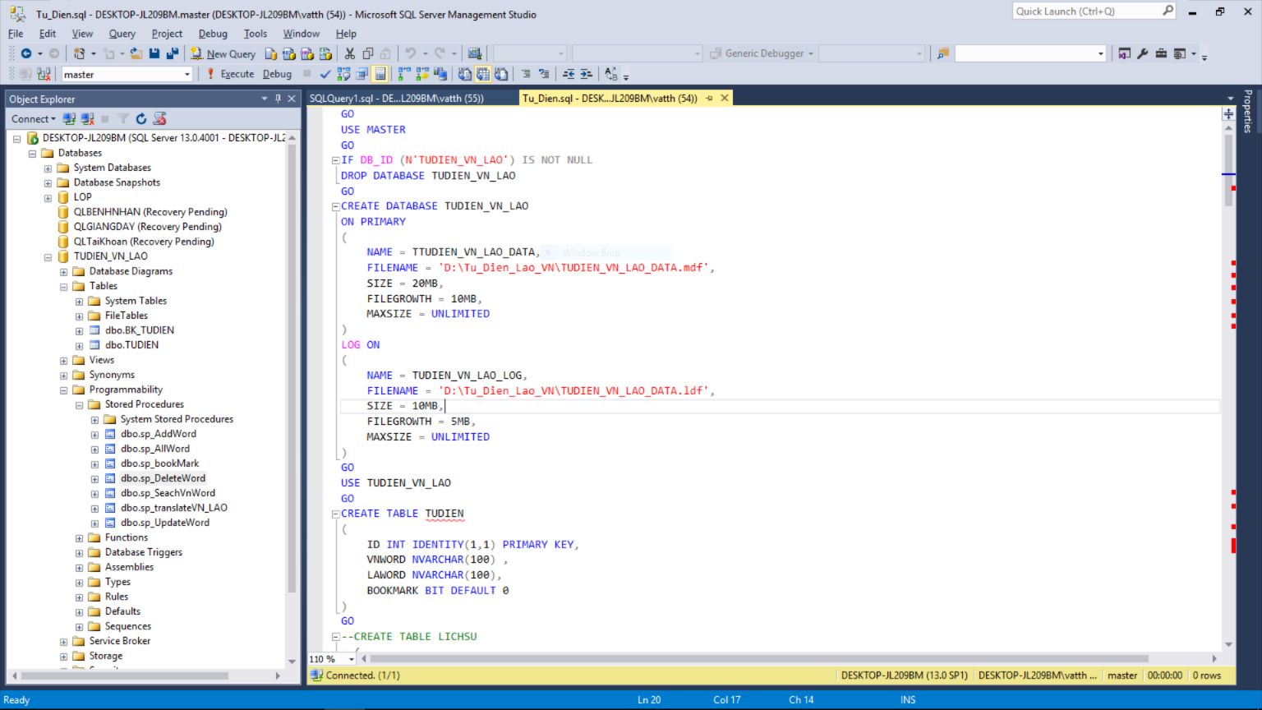

#### Microsoft SQL Server (Create Database)

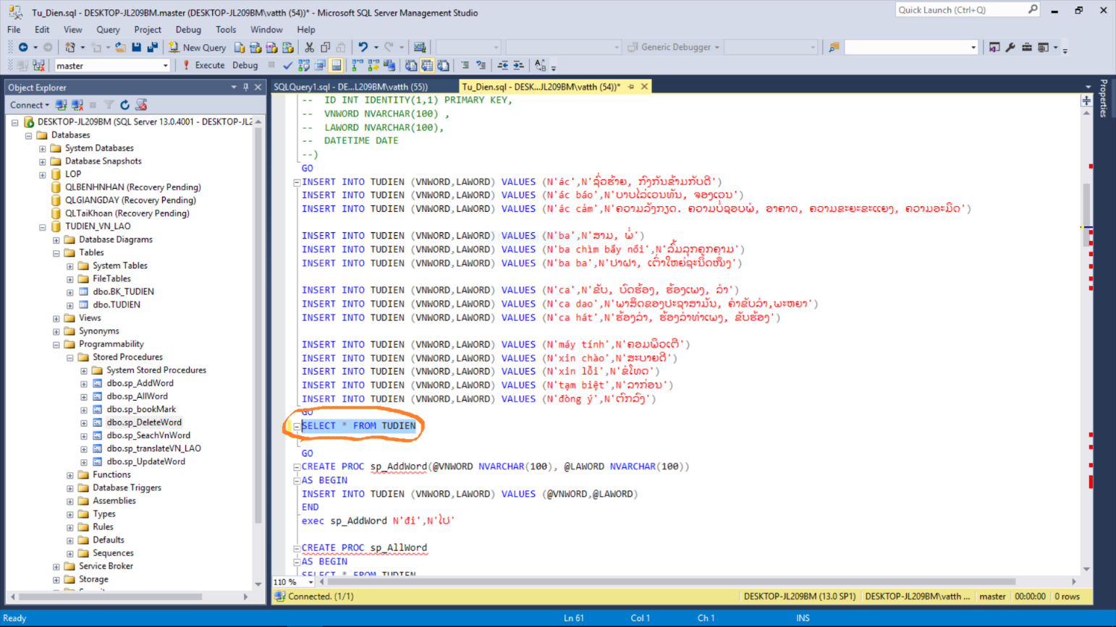

#### Microsoft SQL Server (Use SQL Select Show all words)

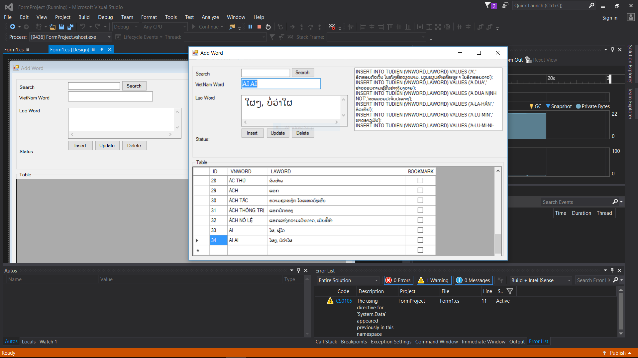

#### Visual Studio (Management Word)

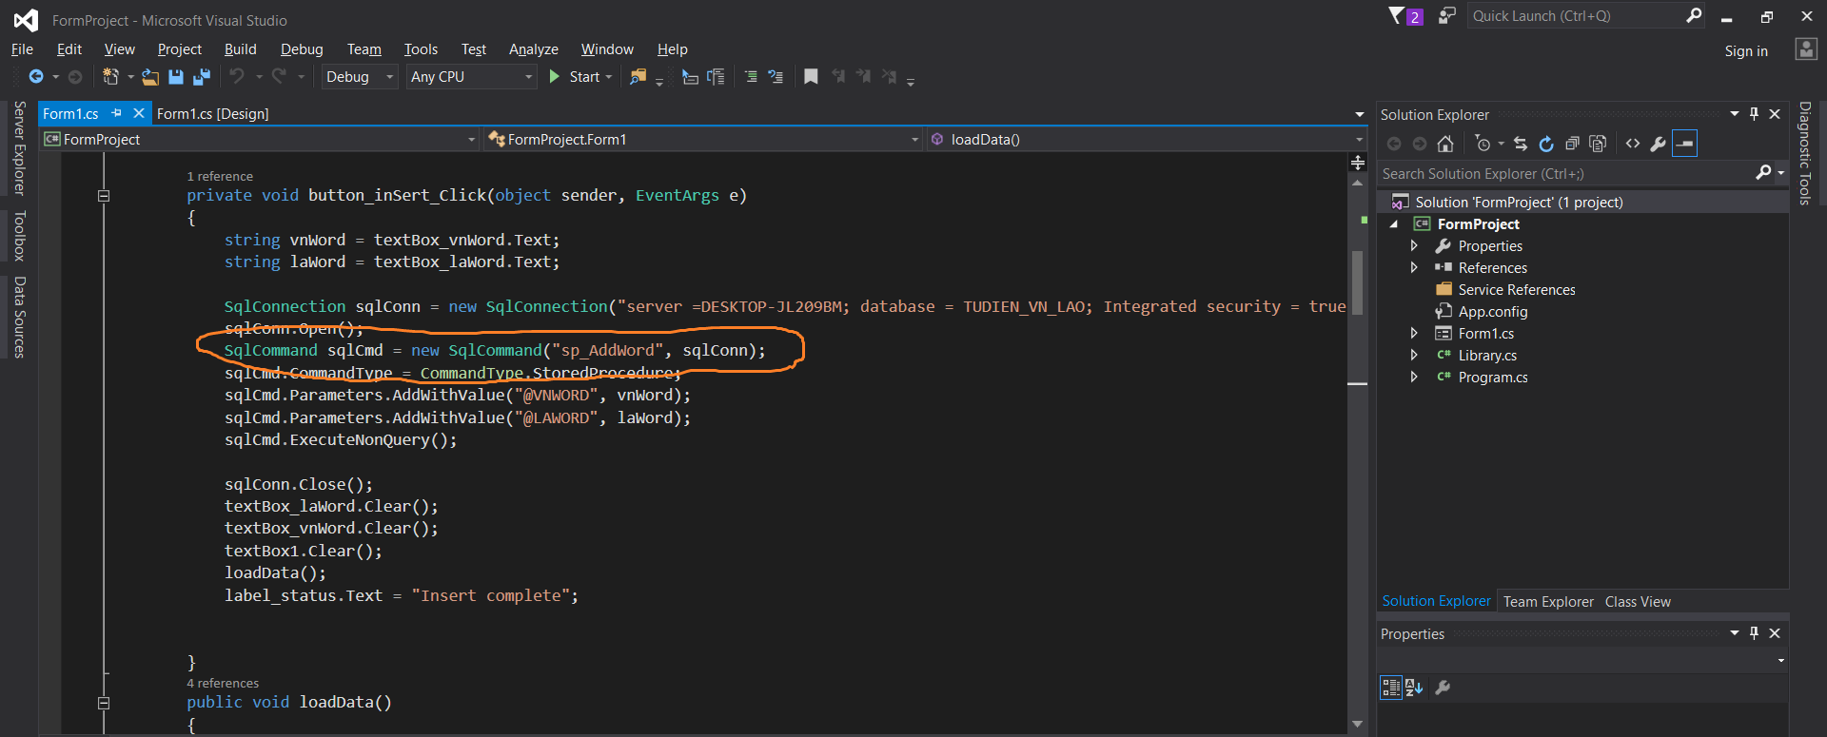

#### Visual Studio (Use stored procedure Add new word)

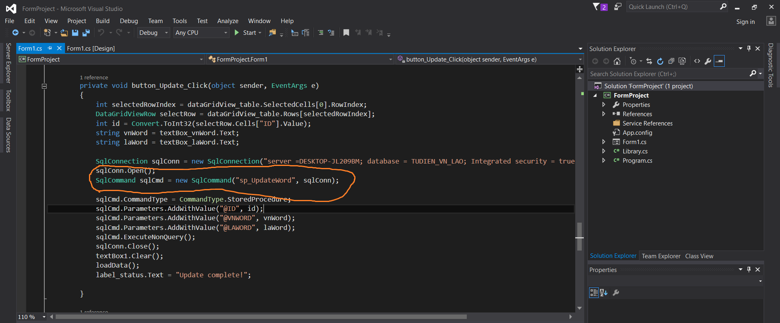

#### Visual Studio (Use stored procedure Update word)

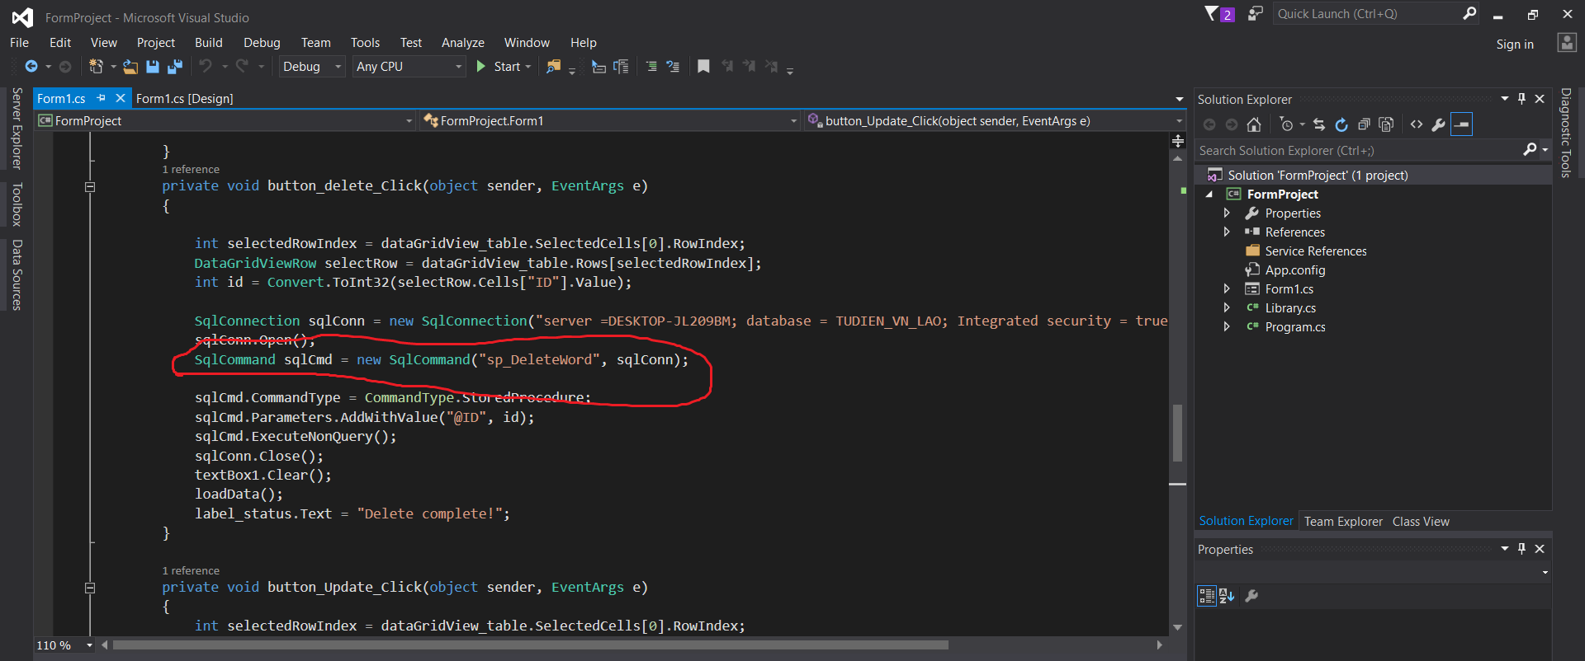

#### Visual Studio (Use stored procedure Update word)

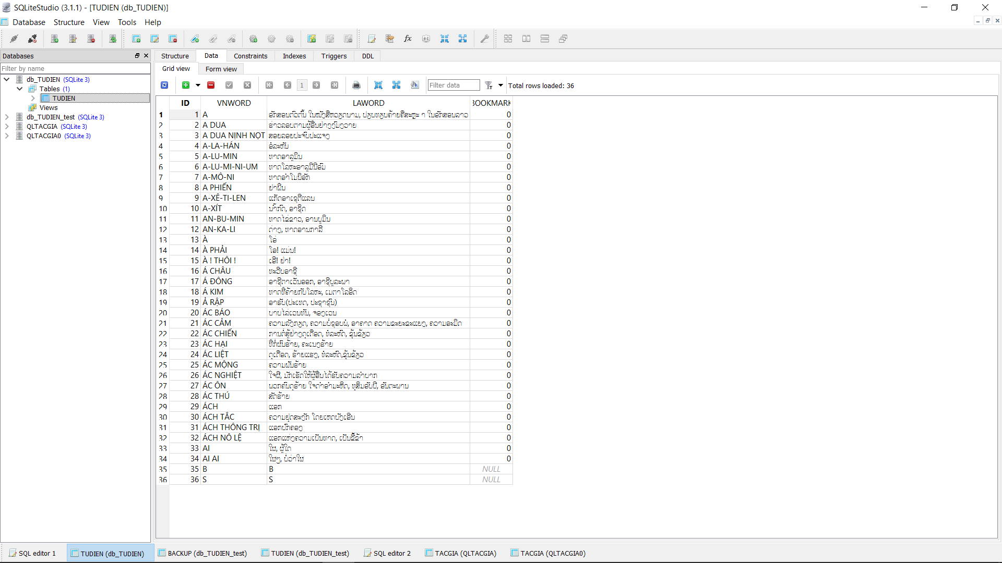

#### SQLite Studio

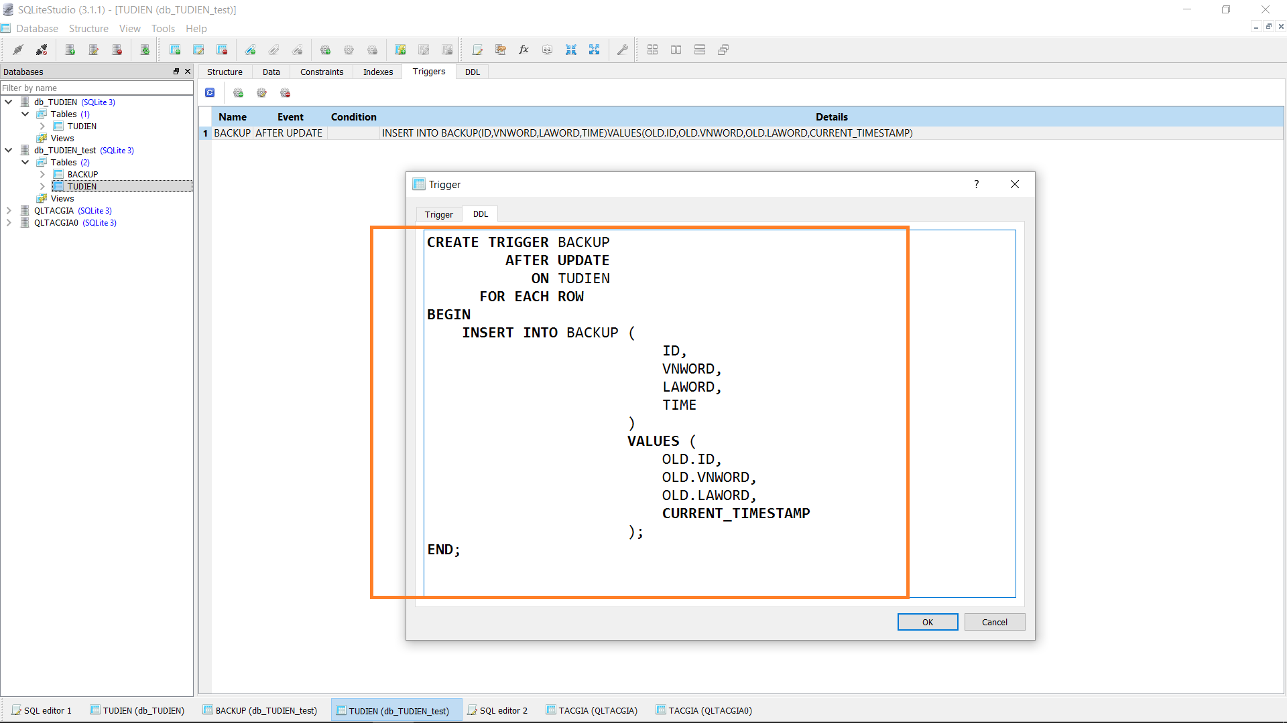

#### SQLite Studio (Use Trigger Backup Word)

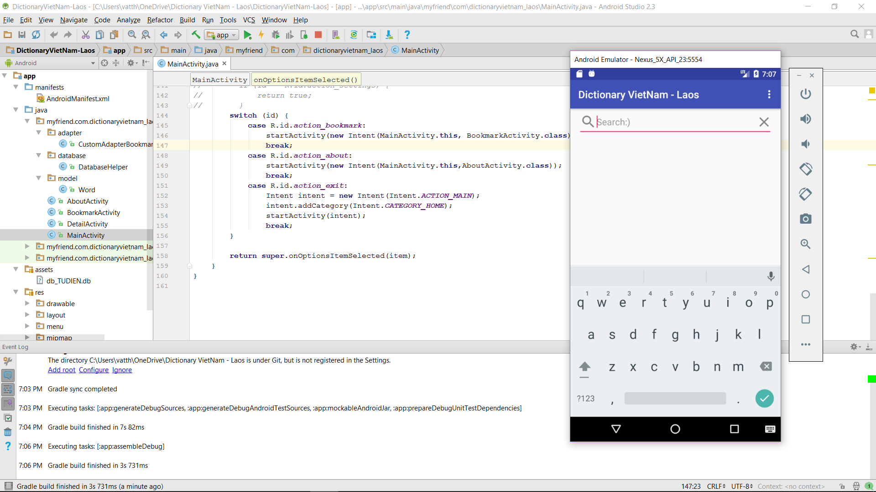

#### Android Studio

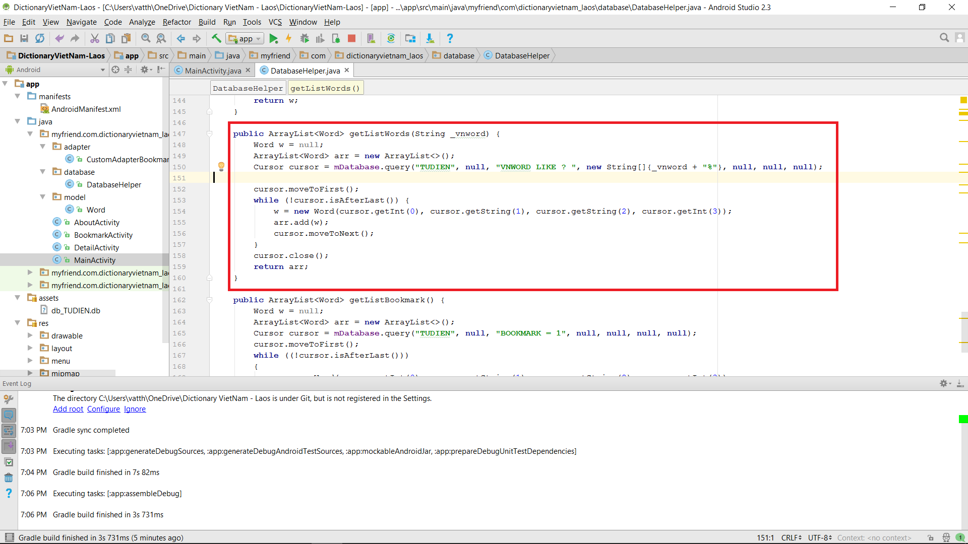

#### Android Studio (Use Search Function)

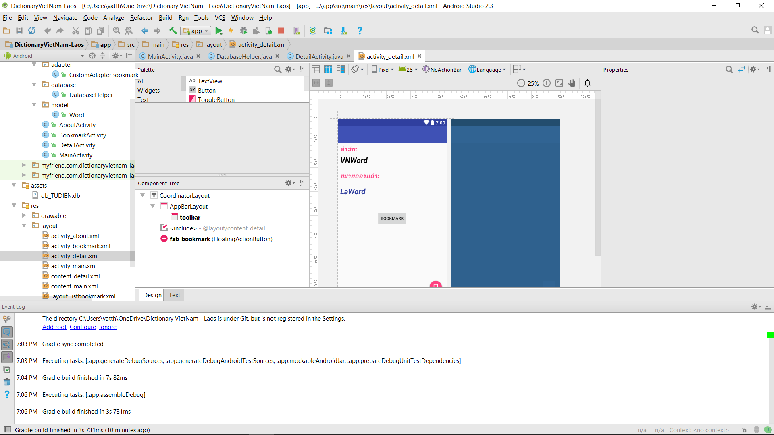

#### Android Studio (Use Translate Function)

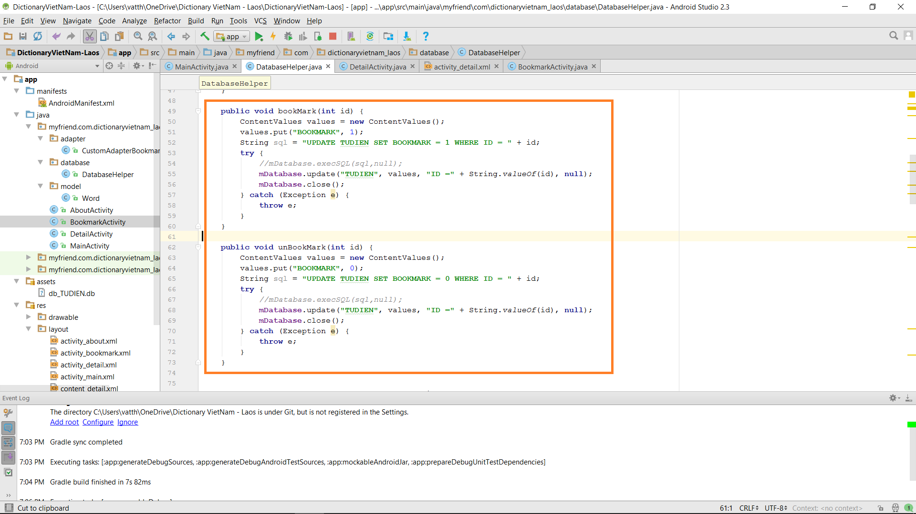

#### Android Studio (Use stored procedure Set Bookmark)