**Thu Dau Mot University**

**Faculty of Information Technology, Electrical and Electronic Engineering**

**Lecture: Vo Thi Hong Tham**

**DATABASE PROGRAMMING PROJECT REPORT**

**Dictionary Viet Nam - Laos**

Team: MyFriend- Class : D14HT01

<*Student Code*> - <*Full name*>

<*Student Code*> - <*Full name*>

<*Student Code*> - <*Full name*>

April 2017

**COURSE SUMMARY**

Consideration questions:

* What have you learnt from this course?
* What did you like best about this course? In case you don’t have one, that is fine.
* What topics do you want to learn more? In case you don’t have one, that is ok.

**TABLE OF CONTENTS**

1 Team Information 4

2 Plan 5

2.1 Plan overview 5

2.2 Plan details 6

2.3 Suport Tools 6

3 Project report contents 7

3.1 Part 1 – Project Introduction 7

3.2 Part 2 – Database design 8

3.3 Part 3 – Different types of SQL SELECT statements and application 9

3.4 Part 4 – Different types of stored procetures and application 10

3.5 Part 5 – Different types of functions and application 11

3.6 Part 6 – Different types of triggers and application 12

3.7 Part 7 – Application overview 14

# Team Information

|  |  |  |  |
| --- | --- | --- | --- |
| Student Code | Full name | Email | Role |
|  |  |  | Leader |
| 1424801040205 | Vatthana Vongpaxa | vatthanavongpaxa@gmail.com | Coordinator |
|  |  |  | Implementer |
|  |  |  | Completer |
|  |  |  | Team worker |

# Plan

## Plan overview

|  |  |  |  |
| --- | --- | --- | --- |
| Date & time | Tasks | Time frame  (man hour) | Products |
| 20/2/2017  Starting | Divide group | 1 hours | Name group: MyFriend |
| 27/02/2017  Preparing | Choose topic | 2 hours | App: Dictionary Viet Nam - Laos |
| Presentation in front of the class | 15 minutes |
| 06/03/2017 | Design database | 1 day | Database is complete (db_TUDIEN.db) |
|  |  |  |
|  |  |  |
| … | … | … | … |

## Plan details

Team meeting agenda

|  |  |  |  |
| --- | --- | --- | --- |
|  |  |  |  |
|  |  |  |  |
|  |  |  |  |
|  |  |  |  |
|  |  |  |  |
| … | … | … | … |

## Support Tools

* Google Mail:
* Android Studio: Coding application
* Word:
* Visual studio: Creating Add word form
* Github: Save and update version of application
* SQLite Studio: Create Data Base

# Project report contents

## Part 1 – Project Introduction

The free offline software Viet-Lao Dictionary application explains the meaning of

Viet Name - Lao words!

It’s work offline and won’t further download

Features:

* Quick search.
* User-Friendly interface.
* Support for Laos student studying, working and traveling in Viet Nam.
* Easy bookmark for your Word.

## Part 2 – Database design

### Table TUDIEN

|  |  |  |  |
| --- | --- | --- | --- |
| **Attributes** | **Data type** | **Allow Null** | **Detail** |
| ID(Pk) | INTERGER  (Auto Increment) | Not null | The primary key for a word, each word will carry a different key |
| VNWORD | TEXT(Unique) | Not null | Words are written in Vietnamese |
| LAOWORD | TEXT | Not null | Words are written in Lao language |
| BOOKMARK | BOOLEAN | Default(0) | Mark the words of interest |

### TABLE TUDIEN_BACKUP

|  |  |  |  |
| --- | --- | --- | --- |
| **Attributes** | **Data type** | **Allow Null** | **Detail** |
| ID | INTERGER | Not null | The primary key for a word, each word will carry a different key |
| VNWORD | TEXT | Not null | Words are written in Vietnamese |
| LAOWORD | TEXT | Not null | Words are written in Lao language |
| BOOKMARK | BOOLEAN | Default(0) | Mark the words of interest |
| TIME | DATETIME  (CURRENT_TIMESTAMP) | Not null | Time of back up words |

## Part 3 – Different types of SQL SELECT statements and application

### Quick search command

SELECT *

FROM TUDIEN

WHERE VNWORD LIKE *‘ tu tieng viet % ’*

### Show bookmark word

SELECT *

FROM TUDIEN

WHERE BOOKMARK = 1

### Translate

SELECT *

FROM TUDIEN

WHERE VNWORD = *‘ ai ai ’*

### Show all words

SELECT * FROM TUDIEN

## Part 4 – Different types of stored procedures and application

### Add new word

CREATE PROCEDURES sp_addWord

(@VNWORD NVARCHAR (100), @LAWORD NVARCHAR (100))

AS BEGIN

INSERT INTO TUDIEN (VNWORD, LAWORD)

VALUES (@VNWORD, @LAWORD)

END

EXEC sp_AddWord N

### Update word

CREATE PROC sp_UpdateWord

(@ID INT, @VNWORD NVARCHAR (100), @LAWORD NVARCHAR (100))

AS BEGIN

UPDATE TUDIEN SET VNWORD = @VNWORD, LAWORD = @LAWORD

WHERE ID = @ID

END

EXEC sp_UpdateWord 15, N *‘đi’*, N *‘ໄປ’*

### Delete Word

CREATE PROC sp_DeleteWord (@ID INT)

AS BEGIN

DELETE FROM TUDIEN WHERE ID = @ID

END

EXEC sp_ DeleteWord 12

### Set Bookmark

CREATE PROC sp_UpdateBookmark

(@ID INT)

AS BEGIN

UPDATE TUDIEN SET BOOKMARK = 1

WHERE ID = @ID

END

EXEC sp_UpdateBookmark 14

## Part 5 – Different types of functions and application

### Translate function

CREATE FUNCTION dbo.translate (@VNWORD NVARCHAR(100))

RETURNS TABLE

AS

RETURN

(SELECT * FROM TUDIEN WHERE VNWORD=@VNWORD)

END

SELECT * FROM dbo.translate (‘xin chào ’)

### Show Bookmark function

CREATE FUNCTION dbo.Bookmark (@bm bit)

RETURNS TABLE

AS

RETURN ( select * from TUDIEN

where BOOKMARK = 1)

SELECT * FROM dbo. Bookmark (‘true’)

### Search function

CREATE FUNCTION dbo.search (@VNWORD NVARCHAR(100)

RETURNS @CAU3 TABLE

(ID INT, LAWORD NVARCHAR (100), BOOKMARK BIT)

AS BEGIN

INSERT INTO @search

SELECT ID, LAWORD, BOOKMARK FROM TUDIEN WHERE VNWORD LIKE @VNWORD + ‘%’

RETURN

END

## Part 6 – Different types of triggers and application

### Backup Word

CREATE TRIGGER BACKUP

AFTER UPDATE

ON TUDIEN

FOR EACH ROW

BEGIN

INSERT INTO BACKUP (ID, VNWORD, LAWORD, TIME)

VALUES (OLD.ID, OLD.VNWORD, OLD.LAWORD, CURRENT_TIMESTAMP);

END;

## 12 Part 7 – Application overviews

|  |  |  |
| --- | --- | --- |
|  | **Function list** | **Application** |
| 1 | Create Database with Microsoft SQL Server Management | ( Part 3, 6 ) |
| 2 | Form Management Word with Visual Studio | ( Part 4, 7 ), ( Part 4, 8 ), ( Part 4, 9 ) |
| 3 | Management Word with SQLiteStudio | ( Part 6, 14 ) |
| 4 | Search word in MainActiviy.class  ( Android application ) | ( Part 3, 3 ), ( Part 5 ,13 ) |
| 5 | Translate in DetailActivity.class  ( Android application ) | ( Part 3, 5 ), ( Part 5, 11 ) |
| 6 | Set bookmarked word in DetailActivity.class  ( Android application ) | ( Part 5, 10 ) |
| 7 | Show all word’bookmark in Bookmark.class  ( Android application ) | ( Part 3, 4 ), ( Part 5, 12 ) |

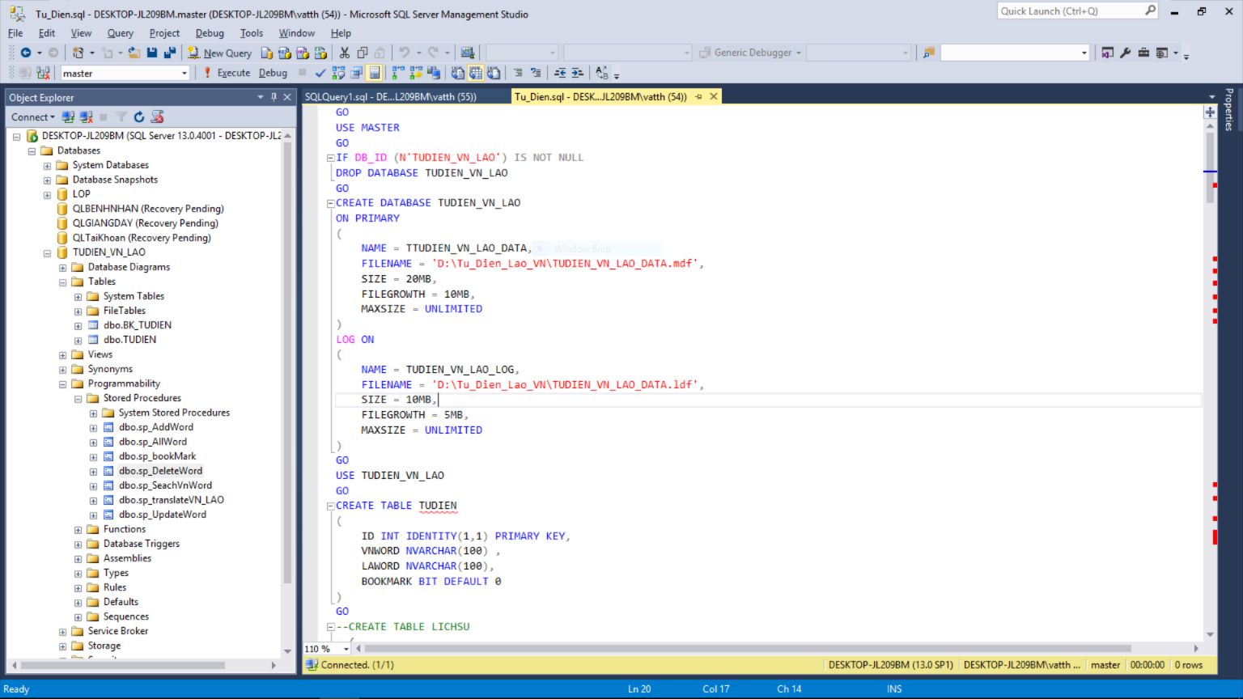

#### Microsoft SQL Server (Create Database)

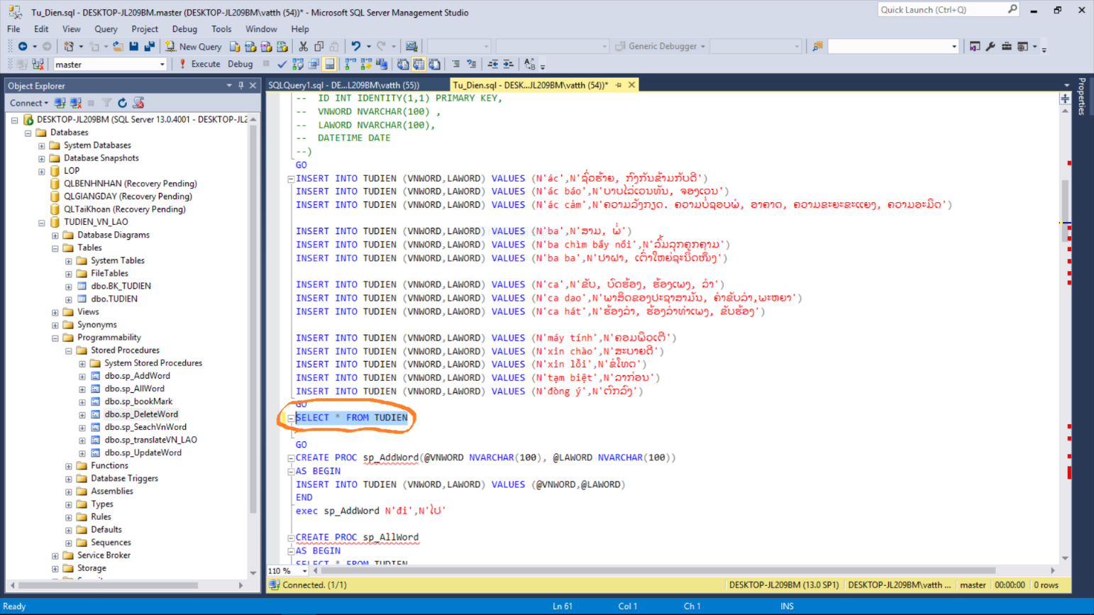

#### Microsoft SQL Server (Use SQL Select Show all words)

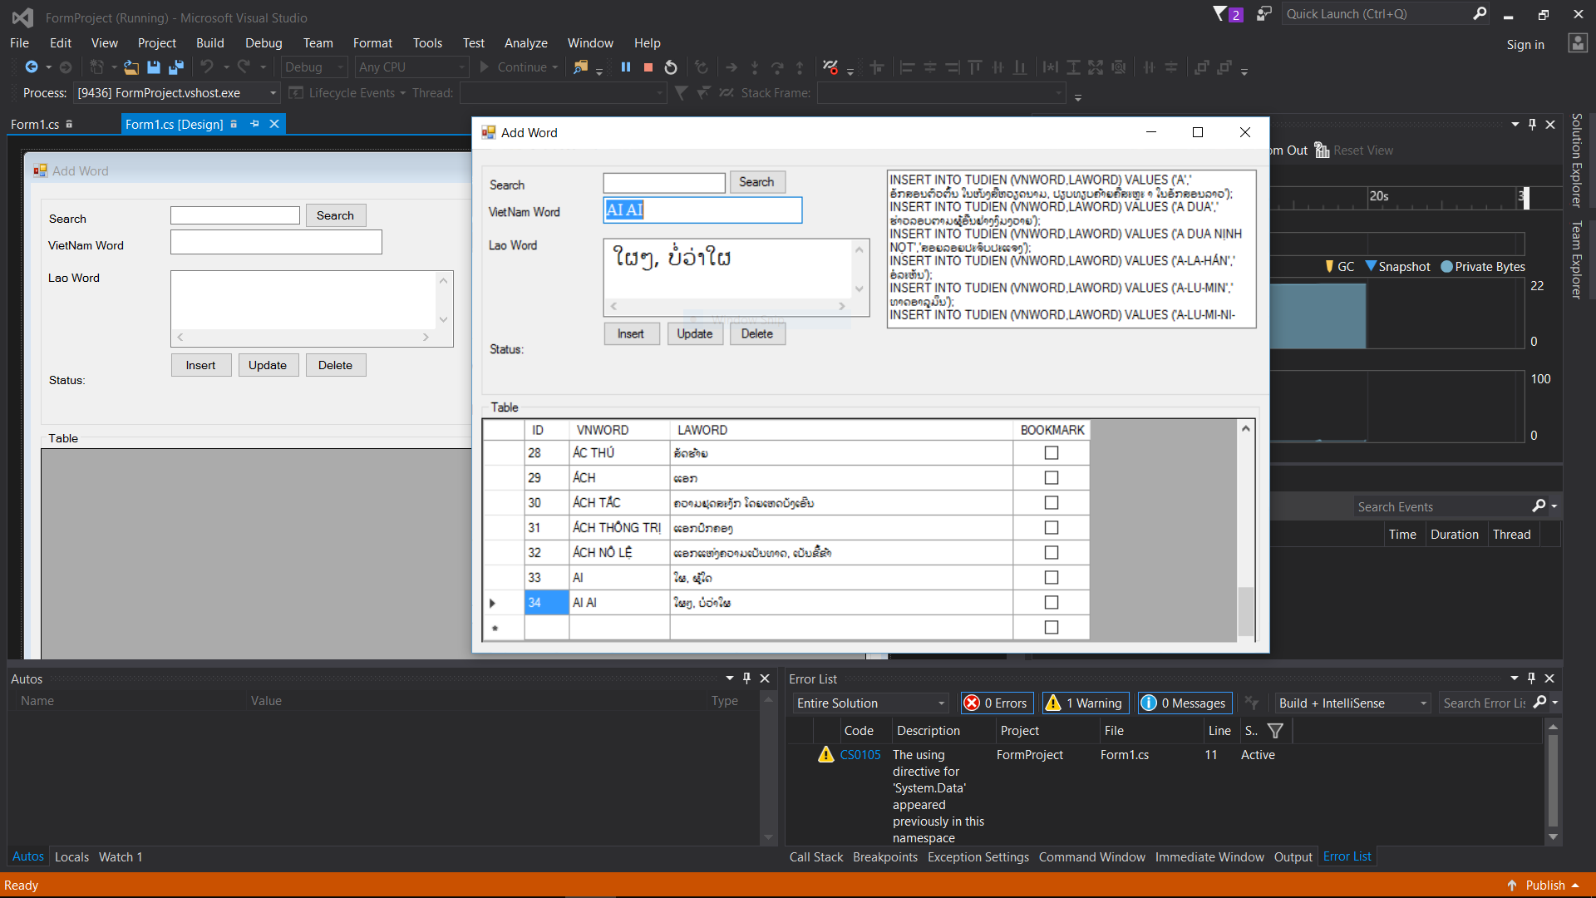

#### Visual Studio (Management Word)

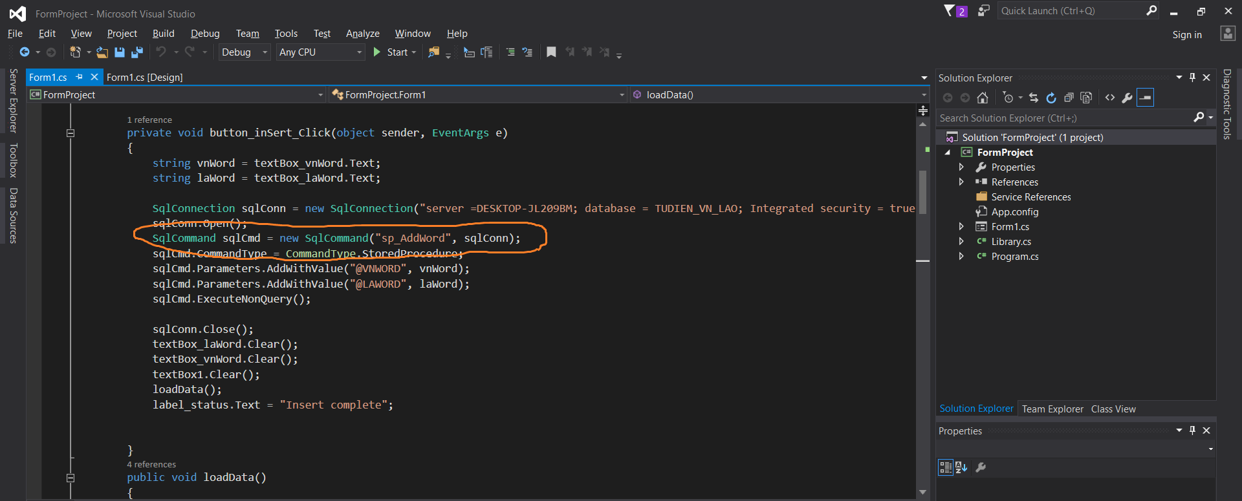

#### Visual Studio (Use stored procedure Add new word)

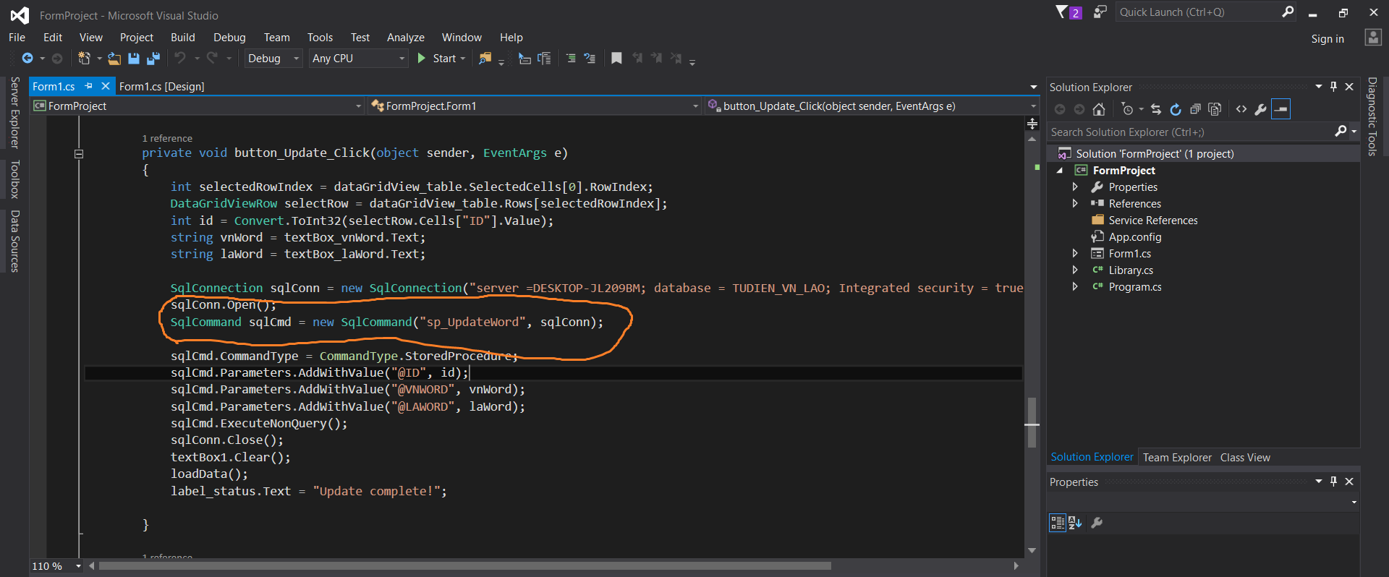

#### Visual Studio (Use stored procedure Update word)

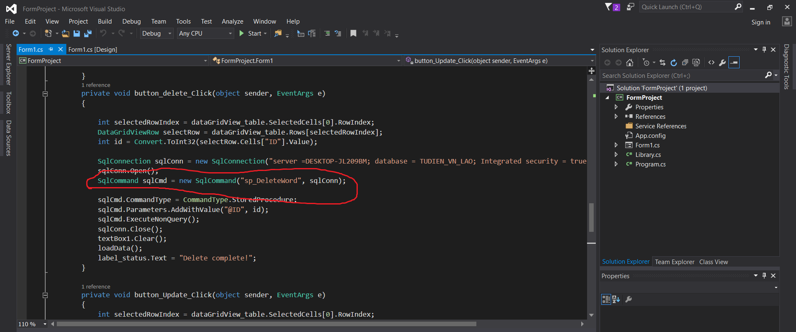

#### Visual Studio (Use stored procedure Update word)

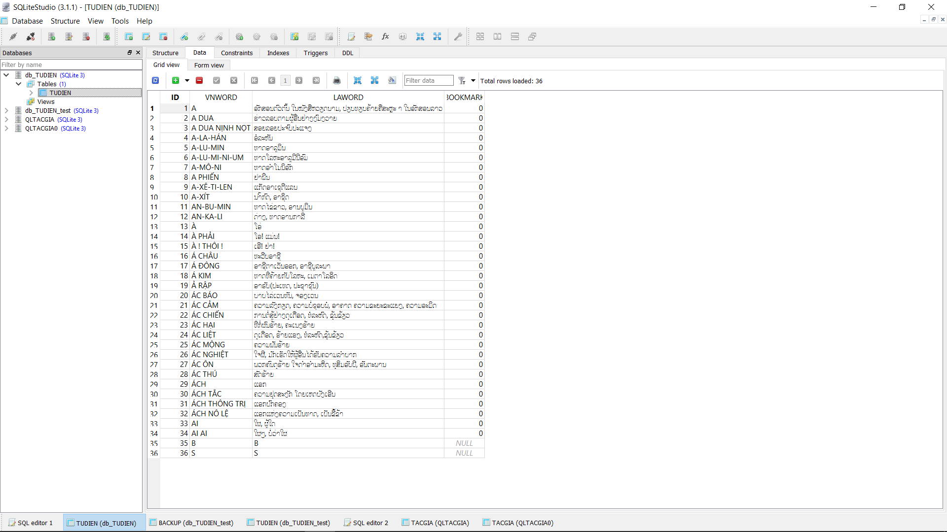

#### SQLite Studio

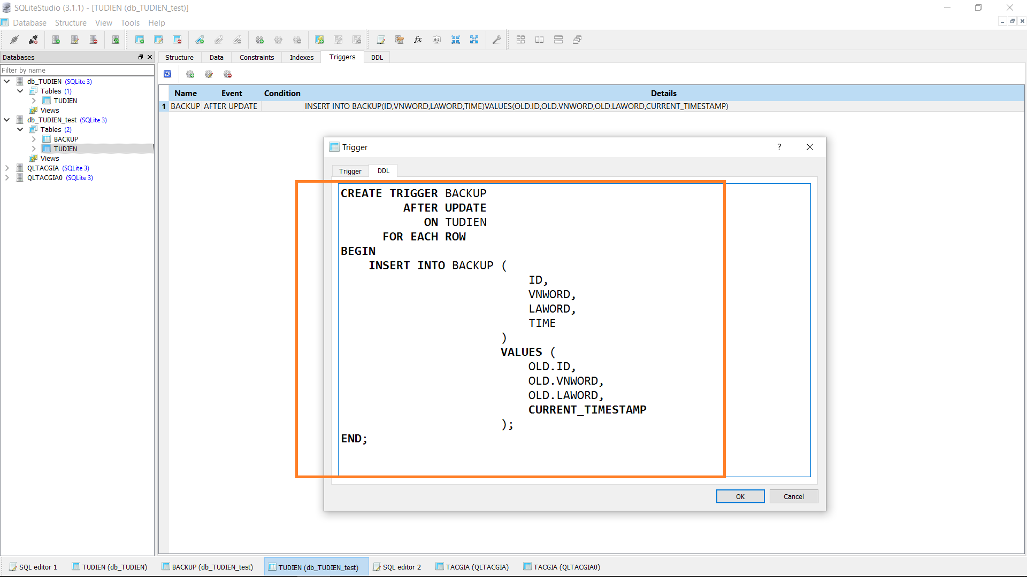

#### SQLite Studio (Use Trigger Backup Word)

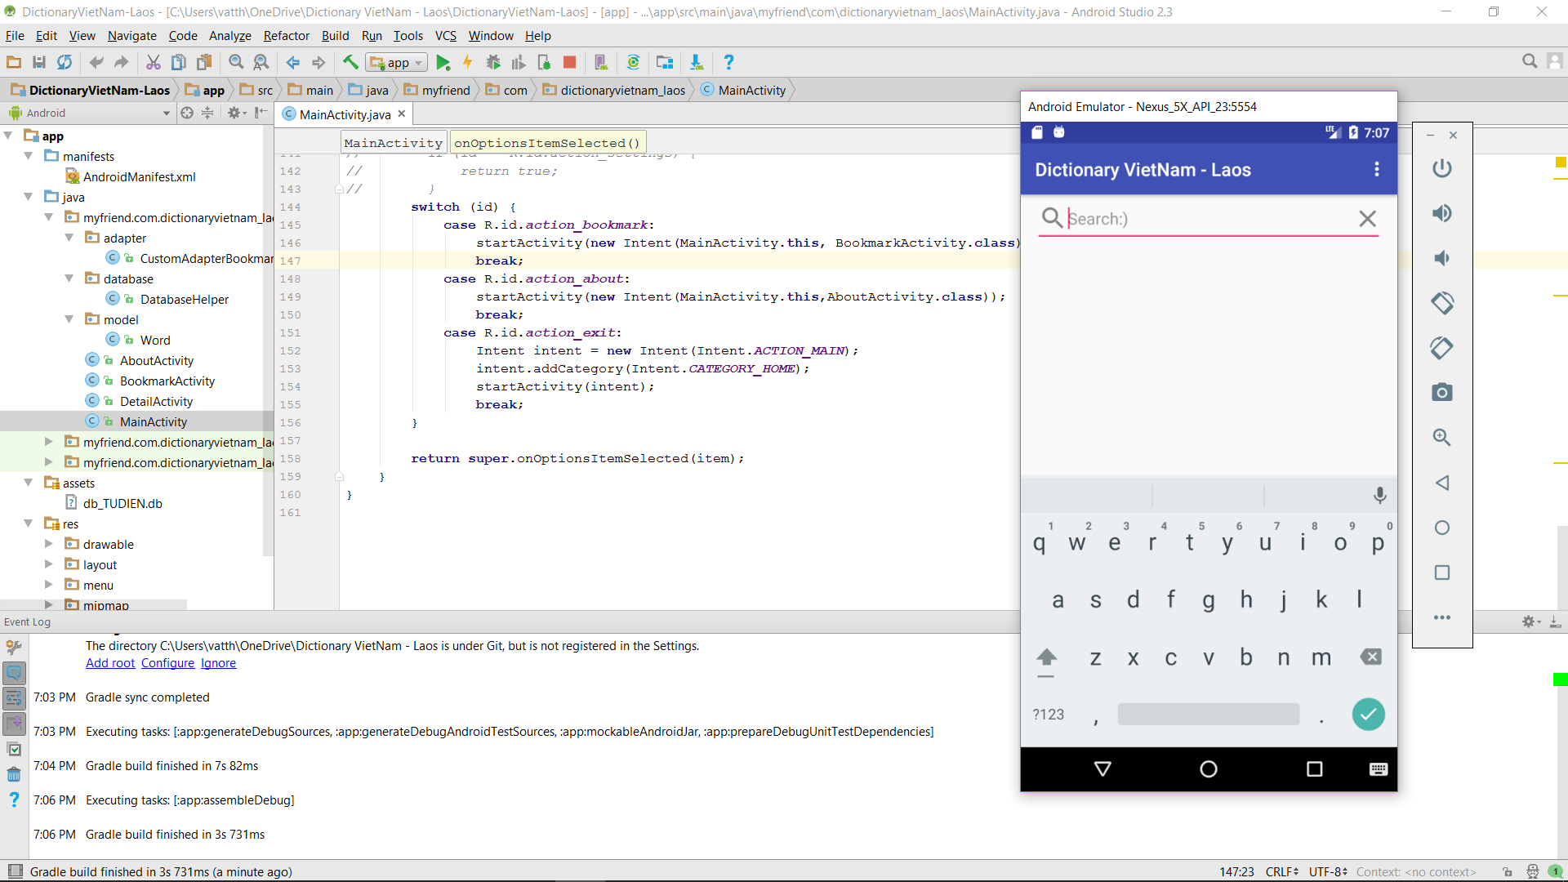

#### Android Studio

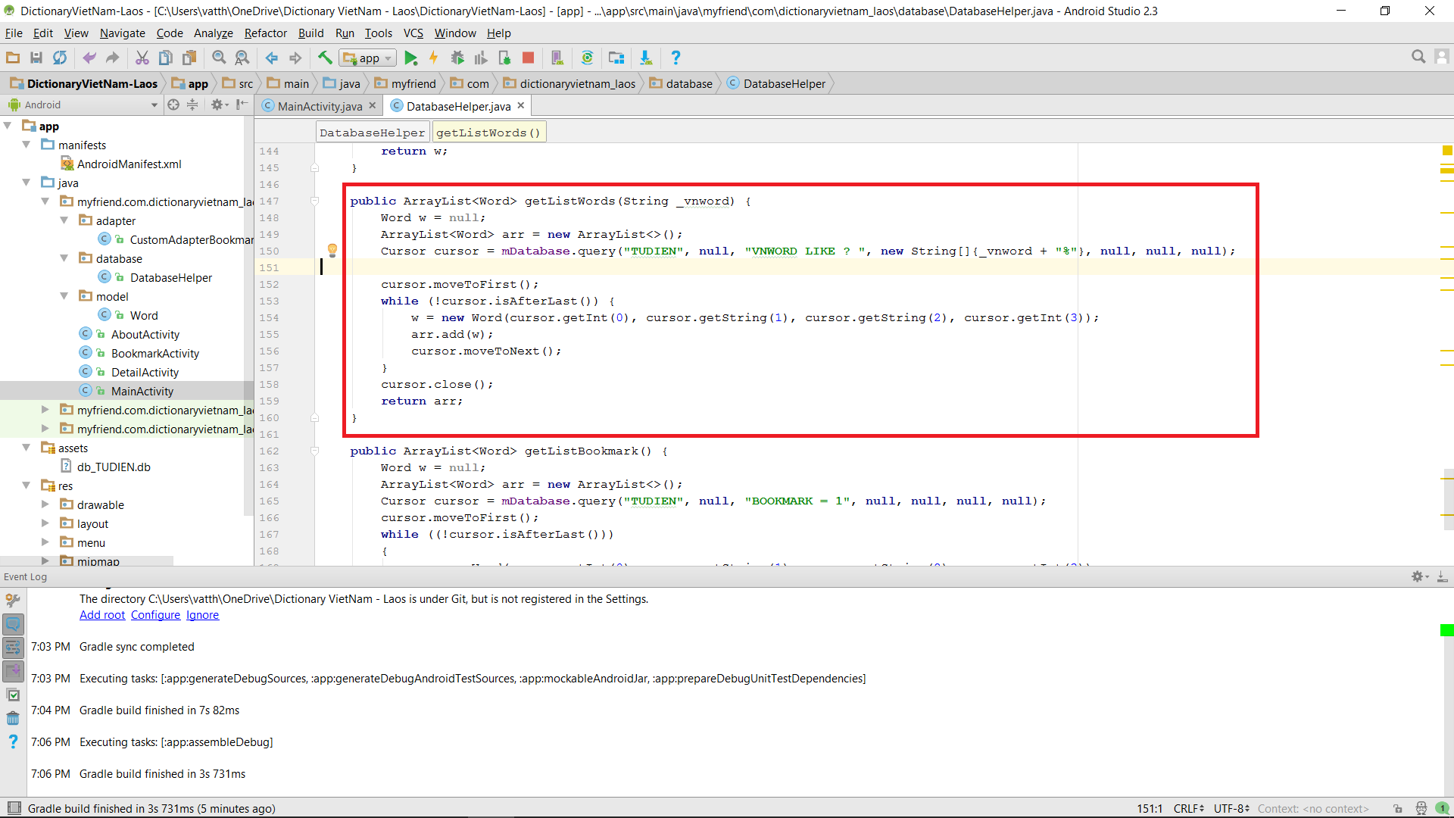

#### Android Studio (Use Search Function)

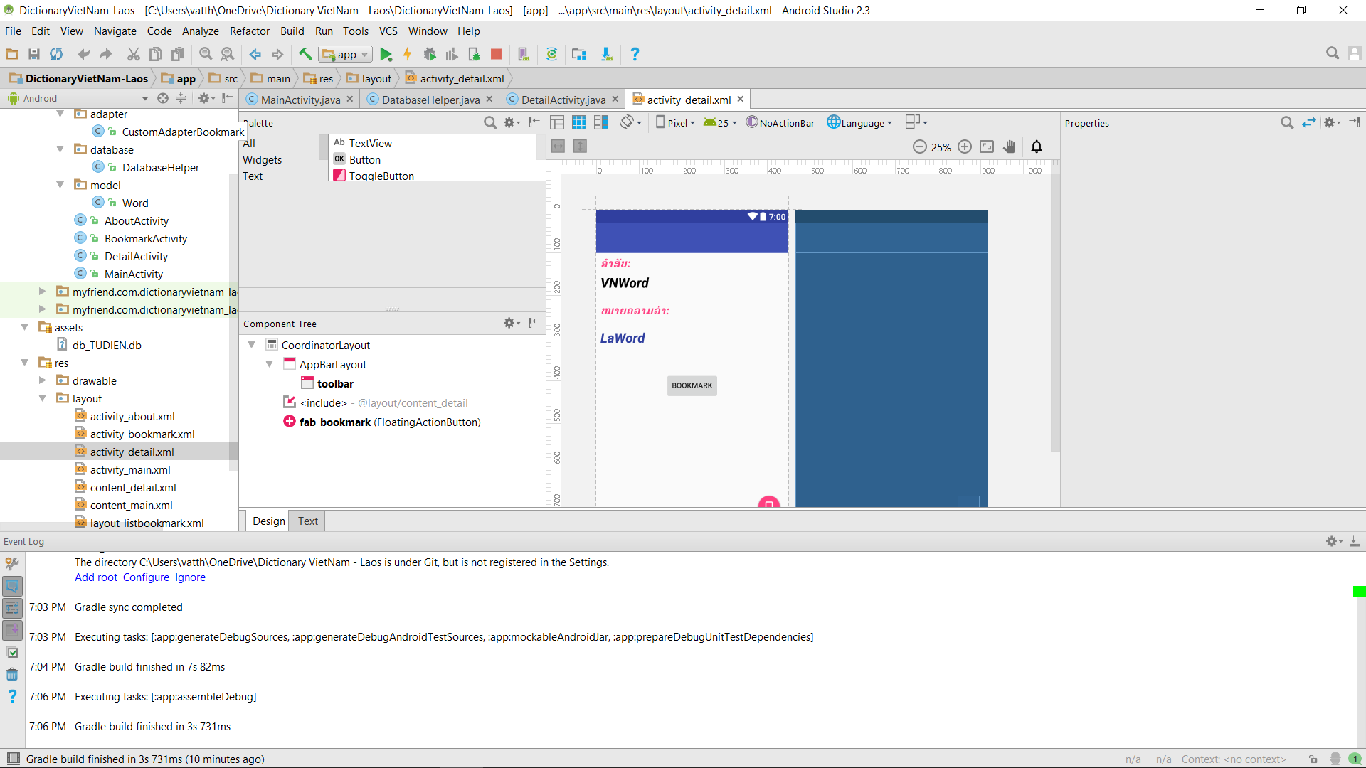

#### Android Studio (Use Translate Function)

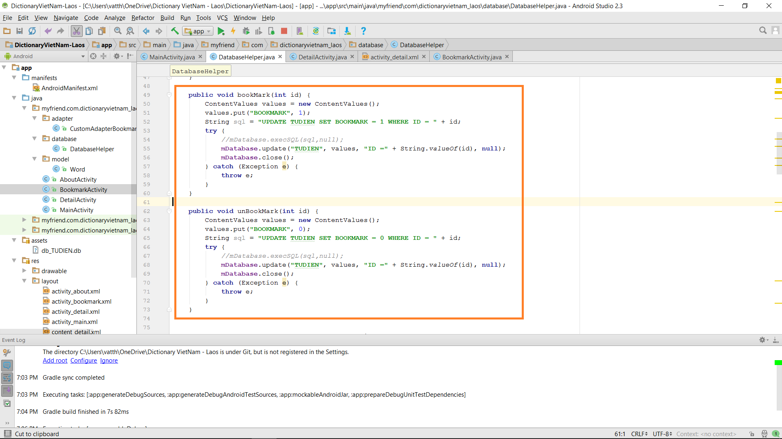

#### Android Studio (Use stored procedure Set Bookmark)