Experience & Challenges
Doing this UDP Pinger lab was a good hands-on experience for understanding the fundamentals of socket programming in Python. By writing the client script to send timestamped packets and manage a strict one-second timeout, I got a clear picture of how connectionless protocols like UDP operate without any prior handshake. Running the server locally and watching it echo back the capitalized messages helped me understand how Round-Trip Time (RTT) is calculated in real time, which is the exact same logic behind the standard ping utility we use in networking.
Ping Address:
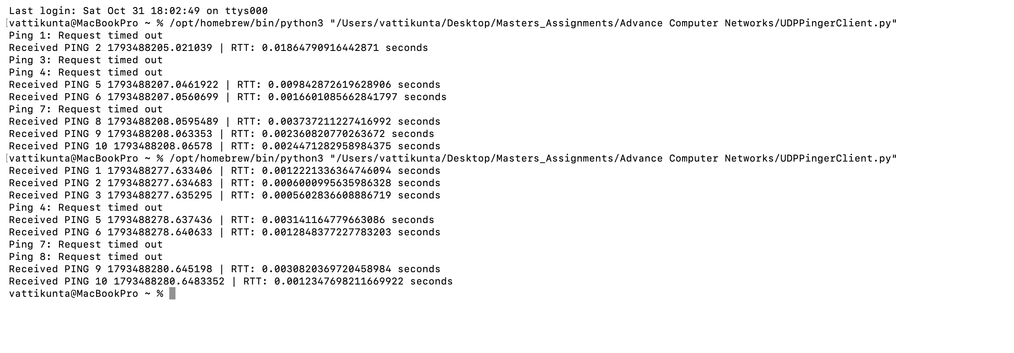
However, I did face a few minor challenges while working on it. Initially, I got stuck with a few connection errors because I forgot to keep the server running in a separate terminal window before executing the client. Once I figured out that UDPPingerServer.py needs to stay active in the background, things ran much smoother. Observing the randomized packet drops where the server intentionally dropped packets based on its random number logic was also quite interesting, as it showed how applications handle network unreliability and timeouts in the real world. Overall, this assignment was a great way to connect theoretical networking concepts with actual coding.
Error Address:


