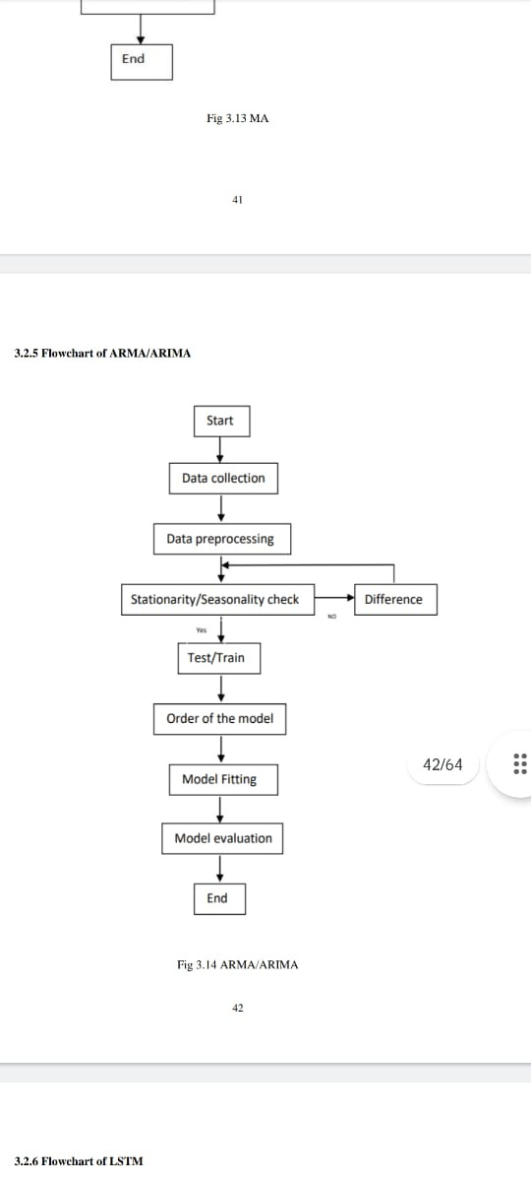

FLOWCHART ARMA/ARIMA