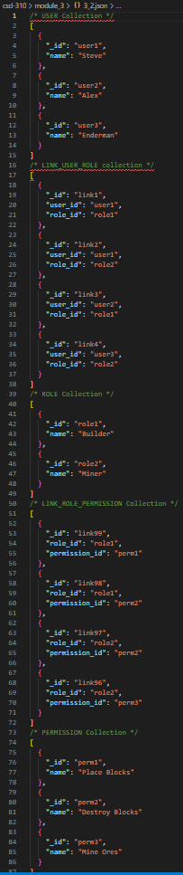A USER may have many LINK_USER_ROLEs.

A LINK_USER_ROLE must have one USER.

A LINK_USER_ROLE must have one ROLE.

A ROLE may have many LINK_USER_ROLEs.

A ROLE may have many LINK_ROLE_PERMISSIONs.

A LINK_ROLE_PERMISSION must have one ROLE.

A LINK_ROLE_PERMISSION must have one PERMISSION.

A PERMISSION may have many LINK_ROLE_PERMISSIONs.