ILOCATE: A WEB-BASED BOARDING HOUSE FINDER IN ILOILO CITY USING THE HAVERSINE ALGORITHM

A Thesis Presented to

The Faculty of the College of Arts and Sciences Iloilo Science and Technology University
La Paz, Iloilo City

In Partial Fulfillment

of the Requirements for the Degree Bachelor of Science in Computer Science

by

Lindayao, Edjay C. Verdugo, Abegail Vanjo G. Prandas, Micah A.

June 2025

ILOILO SCIENCE AND TECHNOLOGY UNIVERSITY COLLEGE OF ARTS AND SCIENCES
COMPUTER DEPARTMENT
La Paz, Iloilo City

APPROVAL SHEET

This thesis, entitled ILOCATE: A WEB-BASED BOARDING HOUSE FINDER IN
ILOILO CITY USING HAVERSINE ALGORITHM prepared and submitted by Lindayao, Edjay C., Verdugo, Abegail Vanjo G., Prandas, Micah A. in partial fulfilment of the requirements for the degree of BACHELOR OF SCIENCE IN COMPUTER SCIENCE, is hereby approved.

CHRISTIAN LESTER D. GIMENO, MSCS
ADVISER

It has passed the final defense on March 27, 2025

and approved by the defense Committee on March 27, 2025, with a grade of PASS. PANEL OF EXAMINERS

ERNEST ANDREIGH C. CENTINA, MSCS
Chairman

GABAWA, LORETO JR. G. TRACY N. TACUBAN, DIT
Panel Member Panel Member

Accepted and approved in partial fulfilment of the requirements for the degree BACHELOR OF SCIENCE IN COMPUTER SCIENCE.

JOYCE F. JAMILE, MSCS TRACY N. TACUBAN, DIT
Head, Computer Department Dean, College of Arts and Sciences
Date: Date:

ACKNOWLEDGMENT

The researchers would like to express their sincere gratitude to all individuals and institutions whose invaluable support and guidance made the completion of this thesis, ILOcate: A Web-based Boarding House Finder in Iloilo City using the Haversine Algorithm, possible.
First and foremost, the researchers would like to sincerely thank Mr. Christian Lester D. Gemino, research adviser, for his expert feedback, and continuous encouragement in the development and success of this research. The researchers also acknowledge the valuable contributions of the panel members — Mr. Ernest Andreigh C. Centina, Mr. Loreto G. Gabawa Jr., and Dr. Tracy N. Tacuban, whose constructive feedback, and academic expertise greatly enhanced the depth of this study. Likewise, sincere thanks are extended to Ms. Joyce F. Jamile, Department Head of the Computer Department, providing a supportive environment throughout our thesis journey.
Moreover, we would like to express our appreciation to the Iloilo City Boarding House Commission, as well as the boarding house owners and student tenants who generously shared their time and valuable insights during the data collection process.
Lastly, we would like to thank and congratulate BSCS 4-A Batch 2025 for achieving this far, and our beloved parents for the unconditional love and support. Above all, we thank God Almighty for giving us strength and courage in completing this study.
Ad astra per aspera. To the stars through difficulties.

E. Lindayao · A.V. Verdugo · M. Prandas

ILOCATE: A WEB-BASED BOARDING HOUSE FINDER IN ILOILO CITY USING THE HAVERSINE ALGORITHM
Lindayao, Edjay C. Verdugo, Abegail Vanjo G. Prandas, Micah A. Researchers
Christian Lester D. Gimeno Adviser

ABSTRACT
Finding suitable boarding houses remains a common challenge for students and workers relocating to Iloilo City due to limited availability, lack of advertisement, and outdated digital platforms. To address this issue, this study developed ILOcate: A Web- based Boarding House Finder in Iloilo City that helps tenants locate affordable, verified accommodations near their desired location. The system utilizes the Haversine Algorithm to calculate accurate distances between user and boarding house coordinates and integrates Google Maps API to provide real-time geospatial mapping and navigation.
The application allows landlords to register their properties, including business permit verification, pricing, amenities, photos, and exact GPS location. It also includes administrative features enabling the Iloilo Boarding House Commission to monitor, verify, or close listings, and tenants to file complaints. The system's effectiveness was evaluated using the ISO 25010 software quality model, yielding an overall mean rating of 4.5 (Excellent), while user acceptability testing resulted in a 4.68 overall mean (Excellent), highlighting strong functionality, usability, and performance efficiency.
ILOcate serves as a comprehensive digital solution that enhances transparency, accessibility, and user experience in boarding house selection—bridging the gap between tenants and landlords in Iloilo City through reliable map-based services.

 | TABLE OF CONTENTS
 |  | Page
TITLE PAGE |  | i
APPROVAL SHEET |  | ii
ACKNOWLEDGEMENT |  | iii
ABSTRACT |  | iv
TABLE OF CONTENTS |  | v
LIST OF FIGURES |  | viii
LIST OF TABLES |  | ix
LIST OF SCRIPTS |  | x
LIST OF APPENDICES |  | xi

Chapter

- INTRODUCTION
Background of the Study 1
Statement of Objectives 4
Conceptual Framework 5
Definition of Terms 6
Significance of the Study 8
Scope and Limitation 9
- REVIEW OF RELATED LITERATURE
Haversine Algorithm 11

Google Maps API 12
Utilization of Recommender System with 13
Ranking Algorithm
HAYBOL: An Android-Based Apartment 14
Locator Application
Board Me App: A Mobile Application for 15
Finding Boarding Houses the in University Belt
Bhouse Web Search Application 16
ISO 25010 17
- METHODOLOGY
Project Description 19
Software Development Methodology 20
Requirement Analysis, Phase 21
Design Phase 22
Development Phase 22
Deployment Phase 23
Project Design 24
Testing and Evaluation 35
- RESULT AND DISCUSSION
Locate and display the nearest boarding houses 38
in Iloilo City from the user’s input location
Provide detailed information about the boarding houses, 40
including the amenities, images, location, prices, and descriptions

Register verified boarding houses with a business 43
clearance and permit certification;
Allow the Iloilo Boarding House Commission to register 46
and close the boarding house;
Allow boarding house to submit registration documents; 50
Allow tenants to report complaints to Iloilo Boarding 55
House Commission;
Evaluation of the System Based on the User 57
Acceptability Test Result
Evaluation of the Software Quality Standards 61
Based on ISO 25010 by IT Experts
- SUMMARY, CONCLUSION AND RECOMMENDATIONS
Summary 73
Conclusion 74
Recommendations 74
REFERENCES 76
APPENDICES 80
CURRICULUM VITAE 94

List of Figures

Figure Page
- The Conceptual Framework of the Study 5
- Rapid Application Development (RAD) Methodology 20
- Use Case Diagram of the ILOcate System 24
- Context Diagram of the ILOcate System 27
- Level 0 Data Flow Diagram (DFD) of the ILOcate System 27
- Activity Diagram of the Tenant 29
- Activity Diagram of the Landlord 31
- Activity Diagram of the Admin 33
- Screenshot for displaying boarding house search results 39
- Screenshot for displaying boarding house listing page, property 41
information and location mapping
- Screenshot of admin interface for verifying boarding house permit 44
- Screenshot of Administrative dashboard for boarding house 46
management and status monitoring
- Screenshot of detailed boarding house information with 47
permit verification and enforcement controls
- Screenshot of property registration form for boarding house 50
information entry
- Screenshot of map location selection and permit document 51
upload functionality
- Screenshot of report listing interface for tenant complaint submission 55
List of Tables

Table Page
- Table of Scale and Interpretation 36
- Functionality of the System 57
- Usability and User Experience of the System 59
- Summary of the User Acceptability Test 60
- Functional Suitability Evaluation Result by IT Experts 61
- Performance Efficiency Evaluation Result by IT Experts 62
- Compatibility Evaluation Result by IT Experts 63
- Usability Evaluation Result by IT Experts 64
- Reliability Evaluation Result by IT Experts 65
- Security Evaluation Result by IT Experts 67
- Maintainability Evaluation Result by IT Experts 68
- Portability Evaluation Result by IT Experts 70
- ISO 25010 Evaluation Summary of Results 71

Script | List of Scripts | Page
1 | Pseudocode of Haversine Algorithm | 28
2 | Snippet of code for implementing boarding house search | 39
3 | Snippet of code for displaying boarding house information | 42
4 | Snippet of code implementation boarding house permit verification | 45
5 | Snippet of code of Boarding House Status Management | 49
6 | Snippet of code for property registration and document submission | 53
7 | Snippet of code for tenant complaint submission | 56

List of Appendices

Appendix Page
- Survey Cover Letter to the Probable Users 81
- Cover Letter to the IT Experts for ISO 25010 Surveys 82
- Survey Cover Letter to the Boarding House Commission 83
- Respondent’s Profile and Survey Questionnaire Users 85
- Respondent’s Profile and Survey Questionnaire for 87
IT Professional Expert Based on ISO 25010
- Tabulated Result of the User Acceptability Test 90
- Tabulated Result of The System’s Quality Survey 91
Based on ISO 25010
- Grammarian Certification 93

Chapter 1 INTRODUCTION
Background of the Study

A web-based system is a software platform that uses web browsers to allow users to access and interact with programs remotely via the Internet. The fundamental goal of such systems is to provide real-time communication, data processing, and service delivery which makes them important in modern businesses. Companies like Amazon and Google use web-based technologies to provide scalable and efficient services like cloud computing and e-commerce which improve customer accessibility while lowering operating costs. Similarly, a Mapping System collects, analyzes, and visualizes geographical data to help with navigation, urban planning, and environmental management. Technologies like Google Maps and Esri are pioneers in Geographic Information System (GIS) software which uses mapping technologies to provide tools that improve decision-making through comprehensive geospatial insights that help industries such as urban development and disaster management.
A boarding house is a service that offers a place or a kind of rental room within a certain time by the agreement of the tenant and the owner of the boarding house, including at a price that has been agreed upon by both [1]. Among the community, boarding houses are a necessity that is important for many people, especially for students studying outside the area who choose boarding houses as temporary housing, and students who may have their homes located quite far from the campus where they study by renting boarding houses near campus so as not to use a lot of energy and time traveling.
Finding a suitable and affordable boarding house is a common challenge for many

students and workers who must relocate to a different city for their education or employment. In the Philippines, especially in Iloilo City, the demand for boarding houses is high due to the presence of several universities and industries. However, the supply of boarding houses is limited and often not well-advertised. There is also a lack of on-campus accommodation in most college areas, forcing students to find an apartment outside near the school [2]. People may have to spend as much time as feasible with their sightseeing to learn something about the rental house closest to the institution where they wish to live. When choosing a dormitory or boarding house for university students in the Philippines, location and price are the two most important factors.
People in the target area can’t easily find a rental house because of the lack of details regarding the location of each rental house, and could not find an affordable rental house immediately. From there, finding rental houses is considered a challenging task, especially when a tenant doesn’t know more about a specific place. Furthermore, according to the homeowners based on the prior survey, an online site must be needed to promote their rental houses to gain a lot of profit since the other websites only focused on hotels.
Despite the availability of online resources, locating suitable boarding houses remains unmanageable due to outdated interfaces and limited functionalities. Current solutions lack real-time updates on availability, making it challenging for users to secure accommodations promptly. This issue is demonstrated in research conducted by Hadwen and Fänge et al., emphasizing the need for innovative approaches to address the inefficiencies in existing systems.
To address these challenges, the researchers developed a web application entitled ILOcate: A Web-based Boarding House Finder in Iloilo City using the Haversine

Algorithm, to help tenants find boarding houses in Iloilo City that match their preferences and budget. The web also benefit landlords who want to reach more potential tenants and increase their occupancy rate. To support the mapping system, a Geographic Information System (GIS) that integrates spatial data with geospatial and geographic data is required [3]. Geographical Information Systems, also known as Geospatial Information Systems (GIS), are a set of tools for capturing, storing, analyzing, managing, and presenting data associated with geographical locations. The GIS Provider enables geo-specific functionality for applications such as map information, map visualization, and directory services.
In order to display the map view on a website, the researchers also made use of the capabilities provided by Google Maps API 3. With aerial imagery and thorough street data, Google Maps offers a responsive and user-friendly mapping interface [4]. Satellite imagery on a map is displayed by Google Maps using latitude and longitude. It involves having access to a Google map that points to the apartment that is listed on the application. It provides users with the ability to determine whether the registered apartment has a business permit, as opposed to the current system. A feature that sets it apart is GPS mapping, which lets the landlord manually or through the use of the Global Positioning System (GPS) register the exact location of their boarding house on Google Maps. Important information is also available, like the owner's contact information, visit reservation, monthly rent, complete address, amenities, and sample images encoded in the system. It also has a web application for the administrators, which is the Iloilo Boarding House Commission, to validate the legality of the business by verifying information about business permits and clearances. Furthermore, a haversine algorithm is used by the system to compute and

analyze the distance between two coordinates in addition to using Google Maps API 3. Using the Haversine algorithm, distance can be measured and estimated more effectively during proximity [5].

Statement of Objectives

Generally, the study aimed to design and develop a web application of Boarding House Finder called “ILOcate” for tenants and landlords in Iloilo City using the Haversine Algorithm with the implementation of Google Maps API.

Specifically, This study aimed to answer the following objectives:

- locate and display the nearest boarding houses in Iloilo City from the user’s input location;
- provide detailed information about the boarding houses, including the amenities, images, location, prices, and descriptions;
- register verified boarding houses with a business clearance and permit certification;
- allow the Iloilo Boarding House Commission to register and close the boarding house;
- llow boarding house to submit registration documents;

- allow tenants to report complaints to the Iloilo Boarding House Commission; and
- evaluate the validity and reliability of the system’s output through ISO 25010 software quality standards.

Conceptual Framework









Evaluate the system using ISO 25010

ILOcate: A Web-based Boarding House Finder
in Iloilo City using Haversine Algorithm
Output
Tenant:
- Browse & filter listings (location/price)
- Book visits → Pay on-site
- Report issues
Landlord:
- Submit & manage listings
- Handle bookings
- Get verified
Admin:
- Verify landlords
- Moderate listings/reports
Process
- Title, Address, Description, Photos
- Price, Rooms, Amenities
- Location (map), Permit
Tenant: Personal Information Landlord: Personal Information, (Image Profile with Id)
Boarding House:
•
Search:
- Location (km radius) [Haversine]
- Price range
- Amenities
Users:
- ​
Input
Figure 1. Conceptual Framework of ILOcate: A Web-based Boarding House Finder in Iloilo City using Haversine Algorithm
The conceptual framework of the ILOcate web application outlines a clear process for connecting tenants and landlords in Iloilo City through a user-friendly system. Users, including both tenants and landlords, provide key information such as names, contact details, and boarding house specifics like title, address, price, amenities, and photos. Tenants can search for boarding houses based on location (proximity in kilometers), price range, and amenities. Once a user inputs their desired search criteria, the Haversine formula is used to calculate the distance to available properties, filtering results to show only those within the selected radius. Landlords are required to create an account and submit valid permits for verification. Tenants can then schedule visits and make payments on-site. The application ensures that all steps, from registration to verification meet high standards as outlined by ISO 25010, guaranteeing reliability and functionality for users.

Definition of Terms

To easily understand the terms used in this study, the following terms are defined:

Boarding House. A boarding house is a type of accommodation facility that provides temporary residence to individuals for a specific period, usually in exchange for rent, and typically includes shared common areas such as kitchens or bathrooms [6].
In this study, a boarding house refers to a place where individuals, typically students or young professionals, rent rooms and often share common areas like kitchens and bathrooms.
Haversine Algorithm. The Haversine Algorithm is a computational method based on the Haversine Formula, used to determine the distance between two points on a sphere's surface, typically applied in geospatial calculations [7].
In this study, the Haversine Formula is used to calculate the shortest distance between two points on a sphere, enabling the system to display the nearest boarding house within a given location.
Google Maps API 3. Google Maps API 3 is a web-based application programming interface (API) provided by Google, offering developers access to mapping services, including displaying maps, retrieving location data, and integrating various functionalities into web and mobile applications [8].
In this study, Google Maps API 3 is utilized within the "ILOcate" application to

provide users with interactive maps displaying the locations of boarding houses in Iloilo City and facilitating navigation.
Geographic Information System (GIS). A Geographic Information System (GIS) is a system designed to capture, store, manipulate, analyze, manage, and present spatial or geographical data, enabling users to understand, interpret, and visualize relationships, patterns, and trends in geographic information [9].
In this study, GIS refers to the underlying technology utilized to intethe grate spatial data and provide mapping functionalities within the "ILOcate" application, enhancing the accuracy and usability of location-based services.
Location. Location refers to a specific point or area identified by geographical coordinates or an address, typically represented by latitude and longitude coordinates on a map [10].
In this study, location pertains to the geographical positioning of boarding houses within Iloilo City, which is essential for accurately presenting available accommodations to users through the "ILOcate" application.
Tenant. A tenant is an individual or entity who occupies or rents a property, such as a residential unit or commercial space, from a landlord in exchange for monetary payment [11].
In this study, a tenant interacts with a software application or system by creating an account on the web app and utilizing it to find available boarding houses.
Landlord. A person or organization that owns a building or an area of land and is

paid by other people for the use of it [12].

In this study, landlords denote property owners who list their boarding houses on the "ILOcate" application to attract potential tenants in Iloilo City.

Significance of the Study

The web application ILOcate utilizes the Haversine Algorithm with the implementation of Google Maps API 3 to help simplify the process of finding boarding houses in Iloilo City. Specifically, it aims to benefit the following:

Students and Workers. The study helps address the pressing need for accessible and affordable boarding houses in Iloilo City, providing students and workers with a convenient solution for their accommodation needs.
Boarding House Owners. The study provides a platform for landlords to showcase their properties, expanding their reach to potential tenants and maximizing occupancy rates.

Iloilo Boarding House Commission. The study’s access to real-time data on housing demand and availability can inform policy decisions and urban development strategies, promoting sustainable growth in Iloilo City.

Tourists. The study helps visitors to Iloilo City by locating temporary accommodations that suit their needs and preferences.

Future Researchers. This study lays the groundwork for future research in the field of housing accessibility and urban development, offering valuable insights and

methodologies for addressing similar challenges in other geographical contexts and industries.

Scope and Limitations of the Study

The goal of the study is to create a web application that will assist those living in the provinces of Iloilo in finding accommodation and boarding houses—for persons such as students or young professionals. Tenants may register on the website, look up local boarding houses, and examine relevant information like availability and room costs. The program determines the shortest path between the user's position and the available boarding places using the Haversine formula, displaying the selections that are closest. In order to list their properties, landlords must register on the website.
This study has several limitations that should be considered. First, it focuses only on Iloilo City, meaning the findings may not apply to other areas without modifications to the system. Additionally, the accuracy of the information, such as room prices and availability, relies on landlords keeping their data up to date. If landlords do not update their listings, the results shown to users may be incorrect. The application also depends on Google Maps and GIS for location data, and any errors or changes in these tools could affect the system's performance. Since the platform is web-based, it requires users to have a stable internet connection, which may limit access for those with poor connectivity or in remote areas. The verification of business permits for boarding houses also depends on the Iloilo Boarding House Commission updating their records, which could cause delays. Moreover, the system assumes users are familiar with technology, which might be a challenge for individuals who are not tech-savvy. The availability of boarding houses might

not always be real-time, meaning some rooms could be booked by the time users try to reserve them. Lastly, the study does not address the legal and financial aspects, such as rental agreements or concerns about data privacy, which could be important for users. Although the system can accommodate both short-term and long-term rentals, it mainly focuses on the immediate needs of students and young professionals. These limitations provide areas for future improvement in the system.

Chapter 2

REVIEW OF RELATED LITERATURE

This chapter presents the relevant literature and studies that the researcher considered to enhance the significance of the current study. It also offers a synthesis of the art to fully grasp the research for improved comprehension of the study. Through this review, the researchers aimed to establish connections, identify gaps, and build upon the existing knowledge to advance the understanding of the research topic.

Haversine Algorithm

The Haversine algorithm is a mathematical technique that calculates the shortest distance between two places on the surface of a sphere using their latitude and longitude coordinates [13]. It is commonly used in navigation and mapping applications, particularly geographic information systems (GIS) and global positioning systems (GPS). In contrast to simpler computations based on flat surfaces, the formula takes into account the Earth's curvature, allowing for precise distance measurements between two places over wide expanses. This technique has proven useful in a variety of applications, including estimating the proximity of geographic sites, optimizing routes, and evaluating spatial data. The Haversine formula's accuracy and simplicity make it an essential tool in industries that require exact distance calculations, such as geospatial science, logistics, and urban planning.

In this study, the Haversine algorithm is used in the ILOcate web app to precisely calculate the distance between a user's present position and neighboring boarding houses

in Iloilo City. By combining this algorithm with the Google Maps API, our online application gives users real-time proximity data, allowing them to locate the best boarding house options based on their tastes and budgets. The algorithm ensures that the presented distances are accurate, which improves the app's overall user experience and functioning. Furthermore, incorporating the Haversine algorithm supports the app's primary goal of facilitating successful and efficient boarding home searches, thereby meeting the demands of both tenants and landlords.
Google Maps API

Garude and Haldikar [14] describe the Google Maps API as a versatile tool widely used in location-based services and mapping applications. It allows developers to embed interactive maps within applications, offering features such as geocoding, routing, and real- time traffic updates. Its applications range from navigation systems to urban planning and location-based marketing. Prasetyo et al. [15] explain that integrating the Google Maps API involves acquiring an API key, setting map parameters, and utilizing Kotlin and Java functions to enable dynamic map display and interaction. The core idea is to leverage Google’s extensive geographic data repository to deliver accurate and real-time location information. By integrating this tool, developers can significantly improve user experience through efficient location search and visualization.
Beside the use of Google Maps API displaying the map view, calculating the distance will be integrated by using the Haversine Algorithm as stated by Nichat [16], it is a fundamental tool in geographical calculations which is widely used in a variety of applications, including calculating the distance between two points on Earth's surface. With

its precise mathematical formulation, this algorithm allows for accurate distance measurement while taking into account the curvature of the Earth, providing critical insights for navigation, logistics, and location-based services. Its implementation uses trigonometric functions to calculate the great-circle distance between two geographical coordinates. Using the Haversine Algorithm can improve the efficiency and accuracy of location-based services, allowing for more informed decision-making and optimizing resource allocation strategies in urban environments.
By utilizing the implementation of Google Maps API together with the Haversine Algorithm, the researchers seek to provide accurate geographic information and location of boarding houses located in Iloilo City. This study aims to develop a web application to implement the integration of Google Maps API for mapping functionalities and employing the Haversine Algorithm for precise distance calculations. Then, the researchers would utilized JavaScript functions to dynamically render maps and integrate the Haversine Algorithm to calculate distances between coordinates. This integration benefits the system by providing accurate geographic information and locating boarding houses in Iloilo City. Additionally, it enhances user experiences by facilitating efficient location search and visualization, displaying nearest options, provide detailed information about amenities and prices, and register verified properties.
Utilization of Recommender System with Ranking Algorithm

A Recommender System Algorithm, when combined with a Ranking Algorithm, serves as a critical tool in modern information systems [17]. These algorithms enable personalized suggestions based on user preferences, enhancing decision-making processes. Collaborative filtering and content-based filtering are commonly used

techniques, designed to recommend items aligned with user interests [18]. When applied to the search for boarding houses, these methods involve incorporating user preferences, ratings, and feedback to provide customized recommendations and streamline the search experience.
The researchers integrated this study to the proposed application which would help the user find their ideal boarding houses and provide recommendations about the existence and location of boarding houses, fares, facilities owned, and other related information based on criteria chosen by the user. To implement the recommender system algorithm in this study, the researchers gathered data on available boarding houses in Iloilo City, including details such as amenities, location, rental prices, and descriptions. Next, the researchers developed a ranking algorithm that utilizes collaborative filtering and content- based filtering techniques to suggest boarding houses that align with user preferences. This algorithm would take into account factors such as location, price, and user feedback to provide personalized recommendations. Through the integration of these techniques, the application aimed to streamline the process of finding boarding houses in Iloilo City, ultimately benefiting both tenants and landlords.

HAYBOL: An Android-Based Apartment Locator Application

Haybol is a mobile app designed for Android phones [19]. It helps users easily find apartments and boarding houses. The app offers three main systems: one for administrators, one for apartment owners, and one for tenants. It also uses GPS mapping to make navigation easier. Owners can use it to promote their properties, while tenants can search for available accommodations. HAYBOL, an Android-based apartment

locator for students and renters seeking apartments and boarding houses. The proponents used the Rapid Application Development (RAD) methodology for software development, which includes four phases, namely requirements planning, mobile application prototype, final construction, and cutover. In the testing and evaluation of the system, the research used purposive sampling and conducted two sets of questionnaires for apartment and boarding house owners and tenants. The study concludes that the proposed system is user- friendly, intuitive, efficient, reliable, and satisfactory for the target users. The system employed GPS technology for mapping, and it provides 100% coverage of the planet, easiness of navigation, and low cost, making it an easy integration into other technologies like mobile phones. The system aims to simplify the process of apartment and boarding house hunting for students and renters, and to help owners promote their businesses
In the same way, "HAYBOL" and "ILOcate: A Boarding House Finder Application using the Haversine Algorithm with Google Maps API 3" both aim to make accommodation searches easier. But "ILOcate" focuses on the Iloilo City boarding house industry, using advanced algorithms and verification techniques to offer a more complete solution. "ILOcate" provides an improved user experience and increased dependability in finding appropriate lodging options by combining the Haversine Algorithm with Google Maps API 3 for location-based searches and a Recommender System Algorithm with Ranking Algorithm for personalized recommendations.
Board Me App: A Mobile Application for Finding Boarding Houses in University Belt

In the study conducted by Abella et al. [20], titled "Board Me App: A Mobile Application for Finding Legitimate Boarding Houses in Sampaloc, Manila," a mobile application aimed at aiding users in locating legitimate boarding houses in Sampaloc,

Manila was introduced. The application's primary feature, the Boarding House Locator module, utilizes a Global Positioning System (GPS) to showcase nearby boarding houses within a 200-meter range, employing an algorithm based on the Agile-Waterfall methodology for system development. This system addresses the prevalent challenge of finding suitable and affordable boarding houses, particularly for students and workers relocating to different cities for education or employment.
However, in contrast to this study, "ILOcate," focuses on aiding tenants and landlords in Iloilo City, however both applications employ GPS-based systems for locating boarding houses, "ILOcate" introduces additional functionalities such as a Recommender System Algorithm with Ranking Algorithm and Sentiment Analysis for tenants, detailed information provision about boarding houses including amenities and prices, and a registration system for verified boarding houses with business clearance and permit certification. Moreover, "ILOcate" enhances user experience by integrating a mapping system using the Haversine Algorithm with the implementation of Google Maps API 3, ensuring more accurate distance computation and effective proximity estimation. Thus, while both studies offer solutions to the challenge of finding suitable boarding houses, "ILOcate" distinguishes itself by providing a comprehensive and user-friendly platform tailored specifically for the Iloilo City community, with enhanced features and improved accuracy in distance computation.

Bhouse Web Search Application

The study titled "Boarding House Search Web Application" by Benitez et al. introduces a software solution aimed at facilitating the search for boarding houses in La

Paz, Iloilo, via mobile phones and personal computers. Key features include registration and management of boarding house owner accounts, searching for accommodations based on budget and location preferences, and evaluation according to ISO 25010 standards. The system implements verification of owner data, account management functionalities, and detailed boarding house information.
This study is similar to the proposed application "ILOcate: A Boarding House Finder Application," addresses challenges faced by tenants in Iloilo City, leveraging the Haversine Algorithm and Google Maps API 3 for location-based searches. However, unlike the existing system, this application integrates a Recommender System Algorithm, enhancing user experience by providing personalized recommendations. Additionally, the system ensures the verification of boarding houses through business clearance and permit certification, fostering trust and reliability. Unlike its prior study, this application does not solely rely on manual verification processes, thus streamlining the search process and enhancing user confidence in the platform.

ISO 25010

ISO/IEC 25010 is an international standard that defines a comprehensive quality model for software products and systems. It establishes a framework for evaluating software quality through eight key characteristics: functional suitability, performance efficiency, compatibility, usability, reliability, security, maintainability, and portability. Each characteristic is further broken down into sub-characteristics that provide a deeper understanding of how software quality can be systematically measured and improved. This model supports the development and assessment of software by ensuring that it meets both functional requirements and non-functional expectations across various usage contexts.

In this study, the researchers adopted the ISO 25010 quality model to evaluate the ILOcate mobile application in terms of overall system performance and user experience. The model was used to guide expert evaluations by IT professionals, focusing on the following quality characteristics: functional suitability, performance efficiency, compatibility, usability, reliability, security, maintainability, and portability. These criteria were selected to ensure that the ILOcate application not only delivers accurate and relevant boarding house information but also performs efficiently, supports user needs, and maintains adaptability across various devices and environments. By aligning the evaluation with ISO 25010 standards, the study ensures that the system achieves a high level of quality, dependability, and user satisfaction.

Chapter 3 METHODOLOGY
This chapter outlines the methodological approach used in the research. It details the project description, and its development process including requirement analysis and design specification, followed by the testing and evaluation procedures. The chapter also introduces the data gathering instrument, its validity, the targeted respondents, and the data processing and statistical tools employed for analysis.
Project Description

The web application "ILOcate" is designed to address the challenges faced by tenants and landlords when searching for and managing boarding houses in Iloilo City. The application leverages the Haversine Algorithm and Google Maps API 3 to offer real-time, geo-specific information, enhancing the user experience through accurate distance calculations and interactive mapping features. This innovative solution addresses the current inefficiencies in finding suitable and affordable boarding houses, particularly for students and workers relocating to the city.
To meet the varied needs of its users, "ILOcate" provided comprehensive details about each boarding house, including amenities, images, location, rental type, prices, and descriptions. The system ensures that all registered boarding houses are verified, with necessary business clearances and permits, thus enhancing trust and reliability. This application not only benefits tenants in finding appropriate accommodations but also aids landlords in increasing their occupancy rates by reaching a wider audience.
The development of "ILOcate" adheres to ISO 25010 software quality standards, ensuring the system's output is both valid and reliable. The project integrates geographic

information systems (GIS) with Google Maps API 3 to provide a responsive and user- friendly interface. The application aims to revolutionize the current boarding house search process in Iloilo City by providing up-to-date and accurate information, thus facilitating a seamless and efficient user experience.
Software Development Methodology


The researchers utilized the Rapid Application Development (RAD) methodology to develop ILOcate, a web application designed to streamline the search for boarding houses in Iloilo City, due to its iterative nature that facilitates rapid prototyping and feedback cycles.
Figure 2. Rapid Application Development (RAD) Methodology that serves as basis for developing ILOcate Web Application

Rapid Application Development

This study employed the Rapid Application Development (RAD) prototyping model to develop the Android application ILOcate. RAD's iterative approach is particularly well-suited for projects with evolving requirements, such as those encountered in the Iloilo City boarding house market. This method allows for continuous user feedback and adaptation, ultimately leading to a more robust and user-friendly application. Additionally,

RAD emphasizes quality assurance throughout the development lifecycle, ensuring ILOcate is a reliable solution.
Rapid Application Development, or RAD, is a software development methodology that prioritizes speed and adaptability. Unlike traditional methods with lengthy planning phases, RAD emphasizes iterative development cycles. This means the project progresses through smaller, focused stages where functional prototypes are built, tested, and refined based on user feedback. These rapid prototyping cycles allow developers to quickly identify and address any issues early on, ensuring the final product aligns with user needs. RAD is particularly well-suited for projects with evolving requirements or tight deadlines. By focusing on core functionalities first, a usable product can be delivered quickly, and subsequent iterations can incorporate additional features based on user feedback. This iterative approach fosters a collaborative environment where developers and stakeholders work together to improve the application continuously. Additionally,
RAD often utilizes reusable code components, which streamlines development and reduces the risk of errors.
Requirement Analysis Phase

In this phase, the researchers meticulously planned and gathered all the necessary requirements for the proposed application, ILOcate. This involves a thorough analysis of the needs and expectations of the target users, particularly those searching for boarding houses in Iloilo City. The researchers conducted interviews, surveys, and focus group discussions to collect detailed user requirements and preferences. Additionally, the researchers reviewed existing solutions and market trends to identify gaps and opportunities for innovation. This comprehensive requirement-gathering process ensures

that the application is tailored to meet user needs effectively, providing features that enhance usability, reliability, and overall user satisfaction. By understanding and documenting these requirements, the researchers established a solid foundation for the subsequent design and development phases of the ILOcate application.
Design Phase

Following the gathering of requirements, the researchers transitioned to the prototype development phase. In this stage, the researchers created a preliminary version of the ILOcate application based on the collected requirements. Using rapid prototyping techniques, the researchers designed and implemented a functional model that provides a visual representation of the app's key features and user interface. This prototype serves as a tangible demonstration of the proposed solution, allowing stakeholders to visualize and interact with the application before full-scale development begins. Through iterative refinement and feedback loops, the prototype evolved to better align with user expectations and project objectives. Ultimately, this prototyping process facilitates early validation of design decisions, accelerates development timelines, and minimizes the risk of costly errors during later stages of development.
Development Phase

Following the completion and validation of the prototype, the development phase of the ILOcate application commenced. This stage entails the translation of the prototype into a fully functional application by the programmer. The programmer meticulously write and organize the codebase according to the defined requirements and design specifications. This process involves implementing the core features of the application and integrating various components to ensure seamless functionality. Adherence to industry-standard

coding practices and frameworks will be paramount to ensure the scalability, performance, and maintainability of the application. Throughout the construction phase, rigorous testing procedures are conducted to identify and rectify any bugs or issues. Continuous collaboration with stakeholders ensured alignment with project goals and user expectations. The objective of the construction phase is to deliver a high-quality, reliable, and user-friendly application that effectively addresses the needs of its target audience.
Deployment Phase
Once the ILOcate website is fully developed, it was prepared for public access.

This involves configuring the hosting environment, setting up domain names, and ensuring the platform is optimized for security and performance. The development team finalized any necessary backend and frontend configurations. The website then be deployed to a web server, making it accessible to users via standard web browsers. Post- deployment, the site is monitored continuously, and regular updates is provided to address any issues, enhance features, and maintain optimal performance. The ultimate goal is to ensure that users experience a seamless and efficient service when searching for boarding houses in Iloilo City.

Project Design
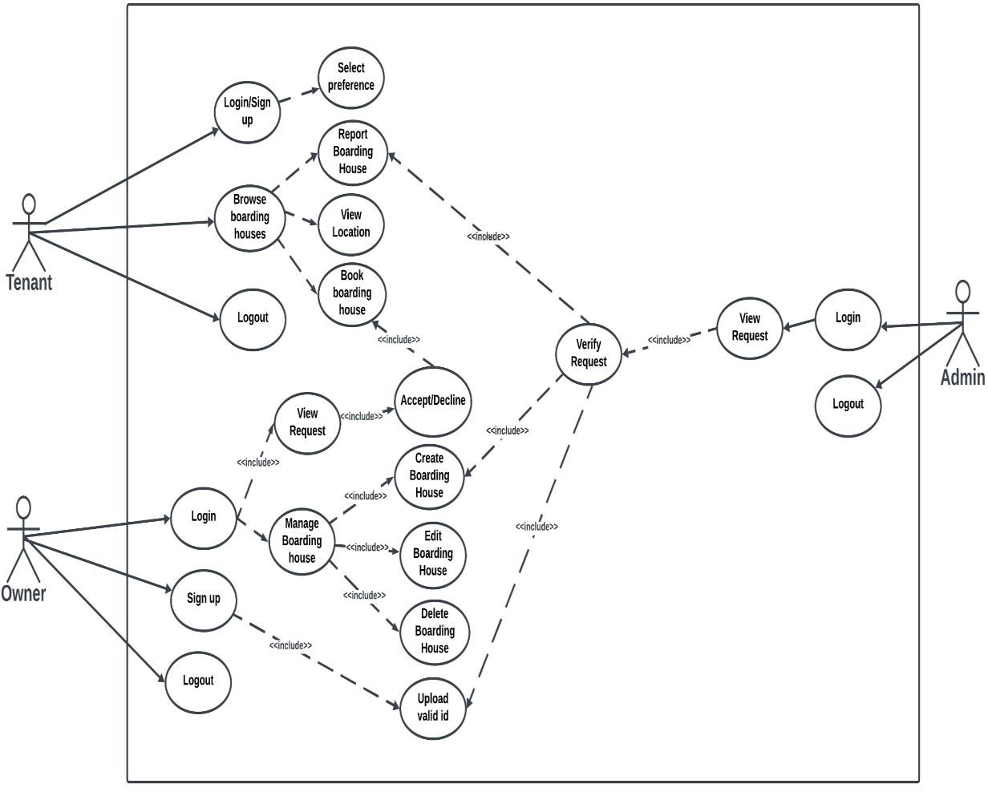
Figure 3. Use Case Diagram of the ILOcate System

Tenant Actions:

  - Sign Up

    - Enter username and password to create an account.

  - Log In

    - Enter username and password to access the system.

  - Browse Boarding Houses

    - View available boarding houses and their location in the map.

  - Input Preferences

    - Enter and preferences such as amenities and price range for a boarding house.

  - Book Boarding House

    - Select and Book a preferred boarding house.

Owner Actions:

  - Sign Up

    - Register by providing a username, password, and a valid ID.

    - Request admin approval for account activation.

  - Log In
    - Access the system using a registered username and password.

  - Post Boarding House

    - Add details and list a boarding house on the platform.

  - Manage Listings

    - Edit or remove posted boarding houses as needed.

  - Send Permit for Verification

    - Submit the necessary permits for admin approval to verify a listed boarding house.

  - Manage Tenant Requests

    - Handle tenant booking requests for boarding houses.

Admin Actions:

  - Log In

    - Access the system using an admin username and password.

  - View Requests

    - Review owner requests for boarding house verification.

    - Monitor owner account verification requests.
    - Assess tenant reports regarding boarding houses.

  - Decision-Making and Actions

    - Approve or decline boarding house listings.

    - Approve or decline owner account verification requests.

    - Review tenant reports and determine whether a boarding house should be banned.

The system is designed to facilitate efficient interactions among three primary actors: tenants, boarding house owners, and system administrators. Each actor has specific roles and responsibilities that contribute to the overall functionality and reliability of the platform.
      - Tenant: Tenants can create an account, log in, and browse available boarding houses. The system allows them to refine their search by specifying preferences such as amenities and price range. Additionally, tenants have the ability to book a boarding house and report any issues or concerns related to a listed property.
      - Owner: Boarding house owners can register and log in to the system, where they can post and manage property listings. To ensure the legitimacy of listings, owners must submit valid permits for verification. They are also responsible for handling booking requests from tenants.
      - Administrator: The system administrator oversees all platform operations to maintain its integrity and reliability. This includes reviewing and processing owner verification requests, approving or rejecting boarding house listings, and evaluating tenant reports to determine whether a property should be banned due to policy violations.

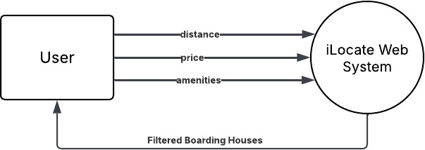
Figure 4. Context Diagram of the iLocate System

The context diagram of the ILOcate system illustrates the high-level interaction between the user and the system, emphasizing the primary data exchanges that occur during the search process. The user serves as an external entity who inputs key search criteria such as preferred distance, desired amenities, and acceptable price range. These data elements are transmitted to the ILOcate system, which functions as the central process responsible for filtering and retrieving relevant boarding house listings. Based on the user’s input, the system processes the request and returns a refined list of boarding houses that match the specified criteria. This interaction represents a fundamental use case within the system, highlighting its core functionality of providing location-based,
preference-aware recommendations to users.
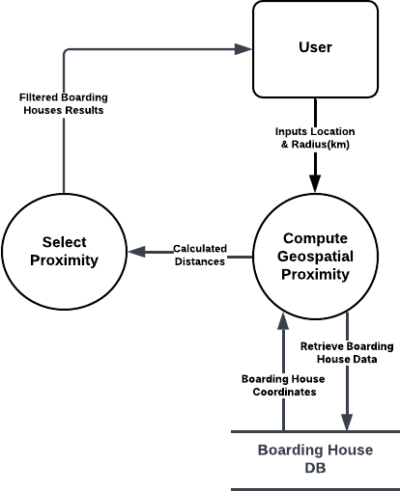
Figure 5. Level 0 Data Flow Diagram (DFD) of the ILOcate System

The Level 0 Data Flow Diagram illustrates the logical flow of data within the ILOcate system. The process begins with the User, who inputs their current location (latitude and longitude) along with a desired search radius (e.g., 1 km). This data is directed to the Geospatial Proximity Computation module, which serves as the system’s core computational component. In this step, the system queries the Boarding House Database to retrieve the geographic coordinates of all listed boarding houses. Using the Haversine formula, the module computes the great-circle distance between the user’s location and each boarding house. The Haversine formula accurately measures distance by accounting for the Earth’s curvature, converting coordinates to radians, and applying trigonometric functions to determine the shortest path over the globe’s surface. After computing these distances, they are passed to the Proximity-Based Selection, which filters out any boarding houses located beyond the user-specified radius. The remaining, relevant boarding houses—those within the defined proximity—are then presented back to the user as the final output. This integration of the Haversine algorithm ensures precise and reliable geospatial computations, enabling the ILOcate system to deliver accurate and location- relevant results efficiently.
START
// Step 1: Input Coordinates
INPUT lat1, lon1 // User's input location (latitude, longitude) INPUT lat2, lon2 // Boarding house location (latitude, longitude)

// Step 2: Convert Degrees to Radians radLat1 = DEG_TO_RAD(lat1) radLon1 = DEG_TO_RAD(lon1) radLat2 = DEG_TO_RAD(lat2) radLon2 = DEG_TO_RAD(lon2)

// Step 3: Compute Differences deltaLat = radLat2 - radLat1 deltaLon = radLon2 - radLon1

// Step 4: Apply Haversine Formula
a = SIN(deltaLat / 2)^2 + COS(radLat1) * COS(radLat2) * SIN(deltaLon / 2)^2 c = 2 * ARCSIN(SQRT(a))
earthRadius = 6371 // Earth's radius in kilometers distance = earthRadius * c

// Step 5: Output Distance OUTPUT distance
END

Script 1: Pseudocode of Haversine Algorithm

In this pseudocode shown in Illustration 1, the Haversine process begins by taking two sets of geographical coordinates (latitude and longitude) as input: one for the user’s input location and one for a boarding house. The latitude and longitude values are first converted from degrees to radians to prepare them for trigonometric calculations. Next, the differences in latitude and longitude between the two points are computed. These differences are then used in the Haversine formula, which calculates the great-circle distance between the points on the Earth's surface by determining the central angle and multiplying it by the Earth’s radius (6,371 km). Finally, the calculated distance is output in kilometers, providing an accurate measurement of proximity. This process ensures precise geospatial computations while maintaining simplicity and clarity in its implementation.
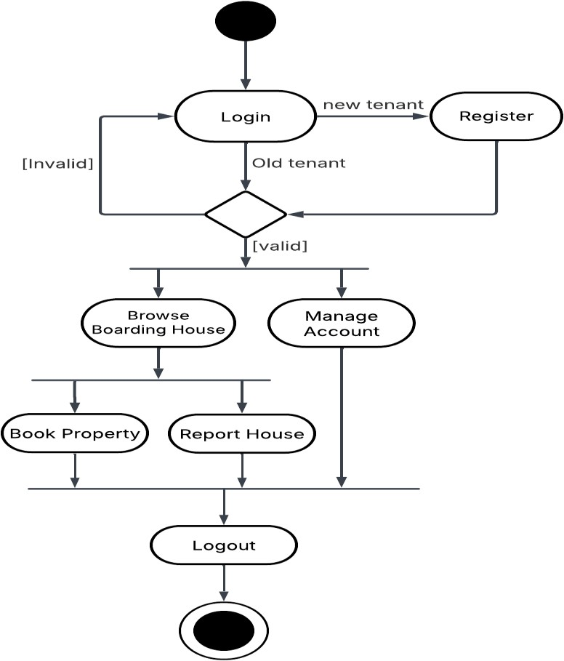
Figure 6. Activity Diagram of the Tenant

Login and Registration Process

  - Login

    - Existing tenants can log into the system using their registered credentials.
    - If the provided login information is invalid, the user is prompted to retry.
    - Upon valid login, users gain access to the system’s tenant functionalities.

Register (New Tenant)

    - New users must register by providing required account information.
    - After successful registration, tenants may proceed to log in and use the system.

Tenant Main Activities

Once logged in, tenants can perform the following actions:

Browse Boarding House

    - View a list of available boarding houses.
    - Use system filters to navigate based on preferences such as location, price, and amenities.

Book Property

    - Select and reserve a preferred boarding house directly from the browsing page.
    - Booking details are stored under the tenant’s account.

Report House

    - Submit reports or concerns regarding a listed property.
    - Issues may include inaccurate listings, safety concerns, or tenant-owner disputes.

Manage Account

    - Edit personal details, update preferences, or change login credentials.
    - Allows users to maintain accurate and up-to-date profile information.

Logout Process

- Tenants can securely log out of their account, ending their session.
- This ensures privacy and protects tenant data from unauthorized access.
The activity diagram for the tenant outlines a streamlined flow from account access to browsing, booking, and account management. The design ensures user-friendly navigation, robust login validation, and access to essential features for both new and returning tenants.
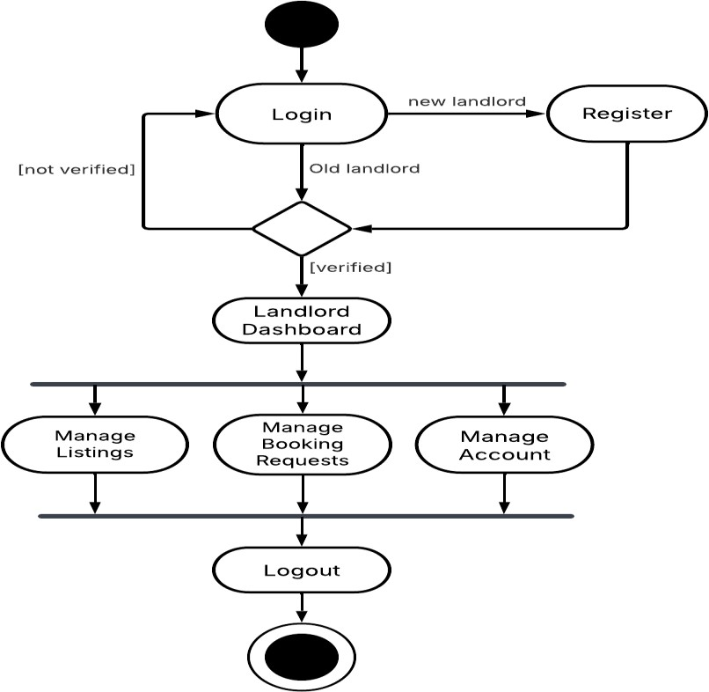
Figure 7. Activity Diagram of the Landlord

Login and Registration Process

  - Login

    - Existing landlords can log into the system using their registered username and password.
    - If the account is not verified, the landlord is redirected back to the login screen.
    - Verified landlords proceed to the main dashboard after successful login.

Register (New Landlord)

    - New users must register by providing required information including a valid ID.
    - Upon registration, landlords must await verification before gaining full access.

Landlord Dashboard Activities

Once verified and logged in, landlords can access the following core functionalities:

Manage Listings

    - Create, edit, or delete boarding house listings.
    - Upload property details, images, pricing, and available amenities.

Manage Booking Requests

    - View and respond to tenant booking requests.
    - Approve or decline requests based on availability and tenant profiles.

Manage Account

    - Update account information such as contact details, login credentials, or documentation.
    - Helps ensure landlord profiles remain accurate and compliant.

Logout Process

- Landlords can securely log out of their accounts.
- This action terminates the session and returns the user to the login state.

The landlord activity diagram illustrates the process starting from user registration or login. New landlords must verify their accounts before accessing the dashboard. Once verified, landlords can manage properties, handle tenant bookings, and update account details. Invalid logins or unverified accounts redirect users back to the login page. The process ends with a secure logout.
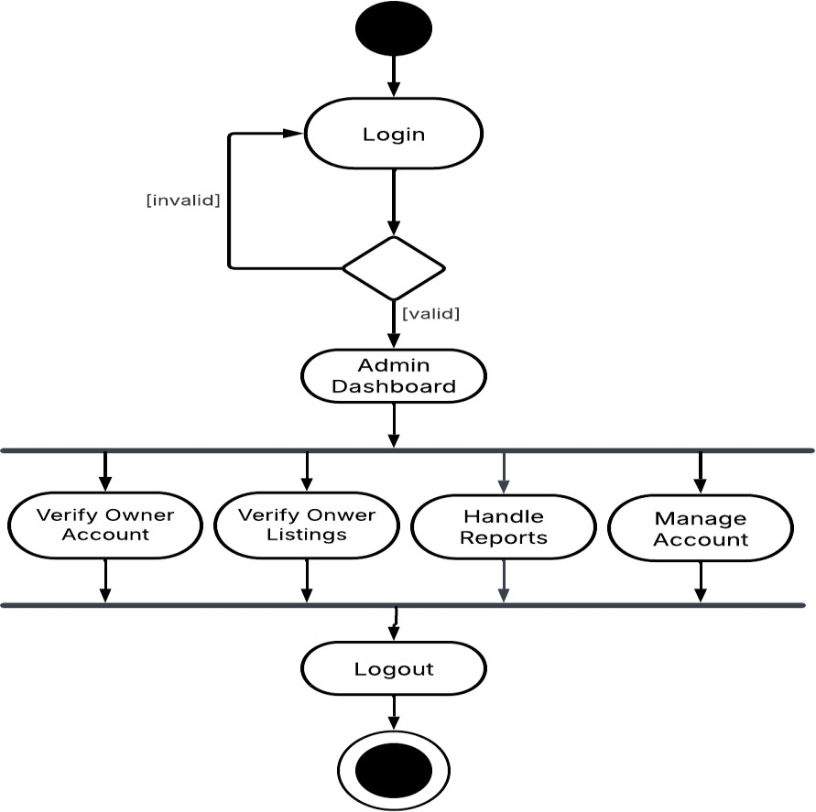
Figure 8. Activity Diagram of the Admin

Login Process

- Login

  - Existing admins log into the system using pre-authorized credentials (username and password).
  - Invalid credentials redirect the admin back to the login screen.
  - Successful login grants access to the admin dashboard.

Admin Dashboard Activities

After logging in, admins can perform the following core administrative functions:

Verify Owner Accounts
    - Review and approve/deny landlord registration requests.
    - Ensure submitted documents (e.g., valid ID) comply with system requirements.

Verify Owner Listings
    - Validate boarding house listings submitted by landlords.
    - Confirm the accuracy of property details, images, amenities, and permits before publishing.

Handle Reports

    - Address reports submitted by users (e.g., disputes, fraudulent listings, or policy violations).
    - Resolve issues by modifying listings, suspending accounts, or escalating matters.

2.4. Manage Account

- Update admin-specific account information, such as contact details or login credentials.

Logout Process

- Admins can securely log out of the system.
- This action terminates the session and returns the user to the login state.

The admin’s primary role revolves around verification, moderation, and system oversight. Unlike landlords, admins do not require registration and focus on ensuring compliance and resolving platform-wide issues. The process begins with login, transitions to dashboard tasks (account/listings verification, report handling), and concludes with a secure logout. Invalid login attempts redirect back to the login screen, maintaining system security.

Testing and Evaluation

The evaluation of the ILOcate web application was conducted in alignment with the ISO 25010 standards, which encompass eight critical quality characteristics: Functional Suitability, Performance Efficiency, Compatibility, Usability, Reliability, Security, Maintainability, and Portability. This comprehensive assessment was facilitated by a diverse group of evaluators, including three IT experts, ten boarding house owners, and ten tenants, and the boarding house commission of Iloilo City. The selection criteria for these respondents were predicated on their relevant expertise and the practicality of their availability to the research team, ensuring an informed evaluation process.

In the evaluation methodology, two distinct testing techniques were employed to garner insights into the application’s quality. The boarding house owners and tenants utilized the Black Box Testing approach, focusing on the application’s inputs and outputs without regard to the internal workings. This method provided valuable user-centric feedback on the application’s functionality and user experience. Conversely, the IT experts applied the White Box Testing technique, delving into the application’s internal structure and codebase. This allowed for a detailed examination of the application’s technical robustness and adherence to best practices in software development.
The survey results, gathered through a five-point Likert Scale, offered an understanding of the application’s performance across the defined quality characteristics. The interpretation of these results are delineated in Table 1.
Table 1

Table of Scale and Interpretation

Scale | Interpretation
1.0 - 1.49 | Strongly Disagree
1.5 - 2.49 | Disagree
2.5 - 3.49 | Undecided
3.5 - 4.49 | Agree
4.5 - 5.00 | Strongly Agree

Data Gathering Instrument

The researchers employed purposive sampling to meticulously select a targeted group of respondents, comprising fifteen boarding house owners and tenants from Iloilo City, ensuring relevance and depth in the data collection process. The development of two

specialized questionnaires using Google Form, one for each respondent group, facilitated the evaluation of the web application across five key criteria—functionality, usability, content, reliability, and performance—with multiple indicators under each criterion to provide a comprehensive assessment. The validity of these instruments was rigorously confirmed by an expert panel of oral examiners during the proposal stage, underscoring the methodological severity and relevance of the study’s data-gathering approach. Using the 5-point Likert scale in Table 1, the average weighted mean is computed and interpreted as
(1) 1.0 - 1.49: Very Poor, (2) 1.5 - 2.49: Poor, (3) 2.5 - 3.49: Fair, (4) 3.5 - 4.49: Good, (5)

4.5 - 5.00: Excellent.

Data Processing and Statistical Tool

To ensure a methodical evaluation of the ILOcate web application, the researchers employed to process the data collected via purposive sampling and Likert Scale assessments using Microsoft Excel, computing average weighted means for each of the five key criteria: functionality, usability, content, reliability, and performance. The software facilitates the coding of responses according to the scale interpretations ranging from ‘Very Poor’ to ‘Excellent’, as delineated in Table 1. Subsequently, it generates mean scores for the various indicators under each criterion, providing an objective measure of the application’s quality across the ISO 25010 standards. This quantitative analysis is an instrumental in interpreting the survey results, offering a clear and concise evaluation of the web application’s performance as perceived by the diverse group of evaluators.

Chapter 4 RESULTS AND DISCUSSION
This chapter presents the findings and analysis of the study conducted on the development of ILOcate: A Web-based Boarding House Finder Application in Iloilo City using Haversine Algorithm. The system was designed to address the challenges faced by tenants in locating suitable and affordable accommodations while assisting landlords in reaching potential tenants efficiently. The discussion includes the system’s functionality, effectiveness, and compliance with software quality standards based on ISO 25010.

Locate and display the nearest boarding houses in Iloilo City from the user’s input location The first objective demonstrates the implementation of locating and displaying the nearest boarding houses in Iloilo City based on the user's input location. The system accepts user location input and displays boarding houses within proximity using the Haversine Algorithm to calculate distances between coordinates. The interface presents search results alongside an interactive map using the Google Maps API that visualizes boarding house locations and its prices with markers, and indicates the search radius with a circular overlay. Each listing displays essential information including monthly rental rates (₱500-
₱3,500), verification status, and address information. The distance filter enables users to refine their search radius according to specific preferences, directly addressing the challenge identified in the background study regarding the difficulty in finding suitable accommodations near desired locations.

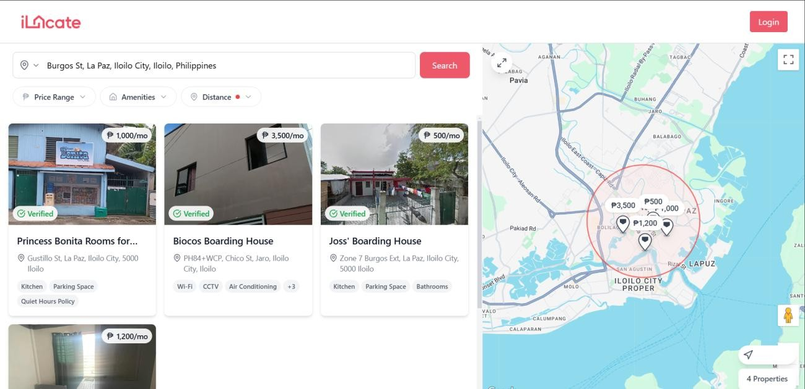
Figure 9. Screenshot for displaying location-based boarding house search results with interactive map integration.
// Home.js
import React, { useState } from "react";
import SearchLocation from "./SearchLocation"; import { BoardingHouses } from "./BhouseCard"; import Map from "./Map";
import DropdownRadio from "../FilterOptions";
import { LoadScript } from "@react-google-maps/api"; import { Maximize2, Minimize2 } from "lucide-react"; const libraries = ["places"];
export const Home = () => {
const [isMapExpanded, setIsMapExpanded] = useState(false); return (
<LoadScript googleMapsApiKey={process.env.REACT_APP_GOOGLE_MAPS_API_KEY} libraries={libraries} >
<div className="flex flex-col md:flex-row relative w-full h-[calc(100vh-4rem)]">
{/* Left Section: Search, Filters, and Listings */}
<div className={` w-full
${isMapExpanded ? "hidden md:flex md:w-1/3" : "md:w-3/5"} flex flex-col
transition-all duration-300
`}>
<div className="px-4 md:px-6 py-4">
<SearchLocation />
<div className="mt-4">
<DropdownRadio />
</div>
</div>
<div className="flex-1 overflow-y-auto scrollbar-thin scrollbar-thumb-gray-300 scrollbar-track-gray-100">
<BoardingHouses />
</div>
</div>
{/* Right Section: Map */}
<div className={` relative
${isMapExpanded ? "w-full" : "w-full md:w-2/5"} h-[50vh] md:h-full
transition-all duration-300
`}
>
<Map />
{/* Map Toggle Button (visible on md and larger screens) */}
<button
onClick={() => setIsMapExpanded(!isMapExpanded)}
className="hidden md:flex absolute top-4 left-4 z-10 items-center justify-center w-10 h-10 bg-white rounded-full shadow-lg hover:bg-gray-50 transition-colors"
>
{isMapExpanded ? (
<Minimize2 className="w-5 h-5 text-gray-600" />
) : (
<Maximize2 className="w-5 h-5 text-gray-600" />
)}
</button>
</div>
</div>
Script 2: Snippet of code in React component for implementing location-based boarding house search functionality

The implementation of ILOcate's location-based boarding house finder is accomplished through a structured React component system. The Home.js component integrates proximity-based searches, with the Google Maps API implementation. The code imports the SearchLocation component (`import SearchLocation from "./SearchLocation"`) that captures the user's desired location input, which serves as the reference point for distance calculations. The Google Maps integration is established through the LoadScript component (`<LoadScript googleMapsApiKey={process.env.REACT_APP_GOOGLE_MAPS_API_KEY}libraries
={libraries}>`) which provides the geographical foundation needed for the location services. The "places" library (`const libraries = ["places"]`) enables location autocomplete functionality, enhancing user experience when entering addresses. The Map component (`<Map />`) visualizes boarding house locations and implements the circular radius display, while the BoardingHouses component (`<BoardingHouses />`) renders the filtered results based on proximity calculations performed using the Haversine Algorithm in the backend services.

Provide detailed information about the boarding houses, including the amenities, images, location, prices, and descriptions
The second objective was accomplished by researchers by implementing a user interface that provides comprehensive boarding house information as illustrated in Figure
10. From the dashboard, users can click a verified boarding house and the system presents a structured property page where tenants can easily access all essential details needed in boarding house. Upon accessing the boarding house listing, users immediately see the

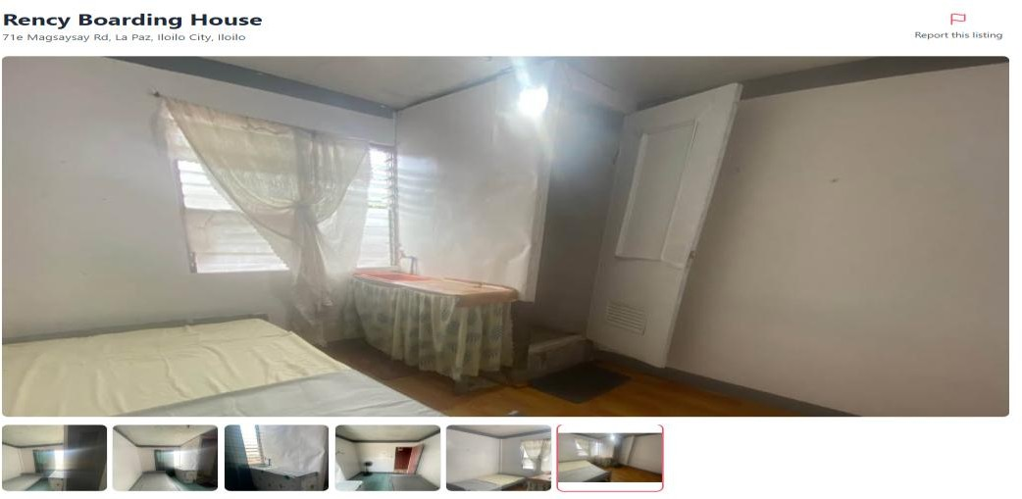
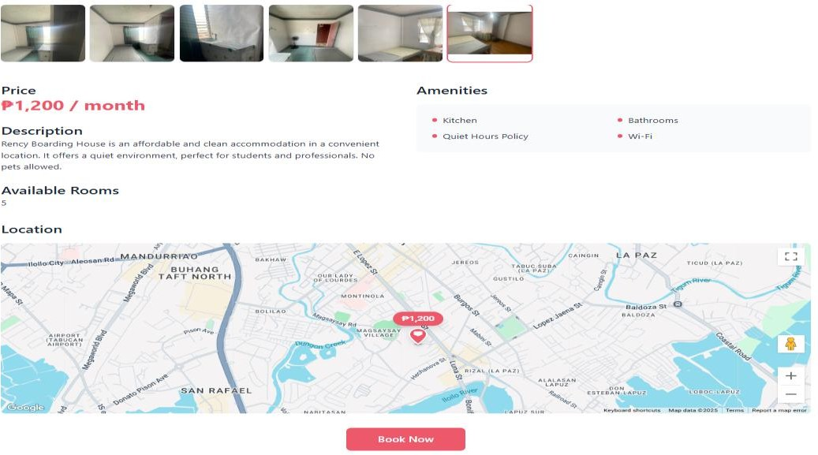
property name ("Rency Boarding House") and complete address, followed by six thumbnail photographs below the main image where users can navigate that offers clear visual representation of the living space. As users scroll down, they can see all labeled sections with the monthly rental price (₱1,200/month), available amenities (Kitchen, Bathrooms, Quiet Hours Policy, Wi-Fi), a descriptive overview, and current room availability (5 rooms). The implementation also includes location visualization where users can interact with the Google Maps integration to assess the boarding house's proximity to key landmarks in Iloilo City with the property precisely marked by a location pin and price tag. The "Book Now" button at the bottom provides the direct booking functionality for tenants to schedule a physical visit to the property.

Figure 10. Screenshot for displaying boarding house listing page, property information and location mapping
const HouseDetails = ({ id }) => {
const { isAuthenticated, user } = useAuth(); const navigate = useNavigate();
const [houseDetails, setHouseDetails] = useState(null); const [loading, setLoading] = useState(true);
const [error, setError] = useState(null);
const [selectedImage, setSelectedImage] = useState(0); const [modalOpen, setModalOpen] = useState(false);
const [isReportModalOpen, setIsReportModalOpen] = useState(false); const mapOptions = { ...
}
const mapSection = houseDetails && { ...
}
const handleSubmitReport = async (description) => { ...
}
const handleNavigate = (id) => { ...
}
// Report Modal Component
const ReportModal = ({ isOpen, onClose, onSubmit }) => {...
};
useEffect(() => {...
}, [id]);
if (loading) return ( ...
);
if (error) return (...
);
if(!houseDetails) return ( ...
);
const images = houseDetails.images?.length
? houseDetails.images.map((img) => `http://localhost:8080/images/ ${img}`)
: [];
console.log("Processed images:", images); return ( ...
);
};
HouseDetails.propTypes = {
id: PropTypes.string.isRequired,
};
export default HouseDetails;
Script 3. React component code for displaying comprehensive boarding house information

The component utilizes React's useState hook to manage critical data including houseDetails which stores all property information retrieved from the backend. The implementation processes boarding house images through the code const images = houseDetails.images?.length ? houseDetails.images.map((img) => 'http://localhost:8080/images/${img}') : [], which transforms backend image references into fully qualified URLs for frontend display which enables the visual gallery feature. For location visualization, the component implements map functionality through the mapSection and mapOptions configurations which uses the Google Maps API integration to display the boarding house's precise location. The component handles user interaction through specialized modal states such as isReportModalOpen for the reporting functionality that allows tenants to report issues to the Iloilo Boarding House Commission. The useEffect hook arrange data fetching based on the property ID to ensure that all detailed information including amenities, descriptions, and pricing is retrieved from the Express.js backend and displayed to the user.
Register verified boarding houses with a business clearance and permit certification;

This third objective implemented a comprehensive administrative verification interface as shown in Figure 11. The system provides the Iloilo Boarding House Commission as an admin with a structured dashboard to verify submitted boarding house documentation from landlords before approving listings. The interface displays essential property information including the boarding house name ("Rency Boarding House") with a "Pending" status indicator, visual representation through a main image and gallery thumbnails, and core property details (price, description, available rooms, address, and insurance ID). The critical verification functionality is achieved through the "Permits &

Documentation" section, which systematically organizes five required regulatory documents: Business Permit, Bill Permit, Sanitation Permit, Fire Permit, and Building Permit, each displayed with corresponding official seals from governing authorities. The visual presentation of these documents enables administrative users to efficiently verify the legitimacy and compliance of each boarding house listing. The implementation completes the verification workflow with clear action controls at the bottom—"Approve" and "Decline" buttons— allowing administrators to make verification decisions directly within the interface which ensures that only legitimate and properly documented properties are
made available to users.
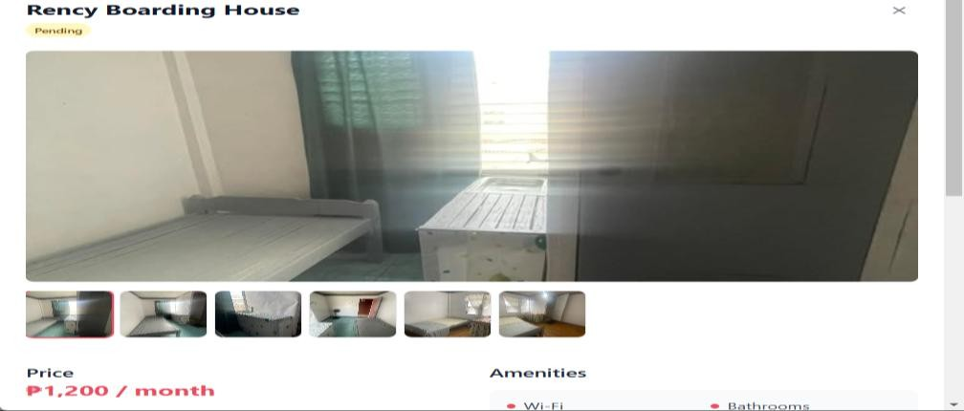
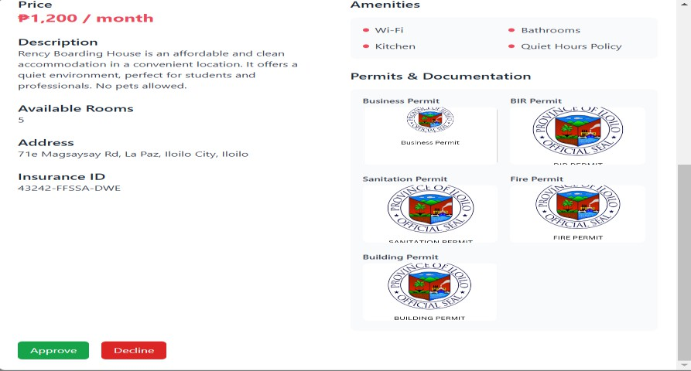
Figure 11. Screenshot of admin interface for verifying boarding house permit and documentation

const BoardingHouseVerification = ({ house: initialHouse, onClose, onAction })
=> {
const [showImageModal, setShowImageModal] = useState(false); const [showPermitModal, setShowPermitModal] = useState(false); const [currentPermit, setCurrentPermit] = useState(null);
const [selectedImage, setSelectedImage] = useState(0); const [house, setHouse] = useState(initialHouse); const [loading, setLoading] = useState(false);
const [error, setError] = useState(null); useEffect(() => { ...
}, [initialHouse]);
useEffect(() => { ...
}, [initialHouse.listingId]);
const images = house.images?.length
? house.images.map((img) => `http://localhost:8080/images${img}`)
: [];
const handleViewPermit = (permitPath, permitName) => ...} const getStatusBadge = (status) => {...};
const handleAction = async (newStatus, listingId) => {...}; const renderActions = () => {...};
if (error) {...};
return (...);
};
BoardingHouseDetails.propTypes = { house: PropTypes.shape({
listingId: PropTypes.number.isRequired, title: PropTypes.string.isRequired, status: PropTypes.string.isRequired, description: PropTypes.string,
price: PropTypes.number.isRequired, rooms: PropTypes.number,
address: PropTypes.string.isRequired,
amenities: PropTypes.arrayOf(PropTypes.string), images: PropTypes.arrayOf(PropTypes.string), permit_img: PropTypes.string,
business_permit: PropTypes.string, bir_permit: PropTypes.string, sanitation_permit: PropTypes.string, fire_permit: PropTypes.string, building_permit: PropTypes.string, insurance_id: PropTypes.string,
}).isRequired,
onClose: PropTypes.func.isRequired, onAction: PropTypes.func.isRequired,
};
export default BoardingHouseVerification;
Script 4. Snippet of code implementation boarding house permit verification

The BoardingHouseVerification component implements third objective by providing a structure for administrative verification of boarding house documents. The component is designed to handle permit verification through the PropTypes definition that requires multiple permit types (business_permit, bir_permit, sanitation_permit, fire_permit, and building_permit) as specified properties within the house object. This approach ensures all regulatory requirements are addressed before approval. The verification workflow is managed through the handleAction function that processes status changes when administrators approve or decline listings based on document verification. The handleViewPermit function allows administrators to inspect permit documents in detail before making verification decisions. State management is implemented through React's useState hooks, with currentPermit specifically tracking the permit currently being reviewed. The component integrates with backend services through the useEffect hooks that fetch updated house data and process image URLs for permit display (const images = house.images?.length ? house.images.map((img) => "http://localhost:8080/images${img}") : []).
Allow Iloilo Boarding House Commission to register and close the boarding house;
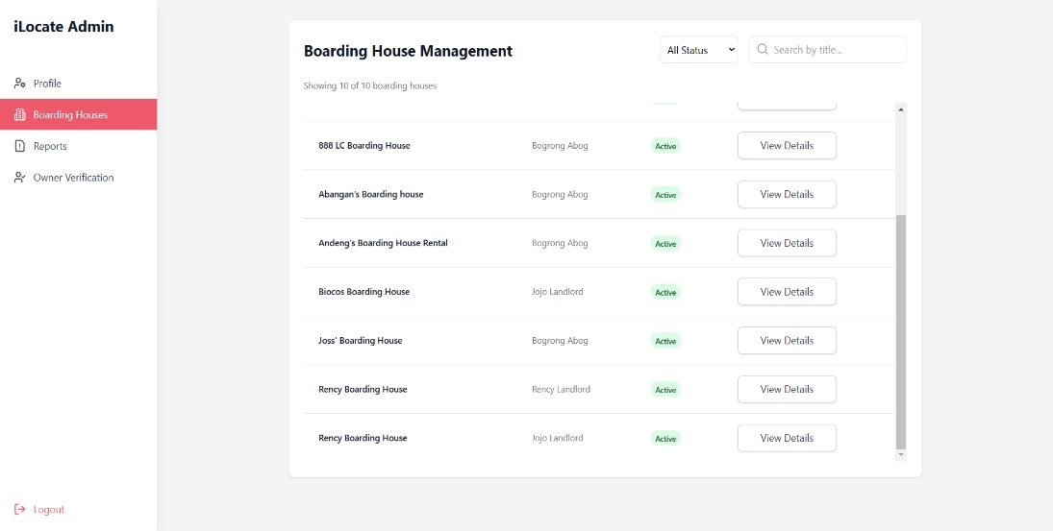
Figure 12. Screenshot of Administrative dashboard interface for boarding house management and status monitoring

The ILOcate system achieves the fourth objective through an extensive administrative interface illustrated in Figure 12.The dashboard provides the Iloilo Boarding House Commission with a centralized management platform featuring a dedicated "Boarding Houses" section in the navigation menu. The main interface displays a structured table of registered properties (showing "10 of 10 boarding houses") with essential information including boarding house names, landlord information, and current status indicators. Each listing displays an "Active" status badge in green, indicating properties that have passed verification and are currently operational. The implementation includes search functionality ("Search by title...") and status filtering ("All Status" dropdown), enabling administrators to efficiently manage large numbers of properties. Each boarding house entry includes a "View Details" button that allows administrators to access property information.
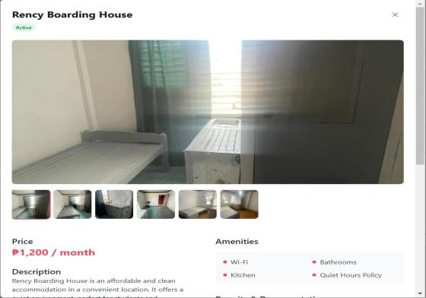
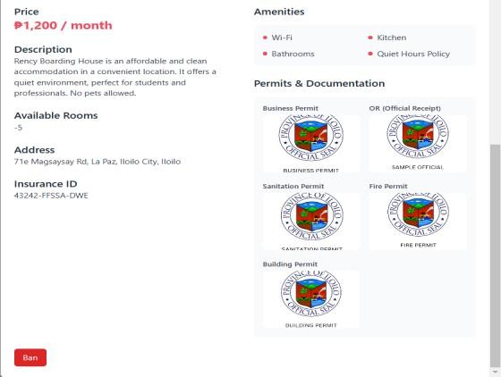
Figure 13. Screenshot of detailed boarding house information with permit verification and enforcement controls

The interface displays comprehensive boarding house information including status ("Active"), visual content, pricing, amenities, room availability, location details, and insurance identification. Critically, the implementation includes a "Permits & Documentation" section displaying five regulatory documents (Business Permit, BIR Permit, Sanitation Permit, Fire Permit, and Building Permit) with official seals, enabling administrators to review compliance documentation. The enforcement functionality is implemented through the "Ban" button at the bottom of the interface, allowing the Boarding House Commission to take immediate action against properties that violate regulations or receive substantiated complaints from tenants. This implementation directly addresses the project objective by providing a streamlined system for administrative oversight, verification, and regulatory enforcement, supporting the Commission's role in maintaining boarding house standards in Iloilo City.

import React, { useState, useMemo, useEffect } from "react"; import PropTypes from "prop-types";
import BoardingHouseDetails from "./BoardingHouseDetails"; import { Search, X, Loader2, AlertTriangle } from "lucide-react"; import { debounce } from "lodash";
import axios from "axios";
const ActionConfirmationDialog = ({ isOpen,
action, onConfirm, onCancel, houseName,
}) => {
if(!isOpen) return null; const actionMessages = { ...
}
const message = actionMessages[action] || "take this action"; return ( ... );
};
const BoardingHouseManagement = ({ listings: initialListings }) => { const [listings, setListings] = useState(initialListings);
const [selectedHouse, setSelectedHouse] = useState(null); const [searchQuery, setSearchQuery] = useState(""); const [isSearching, setIsSearching] = useState(false); const [selectedStatus, setSelectedStatus] = useState("all"); const [owners, setOwners] = useState({});
const [confirmDialog, setConfirmDialog] = useState({ isOpen: false,
action: null, listingId: null, houseName: "",
});
const refreshListings = async () => {...}; const getOwner = async (ownerId) => {...}; useEffect(() => {...
}, [listings]);
const debouncedSearch = useMemo( () =>
debounce(() => { setIsSearching(false);
}, 300), []
);
const handleSearchChange = (e) => {...
}, [listings, searchQuery, selectedStatus]); const clearSearch = () => { setSearchQuery(""); setSelectedStatus("all"); setIsSearching(false);
};
const filteredListings = useMemo(() => {...
}, [listings, searchQuery, selectedStatus]); const getStatusBadge = (status) => {...
};
const openConfirmDialog = (action, listingId, houseName) => {...
};
const closeConfirmDialog = () => {...
};
useEffect(() => { setListings(initialListings);
}, [initialListings]); return ( ...
);
};
BoardingHouseManagement.propTypes = { listings: PropTypes.arrayOf( PropTypes.shape({
listingId: PropTypes.number.isRequired, title: PropTypes.string.isRequired, ownerId: PropTypes.number.isRequired, status: PropTypes.string.isRequired, description: PropTypes.string,
price: PropTypes.number.isRequired, rooms: PropTypes.number,
address: PropTypes.string.isRequired,
amenities: PropTypes.arrayOf(PropTypes.string), images: PropTypes.arrayOf(PropTypes.string),
})
).isRequired,
};
export default BoardingHouseManagement;
Script 5. Snippet of code of Boarding House Status Management

The objective to allow the Iloilo Boarding House Commission to register and close boarding houses has been implemented through the BoardingHouseManagement component. The key functionality is demonstrated in the openConfirmDialog function, which dynamically manages the action of registering or closing a boarding house by opening a confirmation dialog with appropriate messages and actions (actionMessages[action]). This ensures clear communication and proper execution of administrative decisions. Additionally, the refreshListings function uses asynchronous API calls through axios to fetch updated data, maintaining real-time accuracy of the boarding house statuses. The application of useState and useEffect hooks ensures seamless state management, dynamically updating the UI to reflect any changes in registration or closure. The use of conditional rendering within the ActionConfirmationDialog component enhances user experience by displaying relevant action messages, contributing to the effective implementation of the objective.
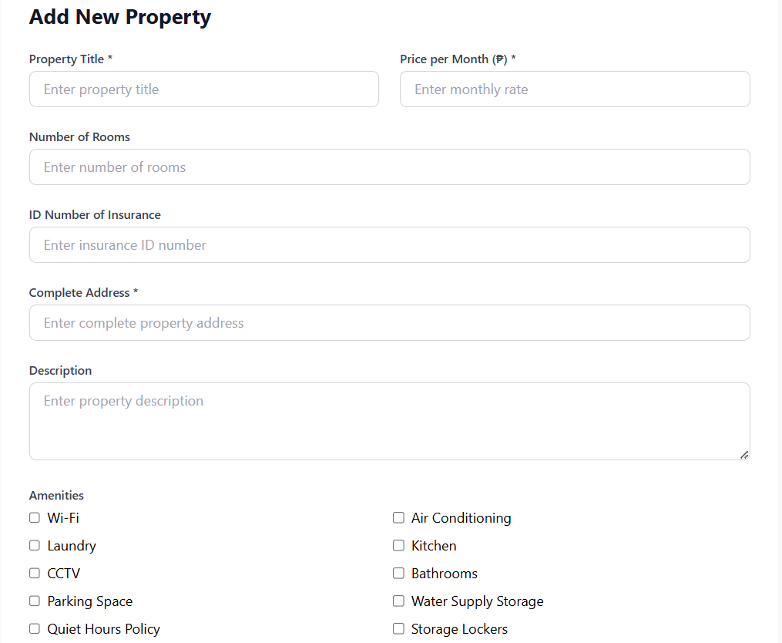
Allow boarding house to submit registration documents;
Figure 14. Screenshot of property registration form interface for boarding house information entry

The fifth objective was achieved by creating an organized property registration interface as illustrated in Figure 14. The form captures essential boarding house information through labeled input fields for "Property Title," "Price per Month," "Number of Rooms," "ID Number of Insurance," "Complete Address," and "Description." Required fields are marked with asterisks to ensure complete data submission. The implementation includes amenities section with multiple checkbox options including Wi-Fi, Laundry, CCTV, Parking Space, Quiet Hours Policy, Air Conditioning, Kitchen, Bathrooms, Water Supply Storage, and Storage Lockers,
allowing landlords to accurately represent their property features.
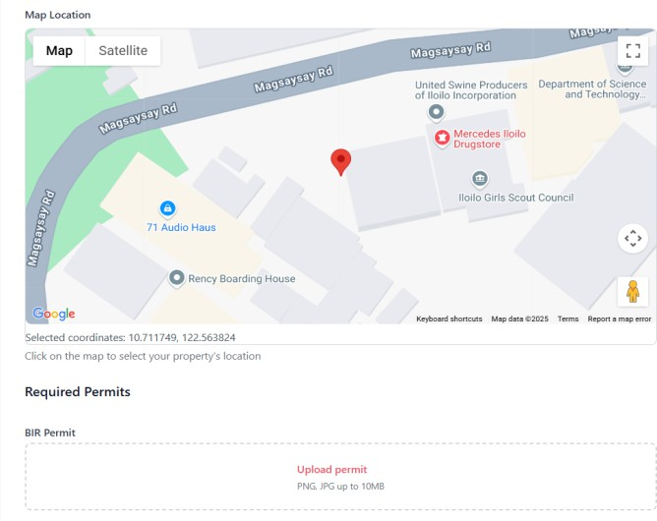
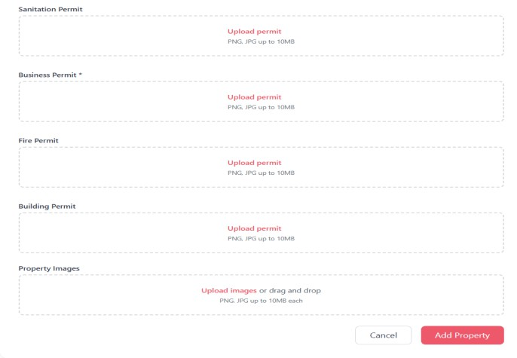
Figure 15. Screenshot of map location selection and permit document upload functionality

The second component of the registration interface, illustrated in Figure 15, completes the fifth objective by focusing on location data and regulatory documentation. The map integration utilizes Google Maps API which enables precise property location selection with real-time coordinate display ("Selected coordinates: 10.717128, 122.561634"). The critical permit submission functionality is implemented through multiple document upload sections for five required regulatory documents: BIR Permit, Sanitation Permit, Business Permit, Fire Permit, and Building Permit. Each upload field includes file format specifications ("PNG, JPG up to 10MB") to ensure compatibility with the system. The interface concludes with a property images upload section that supports both traditional uploads and drag-and-drop functionality for improved user experience. This implementation allows boarding house owners to submit registration documents by providing a step-by-step process that captures all required information and documentation for proper boarding house registration and subsequent verification by the Iloilo Boarding House Commission.

import React, { useState } from "react";
import { useOwnerAuth } from "../../context/OwnerAuthContext"; import axios from "axios";
import LocationMap from "./LocationMap"; const AddProperty = () => {
const amenitiesOptions = [ "Wi-Fi",
"Air Conditioning", "Laundry", "Kitchen", "CCTV",
"Bathrooms", "Parking Space",
"Water Supply Storage", "Quiet Hours Policy", "Storage Lockers",
];
const { user } = useOwnerAuth();
const [property, setProperty] = useState({ ...
};
const [previewImages, setPreviewImages] = useState({...
});
const handleInputChange = (e) => {...
};
const handleAmenityChange = (amenity) => {...
};
// Handle location selection from the map const handleLocationSelect = (location) => {...
};
const validateImage = (file) => {
};
// Handle permit file uploads
const handlePermitUpload = (e, permitType) => {...
};
// Update your handlePropertyImages function const handlePropertyImages = (e) => {...
};
const removePropertyImage = (index) => {...
};
const handleSubmit = async (e) => {...
};
// Permit section render function
const renderPermitUpload = (title, name, required = false) => (...
);
return (...
);
};
export default AddProperty;
Script 6. Snippet of code for implementing property registration and document submission

The AddProperty component establishes a document submission workflow with dedicated permit handling functionality implemented through the handlePermitUpload function. This function processes permit file uploads for regulatory documents required by the Iloilo Boarding House Commission. The component incorporates specific validation through the validateImage function to ensure uploaded permits meet system requirements before submission. Document organization is achieved through the renderPermitUpload function, which creates consistent upload interfaces for each permit type (BIR, Business, Fire, Sanitation, and Building permits). The submission process is completed through the handleSubmit function, which packages property details along with the uploaded permit documents and transmits them to the Express.js backend via axios HTTP requests. The component integrates with the LocationMap component (import LocationMap from "./LocationMap") to capture precise property coordinates which enhance the registration process with accurate geographic data. User authentication is maintained through the Owner context (useOwnerAuth) to ensure that only verified property owners can submit documentation. This implementation directly addresses the objective by providing boarding house owners with a streamlined and secured method to register their properties and submit required permit documentation for verification by the Iloilo Boarding House Commission.

Allow tenants to report complaints to Iloilo Boarding House Commission;
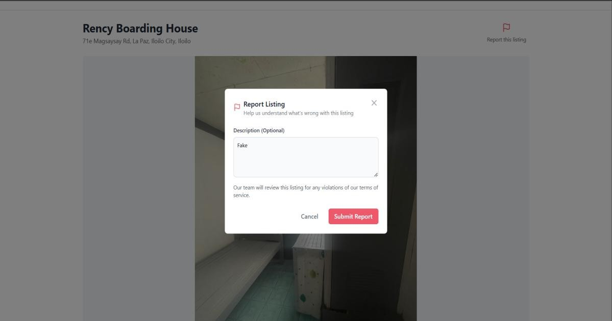

Figure 16. Screenshot of report listing interface for tenant complaint submission

The ILOcate web application fulfills the sixth objective through an efficient complaint submission interface, as illustrated in Figure 16.The implementation features a modal dialog that appears when tenants click the "Report this listing" link in the upper right corner of the boarding house detail page. The interface includes a descriptive text area where tenants can articulate specific concerns about the property. The system includes a reassurance statement ("Our team will review this listing for any violations of our terms of service") that informs users about the review process by the Iloilo Boarding House Commission. The implementation completes the reporting workflow with two action buttons: "Cancel" to dismiss the dialog and "Submit Report" to transmit the complaint to administrative users for review. By enabling direct tenant feedback, the system supports the administrative review process where the Iloilo Boarding House Commission can evaluate reported properties and take appropriate action.

// Report Modal Component
const ReportModal = ({ isOpen, onClose, onSubmit }) => { const [description, setDescription] = useState("");
const { isAuthenticated } = useAuth(); const navigate = useNavigate();
if (!isOpen) return null; return (
<div className="fixed inset-0 bg-black bg-opacity-50 z-50 flex items-center justify-center p-4">
<div className="bg-white rounded-lg max-w-md w-full p-6">
{/* Header */}
<div className="flex justify-between items-start">
<div className="flex items-center gap-2">
<Flag className="w-5 h-5 text-[#ED586B]" />
<div>
<h3 className="text-lg font-semibold text-gray-900"> Report Listing
</h3>
<p className="text-sm text-gray-500">
Help us understand what's wrong with this listing
</p>
</div>
</div>
<button onClick={onClose}
className="text-gray-400 hover:text-gray-500"
>
<svg
className="w-6 h-6" fill="none" stroke="currentColor" viewBox="0 0 24 24"
>
<path strokeLinecap="round" strokeLinejoin="round" strokeWidth="2"
d="M6 18L18 6M6 6l12 12"
/>
</svg>
</button>
</div>
<div className="mt-6">
{!isAuthenticated ? (
<div className="text-center py-4">
<p className="text-gray-600 mb-4"> Please log in to report this listing
</p>
<button
onClick={() => navigate("/login")}
className="bg-[#ED586B] text-white px-4 py-2 rounded-md hover:bg-[#d54d5f] transition-colors"
>
Log In
</button>
</div>
) : (
<>
<div className="mb-4">
<label htmlFor="description"
className="block mb-2 text-sm font-medium text-gray-700"
>
Description (Optional)
</label>
<textarea id="description" rows="4"
className="block p-2.5 w-full text-sm text-gray-900 bg-gray-50 rounded-lg border border-gray-300 focus:ring-blue-500 focus:border-blue-500" placeholder="Provide more details about the issue..."
value={description}
onChange={(e) => setDescription(e.target.value)}
></textarea>
</div>
<div className="mb-6">
<p className="text-sm text-gray-600 mb-2">
Our team will review this listing for any violations of our terms of service.
</p>
</div>
<div className="flex justify-end gap-3">
<button onClick={onClose}
className="px-4 py-2 text-gray-500 hover:text-gray-700 transition-colors font-medium"
>
Cancel
</button>
<button
onClick={() => onSubmit(description)}
className="px-4 py-2 bg-[#ED586B] text-white rounded-md hover:bg-[#d54d5f] transition-colors font-medium"
>
Submit Report
</button>
</div>
</>
)}
</div>
</div>
</div>
);
};
Script 7. Snippet of code for tenant complaint submission functionality

The ILOcate system implements a user-friendly reporting interface through a modal dialog that appears when triggered by user interaction. The core reporting functionality is achieved through state management with const [description, setDescription] = useState(""), which captures the tenant's complaint details. The component incorporates authentication verification through const { isAuthenticated } = useAuth() to ensure that only registered users can submit reports, with redirection to the login page for unauthenticated users via the navigation function. The complaint submission process is completed through the onClick={() => onSubmit(description)} event handler, which transmits the user's complaint to the backend services when the "Submit Report" button is clicked. The interface provides clear instructional text ("Help us understand what's wrong with this listing") and reassurance to users ("Our team will review this listing for any violations of our terms of service"). This implementation provides a formal channel for quality control and regulatory oversight that helps maintain standards in Iloilo City's boarding house ecosystem.

Evaluation of the System Based on the User Acceptability Test Result

The system was evaluated by fifteen (15) tenants, landlords, and Iloilo City Boarding House Commission in accordance with the system functionality based on the research objectives, usability and user experience.
Table II

Functionality of the System

Functionality | Mean | Interpretation
1. Functionality . (The features provided  meet user’s needs.) | 4.67 | Excellent
2. Reliability. (ILOCate provides accurate and relevant results.) | 4.60 | Excellent
3. Performance. (The system is responsive and runs smoothly) | 4.73 | Excellent
Mean | 4.67 | Excellent

Functionality. The ILOcate system achieved exceptional ratings across all evaluation criteria according to fifteen users representing tenants, landlords, and the Iloilo City Boarding House Commission. Performance received the highest score at
4.73 (Excellent), indicating the system delivers superior responsiveness and smooth operation even during complex tasks like map rendering and location searches. Functionality scored 4.67 (Excellent), confirming the implemented features effectively

address user needs. Reliability received a score of 4.6 (Excellent), validating that the system consistently provides accurate and relevant results through its Haversine Algorithm implementation and Google Maps integration. With an overall user satisfaction score of 4.67 (Excellent), the evaluation confirms ILOcate successfully accomplishes all research objectives by delivering a high-quality boarding house finder application that meets international software standards while effectively serving the practical needs of Iloilo City's boarding house ecosystem.

Table III

Usability and User Experience of the System

Usability and User Experience | Mean | Interpretation
1. Ease of Use. (The platform is easy to navigate.) | 4.67 | Excellent
2. Interface Design. (The design is user-friendly  and visually appealing) | 4.87 | Excellent
3. Efficiency. (ILOCate helps simplify the rental  process.) | 4.67 | Excellent
4. Clarity. (Information and instructions are clear  and understandable.) | 4.53 | Excellent
Mean | 4.69 | Excellent

Usability and User Experience. The ILOcate system achieved outstanding usability ratings based on evaluation by fifteen users representing tenants, landlords, and the Iloilo City Boarding House Commission. Interface Design received the highest

score of 4.87 (Excellent), indicating exceptional visual appeal and user-friendly layout that significantly enhances the overall user experience. Ease of Use and Efficiency both scored 4.67 (Excellent), confirming intuitive navigation and effective streamlining of the rental process. Clarity received 4.53 (Excellent), showing strong ratings for information presentation. With an overall usability score of 4.69 (Excellent), the evaluation validates that ILOcate successfully accomplishes its objectives through a highly accessible interface. The consistently superior ratings across all usability dimensions confirm the system effectively addresses the needs of diverse users while maintaining excellent user experience standards—critical factors for successful adoption and continued use of the boarding house finder application in Iloilo City.
Table IV

Summary of the User Acceptability Test

Criteria | Mean | Interpretation
Functionality | 4.67 | Excellent
Usability and User Experience | 4.69 | Excellent
Overall Mean | 4.68 | Excellent

Summary. The ILOcate boarding house finder system received exceptional ratings from fifteen users representing tenants, landlords, and the Iloilo City Boarding House Commission. Usability and User Experience scored slightly higher at 4.69 (Excellent), highlighting the system's interface design and ease of navigation. Functionality received 4.67 (Excellent), confirming that implemented features effectively address user needs across all stakeholder groups. The overall system quality

score of 4.68 (Excellent) validates that ILOcate successfully accomplishes its research objectives by providing an accessible platform that streamlines the boarding house search and management process. This consistently superior user evaluation demonstrates that the system effectively bridges the information gap between tenants seeking accommodations and landlords offering properties in Iloilo City, while providing necessary oversight capabilities for the Iloilo City Boarding House Commission. The exceptional ratings confirm ILOcate meets international software quality standards while delivering practical value to its target users.
Evaluation of the Software Quality Standards Based on ISO 25010 by IT Experts

The system was evaluated by five (5) IT Experts using the ISO 25010 software quality standards to test its conformance to the international standards in terms of its functional suitability, reliability, performance efficiency, usability, security, compatibility, maintainability, and portability.
Table V

Functional Suitability Evaluation Result by IT Experts

Functional Suitability | Mean | Interpretation
1. Functional Completeness. (The system's set of functions covers all the specified tasks and user  objectives.) | 4.4 | Good
2. Functional Correctness. (The system provides the correct results with the needed degree of precision.) | 4.6 | Excellent

3. Functional Appropriateness. (The system's functions facilitate the accomplishment of specified tasks and objectives.) | 4.4 | Good
Mean | 4.47 | Good

Functional Suitability. The ILOcate boarding house finder application demonstrates strong conformance to ISO 25010 software quality standards based on expert evaluation, achieving an overall functional suitability score of 4.47 (Good). The system excelled particularly in Functional Correctness with a mean score of 4.6 (Excellent), indicating high precision in its computational operations, especially the implementation of the Haversine Algorithm for distance calculations and Google Maps API integration. The application also performed consistently well in Functional Completeness and Functional Appropriateness, both scoring 4.4 (Good), confirming that the implemented features address user requirements and effectively facilitate task completion. These results confirm the ILOcate application successfully meets international quality standards while effectively addressing the boarding house search challenges identified in the project background.
Table VI.

Performance Efficiency Evaluation Result by IT Experts

Performance Efficiency | Mean | Interpretation
1. Time Behavior. (The system's response and | 4.6 | Excellent

processing times meet requirements.)
2. Resource Utilization. (The amounts and types of resources used by the system meet requirements.) | 4.6 | Excellent
3. Capacity. (The maximum limits of a system parameter meet requirements.) | 4.4 | Good
Mean | 4.53 | Excellent

Performance Efficiency. Time Behavior and Resource Utilization both achieved superior ratings of 4.6 (Excellent), indicating the application responds quickly to user interactions and efficiently manages system resources during operation. Capacity scored 4.4 (Good), showing effective handling of peak loads and concurrent users. With an overall Performance Efficiency score of 4.53 (Excellent), the ILOcate application excels in delivering responsive performance while maintaining resource efficiency. This evaluation confirms the system effectively handles critical operations such as location-based searches using the Haversine Algorithm and Google Maps integration without performance degradation. The strong performance metrics validate that ILOcate successfully meets its performance objectives, providing a responsive and efficient platform for boarding house search and management in Iloilo City.
Table VII.

Compatibility Evaluation Result by IT Experts

Compatibility | Mean | Interpretation

1. Co-existence. (The system can perform its  functions efficiently while sharing resources with other products.) | 4.6 | Excellent
2. Interoperability. (The system can exchange information and use the information that has been exchanged.) | 4.4 | Good
Mean | 4.5 | Excellent

Compatibility. The ILOcate system demonstrates outstanding compatibility characteristics based on expert evaluation against ISO 25010 standards. Co-existence achieved an excellent mean score of 4.6, indicating the application performs exceptionally well alongside other software without resource conflicts or performance degradation, even during peak usage periods. Interoperability scored 4.4 (Good), reflecting effective information exchange with external APIs and services, particularly the Google Maps API for location mapping and the Haversine Algorithm implementation for distance calculations. The overall Compatibility score of 4.5 (Excellent) confirms ILOcate successfully integrates with external services while maintaining high performance.
Table VIII.

Usability Evaluation Result by IT Experts

Usability | Mean | Interpretation

1. Appropriateness Recognizability. (The users  recognize the appropriate need for the system.) | 4.8 | Excellent
2. Learnability. (The users can use the system  effectively and efficiently to achieve specified learning goals.) | 4.4 | Good
3. Operability. (The system is easy to operate and control.) | 4.6 | Excellent
4. User Error Protection. (The system protects users against making errors.) | 4.2 | Good
5. User Interface Aesthetics. (The user interface enables pleasing and satisfying interaction for the user.) | 4.8 | Excellent
6. Accessibility. (The system is designed to be used by different types of users.) | 4.8 | Excellent
Mean | 4.6 | Excellent

Usability. The ILOcate system demonstrates exceptional usability characteristics according to ISO 25010 standards evaluation. Appropriateness Recognisability (4.8), User Interface Aesthetics (4.8), and Accessibility (4.8) all achieved "Excellent" ratings, indicating the system's interface is intuitive, visually appealing, and accessible to diverse user groups. Operability scored 4.6 (Excellent),

confirming users can easily navigate and control the application. Learnability (4.4) and User Error Protection (4.2) received "Good" ratings, suggesting effective learning curves and error prevention mechanisms. With an overall Usability score of 4.6 (Excellent), the ILOcate application successfully achieves its objective of providing an intuitive, accessible boarding house finder that effectively serves tenants, landlords, and administrators with minimal barriers to adoption and use.
Table IX.

Reliability Evaluation Result by IT Experts

Reliability | Mean | Interpretation
1. Maturity. (The system is reliable under normal  operation.) | 4.4 | Good
2. Availability. (The system is reliable when it is required to be used.) | 4.6 | Excellent
3. Fault Tolerance. (The system operates as intended despite the presence of hardware or software faults.) | 4.2 | Good
4. Recoverability. (In case of an interruption or failure, the system can recover the data directly affected and restore the desired state.) | 4.4 | Good
Mean | 4.4 | Good

Reliability. The ILOcate system demonstrates strong reliability characteristics based on ISO 25010 standards evaluation. Availability achieved the highest score at
4.6 (Excellent), indicating the system consistently performs when needed with minimal downtime, particularly important for real-time boarding house searches. Maturity and Recoverability both received scores of 4.4 (Good), showing effective implementation of stable operations and data recovery mechanisms. Fault Tolerance scored at 4.2 (Good), reflecting adequate handling of software faults during operation. With an overall Reliability score of 4.4 (Good), the ILOcate application successfully meets its reliability objectives while maintaining areas for targeted enhancement. This evaluation confirms the system provides dependable performance for boarding house search and management functions, with particular strength in system availability during peak usage periods.
Table X.

Security Evaluation Result by IT Expertss

Security | Mean | Interpretation
1. Confidentiality. (The system ensures that data is  accessible only to authorized individuals.) | 4.2 | Good
2. Integrity. (The system prevents unauthorized access to or modification of data.) | 4.4 | Good
3. Non-repudiation. (The system records transactions and can prove that they occurred, | 4.3 | Good

preventing later repudiation.)
4. Accountability. (The system allows transactions to be traced uniquely to the entity.) | 4.4 | Good
5. Authenticity. (The identity and function of the resource are verifiable and trustworthy.) | 4.6 | Excellent
Mean | 4.5 | Excellent

Security. The ILOcate system demonstrates outstanding security characteristics based on ISO 25010 standards evaluation. Authenticity received the highest score at
4.6 (Excellent), indicating exceptional implementation of identity verification mechanisms for both users and system resources. Integrity and Accountability both received scores of 4.4 (Good), reflecting effective implementation of data protection and user activity tracking. Non-repudiation scored at 4.3 (Good), showing adequate transaction logging and verification. Confidentiality received score at 4.2 (Good), with enhance data access controls and privacy protection mechanisms. With an overall Security score of 4.5 (Excellent), the ILOcate application excels in protecting sensitive information including user credentials, property documentation, and verification status. This evaluation confirms the system provides exceptional security features critical for a platform handling boarding house registration and tenant-landlord interactions in Iloilo City.
Table XI.

Maintainability Evaluation Result by IT Experts

Maintainability | Mean | Interpretation
1. Modularity. (The system is composed of discrete components that minimize the impact of changes  on other components.) | 4.4 | Good
2. Reusability. (Parts of the system can be used in more than one system or for building other systems.) | 4.3 | Good
3. Analyzability. (The system allows for diagnosing deficiencies, assessing impacts, and identifying necessary modifications.) | 4.6 | Excellent
4. Modifiability. (The system can be modified effectively and efficiently without degrading existing quality.) | 4.2 | Good
5. Testability. (The system can be tested to determine if the test criteria have been met.) | 4.4 | Good
Mean | 4.5 | Excellent

Maintainability. The ILOcate system demonstrates excellent maintainability characteristics based on ISO 25010 standards evaluation. Analysability achieved the highest score at 4.6 (Excellent), indicating the system's architecture facilitates exceptional diagnostic capabilities and impact assessment for potential changes.

Modularity (4.4) and Testability (4.4) received strong ratings, reflecting effective component separation and comprehensive testing frameworks. Reusability scored 4.3 (Good), showing the system's components can be effectively repurposed across the application. Modifiability scored 4.2 (Good), demonstrating the system's capability to accommodate changes while maintaining quality. With an overall Maintainability score of 4.5 (Excellent), the ILOcate application excels in supporting long-term maintenance and adaptability. This evaluation confirms the system's architecture effectively supports future enhancements—essential qualities for a web application serving the evolving needs of tenants, landlords, and the Iloilo Boarding House Commission.

Table XII.

Portability Evaluation Result by IT Experts

Portability | Mean | Interpretation
1. Adaptability. (The system can be adapted for  different or evolving environments.) | 4.4 | Good
2. Installability. (The system can be installed or uninstalled successfully in a specified environment) | 4.4 | Good
3. Replaceability. (The system can replace another software product for the same purpose in the same environment.) | 4.6 | Excellent
Mean | 4.47 | Good

Portability. The ILOcate system demonstrates strong portability characteristics based on ISO 25010 standards evaluation. Replaceability received the highest score at
4.6 (Excellent), indicating the system effectively substitutes existing boarding house management solutions with superior functionality. Adaptability scored 4.4 (Good), showing the application successfully adjusts to different operating environments and usage scenarios. Installability also achieved 4.4 (Good), reflecting generally effective deployment processes. With an overall Portability score of 4.47 (Good), the ILOcate application successfully meets portability requirements. This evaluation confirms the system can be effectively deployed, adapted, and substituted across different environments—important qualities for a web application serving diverse stakeholders in Iloilo City's boarding house ecosystem.
Table XIII.

ISO 25010 Evaluation Summary of Results

ISO 25010 Criteria | Mean | Interpretation
Functionality Suitability | 4.47 | Good
Performance Efficiency | 4.53 | Excellent
Compatibility | 4.5 | Excellent
Usability | 4.6 | Excellent
Reliability | 4.4 | Good
Security | 4.5 | Excellent

Maintainability | 4.5 | Excellent
Portability | 4.47 | Good
Over-all Mean | 4.5 | Excellent

Summary of Result. The ILOcate system achieved an overall mean score of 4.5 across all ISO 25010 criteria, which is interpreted as "Excellent". The evaluation revealed particular strengths in Performance Efficiency (4.53), Usability (4.6), and Maintainability (4.5), all rated as "Excellent." The system also excelled in Security (4.5) and Compatibility (4.5), demonstrating strong data protection and seamless integration with external components. While still performing strongly, Functionality Suitability (4.47), Reliability (4.4), and Portability (4.47) received "Good" ratings, indicating effective implementation. This rating confirms that the web application successfully meets international software quality standards in all evaluated dimensions. The consistently high scores across functionality, performance, compatibility, usability, reliability, security, maintainability, and portability validate the system's implementation of its core features, including the Haversine Algorithm for proximity calculations and Google Maps API integration. The excellent overall quality assessment demonstrates that ILOcate effectively fulfills its objectives as a comprehensive boarding house finder application for Iloilo City, providing a reliable, efficient, and user-friendly platform that successfully addresses the needs of tenants, landlords, and the Iloilo Boarding House Commission.

Chapter 5

SUMMARY, CONCLUSION AND RECOMMENDATIONS

Summary

The concept and development of ILOcate, a web application intended to address the difficulties associated with locating and overseeing boarding houses in Iloilo City, is presented in this paper. The application provides real-time, geo-specific information by utilizing contemporary technologies as the Haversine Algorithm and Google Maps API 3. By offering precise distance calculations and an interactive map, ILOcate aims to enhance the user experience for both landlords and tenants, making the process of locating and overseeing boarding houses more dependable and efficient.
The Rapid Application Development (RAD) technique was used throughout the development process to provide flexibility, quick prototyping, and iterative feedback. Requirement analysis, design, development, and deployment were the four main stages of the project's development. Each of these phases included crucial tasks like obtaining user input, creating and verifying prototypes, coding, testing, and launching the finished product.
ILOcate was built with three key user groups in mind: tenants, landlords/owners, and admins. Tenants can make bookings, enter their preferences, and view the various boarding homes. While admins are in charge of managing owner requests and verifying properties, landlords are able to post and maintain their boarding house adverts.

Conclusion

The key conclusions drawn from the study are as follows:

Based on the findings of this study, the researchers conclude that ILOcate successfully addresses the challenges of locating and managing boarding houses in Iloilo City. The integration of the Haversine Algorithm with Google Maps API enables accurate distance calculations and dynamic map views, significantly enhancing the user experience. By utilizing the Rapid Application Development (RAD) methodology, the development process remained flexible, allowing quick prototyping and adjustments based on user feedback. ILOcate provides a reliable platform for viewing, uploading, and managing boarding house listings, fulfilling the needs of administrators, landlords, and tenants alike. The system increases transparency and trust, benefiting both landlords—by reaching a larger audience—and tenants—by offering access to verified listings.
Recommendations

To further improve the ILOcate system, the following enhancements and additional features are recommended:
- Implement a rating system where tenants can rate their boarding experience and leave feedback. This feature will help future tenants make more informed decisions.
- Introduce a feature for boarding house owners to track and manage their current tenants, making the management process more efficient.
- Allow owners to upload important documents, such as business permits, in PDF format, alongside images, to improve verification and trustworthiness.

- Provide a feature that displays the tenant’s current location and calculates the distance to nearby boarding houses, along with integrated navigation directions.
- Incorporate a real-time messaging feature that allows tenants and owners to communicate directly about availability, pricing, and other concerns.
- Enable owners to list individual rooms within their properties, each with its own photos, pricing, availability, and detailed descriptions, to attract more potential tenants.
- Add an online payment system that allows tenants to pay for reservations or rent securely within the app, using payment gateways like GCash, PayMaya, or credit/debit cards via services such as PayMongo, Stripe, or PayPal.

References

- P. J. Pradana, P. S. Setijanti, and D. Septanti, “Boarding house preferences by middle- up class students in Surabaya,” ResearchGate, 2019. https://www.researchgate.net/publication/331554366_Boarding_House_Preferences_by_ Middle _Up_Class_Students_in_Surabaya (accessed Feb. 27, 2024).
- M. Glo, Ab, R. Valdepeñas, and E. Empig, “BoardHub: Streamlining boarding house management through an innovative web-based information system with...,” ResearchGate, Nov. 8, 2023. https://www.researchgate.net/publication/375455579_BoardHub_Streamlining_Boarding
_House

_Management_through_an_Innovative_Web_Based_Information_System_with_an_Adva nced_Boarding_House_Locator_for_Iligan_City (accessed Feb. 27, 2024).
- Z. Garcia and J. Addy, “On-campus living experiences among Filipino university students,” ResearchGate, Feb. 2016. https://www.researchgate.net/publication/342572596_On_Campus_Living_Experiences_ among_Filipino_University_Students. [Accessed: Feb. 27, 2024].
- R. A. Brilliantes, N. B. Aga, C. Iv, M. P. Perez, A. M. Aya-ay, and E. V. Sagarino, “The living conditions of university students in boarding houses and dormitories in Davao City, Philippines,” IAMURE International Journal of Social Sciences, vol. 1, no. 1, pp. 1–1, 2024. [Online]. Available: https://ejournals.ph/article.php?id=565. [Accessed:
Feb. 27, 2024].

- H. Gommans, G. Mwenda Njiru, N. Arphaxad, Owange, S. Proffessional, and K. Limited, “Rental house management system,” International Journal of Scientific and Research Publications, vol. 4, no. 11, 2014. https://www.ijsrp.org/research-paper- 1114/ijsrp-p35101.pdf.
- “Boarding house,” Collins English Dictionary, n.d. https://www.collinsdictionary.com/dictionary/english/boarding-house.
- N. Chopde, N. Nichat, and K. Mangesh R, “Landmark based shortest path detection by using A* algorithm and Haversine formula,” ResearchGate, n.d. [Online]. Available: https://www.researchgate.net/publication/282314348_Landmark_based_shortest_path_de tection_by_using_A_Algorithm_and_Haversine_Formula.
- “Google Maps API V 3 - Tutorial - w3resource,” w3resource, Aug. 19, 2022. https://www.w3resource.com/API/google-maps/index.php (accessed Feb. 27, 2024).
- “What is a geographic information system (GIS)? | U.S. Geological Survey,” Usgs.gov, 2012. [Online]. https://www.usgs.gov/faqs/what-geographic-information- system- gis#:~:text=A%20Geographic%20Information%20System%20(GIS)%20is%20a%20com puter%20system%20that,Where%20are%20USGS%20streamgages%20located%3F. [Accessed: Feb. 27, 2024].
- Merriam-Webster, “Location,” Merriam-Webster, n.d. https://www.merriam- webster.com/dictionary/location.

- Merriam-Webster, “Tenant,” Merriam-Webster, n.d. https://www.merriam- webster.com/dictionary/tenant.
- Cambridge Dictionary, “Landlord,” Cambridge Dictionary, n.d. https://dictionary.cambridge.org/dictionary/english/landlord.
- shortest path detection by using A* Algorithm and Haversine Formula,” ResearchGate, Apr. 28, 2013.
https://www.researchgate.net/publication/282314348_Landmark_based_shortest_path_de tection _by_using_A_Algorithm_and_Haversine_Formula (accessed Mar. 15, 2024).
- “Real Time Position Tracking System Using Google Maps API V3,” Ijsrp.org, 2024. https://www.ijsrp.org/research-paper-0914.php?rp=P333128 (accessed Mar. 15, 2024).
- S. E. Prasetyo, A. B. Utomo, and N. Hudallah, “Implementation of Google Maps API 3 with Haversine Algorithm in the Development of Geographic Information System Boarding House Finder,” ResearchGate, 2018. [Online]. Available: https://www.researchgate.net/publication/340412988_Implementation_of_Google_Maps
_API_3_with_Haversine_Algorithm_in_the_Development_of_Geographic_Information_ System_Boarding_House_Finder. [Accessed: Mar. 15, 2024].
- Mangesh Kisanrao Nichat, “Landmark basedSeptian Eko Prasetyo, Aryo Baskoro Utomo, and Noor Hudallah, “Implementation of Google Maps API 3 with Haversine Algorithm in the Development of Geographic Information...,” ResearchGate, 2018.

- Y. Yang, H. Yao, R. Li, and S. Wang, “A collaborative filtering recommendation algorithm based on user clustering with preference types,” ResearchGate, Apr. 2021. https://www.researchgate.net/publication/350840682_A_collaborative_filtering_recomm endation_algorithm_based_on_user_clustering_with_preference_types. [Accessed: Mar. 15, 2024].
- S. Li and X. Li, “Collaborative Filtering Recommendation Algorithm Based on User Characteristics and User Interests,” ResearchGate, Aug. 2020. https://www.researchgate.net/publication/343811699_Collaborative_Filtering_Recomme ndation_Algorithm_Based_on_User_Characteristics_and_User_Interests. [Accessed: Mar. 15, 2024].
- M. L. L. S. Consignado, M. L. A. Velasco, A. P. A. Sanvictores, A. M. Jain, and F.

F. Balahadia, “HAYBOL: An Android-Based Apartment Locator Application,” Google Scholar, Jul. 26, 2017. https://scholar.googleusercontent.com/scholar?q=cache%3Ardmwl5YB7CgJ%3Ascholar. google.com%2F%2Bboarding%2Bhouse%2Bfinder&hl=en&as_sdt=0%2C5.
- M. P. Abella, L. M. Pecdasen, G. G. R. Fajardo, L. G. Pascual, and M. N. Jamis, “Board me app: A mobile application for finding boarding houses in university belt,” in TENCON 2017 - 2017 IEEE Region 10 Conference, Penang, Malaysia, 2017, pp. 828-
832, doi: 10.1109/TENCON.2017.8227973.

Appendices

Appendix A
Survey Cover Letter to the Probable User


March 20, 2025 Dear Respondent,
Good day! We are currently pursuing our Bachelor of Science in Computer Science (BSCS) degree in Iloilo Science and Technology University (ISAT U) at La Paz, Iloilo City. As part of the requirements of the said degree program, we are conducting our thesis entitled ILOcate: A Web-based Boarding House Finder in Iloilo City using Haversine Algorithm.
In this regard, we would like to request your participation for the completion of this research by evaluating our system and filling up the attached questionnaire.
Your answers to the survey questions will be taken with high regard and rest assured that everything written here will remain confidential.
Thank you very much and God bless. Respectfully yours,
EDJAY C. LINDAYAO ABEGAIL VANJO G. VERDUGO MICAH A. PRANDAS
BSCS students, ISAT U
Noted by:

CHRISTIAN LESTER D. GIMENO
Thesis Adviser, ISAT U

ERNEST ANDREIGH C. CENTINA
BSCS Thesis Coordinator, ISAT U

Appendix B
Cover Letter to the IT Experts for ISO 25010 Surveys
March 20, 2025 Dear Respondent,
Good day! We are currently pursuing our Bachelor of Science in Computer Science (BSCS) degree in Iloilo Science and Technology University (ISAT U) at La Paz, Iloilo City. As part of the requirements of the said degree program, we are conducting our thesis entitled ILOcate: A Web-based Boarding House Finder in Iloilo City using Haversine Algorithm.
In this regard, we would like to request your participation for the completion of this research by evaluating our system and filling up the attached questionnaire.
Your answers to the survey questions will be taken with high regard and rest assured that everything written here will remain confidential.
Thank you very much and God bless. Respectfully yours,
EDJAY C. LINDAYAO ABEGAIL VANJO G. VERDUGO MICAH A. PRANDAS
BSCS students, ISAT U
Noted by:

CHRISTIAN LESTER D. GIMENO
Thesis Adviser, ISAT U

ERNEST ANDREIGH C. CENTINA
BSCS Thesis Coordinator, ISAT U

Appendix C
Survey Cover Letter to the Boarding House Commission

March 21, 2025

ILOILO CITY BOARDING HOUSE COMMISSION
5th floor Iloilo City Hall, Plaza Libertad, Iloilo City Dear Sir/Ma’am,
Greetings!
We are Edjay C. Lindayao, Abegail Vanjo G. Verdugo, and Micah Prandas, fourth-year Bachelor of Science in Computer Science students at Iloilo Science and Technology University (ISAT U). We are currently working on our thesis titled “ILOcate: A Web- Based Boarding House Finder in Iloilo City using Haversine Algorithm.” Our research aims to develop a reliable and efficient platform to assist individuals in locating suitable boarding houses within Iloilo City by utilizing advanced mapping and algorithmic technologies.
To ensure the accuracy and relevance of our study, we respectfully request your assistance in answering the following questions below. The purpose of this inquiry is to gather valuable insights, data, and perspectives regarding the current state of boarding house operations in Iloilo City. Your input will help us align our proposed system with local regulations and ensure it effectively addresses the needs of the community. Below are questions regarding processes & guidelines of Iloilo Boarding House Commission:

Registration Process for Boarding House Owners

  - What are the steps, required documents, fees, and compliance measures (e.g., inspections) for registering a boarding house in Iloilo City?

Policy Enforcement and Penalties

  - What are the policies, guidelines, and procedures for addressing violations committed by boarding house owners or operators before imposing penalties or bans?

Documentation and Verification

  - What documents and processes are required for the registration and verification of boarding houses and landlords?

Complaint and Reporting Mechanism

  - What is the process for tenants to file complaints or reports against boarding house owners or landlords?

Permit Renewal

  - How long is the validity of boarding house permits, and what is the process for renewal?
This request has been approved and endorsed by our thesis adviser, Mr. Christian Lester
D. Gimeno. We kindly ask that you send your responses at your earliest convenience to

Edjay C. Lindayao at edjay.lindayao@students.isatu.edu.ph.

We deeply appreciate your time and support, as your expertise will be instrumental to the success of our research. Should you have any questions or require further clarification, please feel free to contact Edjay C. Lindayao, our thesis leader, at 09074274612 or edjay.lindayao@students.isatu.edu.ph.

We look forward to your positive response. Thank you, and more power! Sincerely,

EDJAY C. LINDAYAO

BSCS 4-A | Thesis Leader Noted by:

CHRISTIAN LESTER D. GIMENO
Thesis Adviser

Appendix D
Respondent’s Profile and Survey Questionnaire Users

Please fill out this form. All data inputted will not be disclosed in the research paper. This document will only be used to establish the respondent’s credibility.

Name:

Email Address:

Present Position:

Educational Background:

[] Highest Educational Attainment [] Undergraduate / Students
[] Bachelor’s Degree

[] Master’s Degree

[] Doctorate Degree

Course:

School graduated from:

Field of Expertise:

Respondent’s Signature

Instruction:

Please check (✓) the rating that best apply to each statement about the system ILOcate: A Web- based Boarding House Finder in Iloilo City using Haversine Algorithm
(5 - Strongly Agree, 4 - Agree, 3 - Neutral, 2 - Disagree, 1 - Strongly Disagree)

User Defined Criteria | 5 | 4 | 3 | 2 | 1
Functionality
1. The features provided meet user’s needs.
2. ILOCate provides accurate and relevant results.
3. The system is responsive and runs smoothly
Usability and User Experience
1. Ease of Use. (The platform is easy to navigate.)
2. Interface Design. (The design is user-friendly and

visually appealing)
3. Efficiency. (ILOCate helps simplify the rental process.)
4. Clarity. (Information and instructions are clear and

understandable.)

Appendix E

Respondent’s Profile and Survey Questionnaire for IT Professional Expert Based on ISO 25010

Please fill out this form. All data inputted will not be disclosed in the research paper. This document will only be used to establish the respondent’s credibility.

Name:

Email Address:
Present Position:

Educational Background:

[] Highest Educational Attainment [] Undergraduate / Students
[] Bachelor’s Degree

[] Master’s Degree

[] Doctorate Degree

Course:

School graduated from:

Field of Expertise:

Respondent’s Signature

Instruction:

Please check (✓) the rating that best apply to each statement about the system ILOcate: A Web- based Boarding House Finder in Iloilo City using Haversine Algorithm
(5 - Strongly Agree, 4 - Agree, 3 - Neutral, 2 - Disagree, 1 - Strongly Disagree)

ISO 25010 Quality Characteristics | 5 | 4 | 3 | 2 | 1
Functionality
1. Functional Completeness. (The system's set of functions covers all the specified tasks and user objectives.)
2. Functional Correctness. (The system provides the correct results with the needed degree of precision.)
3. Functional Appropriateness. (The system's functions facilitate the accomplishment of specified tasks and objectives.)
Performance Efficiency
1. Time Behavior. (The system's response and processing times meet requirements.)
2. Resource Utilization. (The amounts and types of resources used by the system meet requirements.)
3. Capacity. (The maximum limits of a system parameter meet requirements.)
Compatibility
1. Co-existence. (The system can perform its functions efficiently while sharing resources with other products.)
2. Interoperability. (The system can exchange information and use the information that has been exchanged.)
Usability
1. Appropriateness recognizability. (The users recognize the appropriate need for the system.)
2. Learnability. (The users can use the system effectively and efficiently to achieve specified learning goals.)
3. Operability. (The system is easy to operate and control.)
4. User error protection. (The system protects users against making errors.)
5. User interface aesthetics. (The user interface enables pleasing and satisfying interaction for the user.)
6. Accessibility. (The system is designed to be used by different types of users.)
Reliability
1. Maturity. (The system is reliable under normal operation.)

2. Availability. (The system is reliable when it is required to be used.)
3. Fault Tolerance. (The system operates as intended despite the presence of hardware or software faults.)
4. Recoverability. (In case of an interruption or failure, the system can recover the data directly affected and restore the desired state.)
Security
1. Confidentiality. (The system ensures that data is accessible only to authorized individuals.)
2. Integrity. (The system prevents unauthorized access to or modification of data.)
3. Non-repudiation. (The system records transactions and can prove that they occurred, preventing later repudiation.)
4. Accountability. (The system allows transactions to be traced uniquely to the entity.)
5. Authenticity. (The identity and function of the resource are verifiable and trustworthy.)
Maintainability
1. Modularity. (The system is composed of discrete components that minimize the impact of changes on other components.)
2. Reusability. (Parts of the system can be used in more than one system or for building other systems.)
3. Analyzability. (The system allows for diagnosing deficiencies, assessing impacts, and identifying necessary modifications.)
4. Modifiability. (The system can be modified effectively and efficiently without degrading existing quality.)
5. Testability. (The system can be tested to determine if the test criteria have been met.)
Portability
1. Adaptability. (The system can be adapted for different or evolving environments.)
2. Installability. (The system can be installed or uninstalled successfully in a specified environment)
3. Replaceability. (The system can replace another software product for the same purpose in the same environment.)

Appendix F

Tabulated Result of the User Acceptability Test

Perception of the Respondents who are the Potential Users of the Systems with Regard to the System’s Functionality and Usability.

TASKS | 1 | 2 | 3 | 4 | 5 | 6 | 7 | 8 | 9 | 10 | 11 | 12 | 13 | 14 | 15 | Mean | Overall Mean
Functionality | 5 | 5 | 5 | 4 | 5 | 5 | 4 | 5 | 5 | 4 | 4 | 4 | 5 | 4 | 4 | 4.67 | 4.67
Reliability | 4 | 5 | 5 | 5 | 5 | 4 | 4 | 5 | 5 | 5 | 4 | 3 | 4 | 4 | 3 | 4.60 | 4.67
Performance | 5 | 5 | 5 | 5 | 5 | 5 | 4 | 5 | 5 | 5 | 5 | 4 | 4 | 4 | 5 | 4.73 | 4.67
Ease of Use | 5 | 4 | 5 | 4 | 5 | 5 | 5 | 4 | 5 | 5 | 4 | 4 | 5 | 5 | 4 | 4.67 | 4.69
Interface Design | 5 | 5 | 5 | 5 | 5 | 5 | 5 | 5 | 5 | 4 | 5 | 5 | 5 | 5 | 4 | 4.87 | 4.69
Efficiency | 5 | 5 | 5 | 4 | 5 | 4 | 5 | 5 | 4 | 5 | 4 | 5 | 4 | 5 | 4 | 4.67 | 4.69
Clarity | 5 | 4 | 5 | 4 | 4 | 5 | 4 | 4 | 5 | 4 | 4 | 5 | 4 | 4 | 4 | 4.53 | 4.69
Overall Mean |  |  |  |  |  |  |  |  |  |  |  |  |  |  |  |  | 4.68

Appendix G

Tabulated Result of The System’s Quality Survey Based on ISO 25010

The ISO 25010 Evaluation Summary of Results by IT Experts

TASKS | 1 | 2 | 3 | 4 | 5 | Mean | Overall Mean
Functional Completeness | 5 | 5 | 4 | 4 | 5 | 4.40 | 4.47
Functional Correctness | 5 | 4 | 5 | 5 | 4 | 4.60 | 4.47
Functional Appropriateness | 4 | 5 | 4 | 4 | 5 | 4.40 | 4.47
Time Behavior | 5 | 4 | 5 | 5 | 4 | 4.60 | 4.53
Resource Utilization | 5 | 5 | 5 | 4 | 4 | 4.60 | 4.53
Capacity | 4 | 4 | 5 | 4 | 5 | 4.40 | 4.53
Co-existence | 5 | 4 | 5 | 5 | 4 | 4.60 | 4.50
Interoperability | 4 | 4 | 4 | 5 | 5 | 4.40 | 4.50
Appropriateness Recognizability | 5 | 5 | 4 | 5 | 5 | 4.80 | 4.60
Learnability | 4 | 5 | 4 | 4 | 5 | 4.40 | 4.60
Operability | 5 | 4 | 5 | 5 | 4 | 4.60 | 4.60
User Error Protection | 4 | 4 | 4 | 5 | 4 | 4.20 | 4.60
User Interface Aesthetics | 5 | 5 | 5 | 4 | 5 | 4.80 | 4.60
Accessibility | 5 | 5 | 4 | 5 | 5 | 4.80 | 4.60

Maturity | 4 | 4 | 5 | 4 | 5 | 4.40 | 4.40
Availability | 5 | 4 | 5 | 4 | 5 | 4.60 | 4.40
Fault Tolerance | 4 | 4 | 4 | 5 | 4 | 4.20 | 4.40
Recoverability | 5 | 4 | 4 | 4 | 5 | 4.40 | 4.40
Confidentiality | 4 | 4 | 5 | 4 | 4 | 4.20 | 4.50
Integrity | 5 | 4 | 4 | 5 | 4 | 4.40 | 4.50
Non-repudiation | 4 | 5 | 4 | 4 | 4 | 4.30 | 4.50
Accountability | 5 | 4 | 4 | 4 | 5 | 4.40 | 4.50
Authenticity | 5 | 5 | 4 | 4 | 5 | 4.60 | 4.50
Modularity | 5 | 4 | 4 | 4 | 5 | 4.40 | 4.50
Reusability | 4 | 4 | 5 | 4 | 4 | 4.30 | 4.50
Analyzability | 5 | 5 | 4 | 5 | 4 | 4.60 | 4.50
Modifiability | 4 | 4 | 4 | 5 | 4 | 4.20 | 4.50
Testability | 5 | 4 | 4 | 4 | 5 | 4.40 | 4.50
Adaptability | 4 | 5 | 4 | 4 | 5 | 4.40 | 4.47
Installability | 4 | 4 | 5 | 4 | 5 | 4.40 | 4.47
Replaceability | 5 | 5 | 4 | 5 | 4 | 4.60 | 4.47
Overall Mean |  |  |  |  |  |  | 4.50

Appendix H Certification from the Grammarian

GRAMMARIAN’S CERTIFICATION

This is to certify that the undersigned has reviewed and went through all the pages of the research entitled ILOCATE: A WEB-BASED BOARDING HOUSE FINDER
IN ILOILO CITY USING THE HAVERSINE ALGORITHM developed by Edjay C.

Lindayao, Abegail Vanjo G. Verdugo, Micah A. Prandas and that it has aligned with the set of structural rules that govern sentences, phrases and words in the English language.

Signed:

YVONNE E. PAMPAG MEDIAVILLA
Grammarian

Curriculum Vitae

Name: Edjay C. Lindayao Birthdate: July 28, 2003
Address: Ilaya, Tabuc Suba, Jaro, Iloilo City Cell Phone Number: 09074274612
Email Address: ejlindayao@gmail.com

Educational Background

College: Bachelor of Science in Computer Science Iloilo Science and Technology University Burgos St. La Paz, Iloilo City
2021-2025

Secondary: ABE International Business College
TKT Bldg., Mabini Street, Iloilo City, Philippines 2015-2021

Elementary: Judith Lazarraga Tiongco Memorial School TABUC SUBA (JARO), Iloilo City, Philippines 2009-2015

Curriculum Vitae

Name: Abegail Vanjo G. Verdugo Birthdate: December 2, 2002
Address: Taft Street, Barangay Zone VI, Santa Barbara, Iloilo Cell Phone Number: 09763712872
Email Address: abegailvanjo.verdugo@students.isatu.edu.ph

Educational Background

College: Bachelor of Science in Computer Science Iloilo Science and Technology University Burgos St. La Paz, Iloilo City
2021-2025

Secondary: Santa Barbara National Comprehensive High School
Roosevelt Street, Santa Barbara, Iloilo 2015-2021

Elementary: Santa Barbara Central Elementary School Roosevelt Street, Santa Barbara, Iloilo 2009-2015

Curriculum Vitae

Name: Micah A. Prandas Birthdate: November 22, 2001 Address: Cunsad, Alimodian, Iloilo Cell Phone Number: 09158475073
Email Address: micah.prandasxx@gmail.com

Educational Background

College: Bachelor of Science in Computer Science Iloilo Science and Technology University Burgos St. La Paz, Iloilo City
2021-2025

Secondary: Iloilo Science and Technology University- Barotac Nuevo Campus
Jalaud, Barotac Nuevo, Iloilo 2018-2020

Elementary: Abang-Abang Elementary School Abang-Abang, Alimodian, Iloilo 2012-2014

