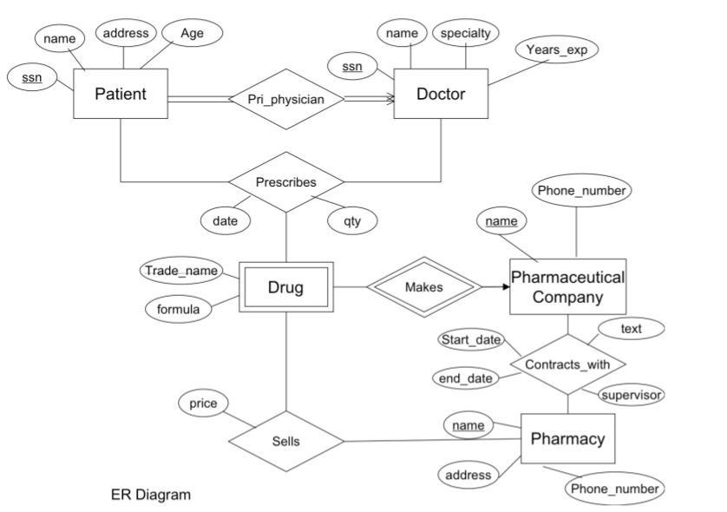
Exercise2
1
n
n
n
1
n
m
m
m
n
1

