**Dynamo DB**

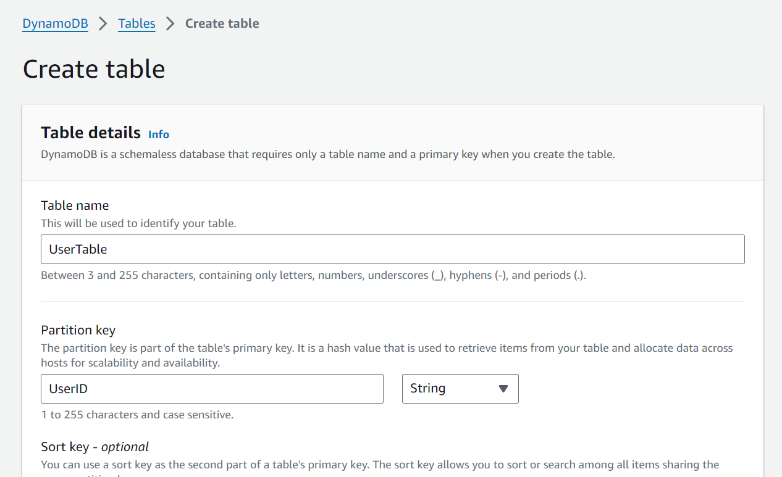

**Lamda Function**

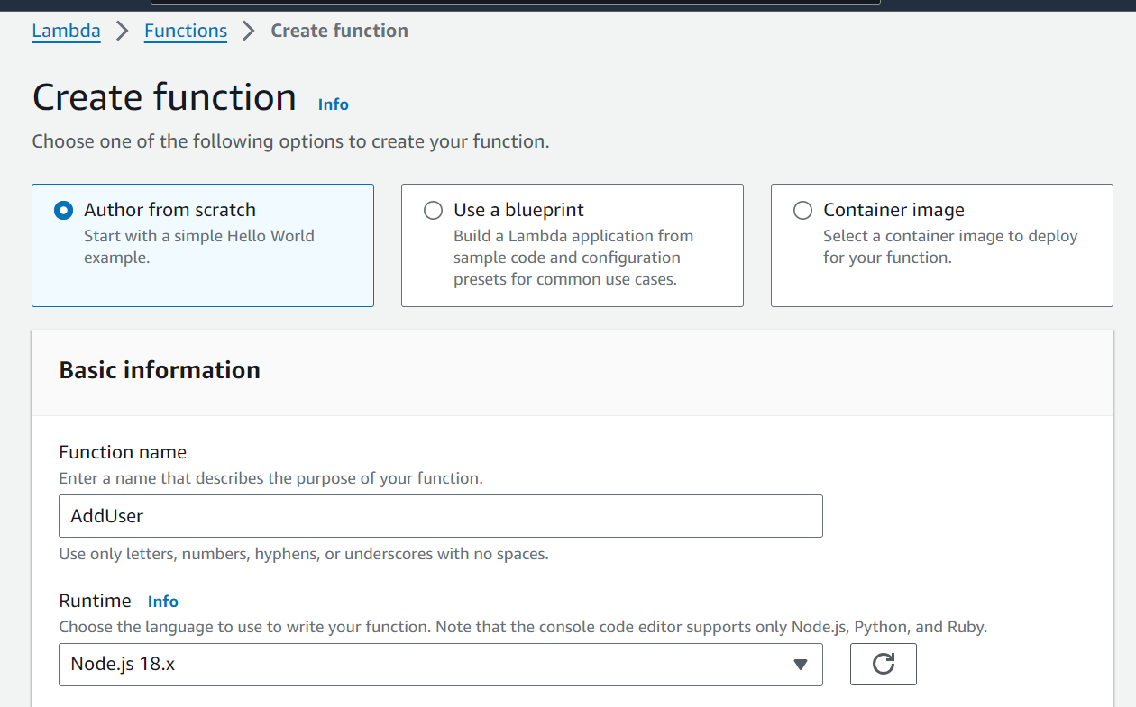

**API Gateway**



