**PROJECT**

**Solar Panel Power Output Simulation**

* **Models PV (**Photovoltaic) **panel under different irradiance & temperature.**
* **Inputs: Solar irradiance, Temperature.**
* **Outputs: I-V & P-V Characteristics,**

**Maximum power point.**

* **Libraries: Numpy, Matplotlib.**
* **Application: Renewable energy system design.**
* **Description:**

As irradiance increases, the **short-circuit current (Isc)** increases almost linearly**.**

Power output of the PV panel also increases with irradiance. With increasing temperature, the **open-circuit voltage (Voc)** decreases. This reduction in voltage causes a decrease in **maximum power output**. Current (Isc) increases slightly with temperature, but the drop in voltage dominates, leading to lower efficiency at higher temperatures. PV panels have a point on the I-V curve where power is maximum.MPP varies with irradiance and temperature.This principle is the basis of **Maximum Power Point Tracking (MPPT)** in real solar systems.

**SOURCE CODE:**

**Import Numpy as np**

**Import matplotlib.pyplot as plot**

**# PV panel reference parameters (at STC: 1000 W/m², 25 °C)**

**Isc_ref = 8.0 # Short-circuit current (A)**

**Voc_ref = 37.0 # Open-circuit voltage (V)**

**T_ref = 25.0 # Reference temperature (°C)**

**G_ref = 1000.0 # Reference irradiance (W/m²)**

**# Temperature coefficients**

**alpha_Isc = 0.005 # A/°C (Isc increases slightly with T)**

**beta_Voc = -0.12 # V/°C (Voc decreases with T)**

**def pv_model(G, T_C, Npoints=200):**

**"""**

**Compute simplified I-V and P-V curve for a PV panel**

**Inputs:**

**G : irradiance (W/m²)**

**T_C: cell temperature (°C)**

**"""**

**# Adjust Isc with irradiance and temperature**

**Isc = Isc_ref * (G / G_ref) + alpha_Isc * (T_C - T_ref)**

**# Adjust Voc with temperature**

**Voc = Voc_ref + beta_Voc * (T_C - T_ref)**

**V = np.linspace(0, Voc, Npoints)**

**# Simple exponential-like shape**

**k = 5 # shaping factor**

**I = Isc * (1 - np.exp(k * (V - Voc) / Voc))**

**I[I < 0] = 0 # clamp to zero**

**P = V * I**

**# Find Maximum Power Point (MPP)**

**idx = np.argmax(P)**

**Vmpp = V[idx]**

**Impp = I[idx]**

**Pmpp = P[idx]**

**return V, I, P, Vmpp, Impp, Pmpp**

**# -----------------**

**# Simulation cases**

**irradiances = [200, 600, 1000] # at fixed 25°C**

**temperatures = [0, 25, 50] # at fixed 1000 W/m²**

**results = []**

**# Plot I-V for irradiance sweep**

**plt.figure()**

**for G in irradiances:**

**V, I, P, Vmpp, Impp, Pmpp = pv_model(G, 25)**

**plt.plot(V, I, label=f"G={G} W/m², T=25°C")**

**results.append(["Irradiance", G, 25, Vmpp, Impp, Pmpp])**

**plt.xlabel("Voltage (V)")**

**plt.ylabel("Current (A)")**

**plt.title("I-V Curves under Different Irradiance")**

**plt.legend()**

**plt.grid(True)**

**plt.show()**

**# Plot P-V for irradiance sweep**

**plt.figure()**

**for G in irradiances:**

**V, I, P, Vmpp, Impp, Pmpp = pv_model(G, 25)**

**plt.plot(V, P, label=f"G={G} W/m², T=25°C")**

**plt.xlabel("Voltage (V)")**

**plt.ylabel("Power (W)")**

**plt.title("P-V Curves under Different Irradiance")**

**plt.legend()**

**plt.grid(True)**

**plt.show()**

**# Plot I-V for temperature sweep**

**plt.figure()**

**for T in temperatures:**

**V, I, P, Vmpp, Impp, Pmpp = pv_model(1000, T)**

**plt.plot(V, I, label=f"G=1000 W/m², T={T}°C")**

**results.append(["Temperature", 1000, T, Vmpp, Impp, Pmpp])**

**plt.xlabel("Voltage (V)")**

**plt.ylabel("Current (A)")**

**plt.title("I-V Curves under Different Temperature")**

**plt.legend()**

**plt.grid(True)**

**plt.show()**

**# Plot P-V for temperature sweep**

**plt.figure()**

**for T in temperatures:**

**V, I, P, Vmpp, Impp, Pmpp = pv_model(1000, T)**

**plt.plot(V, P, label=f"G=1000 W/m², T={T}°C")**

**plt.xlabel("Voltage (V)")**

**plt.ylabel("Power (W)")**

**plt.title("P-V Curves under Different Temperature")**

**plt.legend()**

**plt.grid(True)**

**plt.show()**

**# --------------------------**

**# Print summary table**

**print("\nSummary of Maximum Power Points (MPP):")**

**print("{:<12} {:<10} {:<8} {:<10} {:<10} {:<10}".format(**

**"Sweep", "G (W/m²)", "T(°C)", "Vmpp (V)", "Impp (A)", "Pmpp (W)"**

**))**

**for r in results:**

**print ("{:< 12} {:< 10} {:<8} {:<10.2f} {:<10.2f} {:<10.2f}".format(*r))**

**OUTPUT:**

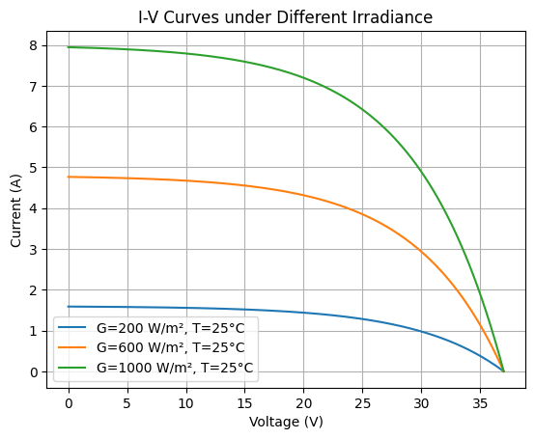 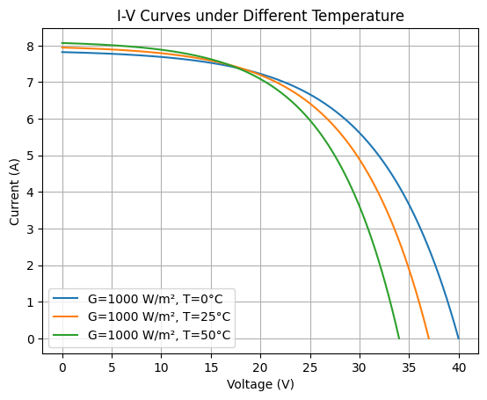

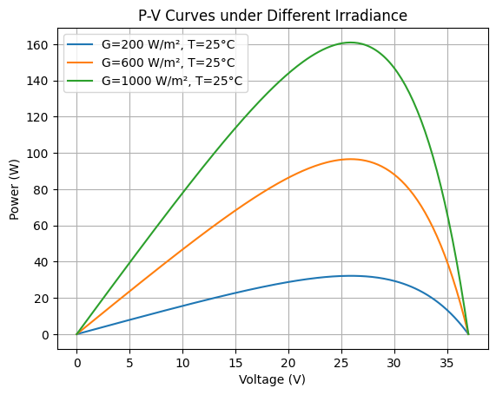 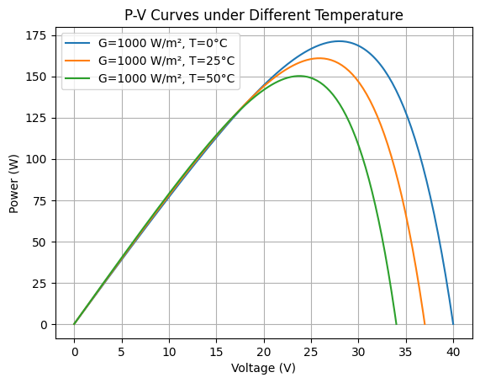

Summary of Maximum Power Points (MPP):

Sweep G (W/m²) T(°C) Vmpp (V) Impp (A) Pmpp (W)

Irradiance 200 25 25.84 1.25 32.19

Irradiance 600 25 25.84 3.74 96.58

Irradiance 1000 25 25.84 6.23 160.97

Temperature 1000 0 27.94 6.13 171.30

Temperature 1000 25 25.84 6.23 160.97

Temperature 1000 50 23.75 6.33 150.23

**Conclusion:**

From the solar panel power output simulation in Python, we can conclude that:

* When **sunlight (irradiance) increases**, the solar panel produces **more current and more power**.
* When **temperature increases**, the **voltage of the panel decreases**, which reduces the overall power output.
* The best performance of a solar panel is obtained at **high sunlight and low temperature**.
* The simulation also shows how the **I-V and P-V curves change**, helping us understand the working of solar panels under different conditions.