Scalable System to Support a Digital Twin of a Stone Factory Production Line
ABSTRACT:
While many industries are rapidly adopting Industry 4.0 technologies, sectors like stone factories are still catching up. This project introduces a smart, web-based system designed to modernize stone factories by creating a Digital Twin—a virtual replica of the production line. Using the widely adopted OPC UA protocol, the system gathers real-time machine data to enhance monitoring and control. It features two key user roles: Admins (Factory Owners), who can manage machines, set safety thresholds, monitor reports, and handle operator accounts; and Operators, who can view live machine data, receive alerts, and control machines remotely. To ensure data privacy and security, all IoT data is encrypted using AES standards. The system has been tested in both lab and real-world conditions, proving its usability and reliability. Although built specifically for stone factories, its flexible design allows it to be adapted to other industrial sectors as well.The platform is developed using HTML, CSS, and JavaScript for the frontend, while the backend is powered by Django, with SQLite used as the database for lightweight and efficient data storage.
Keywords: Industry 4.0, Digital Twin, Real-time Data Monitoring, OPC UA Protocol, AES Encryption
STATEMENT ABOUT THE PROBLEM
Despite the rapid advancement of Industry 4.0 technologies, many traditional industries—such as stone processing—have been slow to adopt real-time monitoring, automation, and secure data handling. As a result, these factories face reduced operational visibility, delayed responses to machine faults, and inefficient manual processes. Existing systems often lack integration with standard industrial communication protocols like OPC UA and do not provide secure, centralized platforms for monitoring and controlling machinery. Furthermore, there is a gap in user-friendly interfaces that allow both factory owners and operators to manage machines, receive alerts, and access historical data in real-time. This project aims to solve these challenges by developing a secure, scalable Digital Twin platform for stone factories that enables real-time machine monitoring, remote control, and encrypted data storage, while being adaptable to other industrial sectors.
SCOPE:
The scope of this project encompasses the design, development, and deployment of a web-based Digital Twin system tailored for stone factories, with future adaptability to other industrial sectors. The system allows real-time monitoring and remote control of machines using the OPC UA protocol, supporting both live and historical data tracking. It provides distinct functionalities for two types of users: Admins can configure machines, set safety thresholds, manage operators, and generate performance and alert reports; Operators can monitor machine status, control machines, and receive critical alerts. All industrial IoT data is securely stored using AES encryption to ensure data confidentiality and integrity. The frontend is built using HTML, CSS, and JavaScript for responsive interaction, while the backend is developed in Django with SQLite as the lightweight database solution. The scope also includes usability testing in both laboratory and simulated industrial environments to ensure the platform is user-friendly, secure, and scalable for future extensions such as predictive maintenance, multi-factory support, or integration with cloud-based analytics tools.
OBJECTIVE OF THE PROJECT:
The objective of this project is to develop a secure and user-friendly Digital Twin system for stone factories that enables real-time monitoring, remote control, and efficient management of industrial machinery. By integrating the OPC UA protocol, the system retrieves live data such as temperature and RPM from machines and displays it through a web-based dashboard. The platform provides role-based access for both Admins and Operators, allowing factory owners to configure machines, set safety thresholds, manage users, and view detailed reports, while operators can monitor machine status, receive alerts, and control machines remotely. To ensure data privacy and integrity, all IoT data is stored using AES encryption.=

EXISTING METHOD
In traditional stone factories, machine monitoring is mostly manual or based on basic SCADA systems, offering limited real-time visibility. Operators rely on physical controls and analog meters without remote access or centralized dashboards. There is no proper alert system for faults like overheating, leading to delays in response and possible equipment damage. Historical data logging is rarely implemented, making performance analysis difficult. User role management is absent, and IoT data is not securely stored. Existing solutions are often costly, complex, and not tailored for small or mid-sized factories, lacking integration with modern protocols like OPC UA and secure encryption methods like AES.
Disadvantages:
- No real-time machine monitoring or live data visualization.
- No automatic alerts for faults like overheating or motor failure.
- No role-based access control for admins and operators.
- Data is stored without encryption, leading to security vulnerabilities.
- No proper tracking or logging of file activities.
PROPOSED SYSTEM:
The proposed system is a secure, web-based Digital Twin platform designed to modernize stone factories using Industry 4.0 technologies. It retrieves real-time machine data such as temperature and RPM through the OPC UA protocol and displays it on an interactive dashboard. The system supports two user roles—Admins can configure machines, set safety thresholds, manage operators, and view reports, while Operators can monitor machines, receive alerts, and control them remotely. All IoT data is securely stored using AES encryption to ensure confidentiality. The platform is built using HTML, CSS, JavaScript, Django, and SQLite, making it lightweight, scalable, and adaptable to other industries. It enables efficient machine control, real-time visibility, and data-driven decision-making.

Advantages:
- Real-Time Monitoring.
- Role-Based Access.
- Secure Data Storage.
- OPC UA Integration.
- Historical Reports.
PROJECT FLOW:
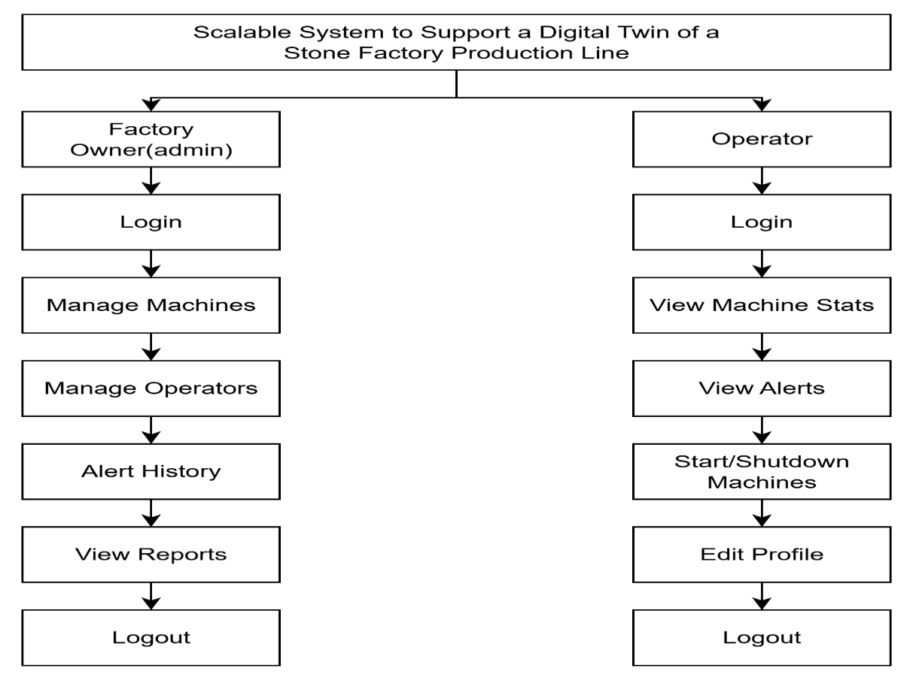

SOFTWARE FRONT END REQUIREMENTS

H/W CONFIGURATION:

Processor - I3/Intel Processor
Hard Disk - 160GB
Key Board - Standard Windows Keyboard
Mouse - Two or Three Button Mouse
Monitor - SVGA
RAM - 8GB
S/W CONFIGURATION:
- Operating System : Windows 7/8/10+
- Server side Script : HTML, CSS & JS
- Programming Language : Python
- Libraries : Django
- Technology : Python 3.6+
- Database : Sqlite
MODULES/IMPLEMENTATION

Admin (Factory Owner) Module:
- Login:
Admin securely logs into the system using authorized credentials to access the admin dashboard.
- Add/Edit Machines:
Admin can register new machines or edit existing ones by entering machine name, selecting the machine type (e.g., Cutter), specifying the OPC UA endpoint, and selecting which parameters to monitor (e.g., temperature, RPM).
- Set Thresholds:
Admin defines safe operating limits for machines (e.g., temperature < 90°C, RPM < 2000). These thresholds are used to trigger alerts automatically.
- Manage Alerts:
Admin configures alert rules (e.g., Temp > 90°C → Overheating Alert) to notify operators in case of machine abnormalities.
- Manage Operators:
Admin can create, update, or delete operator accounts, managing who has access to machine control and monitoring functionalities.
- View Reports:
Admin can view historical logs
- Logout:
Ends the admin session securely and logs out from the system.

Operator Module:
- Login:
Operator logs into the system using valid credentials to access the live monitoring dashboard.
- View Machine Status (Live Dashboard):
Operators can view real-time machine data such as temperature, RPM, and running status.
- Start/Stop Machines:
Operators control machines remotely using Start/Stop buttons. These actions trigger Python-based OPC UA client commands to write to the machine's control tag, turning the machine ON or OFF.
- Receive Alerts:
Operators receive instant alerts for abnormal conditions (e.g., Overheat, Motor Fault). Upon receiving alerts, the operator can shut down the affected machine for safety.
- Edit Profile:
Operators can manage their profile, including updating their name, email, and password.
- Logout:
Securely ends the session and logs out the operator from the system.

