- CPU Organization & Bus Structures:
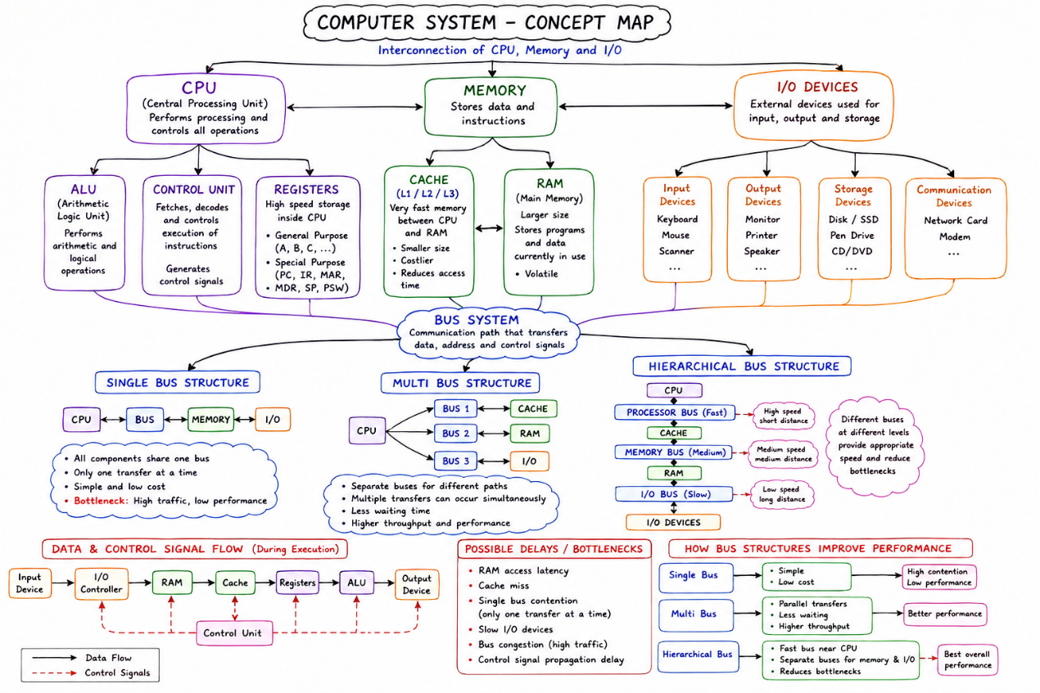

- Instruction Execution & CPU Performance:
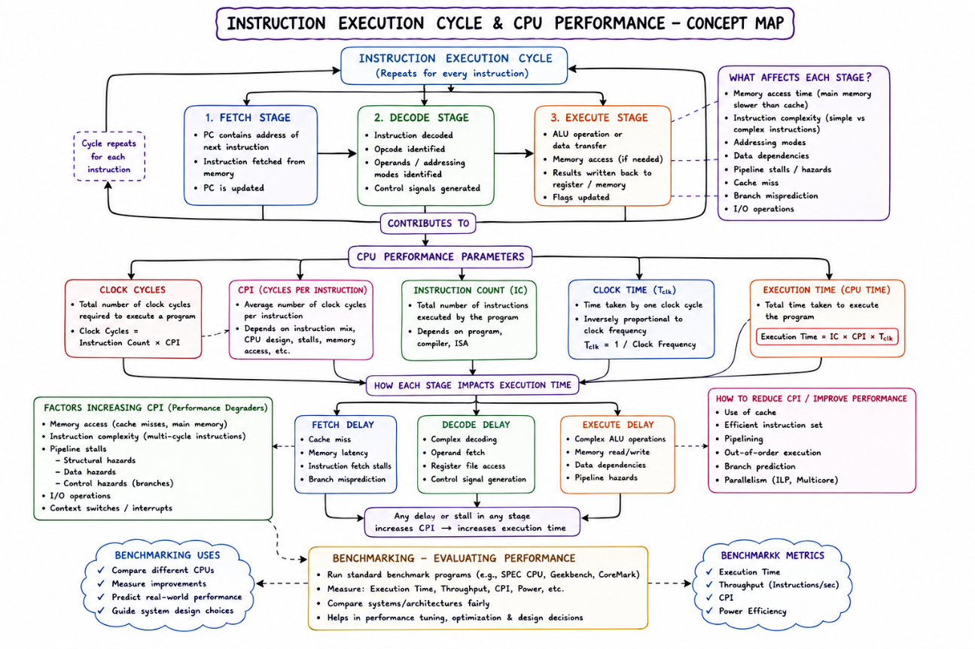

- 8085 vs 8086 Architecture:
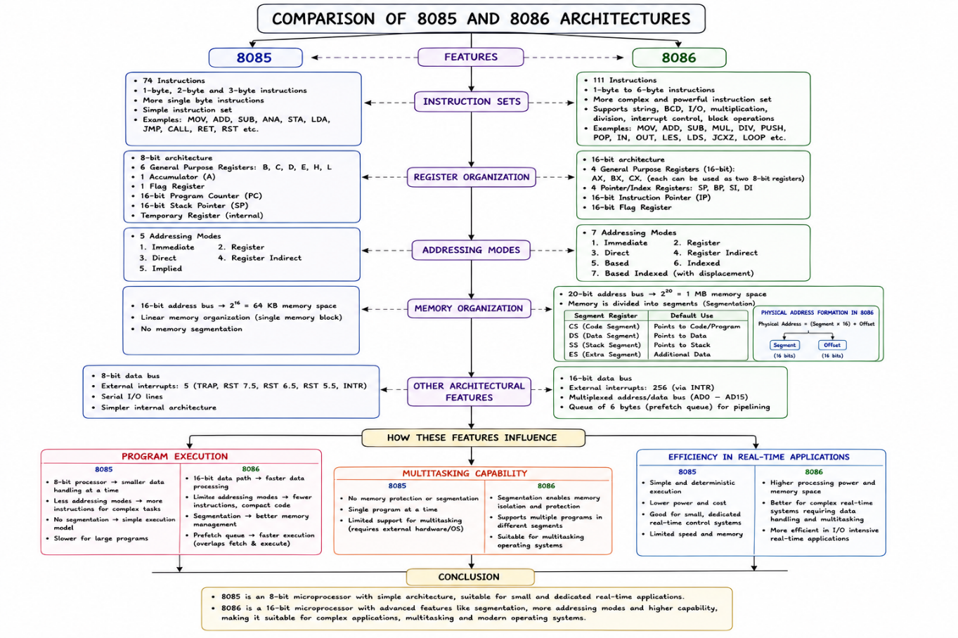

- Addressing Modes & Instruction Types:
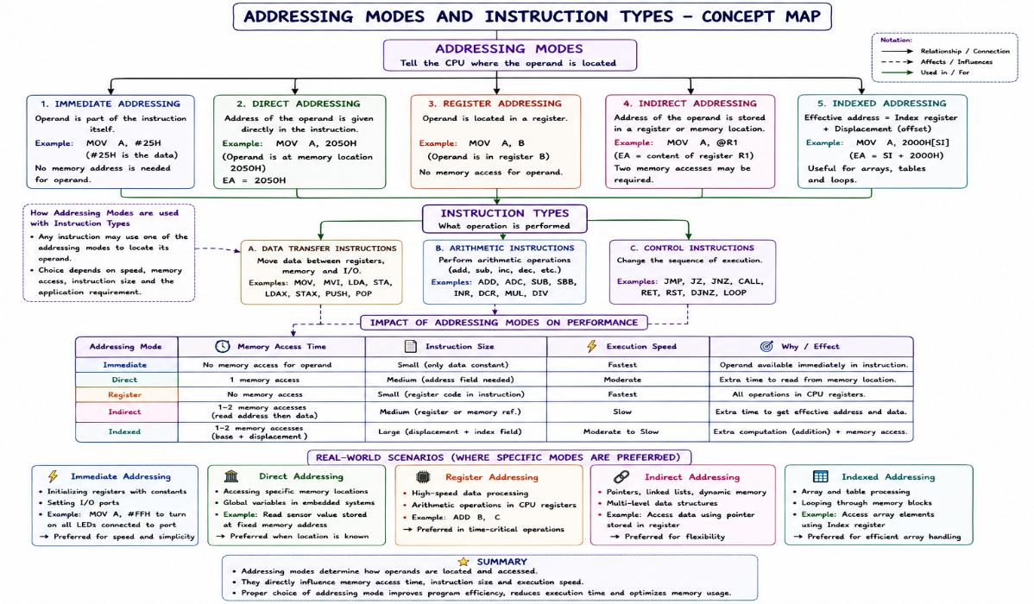

- Number Systems & Instruction Representation:
