SIMATS ENGINEERING
Department of Computer Science & Engineering
ASSESSMENT TOOL 1- EXPERIMENTS

Course Code: | CSA1209 & CSA1215 | Course Title: | Computer Architecture
CO Assessed: | CO3 | Assessment: | ASSESSMENT TOOL 1- EXPERIMENTS
Weightage: | 40% | Total Marks: | 25
CO3 Statement: | Design processor organization by constructing pipelined datapath structures, identifying hazard types (data, control, structural), and comparing superscalar techniques such as out-of-order execution, speculative execution, and simultaneous multithreading (SMT). (BL6)
Student Name: | V.Rajitha | Reg.No.: | 192311036
Department: |  | Date:

ANNEXURE A

1. Design and simulate a system that performs register transfer operations along with basic arithmetic and logic operations such as addition, subtraction, AND, and OR. Use multiple registers to demonstrate how data is transferred between them during execution, and analyze the sequence of operations and the role of the ALU in processing data.
1. Aim
To design and simulate register transfer operations and basic arithmetic and logical operations using multiple registers and an ALU.

2. Objective
The system demonstrates:
- Register-to-register data transfer
- Addition
- Subtraction
- AND
- OR
- Role of ALU
- Sequence of operations

3.Java Implementation

public class Main {

// Registers

static int R1 = 0;

static int R2 = 0;

static int R3 = 0;

static int R4 = 0;

// ALU operations

static int ALU(int a, int b, int operation) {

switch (operation) {

case 0:

return a + b; // ADD

case 1:

return a - b; // SUBTRACT

case 2:

return a & b; // AND

case 3:

return a | b; // OR

default:

return 0;

}

}

static void showRegisters() {

System.out.println("R1 = " + R1);

System.out.println("R2 = " + R2);

System.out.println("R3 = " + R3);

System.out.println("R4 = " + R4);

System.out.println();

}

public static void main(String[] args) {

// Register Transfer

R1 = 10;

R2 = 3;

System.out.println("Initial Register Values:");

showRegisters();

// Addition

R3 = ALU(R1, R2, 0);

R4 = R3;

System.out.println("After ADD: R4 = R1 + R2");

showRegisters();

// Subtraction

R3 = ALU(R1, R2, 1);

R4 = R3;

System.out.println("After SUBTRACTION: R4 = R1 - R2");

showRegisters();

// AND

R3 = ALU(R1, R2, 2);

R4 = R3;

System.out.println("After AND: R4 = R1 AND R2");

showRegisters();

// OR

R3 = ALU(R1, R2, 3);

R4 = R3;

System.out.println("After OR: R4 = R1 OR R2");

showRegisters();

}

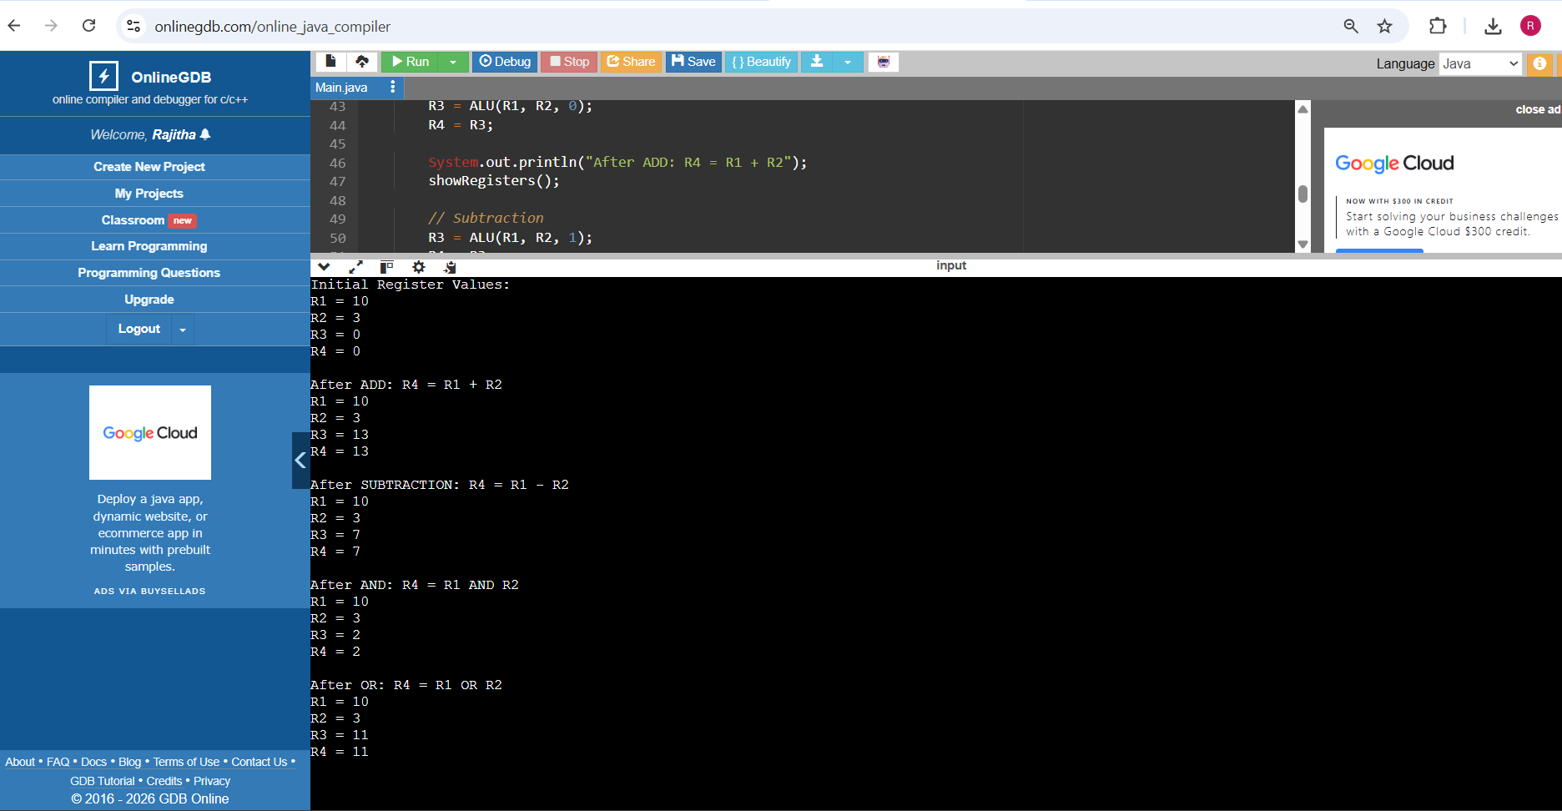

2. Create a model of a computer system using single-bus and multi-bus organization, and perform data transfer operations between registers, memory, and I/O. Compare the time taken and efficiency of both approaches, and analyze how multiple bus structures improve parallel data transfer and reduce bottlenecks.
1. Aim
To model single-bus and multi-bus computer organization and compare their data transfer efficiency.

Single-Bus Organization
In a single-bus system, all components share one common bus.
R1 ──┐
R2 ──┤
R3 ──┤──► SINGLE BUS ──► ALU
R4 ──┤
MEM ─┘
Only one major transfer can use the bus at a time.

Example
For:
R3 = R1 + R2
The processor needs:
R1 → Bus
Bus → ALU
R2 → Bus
Bus → ALU ALU → R3
This creates more transfer steps.

Multi-Bus Organization
A multi-bus system can transfer multiple operands simultaneously.
┌──────────┐
R1 ─────────►│ │
│ Bus A │
│ │
└────┬─────┘
│
▼
┌─────┐
│ ALU │
└─────┘
▲ │
┌────┴─────┐
R2 ─────────►│ Bus B │ └──────────┘
R1 and R2 can be supplied to the ALU at the same time.

Java Simulation
# Q2 - Single Bus vs Multi Bus

public class Main {

// Simulated transfer time for one bus operation
static final int TRANSFER_TIME = 10;

// ---------------- SINGLE BUS ----------------
static int singleBusSimulation() {

int time = 0;

System.out.println("===== SINGLE-BUS ORGANIZATION =====");

System.out.println("1. R1 -> Memory");
time += TRANSFER_TIME;

System.out.println("2. Memory -> R2");
time += TRANSFER_TIME;

System.out.println("3. R2 -> I/O");
time += TRANSFER_TIME;

System.out.println("4. I/O -> R3");
time += TRANSFER_TIME;

System.out.println("5. R3 -> Memory");
time += TRANSFER_TIME;

System.out.println("6. Memory -> R1");
time += TRANSFER_TIME;

return time;
}

// ---------------- MULTI BUS ----------------
static int multiBusSimulation() {

int time = 0;

System.out.println("\n===== MULTI-BUS ORGANIZATION =====");

// Two transfers can happen at the same time
System.out.println("Time 0-10:");
System.out.println("Bus 1: R1 -> Memory");
System.out.println("Bus 2: R2 -> I/O");
time += TRANSFER_TIME;

System.out.println("\nTime 10-20:");
System.out.println("Bus 1: Memory -> R2");
System.out.println("Bus 2: I/O -> R3");
time += TRANSFER_TIME
System.out.println("\nTime 20-30:");
System.out.println("Bus 1: R3 -> Memory");
System.out.println("Bus 2: Memory -> R1");
time += TRANSFER_TIME;

return time;
}

public static void main(String[] args) {
int singleBusTime = singleBusSimulation();
int multiBusTime = multiBusSimulation();
System.out.println("\n================================");
System.out.println("Single-Bus Time = "
+ singleBusTime + " units");
System.out.println("Multi-Bus Time = "
+ multiBusTime + " units");

double improvement =
((double)(singleBusTime - multiBusTime)
/ singleBusTime) * 100;
System.out.printf("Time Reduction = %.2f%%%n", improvement);
System.out.println("\nEfficiency Analysis:");
if (multiBusTime < singleBusTime) {
System.out.println(
"Multi-bus organization is faster because "
+ "multiple transfers can occur in parallel."
);
}
}
}%")

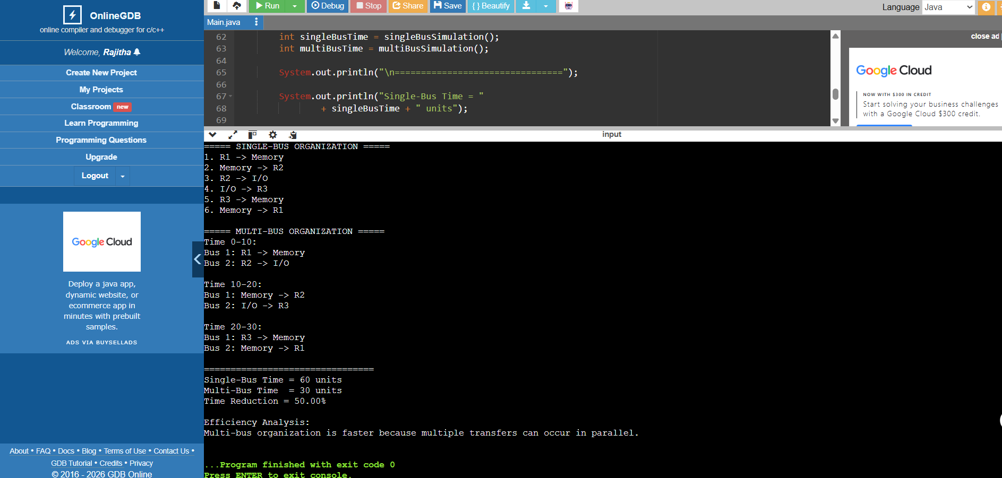

3. Simulate a 5-stage instruction pipeline (Fetch, Decode, Execute, Memory, Write-back) and execute a set of instructions. Measure the performance in terms of speedup and throughput, and compare it with a non-pipelined system to evaluate the effectiveness of pipelining.
1. Aim
To simulate a 5-stage instruction pipeline and compare its performance with a non-pipelined processor.

2. Five Stages
IF → ID → EX → MEM → WB Where:
Stage Meaning
IF Instruction Fetch
ID Instruction Decode
EX Execute
MEM Memory Access WB Write Back

Pipeline Diagram
For five instructions:
Cycle → 1 2 3 4 5 6 7 8 9

I1 IF ID EX MEM WB
I2 IF ID EX MEM WB
I3 IF ID EX MEM WB
I4 IF ID EX MEM WB
I5 IF ID EX MEM WB
The important point is that multiple instructions are being processed simultaneously in different stages

Java Implementation

public class Main {

static final int STAGES = 5;

public static void main(String[] args) {

String[] instructions = {
"I1",
"I2",
"I3",
"I4",
"I5",
"I6",
"I7",
"I8"
};

int n = instructions.length;

// ---------------- NON-PIPELINED ----------------
int nonPipelinedCycles = n * STAGES;

// ---------------- PIPELINED ----------------
// For n instructions and 5 stages:
// Total cycles = stages + instructions - 1
int pipelinedCycles = STAGES + n - 1;

// Speedup
double speedup =
(double) nonPipelinedCycles / pipelinedCycles;

// Throughput
double pipelinedThroughput =
(double) n / pipelinedCycles;

double nonPipelinedThroughput =
(double) n / nonPipelinedCycles;

// ---------------- PIPELINE TABLE ----------------
System.out.println("========== 5-STAGE PIPELINE SIMULATION ==========\n");

System.out.println("Stages: Fetch -> Decode -> Execute -> Memory -> Write-back\n");

System.out.printf("%-12s", "Instruction");

for (int cycle = 1; cycle <= pipelinedCycles; cycle++) {
System.out.printf("%-6s", "C" + cycle);
}

System.out.println();

for (int i = 0; i < n; i++) {

System.out.printf("%-12s", instructions[i]);

int start = i + 1;

for (int cycle = 1; cycle <= pipelinedCycles; cycle++) {

int position = cycle - start;

String stage = "";

switch (position) {
case 0:
stage = "F";
break;
case 1:
stage = "D";
break;
case 2:
stage = "E";
break;
case 3:
stage = "M";
break;
case 4:
stage = "W";
break;
}

System.out.printf("%-6s", stage);
}

System.out.println();
}

// ---------------- RESULTS ----------------
System.out.println("\n========== PERFORMANCE COMPARISON ==========");

System.out.println(
"Number of Instructions : " + n);

System.out.println(
"Pipeline Stages : " + STAGES);

System.out.println(
"Non-Pipelined Cycles : "
+ nonPipelinedCycles);

System.out.println(
"Pipelined Cycles : "
+ pipelinedCycles);

System.out.printf(
"Speedup : %.2f%n",
speedup);

System.out.printf(
"Non-Pipelined Throughput: %.3f instructions/cycle%n",
nonPipelinedThroughput);

System.out.printf(
"Pipelined Throughput : %.3f instructions/cycle%n",
pipelinedThroughput);

System.out.println("\n========== ANALYSIS ==========");

System.out.println(
"Pipelining allows multiple instructions "
+ "to occupy different stages simultaneously.");

System.out.println(
"After the pipeline is filled, approximately "
+ "one instruction completes every cycle.");

System.out.printf(
"The simulated speedup is %.2fx compared "
+ "with the non-pipelined system.%n",
speedup);
}
}

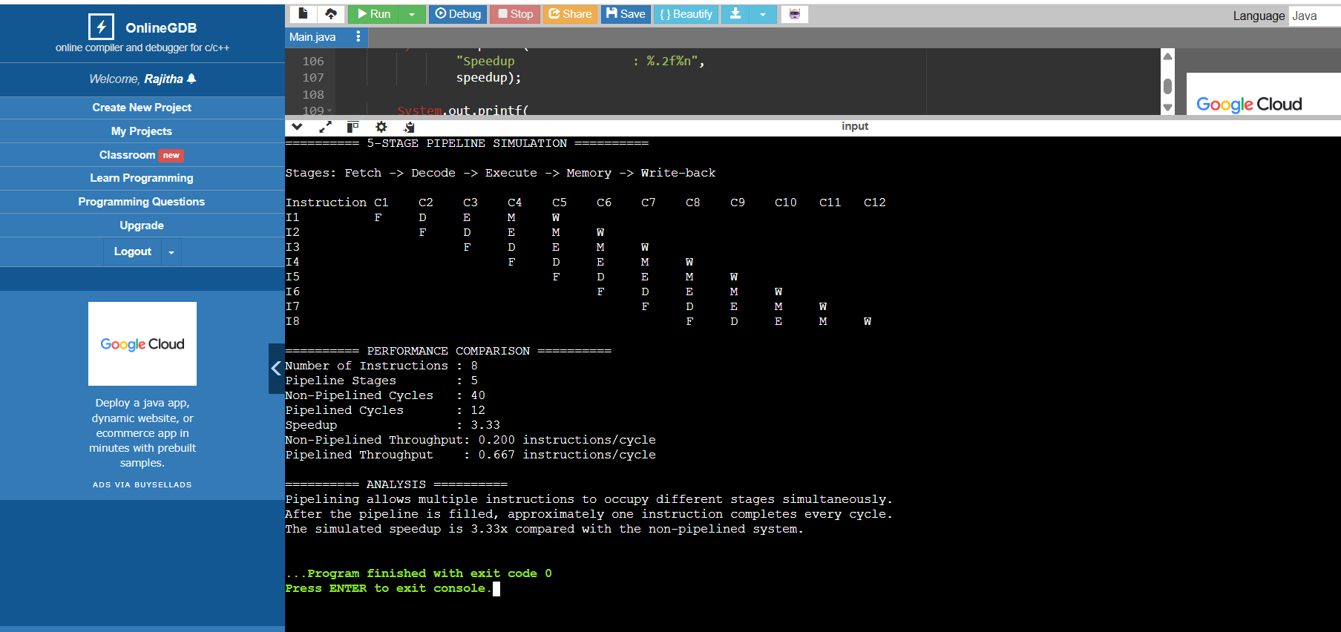

4. Develop a pipeline execution scenario where data hazards, control hazards, and structural hazards occur. Observe their impact on instruction execution, and implement techniques such as stalling, data forwarding, and branch prediction to resolve these hazards and improve performance.

1. Aim
To simulate data, control and structural hazards and demonstrate techniques such as stalling, forwarding and branch prediction.

Types of Hazards A. Data Hazard
Occurs when one instruction depends on the result of a previous instruction.
Example:
I1: ADD R1,R2,R3 I2: SUB R4,R1,R5
I2 needs R1, but I1 has not completed writing R1.
I1 → produces R1
↓
I2 → needs R1

B. Control Hazard
Occurs because of branch instructions.
Example:
I1: ADD R1,R2,R3
I2: BEQ R1,R0,LABEL I3: SUB R4,R5,R6
The processor does not immediately know whether I3 should execute.

C. Structural Hazard
Occurs when two instructions need the same hardware resource simultaneously.
Example:
Instruction 1 → Memory
Instruction 2 → Memory
If only one memory unit exists, they compete for the resource.

Hazard Handling Data hazard → Forwarding
EX result
│
└────────► next instruction
Instead of waiting for the result to be written to the register.

Control hazard → Branch Prediction Processor predicts: Branch Taken
or:
Branch Not Taken
Structural hazard → Stalling
One instruction waits until the resource becomes available.

Java Simulation
# Q4 - Pipeline Hazard Simulation

public class Main {

public static void main(String[] args) {

System.out.println("PIPELINE HAZARD SIMULATION");
System.out.println("--------------------------");

// Instructions
String[] instructions = {
"I1: ADD R1,R2,R3",
"I2: SUB R4,R1,R5",
"I3: BEQ R4,R0",
"I4: LOAD R6,[R7]"
};

for (String i : instructions)
System.out.println(i);

System.out.println("\nDATA HAZARD:");
System.out.println("I2 depends on I1");
System.out.println("Solution: Data Forwarding");

System.out.println("\nCONTROL HAZARD:");
System.out.println("I3 is a branch instruction");
System.out.println("Solution: Branch Prediction");

System.out.println("\nSTRUCTURAL HAZARD:");
System.out.println("Memory resource conflict");
System.out.println("Solution: Stall for one cycle");

System.out.println("\nPIPELINE:");
System.out.println("Cycle 1: I1-IF");
System.out.println("Cycle 2: I1-ID | I2-IF");
System.out.println("Cycle 3: I1-EX | I2-ID");
System.out.println("Cycle 4: I1-MEM | I2-EX");
System.out.println("Cycle 5: I1-WB | I2-MEM");
System.out.println("Cycle 6: I2-WB | STALL");
System.out.println("Cycle 7: I3-EX | I4-IF");

System.out.println("\nHazards resolved successfully!");
}
}
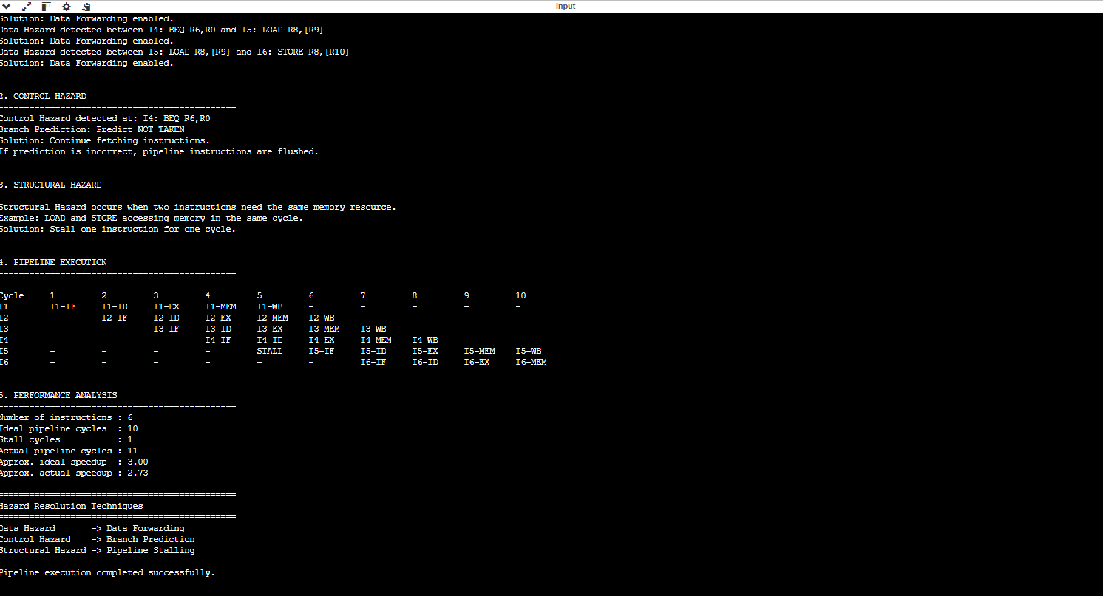

5. Analyze a processor supporting superscalar execution, including out-of-order and speculative execution, and extend the study to include hyper-threading and simultaneous multithreading (SMT). Evaluate how multiple instructions are executed in parallel and compare the performance improvements in terms of instruction throughput and resource utilization.

1. Aim
To simulate a superscalar processor supporting out-of-order execution, speculative execution and simultaneous multithreading.

2. Superscalar Processor
A normal scalar processor might execute:
1 instruction/cycle
A 2-wide superscalar processor can potentially execute:
2 instructions/cycle
Example:
Cycle 1:

ADD ─────► ALU 1
SUB ─────► ALU 2

3. Out-of-Order Execution
Suppose:
I1: LOAD R1
I2: ADD R2,R1,R3
I3: ADD R5,R6,R7 I2 must wait for I1.
But I3 does not depend on I1.
Therefore:
I1 → waiting
I2 → waiting

I3 → EXECUTE
This improves resource utilization.

4. Speculative Execution
For a branch:
BEQ R1,R2,LABEL
The processor predicts the branch.
If prediction is correct:
Continue execution
If prediction is wrong:
Discard speculative instructions

5. SMT
SMT allows multiple software threads to use the same processor resources.
For example:
CPU
│
┌──────┴──────┐
│ │
Thread 1 Thread 2
│ │
ALU/Memory/Execution
Instead of leaving execution units idle when Thread 1 is waiting, Thread 2 can use them.

Python Simulation

# Q5 - Superscalar, Out-of-Order, Speculative Execution and SMT
public class Main {

public static void main(String[] args) {

System.out.println("SUPERSCALAR & SMT PROCESSOR");
System.out.println("---------------------------");

String[] instructions = {
"I1: ADD",
"I2: MUL",
"I3: LOAD",
"I4: SUB",
"I5: DIV",
"I6: STORE"
};

// Superscalar: execute 2 instructions per cycle
System.out.println("\nSuperscalar Execution:");
for (int i = 0; i < instructions.length; i += 2) {
System.out.print("Cycle " + (i / 2 + 1) + ": ");

System.out.print(instructions[i]);

if (i + 1 < instructions.length)
System.out.print(" | " + instructions[i + 1]);

System.out.println();
}

// Out-of-order execution
System.out.println("\nOut-of-Order Execution:");
System.out.println("I1 -> I3 -> I2 -> I5 -> I4 -> I6");

// Speculative execution
System.out.println("\nSpeculative Execution:");
System.out.println("Branch predicted as TAKEN");
System.out.println("Execute predicted instructions");
System.out.println("Wrong prediction -> Flush instructions");

// Hyper-threading / SMT
System.out.println("\nSMT / Hyper-Threading:");
System.out.println("Thread 1: I1 I2 I3");
System.out.println("Thread 2: I4 I5 I6");
System.out.println("Both threads execute using shared CPU resources.");

// Performance comparison
int instructionsCount = 6;
int singleCycles = 6;
int superscalarCycles = 3;

double speedup =
(double) singleCycles / superscalarCycles;

System.out.println("\nPerformance:");
System.out.println("Single Issue Cycles : " + singleCycles);
System.out.println("Superscalar Cycles : " + superscalarCycles);
System.out.println("Instruction Throughput: "
+ (instructionsCount / (double)superscalarCycles)
+ " instructions/cycle");
System.out.println("Speedup : " + speedup + "x");

System.out.println("\nResource Utilization:");
System.out.println("Superscalar -> Higher parallel execution");
System.out.println("Out-of-order -> Reduces waiting time");
System.out.println("Speculation -> Reduces branch delays");
System.out.println("SMT -> Keeps CPU resources busy");

System.out.println("\nSimulation completed successfully!");
}
}

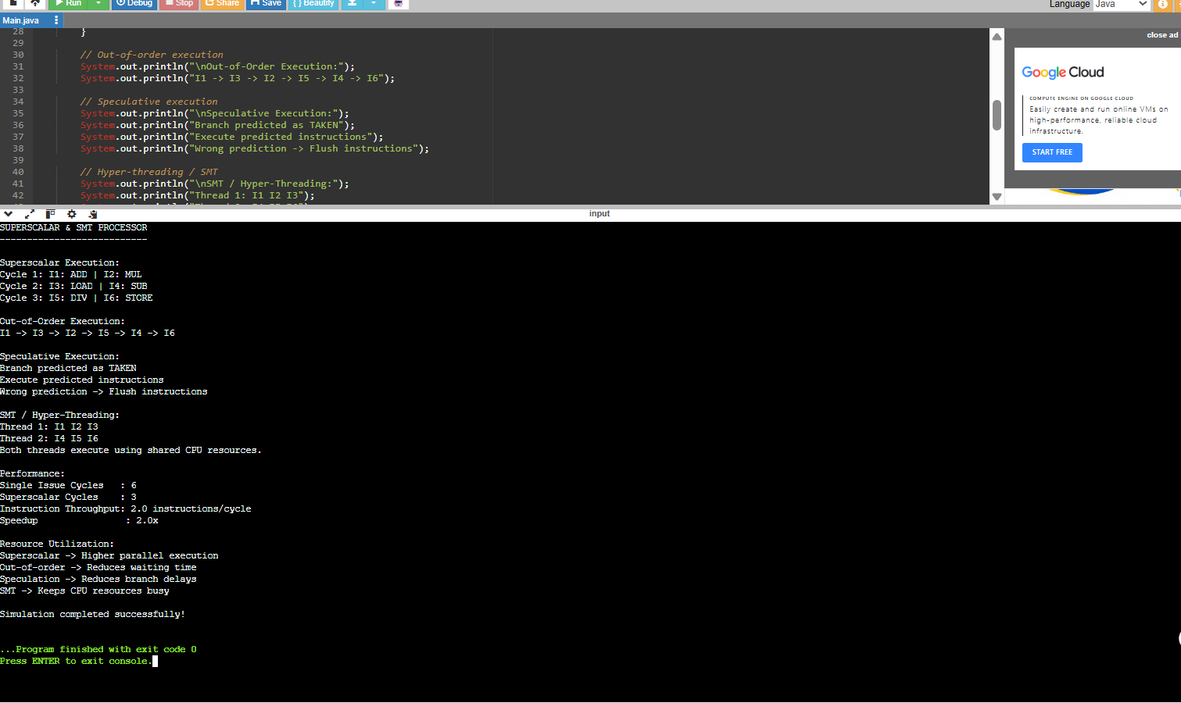

Code of Conduct:

I V.Rajitha(192311036 (Name / Reg No) certify that this submission is
my original work and that I have adhered to the guidelines specified for this assessment.I understand that any violation of academic integrity rules will result in disciplinary action.

Signature of the student: V.Rajitha

MARKS ALLOCATION

 | Understanding of Concepts (20%) | Experimental Design (20%) | Use of Tools  (25%) | Analysis of Results (20%) | Documentation  (15%)
Q1
Q2
Q3
Q4
Q5

RUBRICS FOR CALCULATION:

Criteria | Weightag  e | Level 4 – Exemplary | Level 3 –  Proficient | Level 2 –  Developing | Level 1 –  Beginning
Understanding of Concepts | 25 | Demonstrates thorough understanding and  effectively integrates multiple concepts/technologies | Good understanding with proper  integration of most concepts | Basic understanding;  limited or partial integration | Poor understanding; unable to integrate concepts
Experimental Design | 30 | Well-planned, systematic implementation with optimal solution | Correct implementation with minor issues | Basic implementation with errors or inefficiencies | Incorrect or incomplete implementation
Use of Tools | 20 | Effective and advanced use of tools/technologies with proper configuration | Appropriate use of tools with correct execution | Limited or inconsistent use of tools | Incorrect or minimal use of tools
Analysis of Results | 15 | Insightful analysis with accurate interpretation and validation of results | Good analysis with reasonable interpretation | Basic analysis with limited insights | Poor or incorrect analysis of results
Documentation | 10 | Clear, well-structured documentation with  diagrams, code, and results | Organized documentation with necessary details | Basic documentation  with missing details | Poor or incomplete documentation

