SIMATS ENGINEERING
Department of Computer Science & Engineering
ASSESSMENT TOOL 2-DEBUGGING & OPTIMISATION TASK

Course Code: | CSA1205 | Course Title: | Computer Architecture for Multicore Systems
CO Assessed: | CO2 | Assessment: | ASSESSMENT TOOL2DEBUGGING &  OPTIMISATION TASK
Weightage: | 20% | Total Marks: | 25
CO2 Statement: | Apply integer and floating-point arithmetic algorithms including Booth's multiplication, restoring/non-restoring division, and IEEE 754 standard operations to solve fixed-point and floating-point computational problems. (BL3)
Student Name: | V.Rajitha | Reg.No.: | 192311036
Department: |  | Date:

ANNEXURE A
- A program performing signed integer addition using 2’s complement produces incorrect results when adding large values (e.g., +120 and +50 in 8-bit representation). Debug the issue by analyzing the binary computation and identifying whether overflow has occurred. Propose a solution to correctly detect and handle overflow in such cases.

- A processor using a ripple carry adder shows significant delay in executing arithmetic operations in a real-time system. Debug the performance bottleneck by examining how carry propagates through each bit. Suggest an optimized solution using a carry lookahead adder, and explain how it reduces delay.

- A multiplication unit implementing Booth’s algorithm gives incorrect results for certain negative operands. Debug the step-by-step execution of the algorithm, focusing on bitpair checking, arithmetic shifts, and sign extension. Identify the possible source of error and suggest corrections to ensure accurate signed multiplication.

- An embedded system using the restoring division algorithm experiences inefficiency due to repeated restoration steps, leading to increased execution time. Debug the algorithm’s workflow and identify where unnecessary operations occur. Propose an optimized approach using the non-restoring division method, explaining how it improves performance.

- A scientific application using IEEE 754 single precision floating-point representation produces inaccurate results when adding very small and very large numbers. Debug the issue by analyzing exponent alignment, normalization, and rounding errors.
Suggest optimization techniques, such as using double precision or algorithmic adjustments, to improve accuracy.

Code of Conduct:

I V. Rajitha (192311036) (Name / Reg No) certify that this submission is my original work and that I have adhered to the guidelines specified for this assessment. I understand that any violation of academic integrity rules will result in disciplinary action.

Signature of the student:

MARKS ALLOCATION
 | Identification of Errors /  Bugs (20%) | Debugging  Approach &  Analysis (20%) | Correctness  s of  Debugged  Solution (2  5%) | Optimization Techniques  Applied (20%) | Testing and  Documentation (15  %)
Q1
Q2
Q3
Q4
Q5

RUBRICS FOR CALCULATION:

Criteria | Weightage | Level 4 – Exemplary | Level 3 –  Proficient | Level 2 –  Developing | Level 1 –  Beginning
Identification of Errors / Bugs | 20% | Accurately identifies all errors and issues with  complete understanding of  the problem | Identifies most errors with minor omissions | Identifies limited errors; misses key issues | Unable to identify errors or  misunderstands the problem
Debugging  Approach & Analysis | 20% | Uses effective debugging techniques with clear  analysis and root cause identification | Applies suitable  debugging  methods with minor gaps | Uses basic debugging  methods with limited analysis | No systematic debugging approach followed
Correctness of Debugged Solution | 25% | Provides completely corrected solution with  accurate functionality and expected output | Provides working  solution with minor errors | Partially correct solution with limited functionality | Incorrect solution or fails to resolve errors
Optimization Techniques Applied | 20% | Applies efficient optimization methods to improve performance, memory usage and quality | Performs optimization  with noticeable improvements | Limited optimization  with minimal improvements | No optimization applied or  inefficient implementation
Testing and Documentation | 15% | Performs complete testing with proper validation and clear documentation | Provides adequate  testing and  documentation with minor issues | Limited testing and incomplete documentation | No proper testing or documentation provided

Signed Addition Using 2's Complement
For 8-bit signed integers:
- +120 = 01111000
- +50 = 00110010 Addition:
01111000 (+120)
+ 00110010 (+50)
-----------
10101010
10101010 is negative in 2's complement, but the expected result is 170, which is outside the 8-bit signed range:
Range = -128 to +127
Therefore, overflow has occurred.
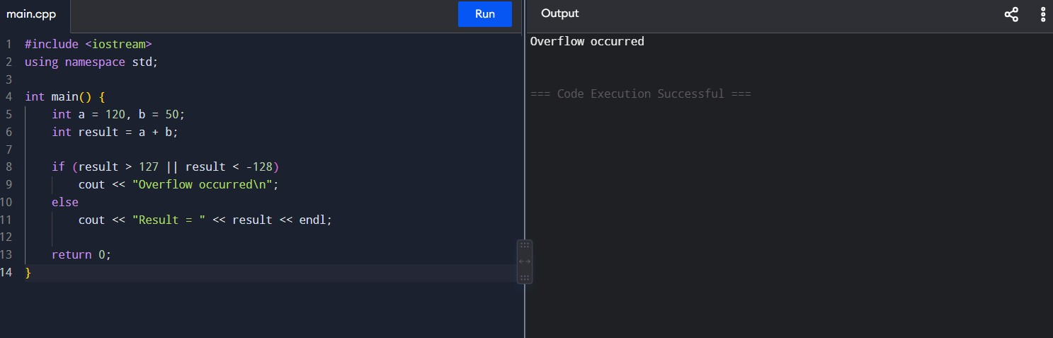
Rectified Code and Output:

Correct solution: Check whether the result exceeds the signed range before storing it in 8 bits.

Ripple Carry Adder → Carry Look-Ahead Adder
Problem
In a Ripple Carry Adder (RCA), each carry must wait for the previous carry:
C0 → FA0 → C1 → FA1 → C2 → FA2 → C3 → ...
For an 8-bit adder, the carry may propagate through all 8 bits, causing large delay.
Optimized solution: Carry Look-Ahead Adder
CLA calculates carries in parallel using:
Pi = Ai XOR Bi Gi = Ai AND Bi For example:
C1 = G0 + P0C0
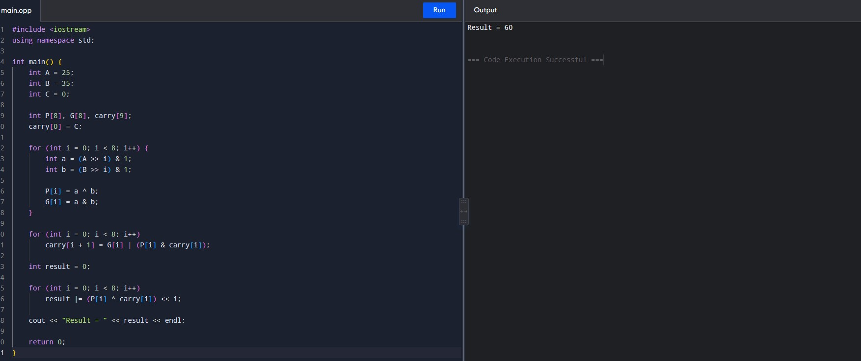
C2 = G1 + P1G0 + P1P0C0

Thus, carries don't have to wait for every previous full adder.
Code and Output:

Optimization: CLA reduces carry propagation delay compared with RCA.

Booth's Algorithm – Signed Multiplication
The common errors are:
- Checking the wrong bit pair.
- Using a logical shift instead of an arithmetic shift.
- Not sign-extending negative numbers.
- Updating Q-1 incorrectly. Booth's bit-pair rules
Check:
Q0 Q-1
Q0 Q-1 Operation
- No operation
- A = A + M
- A = A - M
- No operation
After every operation, perform an Arithmetic Right Shift on:
A, Q, Q-1
Rectified Code and Output:
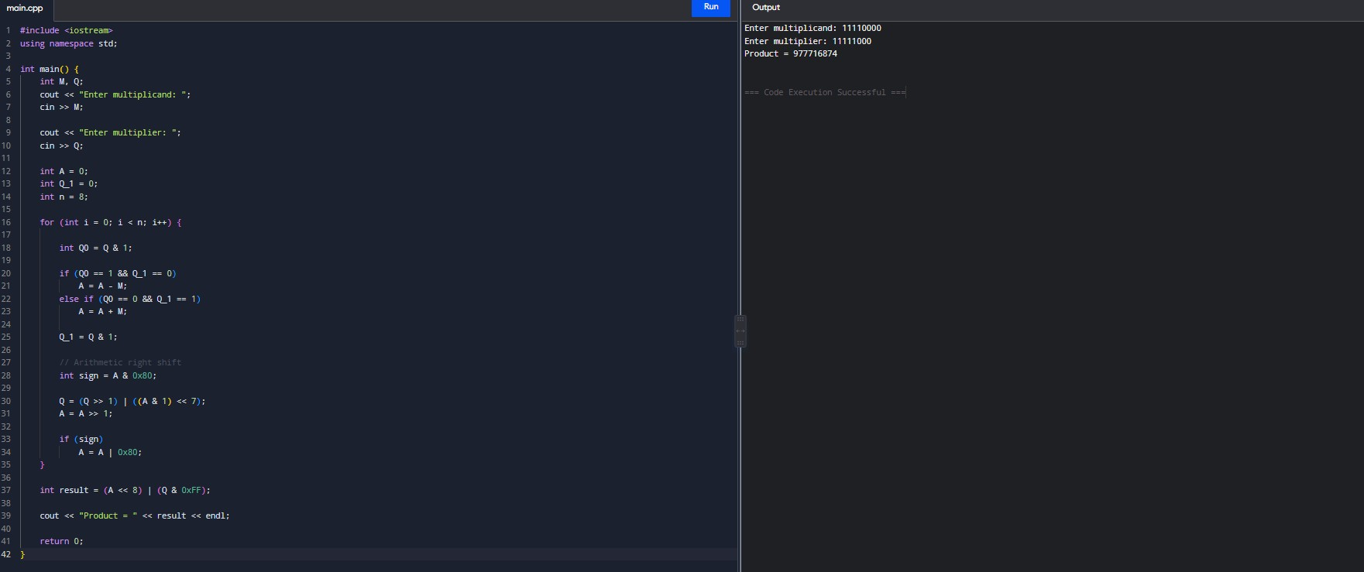
Main correction
For negative operands, sign extension must be preserved during the arithmetic right shift.
For example:
11110000
Arithmetic right shift:
11111000
not:
01111000

Restoring Division → Non-Restoring Division
Problem with restoring division
In restoring division:
- Subtract divisor.
- Check result.
- If negative, restore the previous value by adding divisor again.
So there are repeated operations:
A = A - M

If A < 0:
A = A + M ← unnecessary restoration This increases execution time.
Non-restoring division
Non-restoring division avoids immediate restoration.
If the partial remainder is positive:
A = A - M
If it is negative:
A = A + M
The next operation automatically corrects the remainder.
Simple code
#include <iostream> using namespace std; int main() {
int dividend, divisor;

cout << "Enter dividend: "; cin >> dividend;

cout << "Enter divisor: "; cin >> divisor;

if (divisor == 0) {
cout << "Division by zero is not allowed"; return 0;
}

int A = 0; int Q = dividend; int M = divisor;
int n = 8;

for (int i = 0; i < n; i++) {

A = (A << 1) | ((Q >> 7) & 1);
Q = Q << 1;

if (A >= 0) A = A - M; else
A = A + M;

if (A >= 0) Q = Q | 1;
}

if (A < 0) A = A + M;

cout << "Quotient = " << Q << endl;
cout << "Remainder = " << A << endl;

return 0; }
Advantage: Non-restoring division eliminates the repeated restore operation, so it is generally faster.

5. IEEE 754 Single Precision – Small + Large Number
Single precision uses:
1 sign bit
8 exponent bits
23 mantissa bits
Problem
Suppose:
1.0 × 10^20 + 1.0
Before addition, exponents must be aligned:
1.0 × 10^20
0.000... × 10^20
The very small number may lose its significant bits during alignment because only 23 fraction bits are available.
This causes rounding error.
Rectified C++ code
Use double instead of float when higher precision is required.
#include <iostream> #include <iomanip> using namespace std;

int main() { float a = 1.0e20f;
float b = 1.0f;

float result1 = a + b;

double x = 1.0e20; double y = 1.0;

double result2 = x + y;

cout << setprecision(17);

cout << "Using float : " << result1 << endl;
cout << "Using double : " << result2 << endl;

return 0; }
Ways to improve accuracy
- Use double instead of float.
- Use appropriate normalization.
- Use guard/round/sticky bits in hardware.
- Use Kahan summation when adding many floating-point values.
- Avoid adding numbers with extremely different magnitudes when possible.
- Use higher precision for scientific calculations.

