How to get AD User Properties Using Power Shell

# Introduction:

This document has steps to get the AD user properties and then generate the CSV file. The input is in CSV format and could contain Emails or Account Names of the users, and then output will have the following properties

* UserPrincipalName
* SamAccountName
* First Name
* Last Name
* Country
* State
* Office
* Division
* Department

Again you can modify the script to generate more than these or you can shorten the result set to get what you want.

To get the list of properties you can run the simple command. This tells what the Get-ADUser property returns. Below is the screen capture for reference. Please note that you need to connect to your Company Network and should have Active Directory web services running.

# Artifacts:

Below is the sample script. In the Github repository, check out the complete script with title GetUserDetails.ps1. Below command helps you to determine what objects are returned from your AD.

The command is

Get-ADUser -Identity <SamAccountName> -Properties *

Replace <SamAccountName> with your account ID.

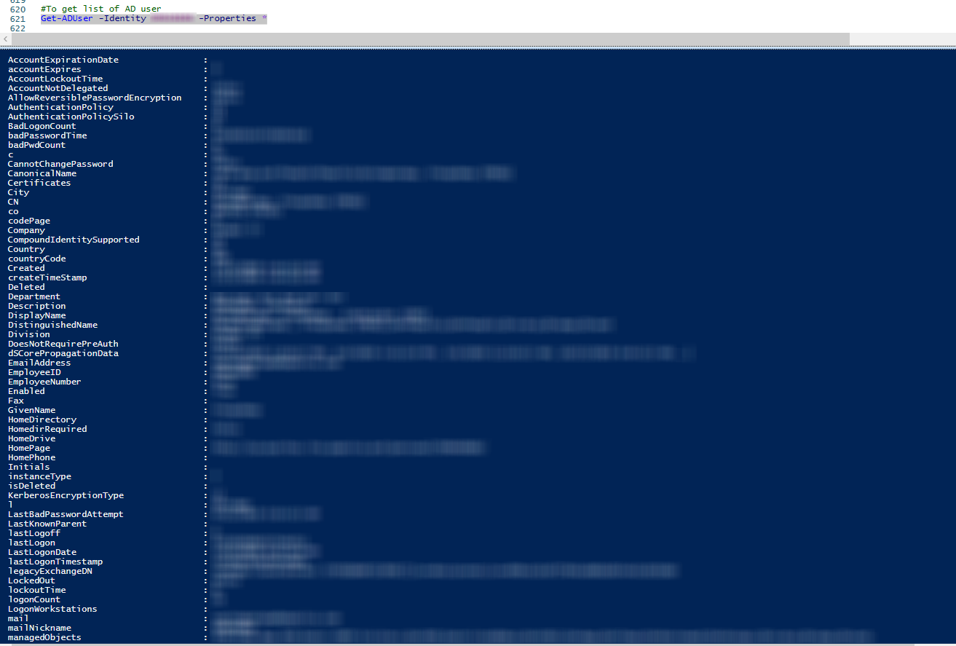

Please make sure the update the following variables

$outputFile: Where the output file of excel needs to be generated

$users: The input file in csv format with first element as ‘Email’.

Screen captures of sample inputs and outputs

Sample input file:

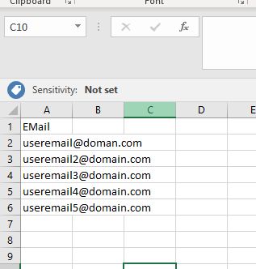

Sample Output File

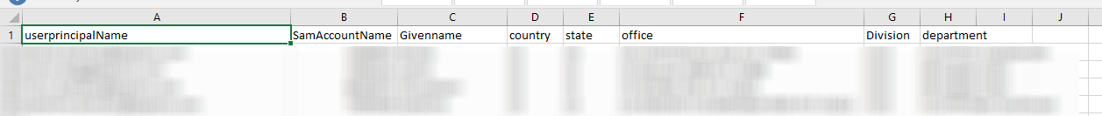

# References:

<https://docs.microsoft.com/en-us/powershell/module/addsadministration/get-aduser?view=win10-ps>