Implementing below architecture using java spring boot using h2 database.

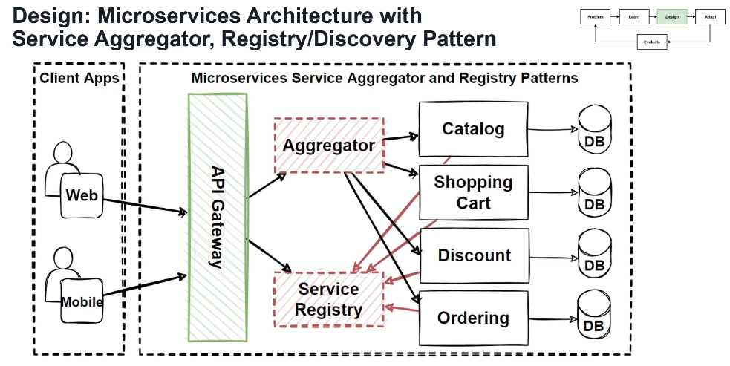

**1. Tech Stack Overview**

* **Java** (17+)
* **Spring Boot** (for all services)
* **Spring Cloud Eureka** (for service discovery)
* **Spring Cloud Gateway** (as API Gateway)
* **Spring Web** + **Spring Data JPA** (for microservices)
* **H2 DB** (in-memory database)
* **Feign Client or RestTemplate/WebClient** (for inter-service communication)

## 2. ****Architecture Components You Will Build****

| **Component** | **Description** |
| --- | --- |
| api-gateway | Routes client requests to backend |
| aggregator | Combines data from multiple services |
| catalog-service | Product information service |
| cart-service | Shopping cart service |
| discount-service | Discount-related data |
| order-service | Order and checkout |
| eureka-server | Service registry |

3. **Step-by-Step Implementation Plan**

Step 1: Set Up Eureka Server (Service Registry)

Step 2: Create API Gateway

Step 3: Build Each Microservice

Create these projects:

* catalog-service
* cart-service
* discount-service
* order-service

Step 4: Create Aggregator Service

4. Directory Structure Example

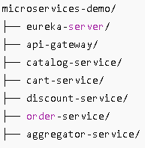

5. Test the System

* Start eureka-server
* Start all microservices and aggregator
* Start api-gateway
* Visit: http://localhost:8080/catalog/products or <http://localhost:8080/full-order-summary>.

**Implementation**

### Step 1: Set Up Eureka Server (Service Registry)

1. Create a Spring Boot project: eureka-server
2. Add dependency: spring-cloud-starter-netflix-eureka-server
3. Annotate your main class:

java

CopyEdit

@EnableEurekaServer

@SpringBootApplication

public class EurekaServerApplication { ... }

1. Add config in application.yml:

server:

port: 8761

eureka:

client:

register-with-eureka: false

fetch-registry: false

1. Run it → should be accessible at http://localhost:8761

### Step 2: Create API Gateway

1. Create project: api-gateway
2. Add:

spring-cloud-starter-gateway

spring-cloud-starter-netflix-eureka-client

1. Annotate main class with @EnableDiscoveryClient
2. Example application.yml:

