Visualization Class, Computer Project: Iso-Surfaces

00957116 王嘉羽

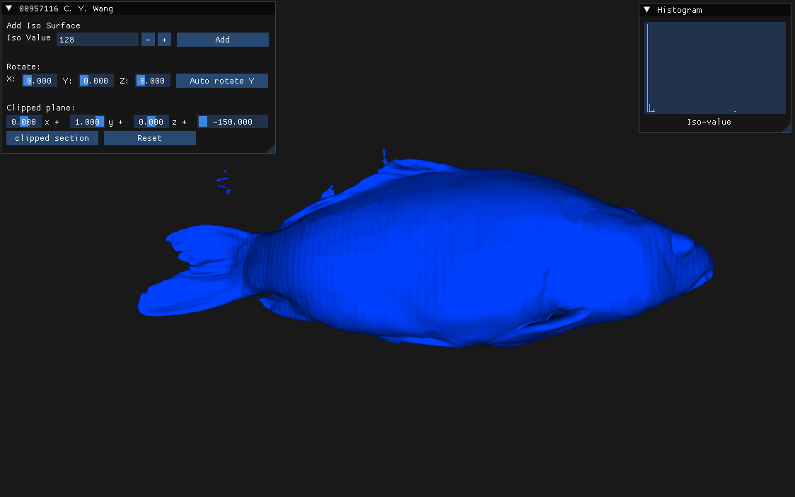

* Construct iso-surface: Marching-cube method
* Construct Normal vector: Gradient method