Document filename: MediPi Test Report
Directorate / Programme | Operations and Assurance Services | Project | Functional Assurance
Document Reference |  | NPFIT-FNT-TO-RM-GEN-0162
Project Manager | Debbie Chinn | Status | Draft
Owner | Damian Murphy | Version | V0.5
Author | Steve Willis | Version issue date | 19/10/2017

MediPi Test Report

Revision History
Version | Date | Summary of Changes
0.1 | 21/11/2016 | First draft
0.2 | 09/05/2017 | Uplifted version following final MediPi testing
0.3 | 10/05/2017 | Updated following review comments
0.4 | 21/06/2017 | Updated following additional testing against functional changes requested by pilot site – Hertfordshire Trust
0.5 | 19/10/2017 | Updated following additional testing due to Bluetooth and direct message functional changes

Reviewers
This document must be reviewed by the following people:
Reviewer name | Title / Responsibility | Date | Version
Anne Dyson | MediPi Project Manager
Damian Murphy | Senior Solution Assurance Manager
Richard Robinson | Senior Support Services Integration Specialist
Ian Dugdale | Safety Engineer
Damian Murphy | Senior Solution Assurance Manager
Richard McStay | Programme Manager: Apps and Wearables Programme

Approved by
This document must be approved by the following people:
Name | Signature | Title | Date | Version

Glossary of Terms
Term / Abbreviation | What it stands for

Related Documents
These documents will provide additional information.

Document Control
The controlled copy of this document is maintained in the NHS Digital corporate network. Any copies of this document held outside of that area, in whatever format (e.g. paper, email attachment), are considered to have passed out of control and should be checked for currency and validity.
Contents

Revision History 2
Reviewers 2
Approved by 2
Glossary of Terms 2
Related Documents 2
Document Control 3
Overview 5
1. Management Summary 6
1.1 Test Script Results Summary 6
1.2 Test Issue Summary 7
2. Test Issue Resolution 8
3. System Configuration 9
4. Problems Encountered 9

Overview
Test report detailing the testing completing against MediPi and Clinical Web Application

Management Summary
Detail actual test start and end dates and any corresponding notes applicable to these dates compared to the planned dates listed in the Test Plan.
Action | Date | Notes
Start | 22/09/2016
Finish | 03/10/2017

1.1 Test Script Results Summary
Summarise test execution results against test cases prepared by Test Phase.
* The impact of this test failure has been mitigated by advising users of the Clinical Web Application to use the Chrome browser rather than Internet Explorer.
~ Following consultation with Hertfordshire Trust a number of functional changes were requested for the pilot, this final MediPi_v1.0.15-PILOT-20170530-1includes these changes and as a result 5 specific test scripts were written and executed successfully.
# Some issues were identified with the Bluetooth devices where some erroneous results were received and some patients had issues connecting to the devices, as a result of these some changes were introduced to the Bluetooth functionality to make measurements more robust and to have great control over the Bluetooth connections.
Further functional changes were made to introduce a direct message to patients via the MediPi app; this was as result of feedback received at the three month review completed during the Pilot.
Test Phase | Total Planned Test Cases | Total Test Cases Run | Test Cases Not Completed / Blocked/Not Applicable | Total Test Cases Passed | Total Test Cases Failed | Total Test Cases Not Run
MediPi v1.08/a | 23 | 20 | 2 | 9 | 9 | 3
MediPi v1.0.9 | 20 | 16 | 0 | 9 | 7 | 4
MediPi v1.0.11 | 12 | 7 | 0 | 6 | 1 | 5
MediPi v1.0.12 | 51 | 51 | 6 | 32 | 13 | 0
MediPi v1.0.14 | 30 | 30 | 0 | 26 | 4 | 0
MediPi v1.0.15 | 63 | 63 | 6 | 56 | 1* | 0
MediPi_v1.0.15-PILOT-20170530-1 ~ | 5 | 5 | 0 | 5 | 0 | 0
MediPi_v1.0.15-20170911-1 # | 22 | 22 | 0 | 21 | 1 | 0
MediPi_v1.0.15-20171003-1 # | 9 | 9 | 0 | 9 | 0 | 0
Total | 235 | 223 | 14 | 173 | 36 | 12
List source: e.g. “Quality Center” Date/Time: 19/10/2017
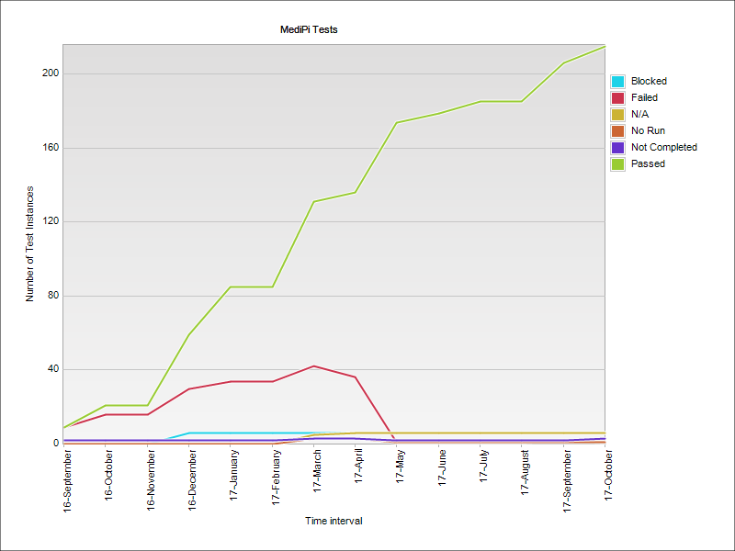

1.2 Test Issue Summary
Summarise the Test Issues raised and still outstanding, identified at each severity level.
All outstanding issues have been reviewed and agreed to remain open from a tracking point of view and have no or minor impact to the pilot at Hertfordshire Trust.
Test Phase | Issues Raised
 | Severity 1 | Severity 2 | Severity 3 | Severity 4 | Severity 5
MediPi (All Builds) | 0 | 7 | 15 | 27 | 40
Total
Test Phase | Issues Outstanding
 | Severity 1 | Severity 2 | Severity 3 | Severity 4 | Severity 5
MediPi (All Builds) | 0 | 2 | 5 | 6 | 6
Total
List source: e.g. “Quality Center” Date/Time: 19/10/2017

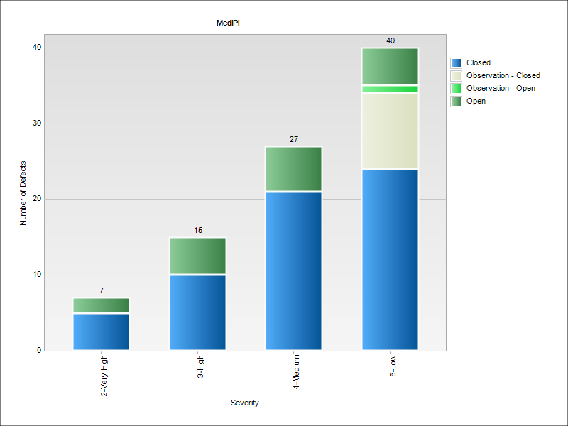

Test Issue Resolution
All defects to be reviewed by NHS Digital and Mastek development teams to identify if a resolution is required. Any resolutions required will be included against the relevant defects and listed in Quality Center.

System Configuration
Application | Initial Version | Current Version
MediPi | MediPi v1.0.8 | MediPi_v1.0.15-20171003-1

Problems Encountered
No outstanding problems

